FACTORS INFLUENCING TEACHER TURNOVER IN PRIVATE SECONDARY SCHOOLS IN WAKISO DISTRICT

BY
NSAMBA WASSWA KIZITO
2017/AUG/MEMP/M222608/DIST/KYE

A RESEARCH DISSERTATION SUBMITTED TO SCHOOL OF
EDUCATION, HUMANITIES AND SCIENCE IN PARTIAL
FULFILMENT OF THE REQUIREMENPTS FOR THE
AWARDOF THE DEGREE OF MASTERS IN
EDUCATION MANAGEMENTAND PLANNING
OF NKUMBA UNIVERSITY- ENTEBBE

OCTOBER 2019

DECLARATION

I, NsambaWasswaKizito, hereby declare that this is my original work and has never been presented to any university for the award of a degree.

Signed: …………………………………….
NsambaWasswaKizito

Date: ……………………………………….

APPROVAL
I hereby certify that the dissertation titled “Factors affecting teacher turnover in private secondary schools in Wakiso District” is the original and individual work of Candle Juliet. This has been done under my supervision and is ready for submission for the award of a degree with my due knowledge.

Signed: ………………………………………….
DR. JOYCE BUKIRWA
SUPERVISOR

Date: ……………………………………………

DEDICATION
This dissertation is dedicated to my wife: Ngonzi Justine Amooti; for her financial and moral support in my study; and to my children; Robert, Switzen, Prisca and Josephine for missing my parental love while I was studying.

ACKNOWLEDGEMENT
I am deeply indebted to my research supervisor, Dr. Joyce Bukirwa for her patience with my inadequacies as she guided me through the research. Without her parental and professional input, this research would have been difficult to elevate to its current level.
I acknowledge with gratitude the contributions and co-operation made by the head teachers, teachers and students of the sample schools for their willingness to provide the necessary information when I visited theirrespective schools during the research process. Without their cooperation, this study would have been impossible to accomplish.
In a special way, I wish to extend my sincere gratitude to Dr. Cleophus Mugenyi for the support and guidance he accorded me during my study.
I would like to deeply thank all my lecturers at the School of Education. These have adequately guided and equipped me with both theoretical and practical skills. I would also like to acknowledge the contribution of my colleagues from whom I enjoyed fruitful discussions on challenging topics.
Finally, I also thank Mr. Musimenta Daniel, the secretary at Quality Graphix Igayaza for typing this work whole heartedly to the required standard.

TABLE OF CONTENTS
DECLARATION i
APPROVAL ii
DEDICATION iii
ACKNOWLEDGEMENT iv
TABLE OF CONTENTS v
ABSTRACT vii
CHAPTER ONE 1
INTRODUCTION 1
1.0 Introduction 1
1.1 Historical background to the study 1
1.2. Statement of the Problem. 6
1.3. Purpose of the study 7
1.4. Research study Objectives 7
1.5. Research Questions 7
1.6. Scope of the Study 8
1.7 Significance of the Study 8
CHAPTER TWO 9
LITERATURE REVIEW 9
2.0 Introduction 9
2.1 Theoretical Review and Conceptual framework 9
2.2 Review of Related Literature 12
2.2.1 Employer related factors and teacher turnover 12
2.2.2 Employee related factors and teacher turnover 16
2.2.3 External factors and teacher turnover 20
2.3 Research hypotheses 22
CHAPTER THREE 23
METHODOLOGY 23
3.0 Introduction 23
3.1 Research Design 23
3.2 Study Population 24
3.3 Sample size 24
3.4 Sample selection procedure 25
3.5 Data collection instruments and methods 25
3.5.1 Questionnaire survey 25
3.5.2 Key Informant Interviews 26
3.5.3 Documentary Analysis 26
3.5.4 Procedure of data collection 26
3.5.5 Ethical consideration 27
3.8 Assumptions and Limitations 30
CHAPTER FOUR: DATA PRESENTATION, ANALYSIS AND INTERPRETATION 31
4.1 Introduction 31
4.2 Background information 31
CHAPTER FIVE: DISCUSSION, CONCLUSIONS AND RECOMMENDATIONS 53
5.1 Introduction 53
5.2 Discussion 53
5.3 Conclusions 61
5.4 Recommendations 62
APPENDIX A: INTERVIEW GUIDE FOR TEACHERS 68
APPENDIX B: INTERVIEW GUIDE FOR HEADTEACHERS 70
APPENDIX C: QUESTIONNAIRE FOR STUDENTS 71

ABSTRACT
The researcher’s concern was on the factors affecting teacher turnover in privatesecondary schools in Wakiso district. The study particularly sought to establish how employer, employee and external related factors affect teacher turnover. The study was prompted by the overwhelming teacher attrition in most private secondary schools in Uganda. Private secondary schools have higher teacher turnover than government schools but ironically, the former constitute the biggest percentage of secondary schools in Uganda. .
The study was conducted using the descriptive research design where a cross-sectional survey was used because the population to be studied was too big and this study design proved to be less costly and time saving. Simple random sampling was used to select the respondents who were comprised of: school heads, teachers and students. Data was collected with the use of interview guides, questionnaires and document check lists. It was analyzed by descriptive statistical techniques and presented in the form of tables, frequencies and percentage distributions. Several findings were made in regard to the study but notable of these were that; loss of group cohesion, poor working conditions, poor pay, poor management or supervision which were categorized under employer related factors significantly affected teacher turnover in private secondary schools in Wakiso District. It was also revealed that employee related factors also affected teacher turnover. Many teachers joined the private secondary schools with numerous expectations which were not met and this increased their dissatisfaction causing lack of commitment and the end result was always resignation.

CHAPTER ONE

INTRODUCTION

1.0 Introduction
This chapter gives the background, problem statement, objectives of the study, research questions, scope and the significance of the study.
  - Historical background to the study
Children hold the candle for the bright future and development of a givenstate and success in their studies provides the backbone to this effect. However, this can only be possible if they are availed with sufficient resources such as textbooks, laboratory equipments, teaching staff and other services. But of all those, human resources have come to be the most important resource. Maicibi (2003) agrees with this by arguing that when the right quantity and quality of the human resources is brought together, it can manipulate other resources towards realizing the organisational goals and objectives. It has long been argued and established that the quality of the human resources has a high correlation with the level and quality of organisational performance and productivity. If this were the case, then every school should strive to attract and retain the best quality and right quality of the teachers.
A school is an avenue through which many children’s future events and opportunities can be realized; unfortunately, it is the teaching profession that loses thousands of dedicated members each year, putting those most vulnerable children and youth at arisk of failing to realise opportunities offered to them through quality education (Benner, 2000). Indeed, research has shown that approximately one-quarter of all beginning teachers leave teaching within four years (Benner, 2000; Rowan et al; 2002). In Chicago, a report on teacher turnover released on June 29th 2009 revealed that within 5 years most schools lose about half of their teachers. The exit of both new and experienced teachers is a great challenge for schools and school administrators as this usually carries along with negative consequences. Besides, any new initiative or professional development winds up having little time to take root; and turnover forces headteachers to spend a lot of time on recruitment and hiring new teachers. The scenario is even worse in many private secondary schools in Uganda like in Wakiso District which apparently loses many teachers every year.
Jones (2000) who carried out a field survey in many African countries including Uganda on the teaching profession in Africa reported that the status of the teaching profession is low; and that and recruitment of the teachers has been haphazard and deployment has been mismanaged while their training has been inadequate. Because of this and more, the Monitor Newspaper (28th March 2003) wrote an article “who will wipe away the tears of teachers?” in which poor pay was pointed out as one of the major factors affecting teacher turnover. The problem of teacher turnover is mainly caused by poor pay among other factors as Blair and Jordan (1999) emphasize that academic staffing has been undermined by large outflows of staff to other sectors of the economy, and it is most probable that it is the well trained and more experienced teachers who leave schools for better employment opportunities leaving a vacuum to be occupied by the less experienced or poor quality teachers. The question remains, why do teachers especially in private secondary schools leave?
A report by the Wakiso District Private Schools Association (2002), indicated that most private secondary schools in Wakiso District could hardly pass on average 10 students in first grade in each of the schools. According to the Texas Centre for educational research (November, 2000), it was established that high teacher turnover is a burden of cost and inefficiency to the Texas public school system and turnover may also affect student performance particularly in schools where the turnover rate is consistently high. This scenario may not be different from the educational system in Wakiso District private secondary schools since the rate of teacher turnover in these schools is high. According to Gerald (2002), a turnover rate of 25% would be considered perfectly satisfactory by most firms. He went ahead to highlight some of its advantages as: providing an incentive to recruit fresh staff, open up promotion channels for longer-serving employees and enable organisations to shed off more easily when redundancies are realized (i.e. natural wastage).
Robre (2004) supports this view by stressing some positive elements of labour turnover as helping the business to bring in fresh ideas, enthusiasm, experience, creativity, new perspectives, new approaches to mention but a few. Much as various scholars agree to the positivity of labour turnover to some extent, many in a concerted effort believe that a constant turnover of staff can only bring about a disastrous effect on the organisation. This study specifically looked at factors for increased teacher turnover in private secondary schools in Wakiso District.
Turnover according to Gerald (2002) refers to the ratio of leavers to the average numbers employed during the course of the year. Maund (1988) looks at labour turnover as a measure of the rate of change of an organisation’s workforce, The website http://search-live.com/results (2008) defines employee turnover as a ratio comparison of the number of employees a company must replace in a given period of time. It is the ratio of the number of workers that had to be replaced in a given time. In this study, teacher turnover was looked at as the rate at which teachers leave a given school in comparison to the average number of teachers employed in that year; that is, the inability of school heads to retain their teaching staff and it was measured by determining the ratio at which teachers leave in a given period of time. Gerald (2002) presented the formular for such a measurement as:
Labour turnover = Number of staff leaving per year x 100
Average numbers employed during a year
It should be noted that if the rate at which teachers leave the school is high, the figure may reflect an ineffective human resource management strategy (Marcous, et al, 1999).
Theoretical background
Teacher turnover is based on the following two theories:-
- The Hertzberg’s motivation-hygiene theory of job satisfaction which proposes that every worker has two sets of needs or requirement i.e. motivational and hygiene need.
- The expectancy theory as advocated by Victor Vroom proposed that the strength of a tendency to act in a certain way depends on the strength of an expectation that the act will be followed by a given outcome and the attractiveness of the outcome to the individual.
The study therefore focused factors influencing teacher turnover in private secondary schools in Wakiso District.
This study was guided by Herzberg’s motivation-hygiene theory of job satisfaction. Hertzberg proposes that every worker has two sets of needs or requirements motivational and hygiene needs. This theory indicates that teachers will stay in the school as long as they can satisfy their needs and they are motivated (Job satisfaction), but when their needs surpass their income and they feel they are no longer motivated, they will seek better employment where they will feel motivated. The study was further guided by the expectancy theory postulated by Victor Vroom in 1964. This theory argues that the strength of a tendency to act in a certain way depends on the strength of an expectation that the act will be followed by a given outcome and the attractiveness of the outcome to the individual. In this theory, it is assumed that a teacher is likely to remain working in his present job if he/she knows that performance will be measured, evaluated and rewarded with positive outcomes like pay rise, fringe benefits, promotion, recognition and others. Failure to be rewarded as expected, may get a teacher frustrated, reduce his or her effort, be demotivated and may eventually quit the job.
The expectancy theory chosen by the researcher therefore, provides a theoretical foundation for factors affecting teacher turnover. School heads need to realise that failure to meet teachers expectations will eventually lead to their frustration and henceforth turnover. However, it should be noted that a stable staff with experience is a pre-requisite for good academic performance. The two theories above were selected because they deal with job satisfaction, an element which when not met, usually lead to labour turnover and in this reference teacher turnover which was of interest in this study. The study therefore focused on factors affecting turnover in private secondary schools in Wakiso District.

1.2. Statement of the Problem.
The most important single resource in any organisation is people (General, 2002). Teachers therefore have the biggest impact on the students because their teaching methods are instrumental in helping them learn and one approach is likely to produce different results from another (Western and Ganton, 1986). In Wakiso District, apart from a few government schools like Buddo Kings College, St. Mary’s College Kisubi, Gayaza High School and the like, the general teacher turnover is overwhelmingly high largely so in private secondary schools which constitute the biggest percentage of secondary schools in the District. It should be noted that there is a general outcry about teacher turnover especially in private secondary schools in search of “greener pastures”. In private secondary schools in Wakiso District, there is evidence of mediocre commitment of staff, this perhaps explains the high teacher-turnover. Wakiso District Private Schools Association Report indicates that in 2004 alone, out of 368 new teachers, who were hired 253 left their schools in the 162 registered private secondary schools in the District. If this matter is not arrested immediately, there is a possibility of loosing all potential teachers to other businesses or worse still failing to get teachers to fill the various vacuums left. This could in future cripple the Uganda Education System, which basically „survives on the blood‟ of private secondary schools. In view of this discrepancy, it became imperative that a study be made to establish the factors affecting teacher turnover.

1.3. Purpose of the study
The purpose of this study was to establish the factors responsible for teacher turnover in private secondary schools in Wakiso District with a view to try to reduce the rate of teacher turnover so as to improve the general level of academic performance of students in private secondary schools in Wakiso district.

1.4. Research study Objectives
The study was guided by the following research objectives:
- To establish the effect of employer related factors on the rate of teacher turnover in private secondary schools in Wakiso District.
- To find out how employee related factors affect teacher turnover in private secondary schools in Wakiso District.
- To determine the influence of external factors on teacher turnover in private secondary schools in Wakiso District.

1.5. Research Questions
- What are the effects of emJployer related factors on teacher turnover in private secondary schools in Wakiso District?
- How do employee related factors affect teacher turnover in private secondary schools in Wakiso District?
- What influence do external factors have on teacher turnover in private secondary schools in Wakiso District?

1.6. Scope of the Study
The study investigated the factors affecting teacher turnover in private secondary schools in Wakiso District. The study found out how employer, employee and external related factors affect teacher-turnover in Wakiso District. Wakiso District is found in Central Uganda and comprises of 3 counties of Busiro, Kyadondo and Entebbe Municipality. The study was conducted in 64 randomly selected private secondary schools in Wakiso District between March – August 2007 using the descriptive research design and a sample of 380 respondents. Data was collected with the use of questionnaire, interview guide and document techniques.

1.7 Significance of the Study
It is hoped that findings and the recommendations of the study will be useful to the human resource managers and administrators of private secondary schools in Wakiso District and Uganda as a whole to reduce on the rate of teacher turnover and consequently ensure a stable and well-motivated staff in private secondary schools. To the society, the research findings will add knowledge in the education field in Uganda.

CHAPTER TWO

LITERATURE REVIEW

2.0 Introduction
This chapter dealt with the theoretical and conceptual frame works, and the review of related literature. The literature review was presented in accordance with the study objectives.

2.1 Theoretical Review and Conceptual framework
The study was guided by the Hertzberg’s motivation- hygiene theory of job satisfaction. Hertzberg believes that every worker has two sets of needs (motivational and hygiene needs). He contends that employees in this respect, teachers will stay in their schools so long as their needs are satisfied and they are motivated. Failure to meet their needs would automatically call for departure hence teacher turnover. This study was interested in establishing whether teachers‟ turnover is only driven by their desire to satisfy their needs or whether there are other reasons.
The theory however assumes that all human beings have no loyalty to any organisation and that as soon as their needs are no longer satisfied, they seek other employment, which is not the case in the real world where finding employment is sometimes not very easy. Secondly, the theory concentrates on the individual’s needs independent of those of the organisation or school and it does not put into consideration the fact that there may be times when the individual’s services are not worthy of better pay to satisfy his/her needs and that may be a better replacement would be a welcome change. In the context of this study, there is a need to establish whether the teachers will leave the schools as soon as their needs are not satisfied or not.
While Hertzberg concentrates on the motivation-hygiene needs as the driving force for them to seek alternative employment, Capelli (2000) was of the view of that it is the market, not the company that ultimately determines the movement of employees. Capelli believes that it may be difficult to counter the pool of the market and that you can not shield your employees from attractive opportunities and aggressive recruiters and suggests that “the old goal of human resource management to minimize overall employee turnover-needs to be replaced by a new goal: to influence who leaves and when.
The expectancy theory as advocated by Vroom (1964) argues that employees (teachers) are likely to leave if their expectations are not met. This theory was preferred by the researcher because it emphasizes what employees need or expected from an organisation and failure to fulfill them leads to low commitment, frustration, loss of morale and eventually leaving their jobs. In the context of this study, private schools can change their policies, treat their experienced staff better, reward them accordingly so as to reduce teacher turnover.
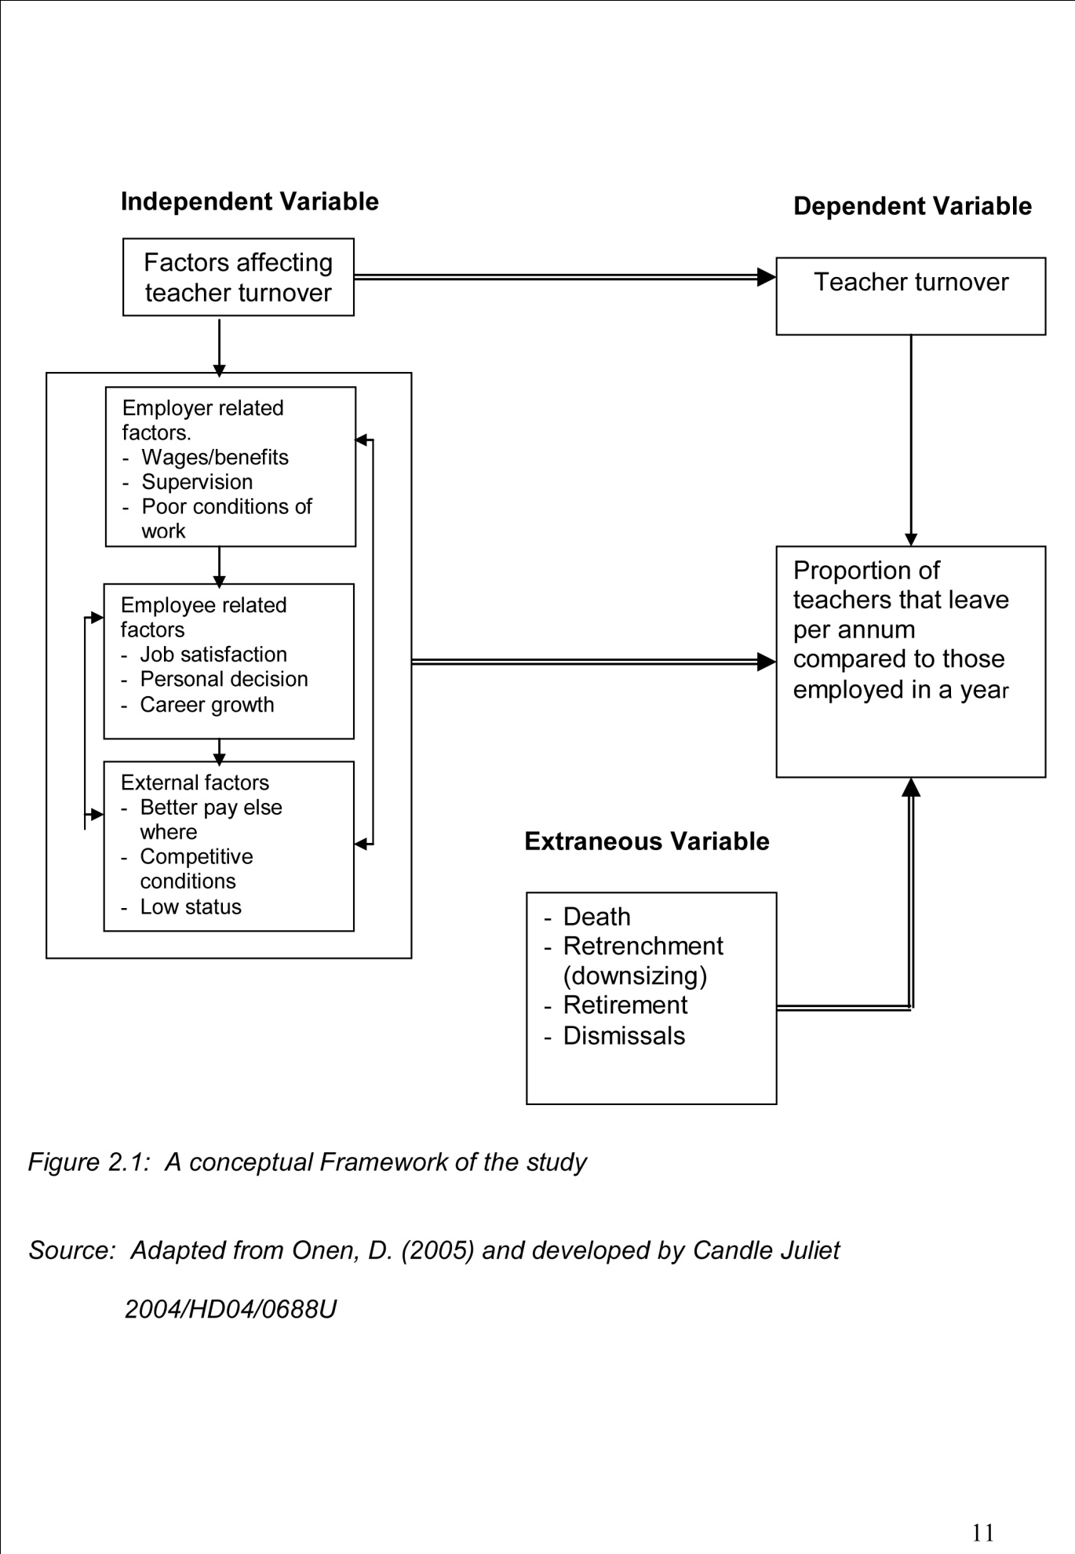
Figure I illustrates the factors affecting teacher turnover. These factors were categorized into 3; that is, employer related factors, employee related and external related factors. Teacher turnover was looked at as the proportion of teachers that leave per annum compared to those employed in the same year. The relationship between employer, employee and external factors and teacher turnover was eminent and the extraneous variables in the study were death of some teacher’s retrenchment, retirement and dismissals.

2.2 REVIEW OF RELATED LITERATURE
This section basically looked at the related literature as per the specific objectives set in the study. These were employer related factors and how they influence teacher turnover, employee related factors and external factors in private secondary schools with reference to Wakiso District.

2.2.1 Employer related factors and teacher turnover
Many researchers cite poor pay as the primary reason for high teacher turnover worldwide. The international journal of education policy and leadership in Texas Districts revealed that “it takes a very strong individual to teach because they are so underplayed. It is a wonder anyone can survive on a teacher’s salary alone especially a new teacher. In addition to the poor salary and starting out brand new, many administrators hurl responsibilities at new teachers like committees and coaching with very meager payments if any. This is the long run leaves the teachers completely burned out and eventually they leave. If this is the situation in Texas, one wonders what Africa has to offer, it is because of such publications that a study had to take place in Uganda and Wakiso District in particular to compare the situations.
Failure to create group cohesion by employers, there are incidences when the school management takes decisions without considering the effects on the other school members. The move can be interpreted as a malicious action by the affected staff. This can cause friction and loss of group cohesion and regrettable decisions can be taken and the whole school might be affected in the long-run (Everand and Morris, 1985) as cited by Smith (1995). Maicibi (2003) in agreement shows that lack of group cohesion makes employees feel isolated and unhappy which might make them leave their schools.
A report in Chicago about teacher turnover in June 1900 also highlighted this as a major cause of turnover, Jessica had this to say “we don’t become teachers for the money, I left a low paying District after four years because I was marginalized. I mean that I felt I had no say in what was going on … we were not „company men‟ and labeled „trouble makers‟”. Such sentiments make many teachers disappointed and they opt out for places they can recognize them, incorporate them in their institutions as team players.
Teachers working conditions play an important role in a school’s ability to attract retain and motivate good teachers, hence a cause of teacher turnover. In relation to the above, Schwartz (1984) adds that those working conditions, which include physical and psychological factors surrounding a job, vary in importance as a motivator and the absence of such motivating factors, employees and in this case teachers will exit. Hanushek, Kain and Rivkin (1982) argue that while clearly important, teacher salaries are not all that matter. They show that teacher preferences cut across a range of job and school conditions may be just as important as salary in the retention decision. According to their study, teachers might be willing to take lower salaries in exchange for better working conditions.
Related to this, is lack of resources in a school. This contributes to teacher job dissatisfaction which then can lead to attrition. In interviews with public school teachers in New York City, a large percentage of new teachers said they did not have access to adequate basic supplies, most teachers had to use their own money to equip their classrooms, most teachers report that they do not have enough textbooks and the ones they have are in poor condition, photocopying materials becomes a considerable part of their tasks, but school copy machines are frequently broken and teachers have to rely on family, friends or other private resources to produce the materials (Tapper, 1995). Most teachers in South Carolina also noted that they were given no support, no mentors and no meaningful professional development. Administrators were more concerned with growing bigger, moving to new buildings, giving themselves allowances at the expense of teachers, who did the donkey work. It takes a lot of interest and love for a teacher to do that which most probably teachers in Wakiso District cannot tolerate explaining the increased rate of turnover.

A study carried out by Hargreaves (1994) among some high school teachers in the United States reveal that supportive school policies like provision of learning opportunities including mentoring of new teachers and other plans for professional development were highly correlated with teachers commitment and turnover. The implication is that teachers are more likely to leave their jobs in circumstances where their schools do not provide learning environment and opportunities for professional growth (career progression or employee development). Similarly, Benner (2000) in his research on teacher turnover discovered that teachers feel disenchanted and demotivated to work in an environment where opportunities for personal growth are minimal. Bowey (1978) agrees with this by arguing that employees who are highly career oriented might change their jobs in order to move to a job which they regard as a step up in their career ladder. The researcher was curious to establish whether such grievances led to teacher turnover in private secondary schools in Wakiso District or not. Natawo (1993) articulates the same view as she reveals that non-promotion was found to be one of the factors contributing to high rate of labour turnover in Ugandan Ministry of Education and Sports. Many employees (teachers) as another study noted look at themselves as helpless with no progression (Kakooza, 1991), as a result their commitment decreases and their absenteeism increases, the end result is turnover. Both authors particularly refer to teachers in government schools which are under the Ministry of Education and Sports, but what about those in private schools? Are they faced with the same problem?
Poor management has been recorded as by many researchers as a factor for labour turnover Maicibi (2003) reported that when employees work under poor management conditions, they tend to behave like caged animals looking for the slightest opportunity to escape, in such a situation when an opportunity opens, whether less than the present on, the employees could leave without looking behind. Poor supervision and a highly centralized administration may lead to decline in motivation and morale of the staff which sometimes results into turnover.
While some employer factors are not intentional some are clearly causes of labour turnover for instance being dismissed due to unprofessional conduct or downsizing. It could be a deliberate policy of the organisation to downsize (Maund, 1988). The fact that many private secondary schools are cropping out especially in Wakiso District means there is increased competition for students to fill these schools, this has reduced student population in schools, with such a scenario it would be wise to reduce on staff thus teacher turnover. This study was basically set to find out if this is a possible cause of teacher turnover in private secondary schools in Wakiso district. Employers have a challenge to change in their management style, policies and embrace teacher-retention policies otherwise recruitment and selection of good teachers would be a wasted effort and most probably good academic results will be a myth.

2.2.2 Employee related factors and teacher turnover
Ian (1997) argued that the pay package is one of the most obvious and visible expression of the employment relationship. How salary scales and delays in payment demoralizes the school staff, who might resort to seeking other sources of income, hence cheating on the students’ teaching hours (Kajubi, 2001). In 2002 survey, teachers in California who were considering leaving the profession ranked “salary considerations” as the most important factor driving their decision (Type and O‟Brien, 2002) Gritz and Theobold (1996) in their study on factors for teacher attrition also discovered that pay was the most important influence on the decision by experienced male and female teachers to remain or leave the profession. The same finding was reported in a survey carried out by Dolton and Klauw (1995) on teacher attrition in the United Kingdom (UK), Maicibi (2003) and Kayizza (1990) too conducted studies on factors of job satisfaction among teachers in selected schools and districts in Uganda and like other researchers found out that poor pay had ranked as the first factor that contributes to teacher turnover.
An increased demand for secondary education in a limited number of secondary schools has resulted into an increase in the teacher-student ratio. This has resulted into an increase in class size and teaching loads through double shifts and multi subject specifications for teachers which is a cause of grievance especially when the salary scale does not match the work load (Kajubi, 2001) some teachers are fatigued, lose morale and when the situation is not corrected or made more bearable, such teachers will seek employment in other schools. Westat (2002) agrees with this by arguing that in a study of personnel needs in special education cited unmanageable workloads, the interference of paper work with teaching and teaching children from 4 or more disability categories caused discontent and later turnover. Could this be a possible cause of teacher turnover in Wakiso district, the study was set out to assertion its validity.
Failure to meet employees‟ expectations has also been identified as a cause of teacher turnover as expounded on by Maicibi (2003) who argued that although a every part of staff management is motivation, if expectations are raised about progress or potential rewards but which are not met, there will be a subsequent drop in commitment and a possible withdrawal of cooperation or even from the job as a whole. This study therefore was conducted to establish the relevancy of this effect to teachers in private secondary schools in Wakiso District.
Failure to be guaranteed job security is also cited as a cause of teacher turnover in many schools around the globe. In June 2009, research was carried out in Chicago to find out factors affecting teacher turnover. It was revealed that many teacher left schools because they were not sure of maintaining their teaching jobs as Debby asserts “One of the primary factors is the explosion of Charter schools where teachers’ jobs are much less stable since they have no union and no contract to protect them from Capricious administrators, could such factors also affect. Wakiso private secondary school teaching staff? The study was carried out to answer such questions.

Lack of job security is also given as one of the factors affecting teacher turnover. The phenomenon of laying off large numbers of teachers in private secondary schools without clear reasons affects teachers interest in teaching, kills their morale and cause fear among them. Rebore (2004) noted that for fear of dismissed at anytime large numbers of teachers have dejected to the business community. This study thus set out to establish whether this is true or not in private secondary schools in Wakiso district.
Need to find jobs which better suit teachers‟ skills and interests could also explain teacher Turnover. Maund (1988) confirms this by arguing that employees will leave the organisation in order to find jobs which better match their skills and interests. If employees, in this case, teachers are not intrinsically motivated and feel they are not being led in the direction they think, they and the organisation should go, will leave their schools to places where their interests can be given priority. Employees can also be demotivated if they are unclear about their responsibilities or performance standards. Maicibi (2003) in relation to this argued that if employees do not feel adequate in their jobs, they are unlikely to stay for very long on the job one wonders if this is relevant to the private secondary school teachers in Wakiso District.
One other aspect is teacher dissatisfaction with their employment. Satisfaction is very important to employees and it determines their loyalty to the organisation (school). A project carried out on the Next Generation of teachers in Harvard Graduate School of Education (1998) confirms this, the key to addressing shortages lies in schools and classrooms where teachers must find success and satisfaction. It is there that they will decide whether or not to continue to teach. In addition to this, conflicts and dissatisfaction with colleagues and or supervisors has also been sighted as a possible factor affecting teacher turnover. Maicibi (2003) contends that a common reason for resignation from the organisation is the feel that management or specific supervisors are not providing the leadership they should or are treating employees unfairly, inequality or are bullying others. Some supervisors do not even orient new members who later become disgusted and leave the school.
Passion for work is a necessity for any successful and committed employee. Teaching is a calling just like other vocations. Many teachers however lack the passion to teach. The young teachers especially in the United States, New York to mention but a few look at teaching just as a job not a career. In fact many are heard saying “Teaching is a sure thing, until something better comes up”, this obviously means they lack the heart to teach. They do not love teaching but just take it on as a step as they search for something better to do. However, one teacher in New York noted that “I would be a fool if I was not looking for “greener pastures”, to me it doesn’tmater where I teach, I love teaching. But love does not pay the bills, if it does please contact my landlord”. Such utterances are a clear sign that passion for work itself without incentives and benefits can not retain workers. A study in Wakiso was carried out to find out the relationship between lack of passion for teaching the turnover rate.

2.2.3 External factors and teacher turnover
Much as employers are largely to blame for increased labour turnover, sometimes they too have to succumb to external pressure for instance as Maund (1988) observed stiff competition for scarce labour supply and varying wages and salaries in other schools may cause labour turnover. Staffing schools with science teachers is still a big challenge to many school administrators, so if wages and salaries do not meet the levels of the organisations in a similar business, then individuals will find employment where the rates are competitive or rewards are better. Could this explain why science teachers tend to move from school to school? This study set to find out if the same applies to private secondary schools in Wakiso District?
Related to this is the fact that other teachers leave to search for better or higher wages and better opportunities elsewhere as Rebore (2004) clarifies “in recent years however educational organisations have experienced a decrease in the number of applicants for mathematics and science teaching positions because of the higher wages and advancement opportunities available in private business and industry, could this be the same in Wakiso District? This is why the study had to be carried out.
Disrespect of teachers by the public or community. Overall, teachers find a professional paradox-their community has great expectations from education but teachers are accorded low social status and held in low esteem (Jones, 2001). Many therefore leave teaching because of public pressure which regards them as the poorest, disrespect them and devalue the teaching profession. Teachers repeatedly battle public stereotypes that their jobs are easier than most other professions, all these reduce their commitment and morale to teach. This study was conducted to ascertain this and see whether it applies in private secondary schools in Wakiso District or not.
General economic conditions of the country or company in isolation may have a considerable influence on the rate of staff movement (Cole, 2002). At times of economic difficulty, firms and public sector organisations may have to cut back severely on employee numbers, leading to redundancies and early retirements.
Most teachers leave schools because they have been offered better jobs elsewhere. Cole (2002) affirms this by noting that some people leave because they have been offered better jobs somewhere else or for a variety of other personal motives. This study was to establish if all these issues apply to teachers in private secondary schools in Wakiso District.
Government too is somehow responsible for the increased rate of teacher turnover in many private secondary schools in Uganda. Many a times, it does not come I to assist the teachers employed on private basis, many a times, it does not come in to assist the teachers employed on private basis, many government teachers remain in their respective schools for many years with a hope of getting pension after retirement. In many private secondary schools, the only option is joining NSSF which most directors of schools are hesitant to join for fear of paying 10% on each and every teachers monthly compulsory saving. Besides teachers in these schools are harshly treated by the headteachers, cheated, abused, mention it but government is totally unconcerned. All these culminate into teacher dissatisfaction and the end result is leaving. The study was to find out if such worries also result into teacher turnover in Wakiso District private secondary schools.

2.3 Research hypotheses
The study verified the following hypotheses:
- There is an effect of employer related factors on teacher turnover in private secondary schools in Wakiso District.
- Employee related factors affect teacher turnover in private secondary schools in Wakiso District.
- External factors influence teacher turnover in private secondary schools in Wakiso District.

CHAPTER THREE

METHODOLOGY

3.0 Introduction
This chapter discusses how the methodology was employed in the study. It indicates the research design, the study population, research instruments and data analysis techniques.

3.1 Research Design
This study adopted descriptive research design, specifically cross-sectional survey design using both the quantitative and qualitative methods of data collection. Descriptive study according to Gall et al (1996) enables the researcher to collect information from a cross-section of a given population. The study design used was the cross-sectional survey which is the most commonly used research method in social research. Amin (2005) asserts that results from such a survey method are easily extrapolated to the entire population. Besides, this method was time saving, and less costly given the fact that my study population was big and I was meeting all the costs. The study was both qualitative and quantitative (Creswell, 2003) asserts that a mixed methods design is useful to capture the best of both quantitative and qualitative approaches. This was used in the different phases of the research to obtain a variety of information on the same issue, use the strength of each method to overcome the deficiencies of the other and generally obtain a higher degree of validity of reliability i.e. have a deeper analysis.

3.2 Study Population
The study was conducted using different categories of subjects and the population from each category was selected using simple random sampling. The study population comprised of students, teachers and head teachers of some selected private secondary schools in Wakiso District. Teachers will be selected because they are directly concerned with the academic performance of students and they know why teachers leave schools, students will be selected because they are directly affected by teacher turnover while Head teachers will be sampled because they are particularly responsible for both students’ academic performance and with teacher turnover, they have the responsibility of recruiting new teachers to fill the gaps.

3.3 Sample size
A sample size representative of the study population was selected using simple random sampling and purposive sampling. A representative sample, according to Gall and others (1996) gives results that can be generalized to the study population the sample of 64 schools and 380 respondents selected from all categories of teaching staff, students and Headteachers. The determination of the sample size was based on the Krejcie and Morgan (1970) table in Amin (2005:454). According to this table, there are given sample sizes(s) for the given population sizes (N). The researcher’s target population was all teachers, students and headteachers in private secondary schools in Wakiso District. 650 were the targeted respondents consisting of 400 teachers, 150 students and 100 Headteachers. Basing on the Krejcie and Morgan table, the sample size was 242 respondents to be representative enough.
The sample size studied was 380, that is, well above the recommended size of 242. The researcher is therefore confident of the generalisability of the study findings.

3.4 Sample selection procedure
Sample selection was by use of probability sampling technique especially simple random sampling and purposive sampling. Simple random sampling was used because the study intended to select a representative without bias from the accessible population (Oso and Onen, 2005). This ensured that each member of the target population had an equal and independent chance of being included in the sample.
Purposive sampling was used to select respondents especially teachers and Head teachers in order to collect focused information, typical and useful information to avoid time and money wasting. The study employed multi-instruments using both primary and secondary methods. The study used the following methods: questionnaires, Key informant interviews and documentary analysis.
The study used convenient sampling in the choice of respondents. That is to say, for instance, the researcher interviewed the teachers who were present on the day when the interview book place and teachers who were absent were automatically excluded; the same applied to headteachers however for the students, the attendance register was used to select them depending on to willingness of students since some refused to participate in the research.

3.5 Data collection instruments and methods

3.5.1 Questionnaire survey
The study used a self-administered questionnaire and semi structured instruments to collect data from students. McMillan and Schumacher (2001) recommend a questionnaire if the researcher knows that the respondents will be in position to answer the questionnaire. Closed ended and scaled items were carefully used because to generate information of influence, facilitates response since the questions are multiple choices and data can be categorized easily. The scaled items, according to Macmillan and Schumacher (2001) allow fairly accurate assessments of opinions. Similarly it has the ability to solicit information from several respondents within a short time (Gupta, 1999).

3.5.2 Key Informant Interviews
Face to face interviews were carried out with the head teachers and teachers to cross check the response from the questionnaire. These were designed in away that more specific and truthful answers were got. These helped capture information, not provided by the questionnaires. The method used Interview guide to capture the respondents‟ views. This method was preferred because of its flexibility and ability to provide new ideas on the subject (Kothri, 1990).

3.5.3 Documentary Analysis
Secondarily data from materials such as textbooks, newspapers, journals and internet was used to back up primary information and relate the findings to other approaches already in existence. The method used document checklists and guides to get views from other writers which were instrumental especially in comparison analysis and literature review.

3.5.4 Procedure of data collection
After the approval of the proposal, the researcher got a letter of introduction from the Dean, school of Education to enable her to proceed to the field. After ascertaining the reliability of the instruments, the researchers proceeded to administer the area of study. The researcher was assisted by research assistants in distribution and administering questionnaires. Interviews were conducted and recorded by the researcher. The data collected was computed with the use of computer, edited and coded to minimize obvious errors. Then data was grouped into tables and frequency graphs. The collected data was analyzed, interpreted and then discussed.

3.5.5 Ethical consideration
The most probable problems in the study were privacy and confidentiality of the respondents. Many teachers and Head teachers were at first uncomfortable to release information on particular aspects like academic performance of students. However the respondents were assured of the confidentiality of their responses by the researcher and eventually responded.
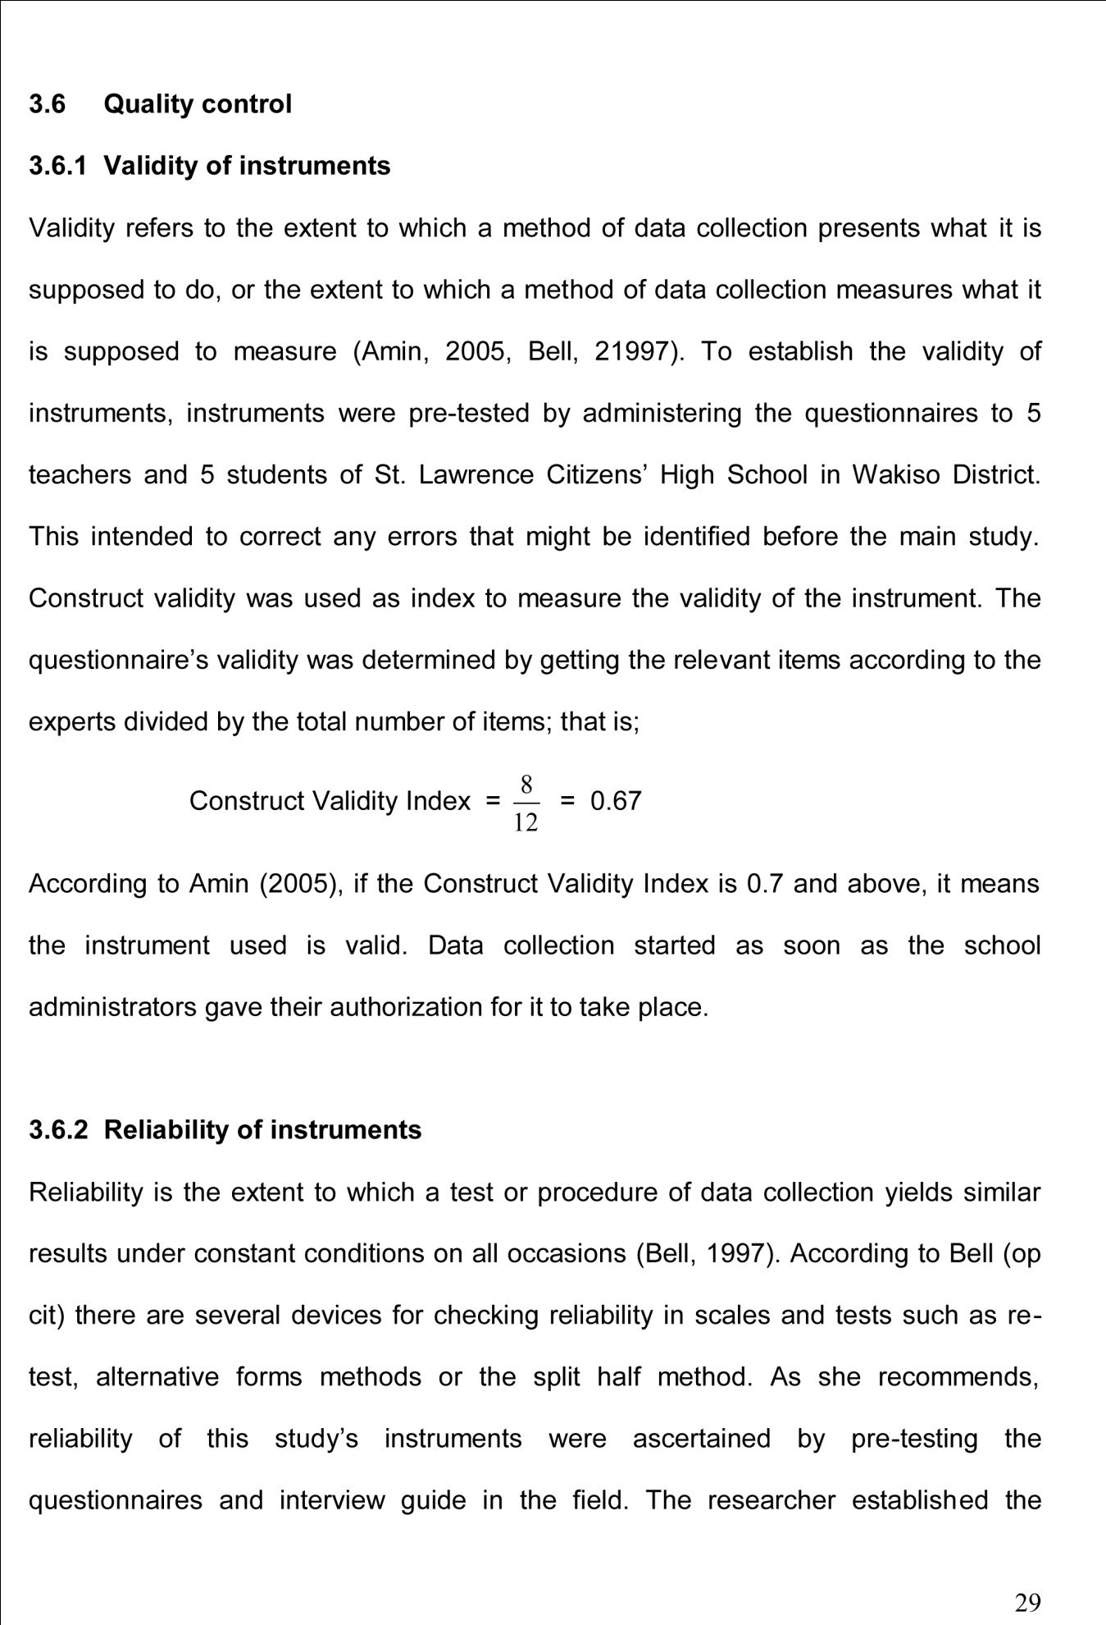



3.8 Assumptions and Limitations
Ideally this study should have been conducted in all private secondary schools in Wakiso District but time and financial constraints dictated a smaller sample. The researcher, besides being required to meet the full cost of the study had very little time to develop a proposal, collect data, compile and submit the report. The chosen sample of 64 schools represents the whole District but automatically, this would mean some important information is missed or worse still generalisability of the results might not be very accurate.

CHAPTER FOUR

DATA PRESENTATION, ANALYSIS AND INTERPRETATION

4.1 Introduction
This study examined the factors affecting teacher turnover in private secondary schools in Wakiso District. It particularly focused on how employer, employee and external factors affect teacher turnover in private secondary schools in Wakiso District. Data was collected from 64 randomly selected private secondary schools in Wakiso District using questionnaires, interviews and document analysis techniques. The data was analysed using percentages and chi-square goodness-of-fit techniques. The researcher grouped the data in accordance to the research objectives and questions.

4.2 Background information
The background information considered the issues such as category of schools by gender, location and level, sex and age of respondents, age of teachers, headteachers and teaching experience. The purpose of the background information was to enable the researcher describe the features or characteristics of the target population and capture every aspect of the private secondary schools, considered useful for a later elaborate discussion of the findings. The table below 4.1(a) presents the summary of the number of schools studied and category of respondents.
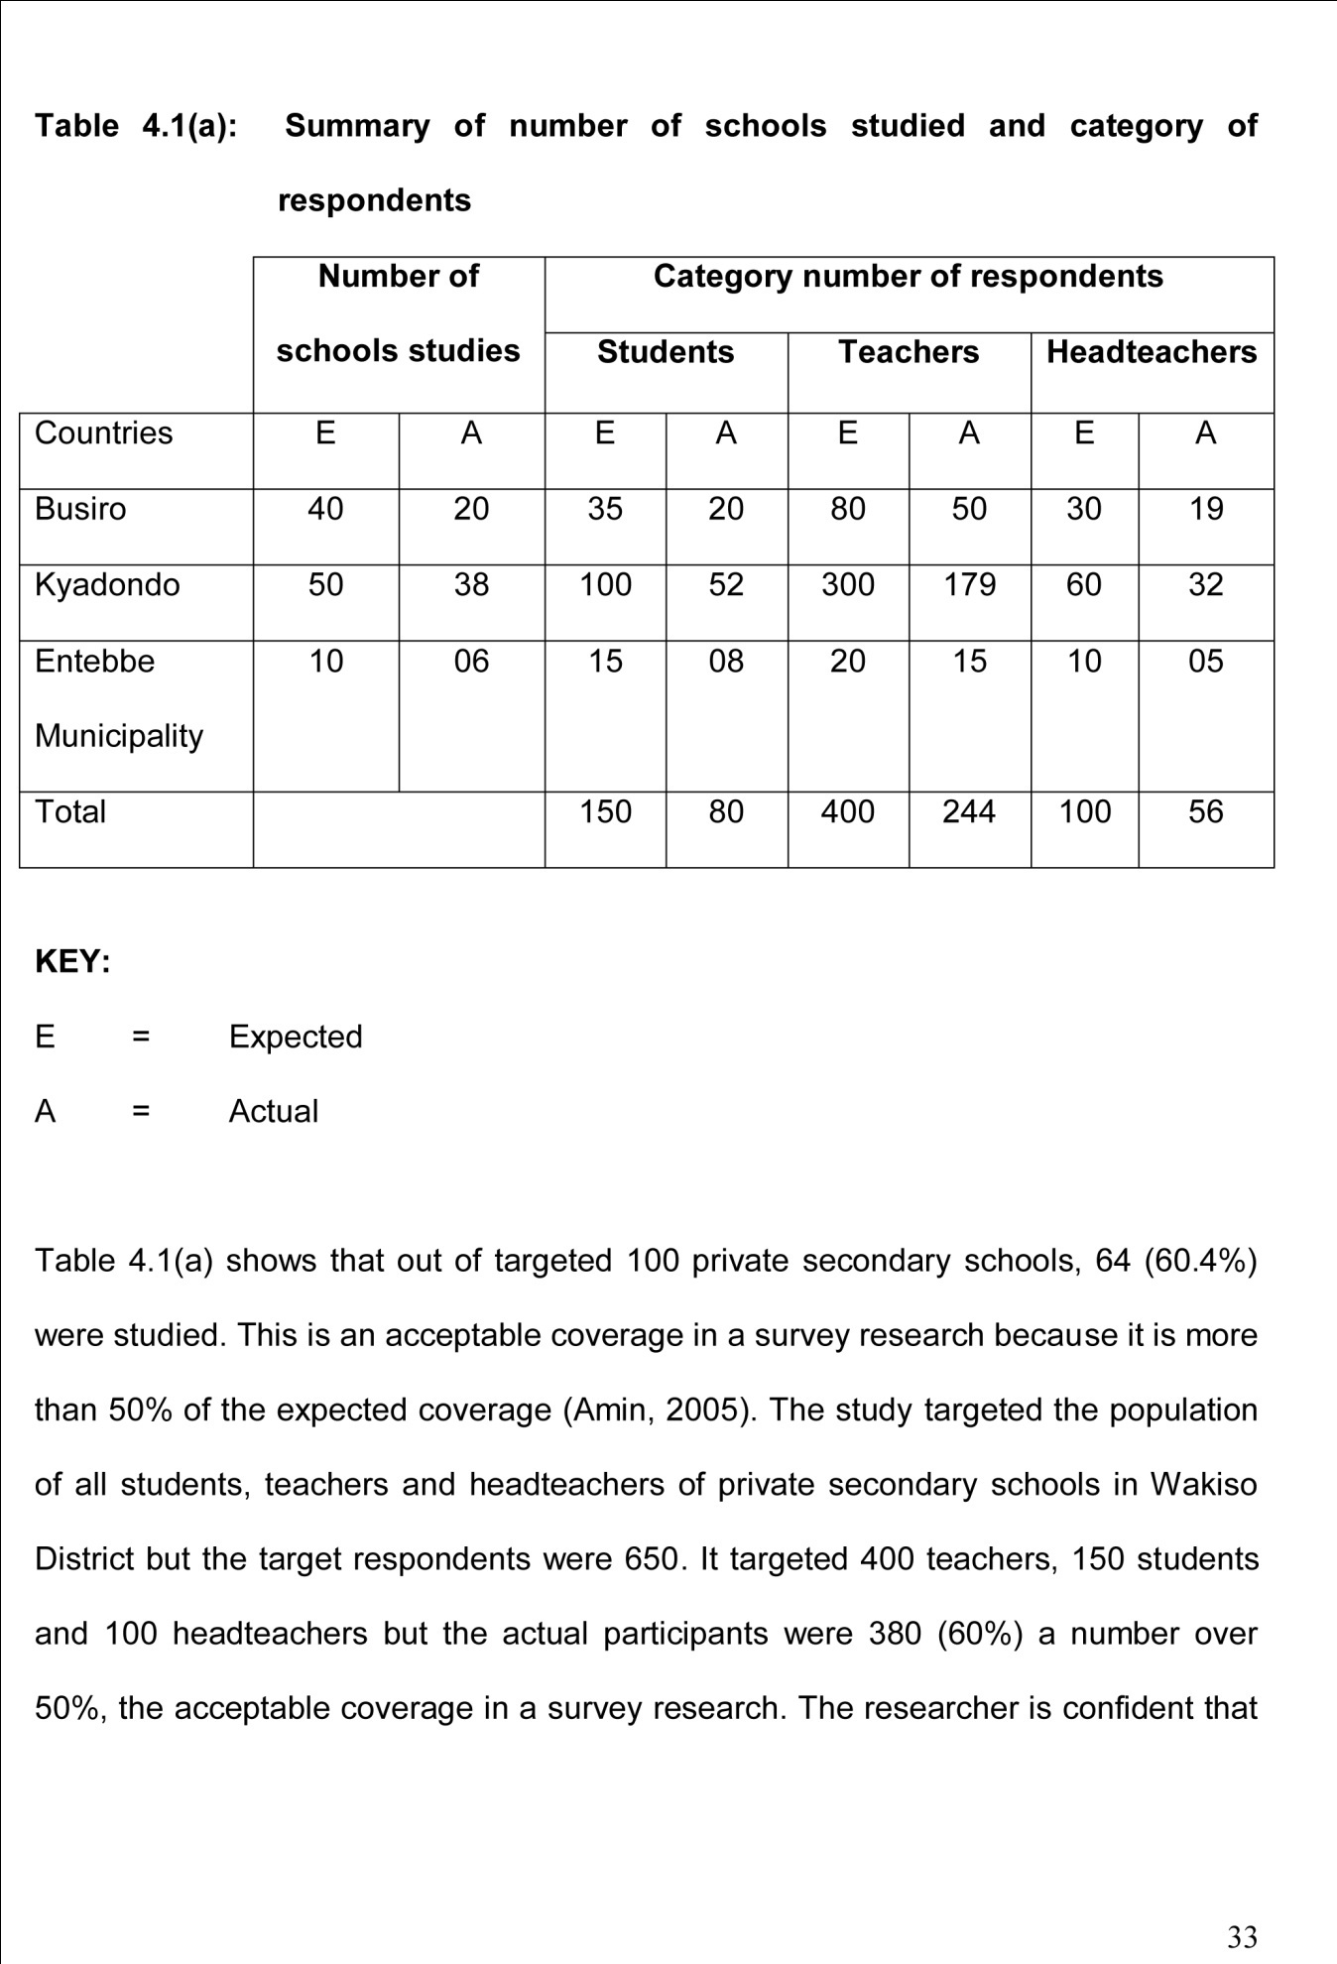

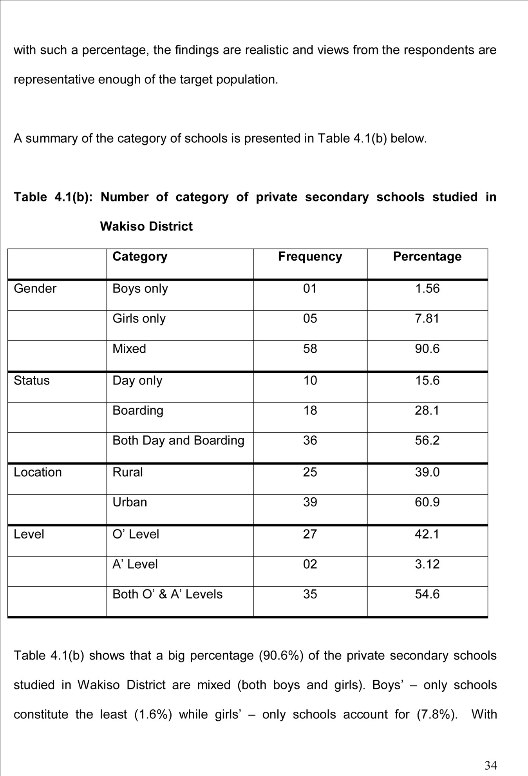

increased desire to ensure women emancipation, the government and other private entrepreneurs have for long been trying to strike a balance and provide equal education opportunities for both girls and boys. That is why mixed schools take the lions share. Further, a relatively big percentage (56.2%) of the private secondary schools in Wakiso District is both day and boarding schools possibly to cater for all students irrespective of their income status.
Day schools only account for (15.6%) and boarding schools only constitute 28.1%. The majority of the private secondary schools are located in urban areas (60.9%) possibly to attract students who usually look for accessible schools. A total of (39.0%) are in rural places, many times teachers flock urban areas looking for teaching opportunities and a few or those frustrated opt for rural schools as their only alternative. It is important to note that many teachers would prefer to teach in Kampala District because of its various opportunities and a few or those frustrated opt for rural schools as their only alternative. It is important to note that many teachers would prefer to teach in Kampala District because of its various opportunities like furthering their studies, accessibility to mention but a few considering the aspect of level, a bigger proportion (54.6%) of the private secondary schools in Wakiso District are both “O” and “A” Level implying that such schools employ teachers of different education levels “O” Level only accounted for (42.1%) while (3.12%) for “A” Level.

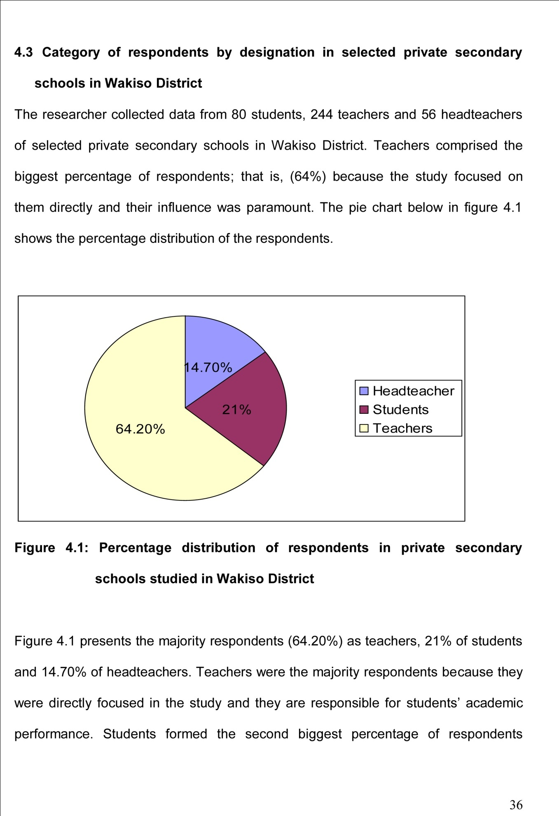

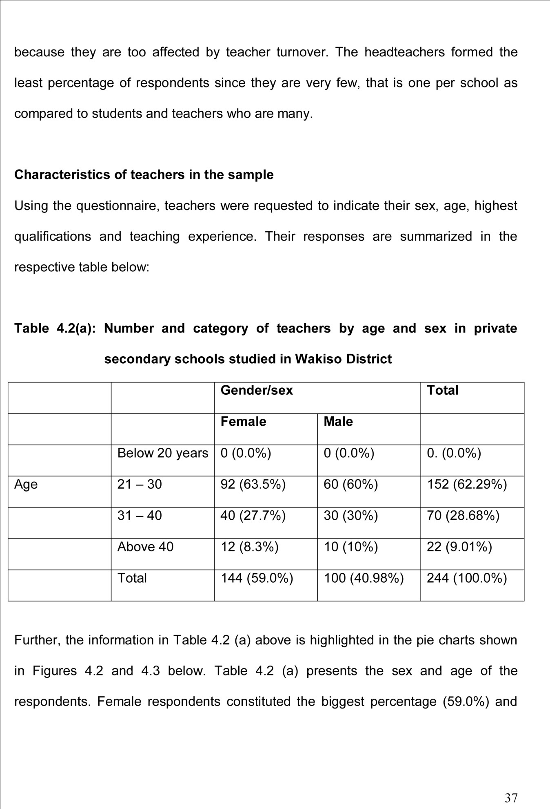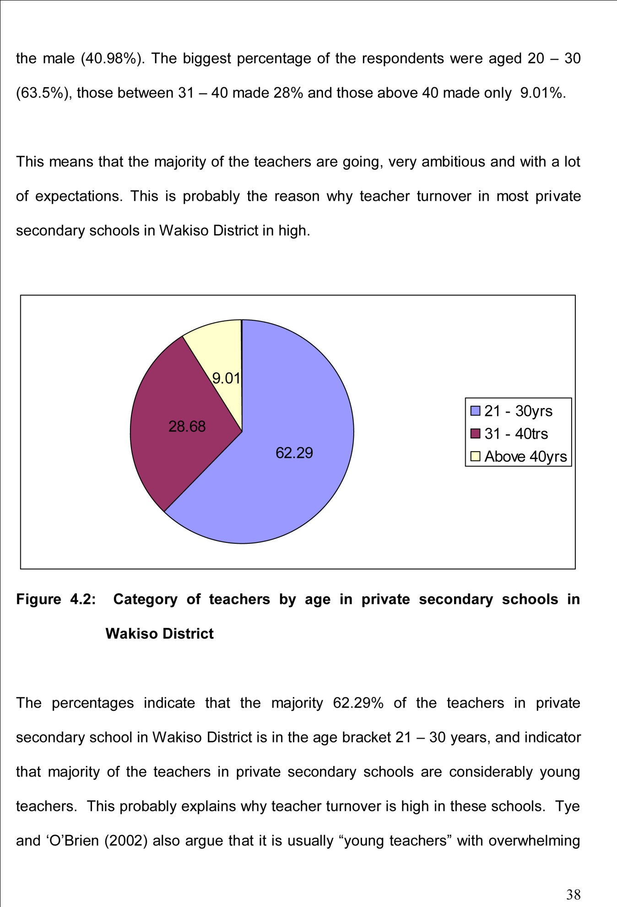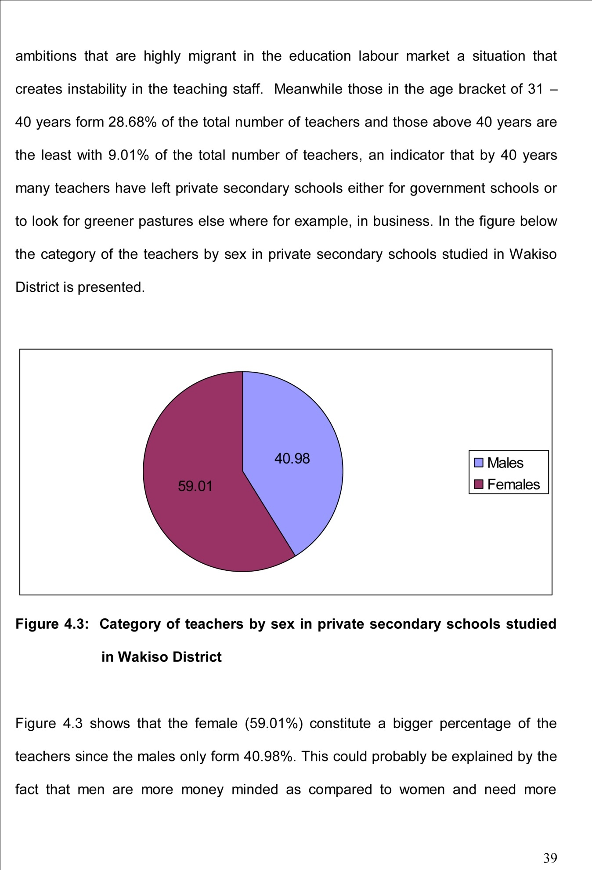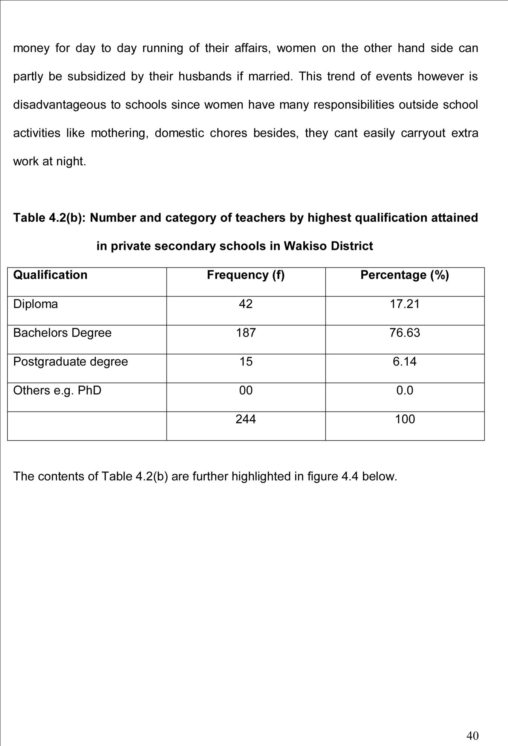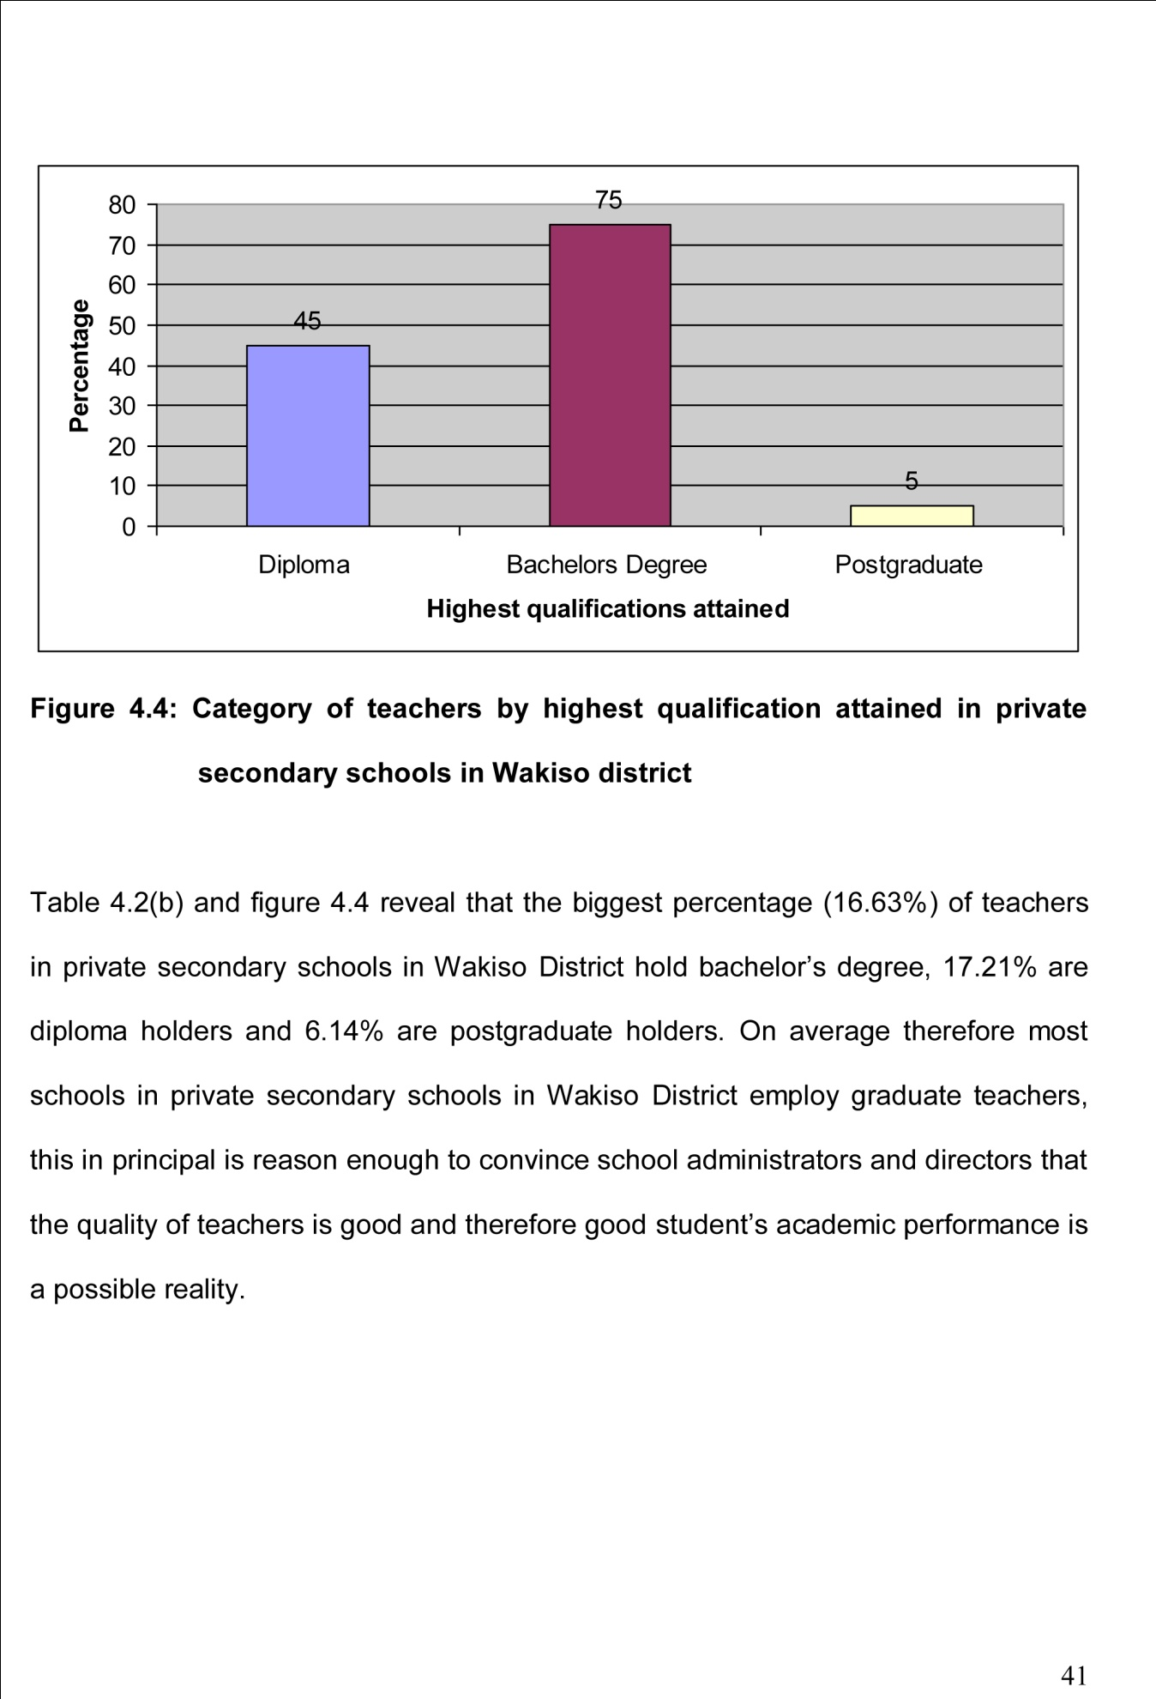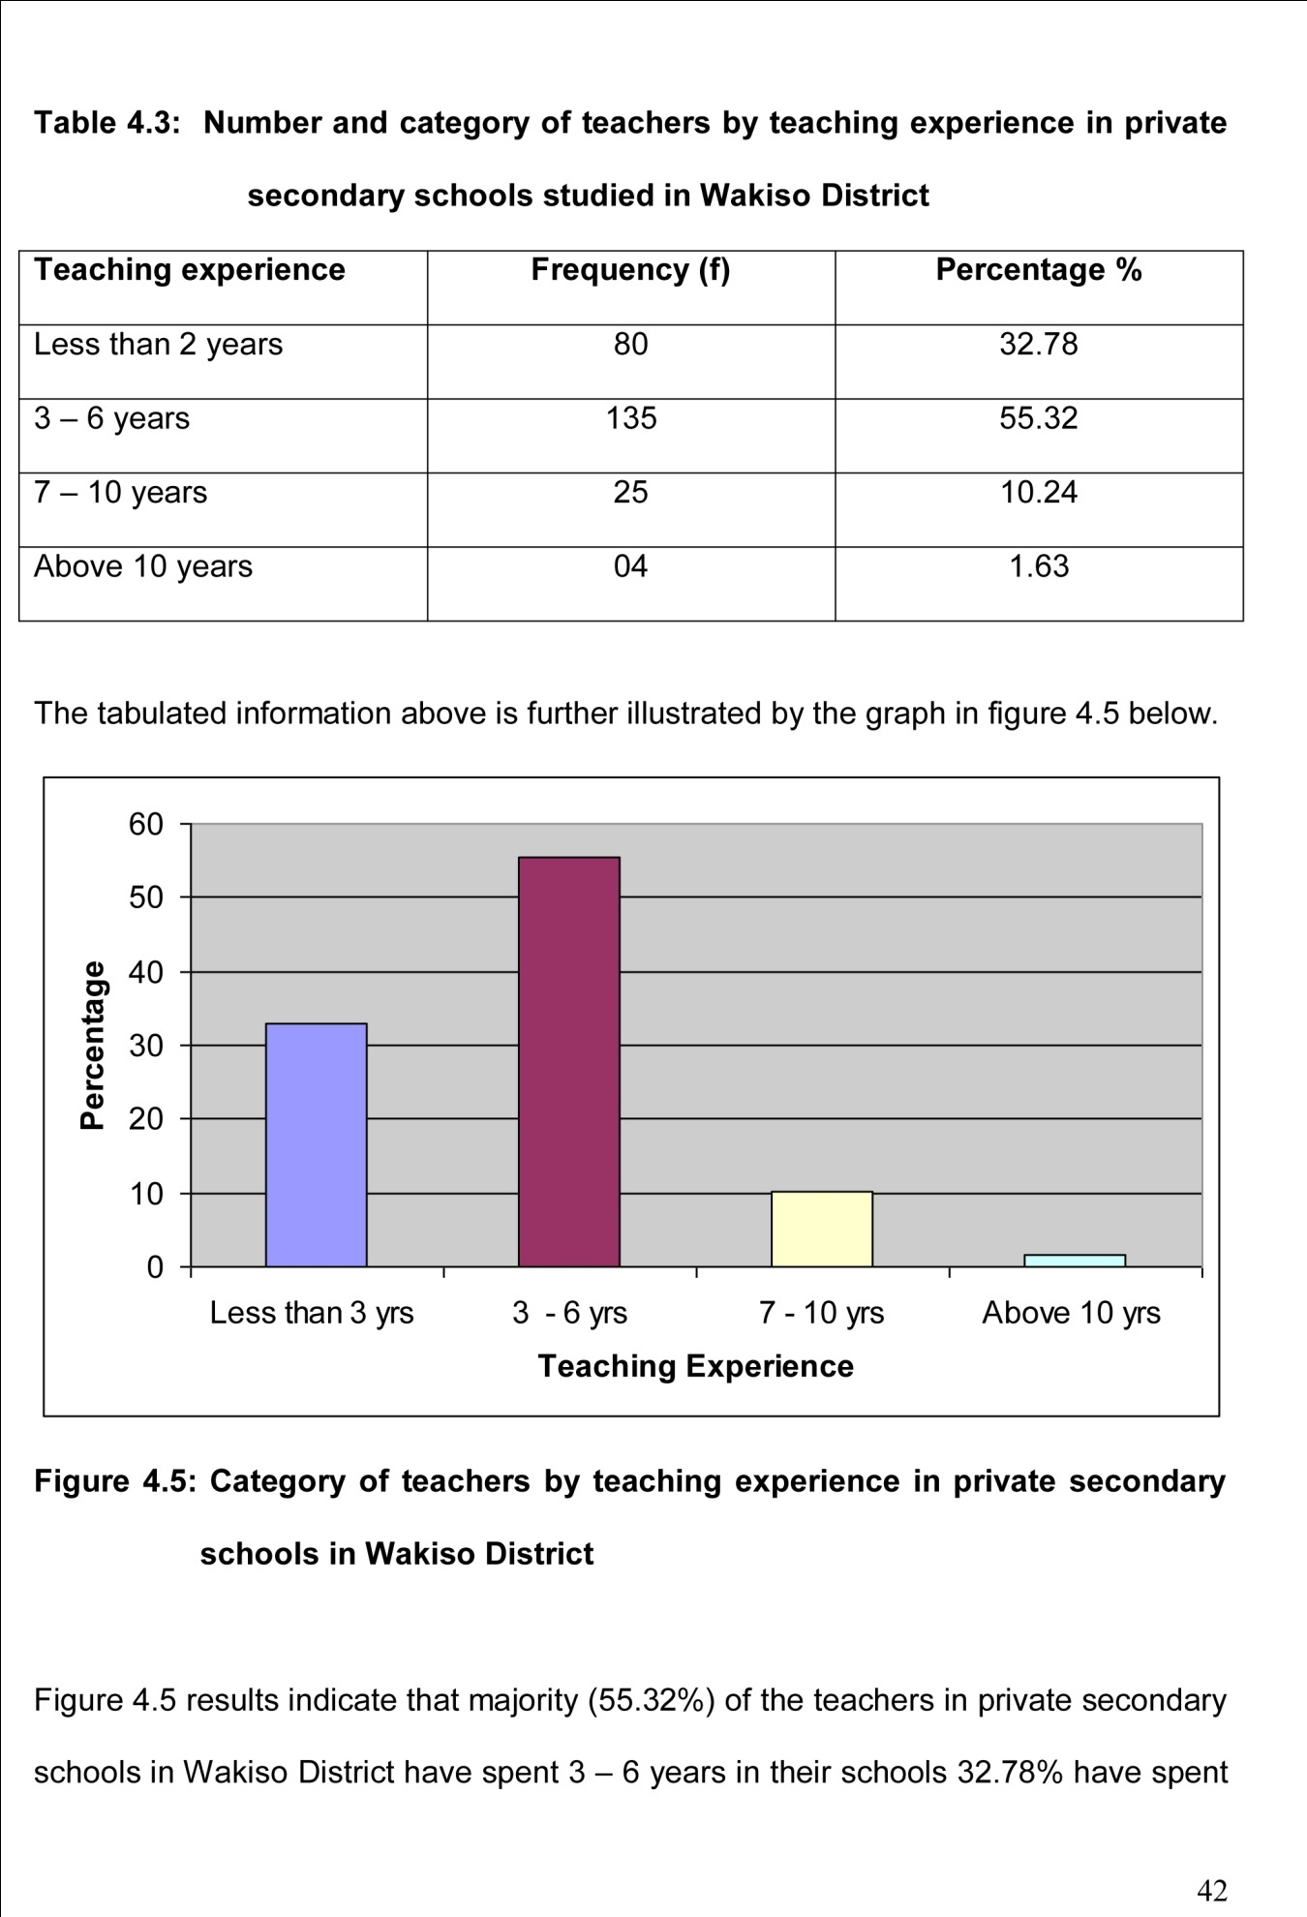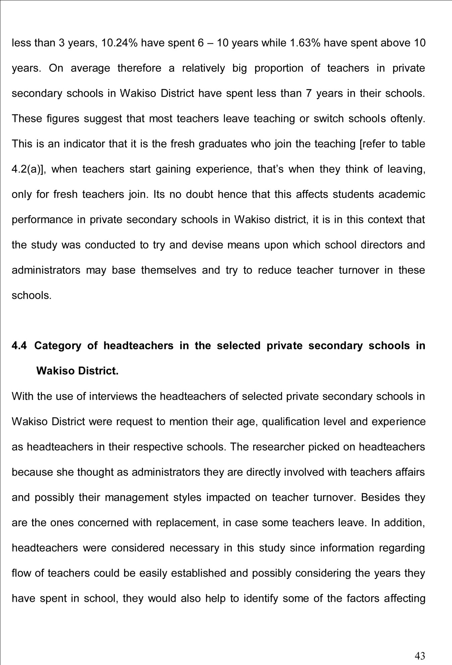

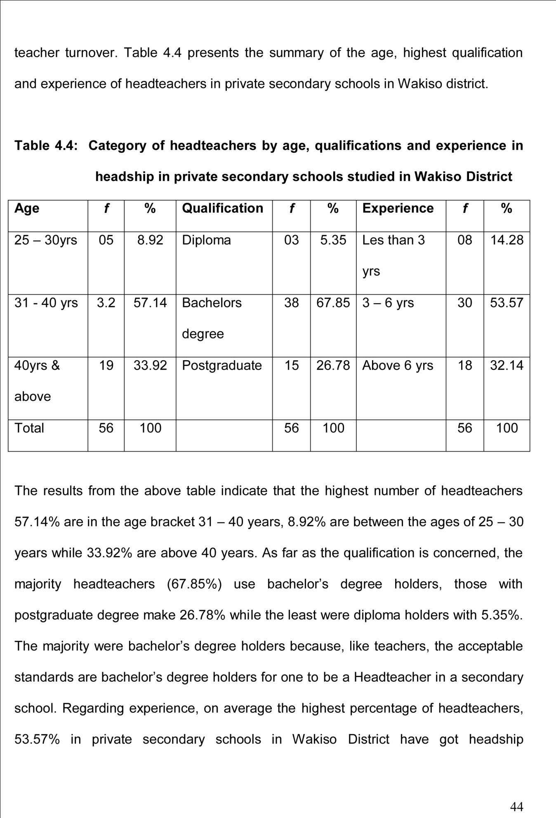

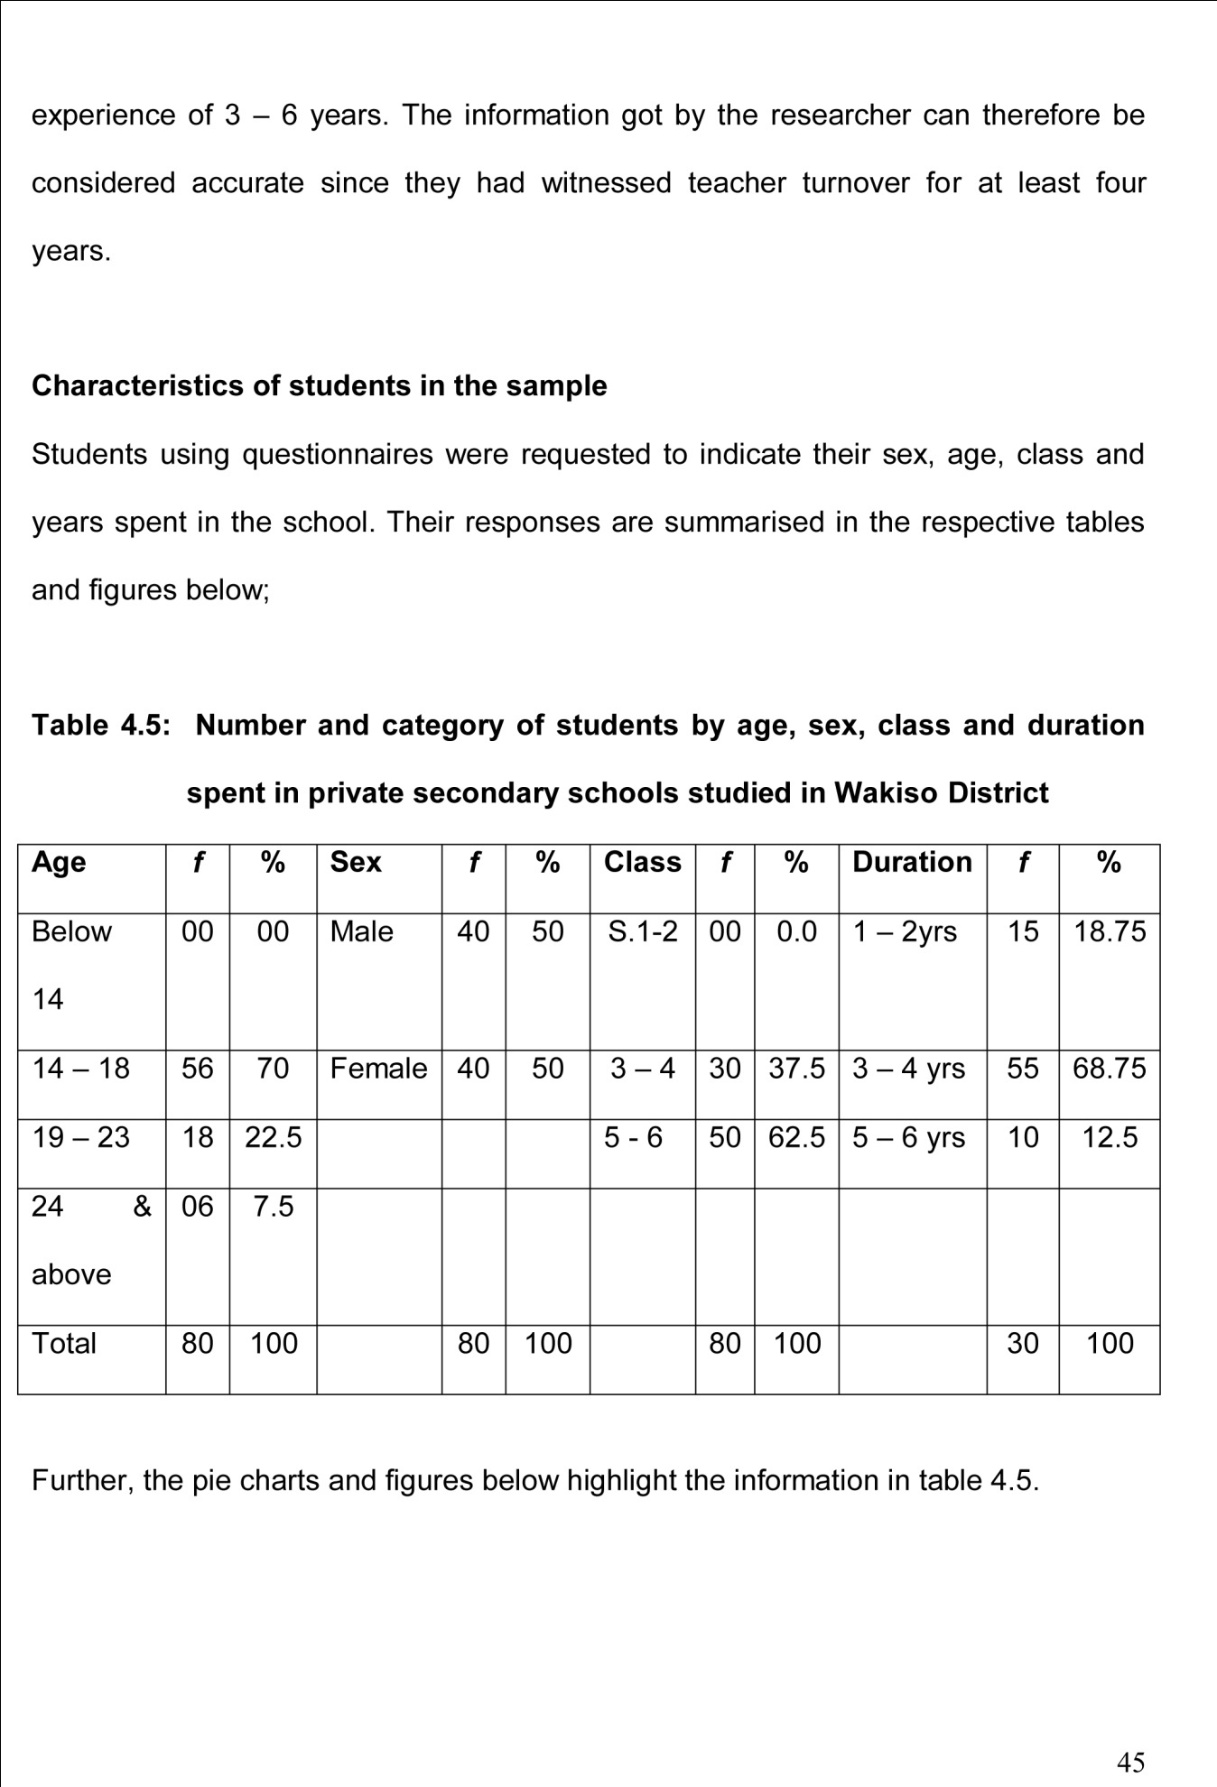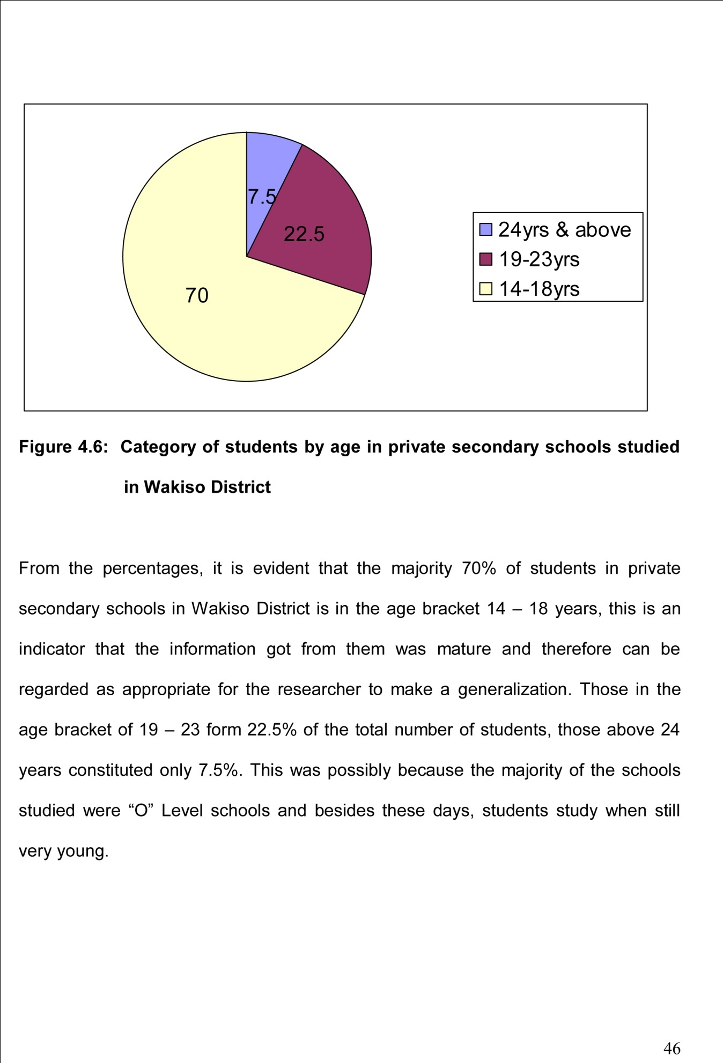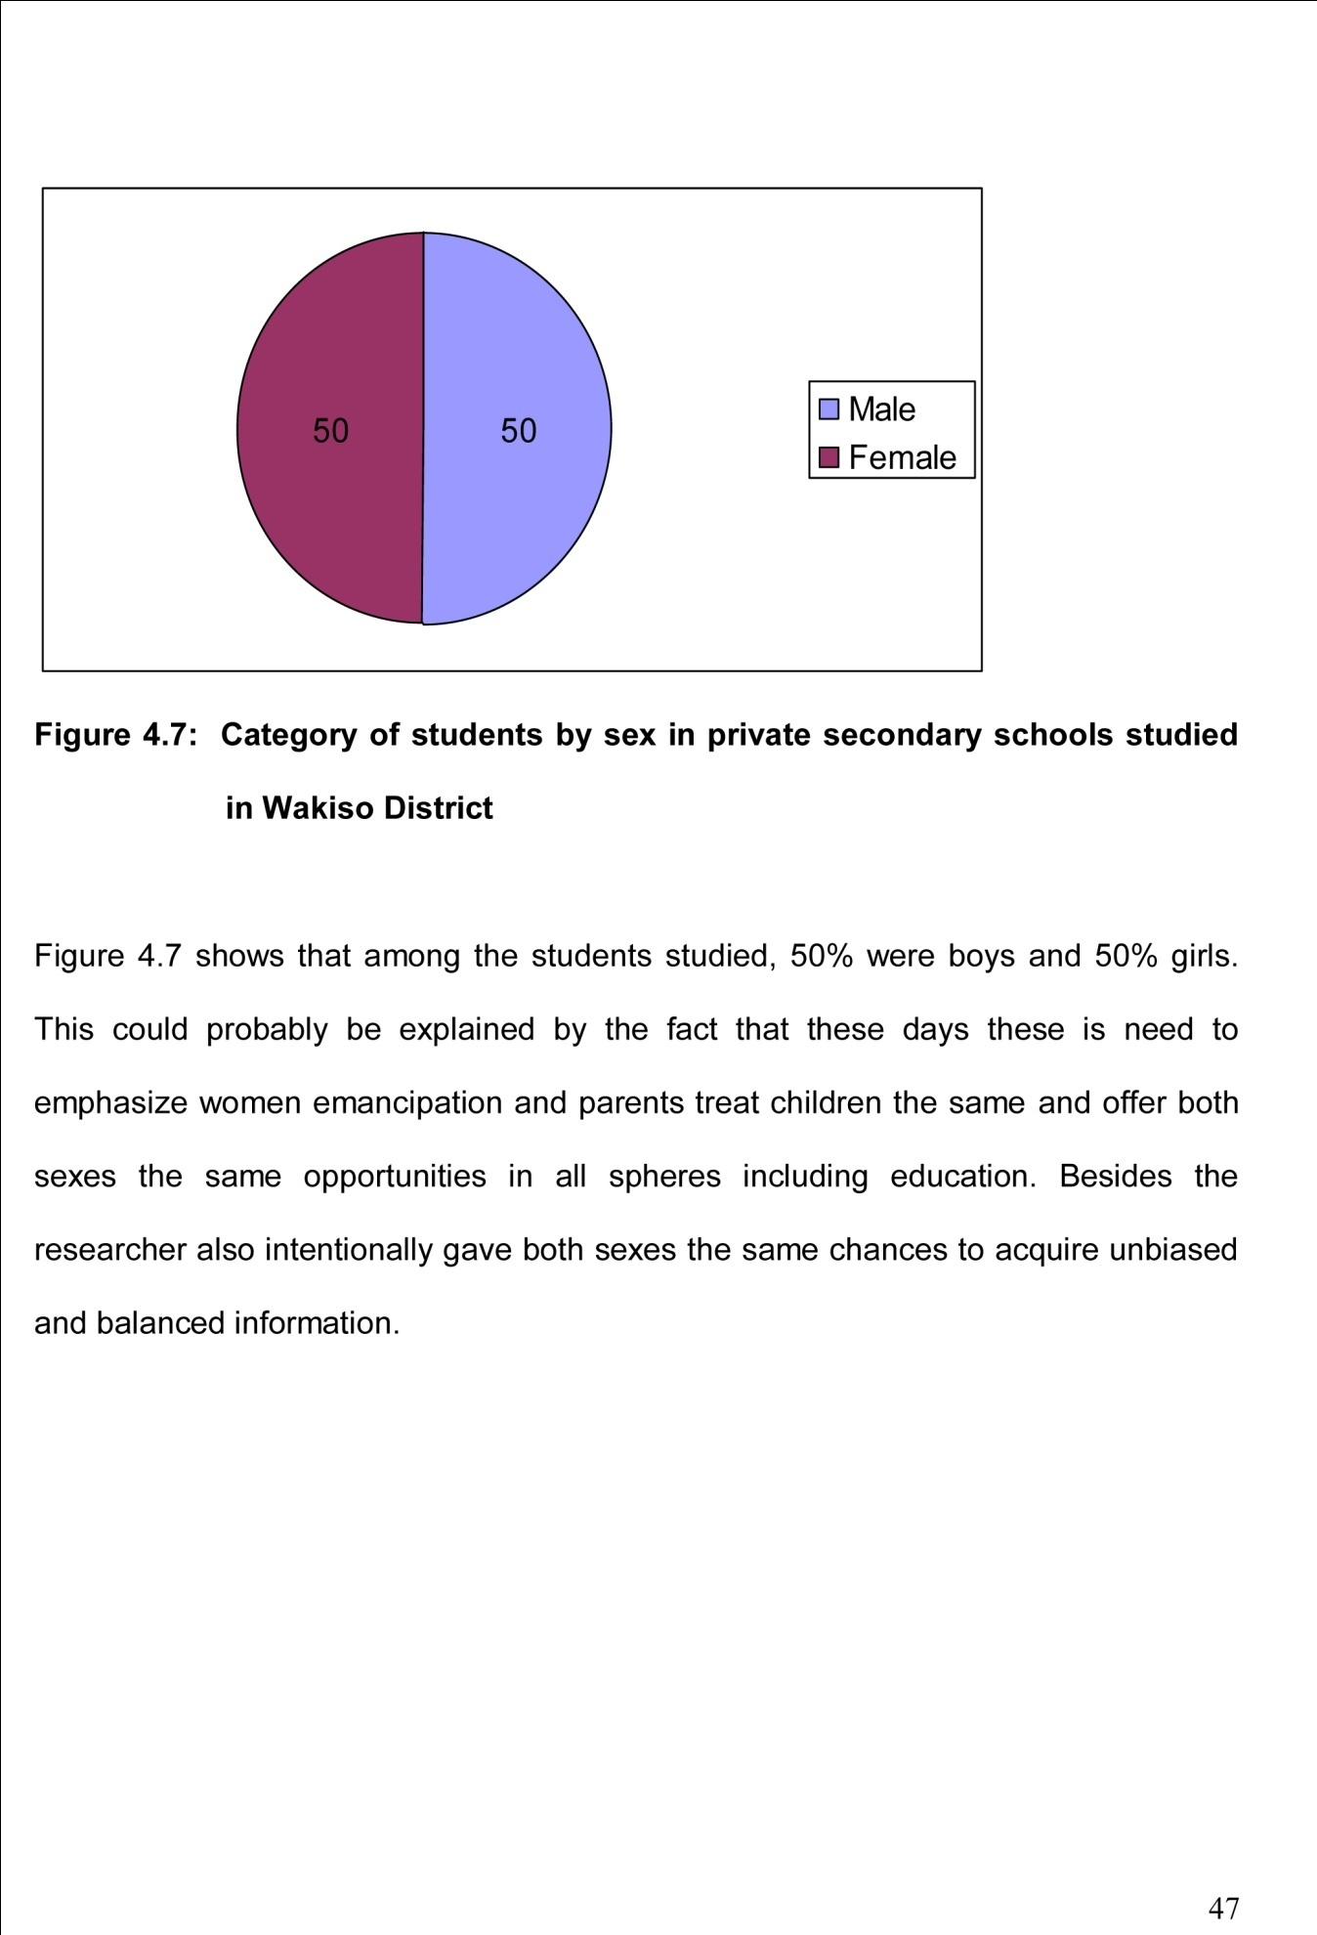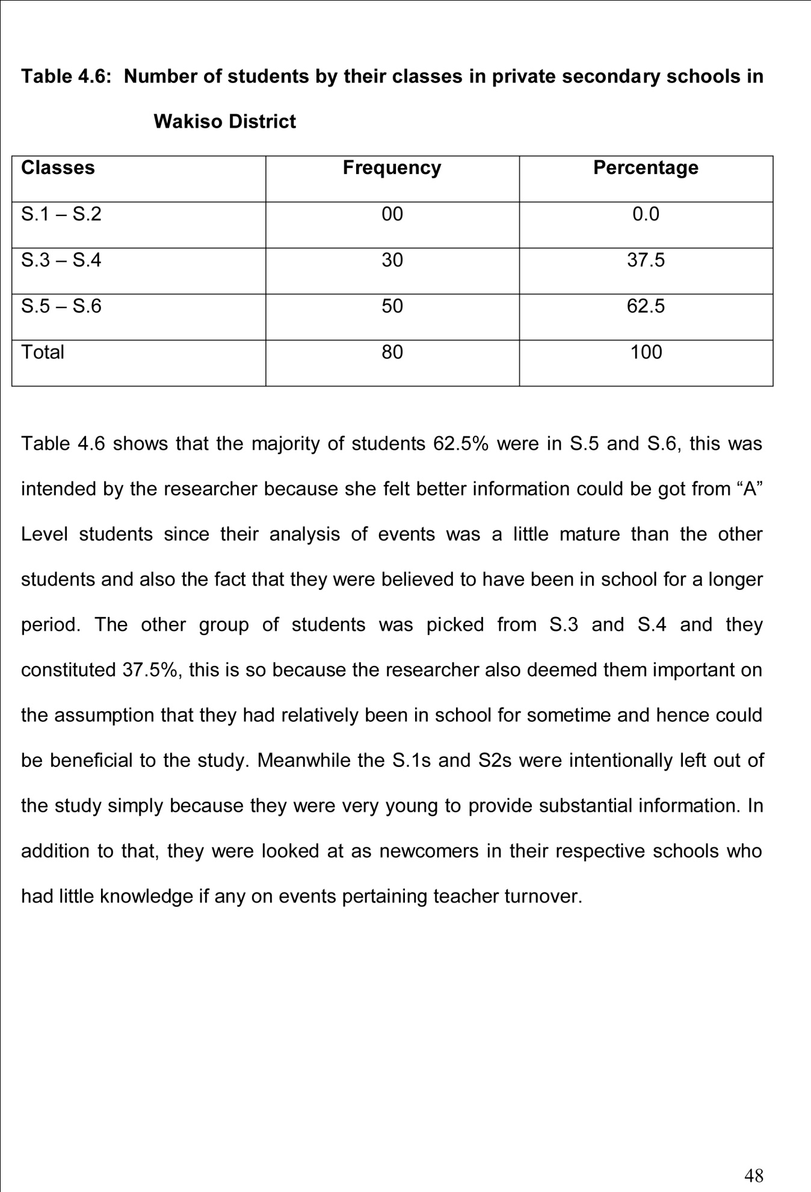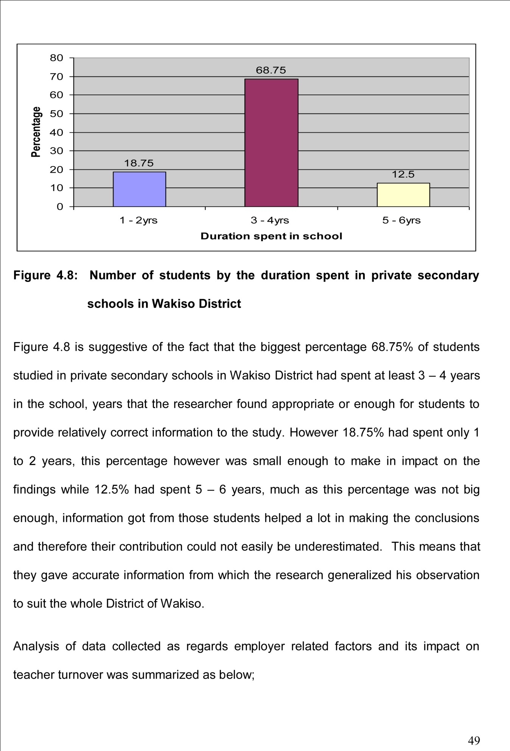

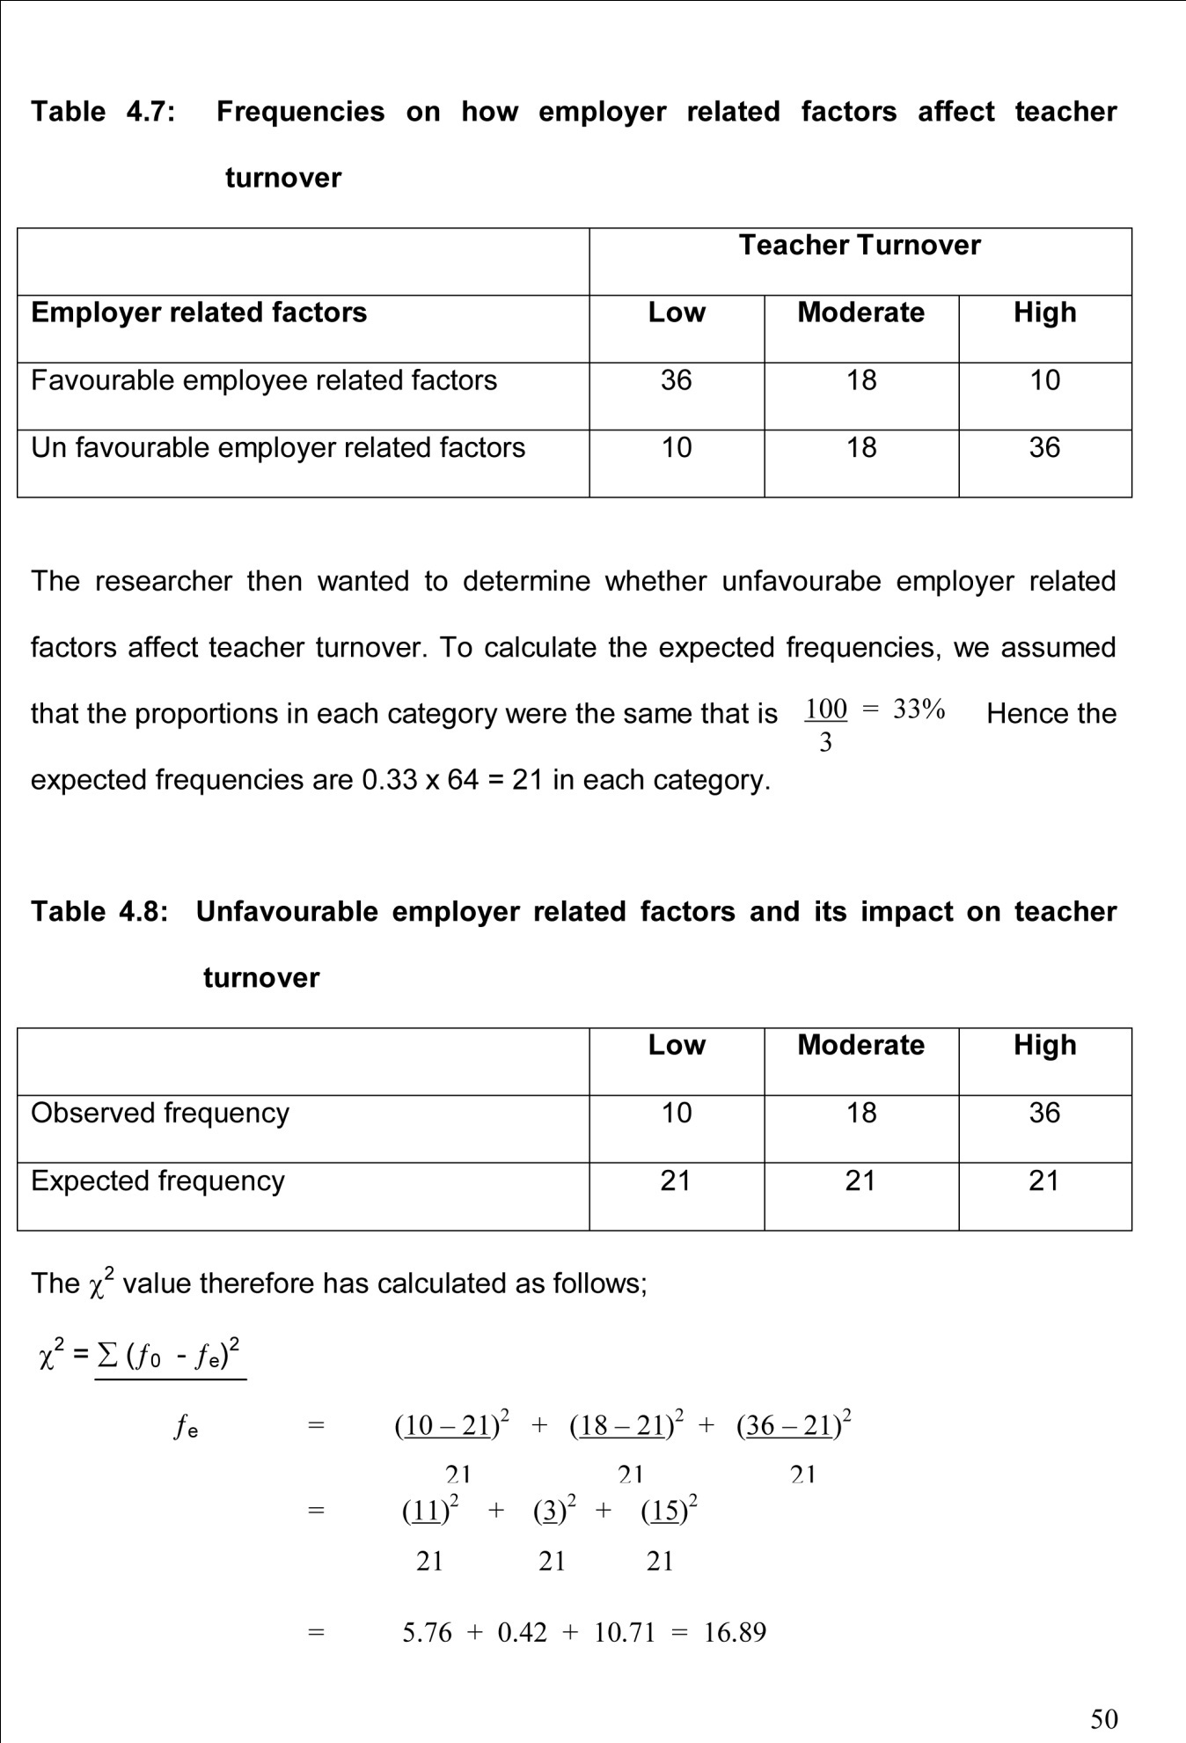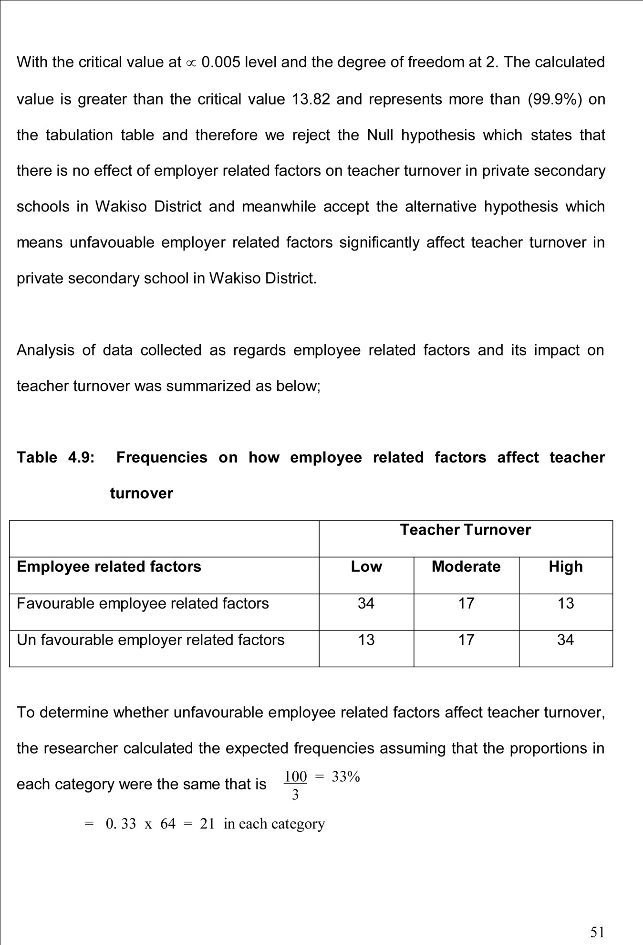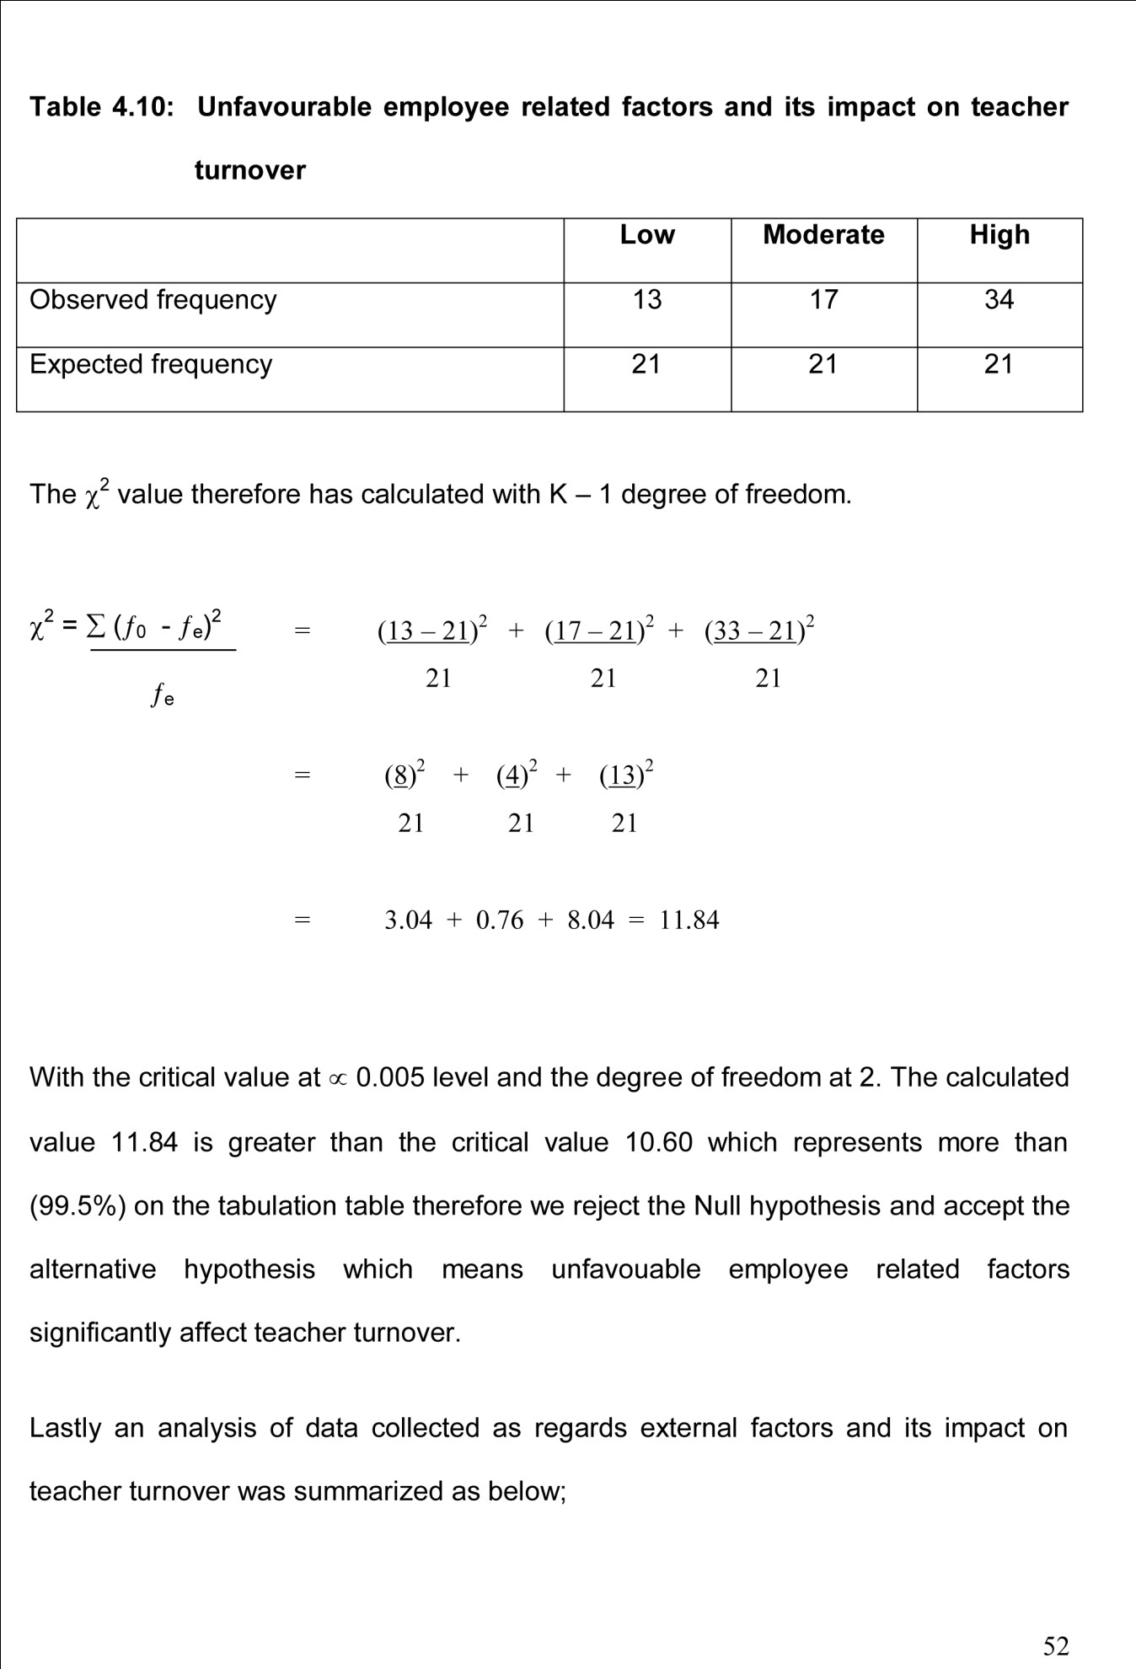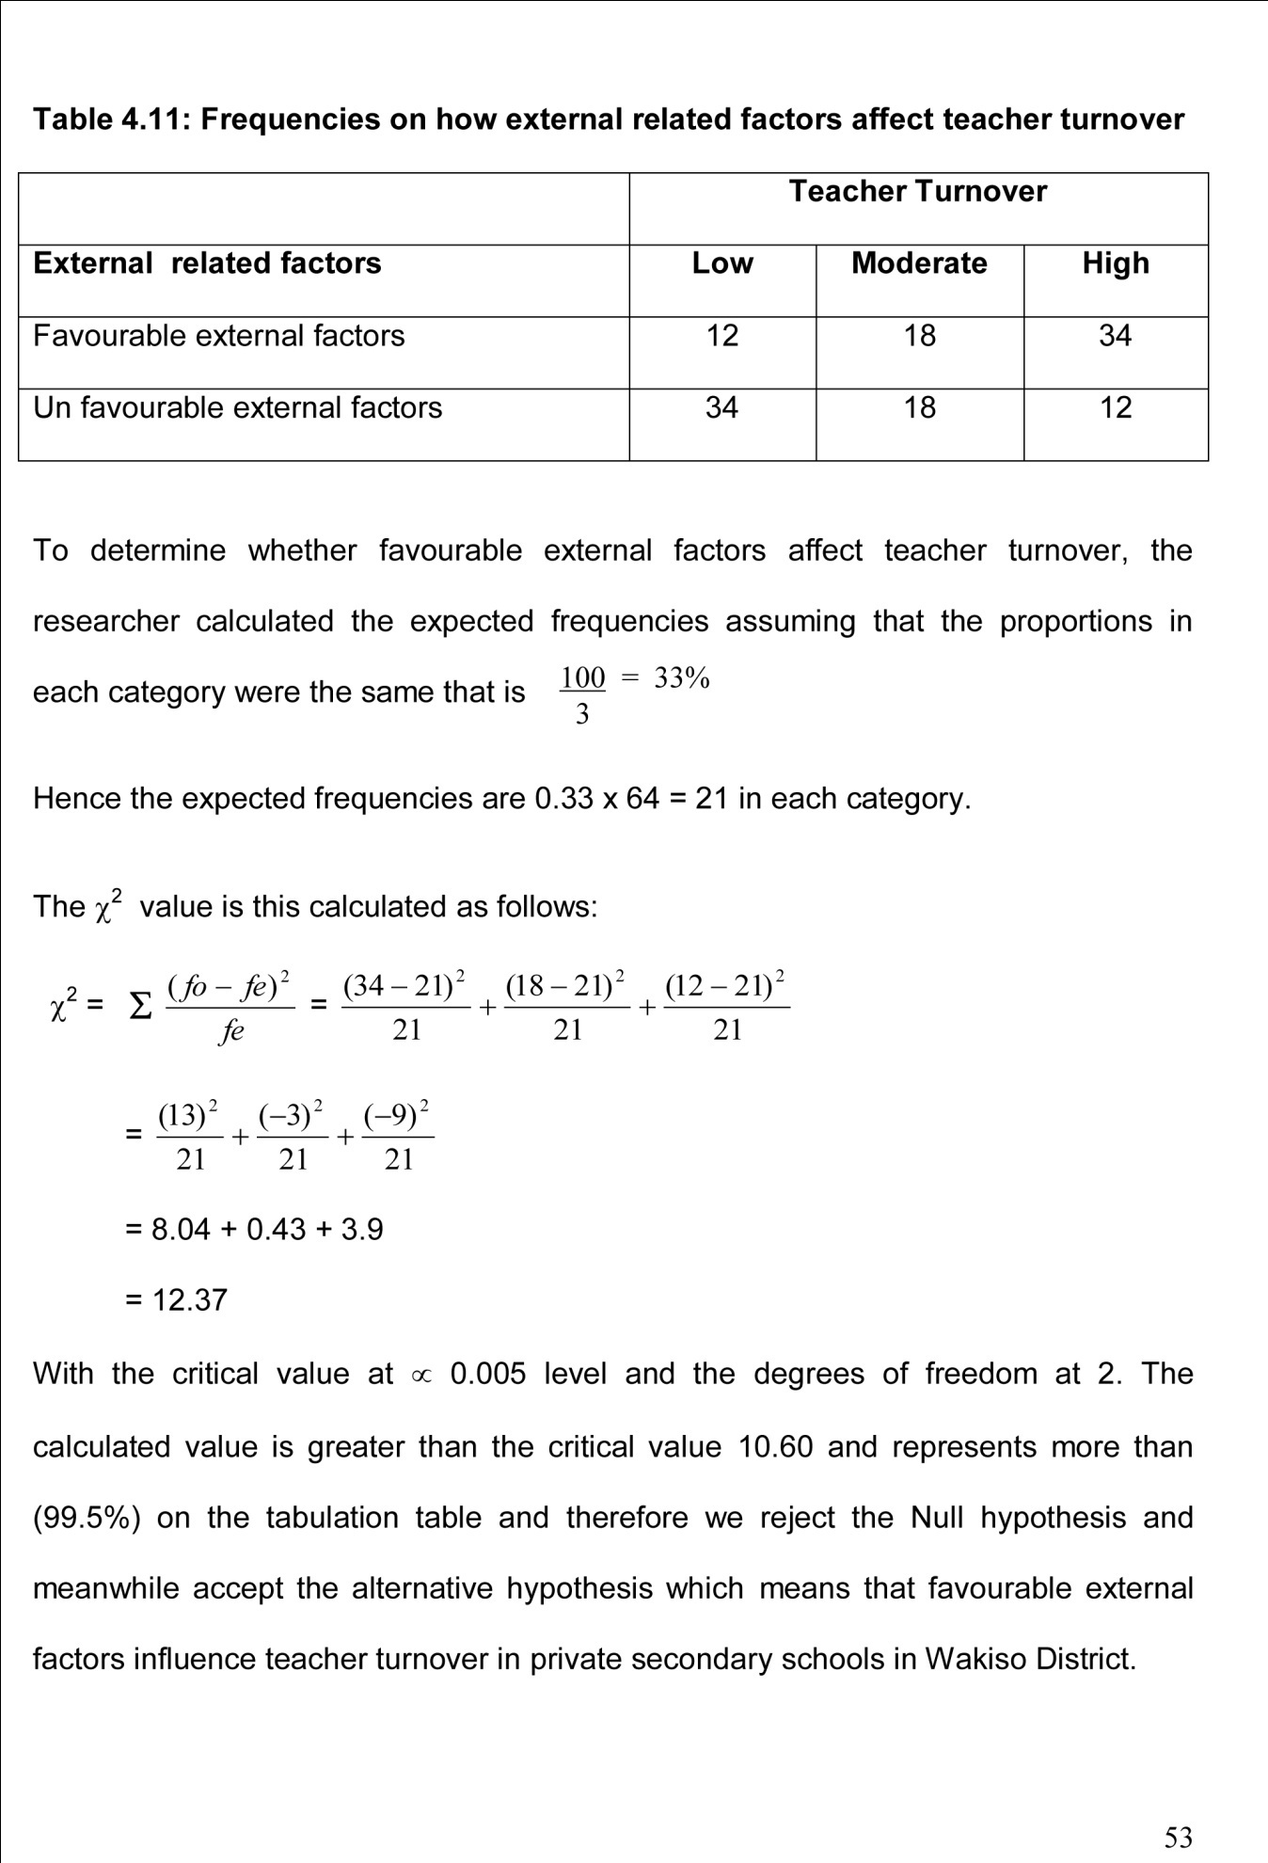

CHAPTER FIVE

DISCUSSION, CONCLUSIONS AND RECOMMENDATIONS

5.1 Introduction
This study determined the factors affecting teacher turnover in selected private secondary schools in Wakiso District. Employer related, employee related and external factors characterized factors affecting teacher turnover while teacher turnover was characterized by low, moderate and high rates. The study was conducted through a sample survey using a cross section of teachers, students and Head teachers from randomly selected 64 private secondary schools in Wakiso District. Data was collected in May and June 2007 by the use of questionnaires, interview guides and document analysis techniques. Data collected was analysed using percentages, frequencies and Chi-Square techniques. This chapter discusses the findings of the study, draws conclusions and makes recommendations based on the findings. The discussions are presented along research objectives.

5.2 Discussion
5.2.1 Employer related factors and teacher turnover in private secondary schools in Wakiso district
The first objective of this study was to find out if employer related factors affect teacher turnover in private secondary schools in Wakiso district, a school where at least 70% to of employer related factors like wages supervision style and poor working conditions were poor had a high rate of teacher turnover. However on the other hand schools that had better wages, supervision and good working conditions had a low rate of teacher turnover, most of the responses from our respondents revealed that there is a positive relationship between employer related factors like poor pay, poor supervision style and general poor working conditions and teacher turnover in private secondary schools in Wakiso District. The poorer the conditions, the higher the teacher turnover. The study also revealed that most private secondary schools in Wakiso District had poor working conditions and consequently high teacher turnover. Maicibi (2003) in support of this reported that when employees work under poor management conditions, they tend to behave like caged animals looking for the slightest opportunity to escape, in such a situation when an opportunity opens, whether less than the present job, the employees could leave without looking behind. Schwartz (1984) adds that these working conditions, which include physical and psychological factors surrounding a job, vary in importance as a motivator and the absence of such motivating factors, employees (teachers in this case) will exist. Therefore employer related factors especially good wages, good supervision and better working conditions are potent motivators which can boost teachers‟ morale, enhance their job satisfaction and reduce turnover.
Human resources in any organisation are ranked the most important resource thus teachers are instrumental in schools for they are responsible for ensuring student academic excellence. This however can only be possible if they are satisfied with their jobs, stable, experienced and if their expectations are met. Vroom’s expectancy theory in this regard, indicates that teachers‟ behaviours are a result of the expectation of what outcome or rewards the school will extend to them. Failure to ensure this, will lead to increased teacher turnover, however if their expectations are realised by their employers, teacher retention rates will be high and consequently reduce teacher turnover.
The study also established that teacher turnover in private secondary schools in Wakiso District is generally influenced by employer related factors, this implies that teachers are poorly paid. This is in agreement with a study conducted in Chicago in 1999 where half of teachers employed in that year left giving poor pay as reason number one alongside other factors, they too work in very uncondusive environments. This trend of events can be explained by the fact the cost of running schools in this competitive era is so high. Besides the parents in most schools visited seemed to be from humble families who could not afford to pay high school fees, the result obviously is poor payment of teachers which resultantly influences teacher turnover. It was observed on a sad note, that even those private secondary schools with relatively good financial positions still give inadequate salaries, school directors and headteachers hence seem not to be conscious of the impact of poor pay and its impact of on teacher turnover.
Failure by the administrators to value teachers was also forwarded as a reason for teacher turnover in many private secondary schools in Wakiso District. Many teachers interviewed showed disgust in how Directors of these private schools look at them as liabilities and not assets. A teacher in one of the St. Lawrence schools and colleges had this to say “We teachers in private schools are given less value and a lot of value is attached to the students we teach, who are considered customers and therefore assets”. Such cause discontent resulting into increased teacher outflow. There is nothing more gratifying to teachers than making them feel important and worthwhile if such feelings are not worked on very soon, the problem of teacher turnover will not come to an end.
Excellent performance in schools can only be realized with a stable and well experienced staff unfortunately many schools in Wakiso District and Uganda generally tend to overlook this fact. They tend to think that because of unemployment levels, when some leave, it is very easy to replace them. So they take no trouble to try and retain their staff, consequently teachers leave their jobs partly because they feel they are not so much needed while others opt for ”greener pastures” elsewhere.
The study also revealed that most teachers left because of poor management styles, in the schools visited, it was found out that most teachers are never sure of whether they will still have their jobs in the next year. Job security is an impossible dream in most of these private secondary schools. Teachers only have their jobs at the mercy, of the school directors and headteachers such uncertainties forced many to leave in search for stable jobs. An Education Report on the Education System in Texas (2004) confirms this by stressing that “teachers do not know whether their school is going to be open the next year, they do not know what type of weird restructuring is going to happen next school year”, all these worries make teachers leave before being disappointed. The study also found out that in schools where there was relatively job security, the retention rate was higher.
The study also established that administrative grievances largely cause teacher turnover. These included management of the schools, unbearable workload, big teacher-student ratios to mention but a few. This finding is supported by Senteza (2001) who mentioned that grievances in secondary schools especially about inefficient management caused teacher turnover. It was also noted that in schools where there was a strong sense of collaboration among teachers and administrators, teacher turnover rate was low. All these findings clearly show that employer related factors have a significant impact on teacher turnover in private secondary schools in Wakiso District.

5.2.2 Employee related factors and their impact on teacher turnover
The second objective of this study was to determine the relationship between employees‟ related factors and teacher turnover in private secondary schools in Wakiso District. Teacher job satisfaction, career growth and personal decisions were used to measure employee related factors. Responses were obtained from all respondents by use of questionnaires, interviews and guided discussions. In schools where about 68% felt had job satisfaction, career growth, teacher turnover was very low, schools that deviated from this criterion were graded as having moderate or inadequate job satisfaction and career growth. Data collected was analysed using percentage distribution and chi-square techniques. Data analysis and interpretation of questionnaire and interview responses revealed two major findings under this objective, first of all the study established that job satisfaction and career growth have a significant effect on teacher turnover in private secondary schools in Wakiso District.
Secondly, the study revealed that job satisfaction and career growth in most private secondary schools is almost a nightmare. This therefore shows that the findings of the study contradict with the research hypothesis that “there is no relationships between employee related factors and teacher turnover in private secondary schools in Wakiso district”. The study instead revealed that schools that ensured career growth of teachers and job satisfaction tend to have lower teacher turnover rates than those with moderate or poor career growth and job satisfaction.
It is no doubt that every school strives to provide quality learning to the students to ensure academic excellence, this therefore means quality teaching staff, experienced and motivated is a must have to ensure the goal is achieved Oliviera and Farrell (1993) confirm to this by arguing that “excellent performance of students is largely influenced by the quality of the teaching force. Developing appropriate human resource strategies that will ensure that such staff does not leave becomes inevitable. With competitive global opportunities elsewhere, it’s very vital that headteachers and all stakeholders of private secondary schools develop human resource strategies to ensure teacher job satisfaction and career growth. This can be enhanced through improvement of the teaching conditions and provision of promotional opportunities for teacher career growth.
Musaazi (1982) observes that promotion is one of the ways used to increase teachers‟ job satisfaction and career growth because of the opportunities associated with it for instance increased responsibilities, challenges, prestige or status and obviously increased pay. Lack of such leads to low morale which may culminate into frustrations and the end result may be leaving teaching in that school for better schools or total neglect of teaching for other avenues like business if all these are rectified; teachers may be willing to remain working in their jobs. Directors and heads of schools in Wakiso District and in Uganda generally need to address this discrepancy to reduce on teacher turnover.
The study also revealed that lack of the passion to teach also increased the rate of teacher turnover. About 70% of the teachers interviewed clearly stated that they did not love teaching and in fact were pushed into teaching because of unavoidable circumstances like unemployment. Many took on teaching as a last resort, such teachers did not plan to stay in teaching for long and were looking for any other opening. The researcher realized that such teachers can easily leave teaching for any other career prospect regardless the pay, working conditions and so forth. This means the administrators have to work so had to motivate such teachers and inculcate in them the liking of the teaching profession if the turnover rate is to reduce.
5.2.3 External related factors and their impact on teacher turnover
The third objective of this study was to investigate the relationship between external related factors and its impact on teacher turnover in private secondary schools in Wakiso district. External factors were characterized by better pay elsewhere competitive conditions elsewhere and low status. Schools where at least 75% of teachers highly agreed that external factors affect teacher turnover, turnover rates were higher than in schools that deviated from this criterion.
Data analysis and interpretation of the questionnaire and interview responses revealed that external related factors affect teacher turnover. This finding contradicts with the hypothesis which showed that “these is no relationship between external related factors and teacher turnover, instead the study revealed that external factors positively influence teacher turnover. This can be clearly demonstrated from the documented literature on the effect of better opportunities elsewhere and its impact on teacher turnover. Rebore (2004) asserts that “in recent years educational organisations have experienced a decrease in the number of applicants to mathematics and science teaching positions because of the higher wages and advancement opportunities available in private business and industry.
Similarly, external factors like disrespect of the teaching profession by the public also accounts for increased teacher turnover, Jones (2001) noted that teachers are accorded low social status and low esteem. The researcher found out that factors like general economic conditions of the country in isolation had profound influence on the rate of staff movement. Cole affirms this by observing that at times because of economic difficulty experienced by many private secondary schools, the directors are forced to cutback severely on teacher numbers leading to redundancies and early retirements.
The researcher found out that about 40% of teachers believed that external factors had considerable effect on staff movement but the majority held the employer factors responsible for increased teacher turnover and their major push factor is “PAY”. The study also established that external factors in Wakiso District on average influenced teacher turnover, one of the implications of this finding is that many private secondary schools were of different economic capacities and therefore could not provide the same pay or even fringe benefits, its on this ground that the researcher made a conclusion that external factors really had an impact on teacher turnover. About 10 schools paid their schools highly and majority of teachers asked preferred to teach in such schools, given an opening therefore such can also leave to join highly paying schools. Such issues are so imperative that every Headteacher and director should take it upon himself to address. The excuse of schools being poor might not count since open communication can be a good platform to talk to teachers and promise better or similar wages when the economic situation becomes better than pretending as if nothing is happening.

5.3 Conclusions
This study sought to establish the factors that affect teacher turnover in selected private secondary schools in Wakiso district. The study specifically sought to analyze the employer, employee and external factors and determine their relationship with teacher turnover in private secondary schools in Wakiso district. The study found out that unfavourable employer related factors significantly affect teacher turnover in private secondary schools in Wakiso district. In particular, the study established that loss of group cohesion, poor working conditions, poor pay, poor management or supervision directly impacted on teachers and caused job dissatisfaction which increased the rate of teacher turnover. The study also established that in schools where the pay, general conditions of work and good supervision were evident, the rate of teacher turnover was low. This implies that most private secondary schools in Wakiso district, paid their teachers poorly, provided poor conditions and had poor supervision policies, they too did nothing to improve these conditions which increased the level of teacher turnover.
It was also revealed that unfavourable employee related factors also affected teacher turnover, many teachers joined the private secondary schools with numerous expectations which were not met this increased their dissatisfaction, lack of commitment and the end result was always resignation. Others found teaching as the last resort and therefore lacked passion to teach. On the other hand, it was established that where teachers‟ expectations were met (though in very few schools), the rate of turnover in such schools was very low. This means that apart from employer related factors, employee related factors also have a role to play in determining the rate of teacher turnover.
Lastly, The study findings also show that external factors like better pay elsewhere, low status of the teaching profession and competitive conditions also affected teacher turnover positively.
All these findings lead to the conclusion that for private secondary schools in Wakiso District and other schools in general to reduce on teacher turnover, employers, school directors and all stakeholders must improve on their policies towards teachers, provide better packages, meet employees‟ expectations and try to control external forces or pressures. All in all, if students academic performance is to be excellent, then a stable experienced staff is paramount, failure to maintain such, the rate of teacher turnover will continuously be high with its disastrous effects.

5.4 Recommendations
The researcher has argued in this report that for a school to reduce on the rate of teacher turnover, employers must change their administrative policies, must put in place strategies that will ensure teacher job satisfaction, for example, better pay, conditions of work, ensure professional development, try to meet teachers‟ expectations, value them and must also control external influence. It is not enough for schools to acquire qualified teachers, retaining the experienced ones is also crucial and reward is central. There is need for all stakeholders especially headteachers and school directors to devise means of regulating the phenomenon of teacher turnover in private secondary schools in Wakiso District and general schools in Uganda as a whole.

It is clear, using our earlier discussions that headteachers and school directors do not take it as an important aspect to reduce teacher turnover they just hide their heads in the sand pretending there isn’t a problem possibly because they are ignorant of its impact on the education system, however, there is need for everyone especially school administrators to regularly organize sessions in which open discussions can take place between teachers and the school heads to allow teachers air out their grievances instead of opting for grapevine. There is also need for the Ministry of Education to organize periodic workshops to train and sensitize the headteachers and school directors on the purpose of teachers as a crucial resource and for that matter, how trying to retain them is obviously significant because the whole education system largely depends on them.
Further, mangers of private schools in particular should note that teacher turnover itself is not the only problem but a cause of a bigger problem for instance is poor academic performance. Many private secondary schools perform poorly academically not only because they get the worst students (rejects from traditional government schools) but also because the school environment, policies and strategies do not allow them to achieve to the best of their potentials. They are subjected to new teachers now and then and their stability becomes a myth. Many private secondary schools are left yearning for experienced teachers a dream many do not realise. Continuous outflow of teachers impacts on students‟ academic chart and breaks continuity in the teaching-learning process. Headteacher and all stakeholders should consider putting in place policies and rewards that will attract and retain teachers.
Finally, the researcher recommends that the study be made the background for further research especially since not much has been done on the area of how to reduce the rate of teacher turnover. The researcher also particularly, identifies a missing link of the impact of teacher turnover in schools. The researcher therefore recommends that a study be conducted to find out how teacher turnover can be reduced to allow effective teaching and learning of students. The researcher also recommends that an extensive/research be conducted to establish how teacher turnover affects continuity of school programmes especially academic performance.
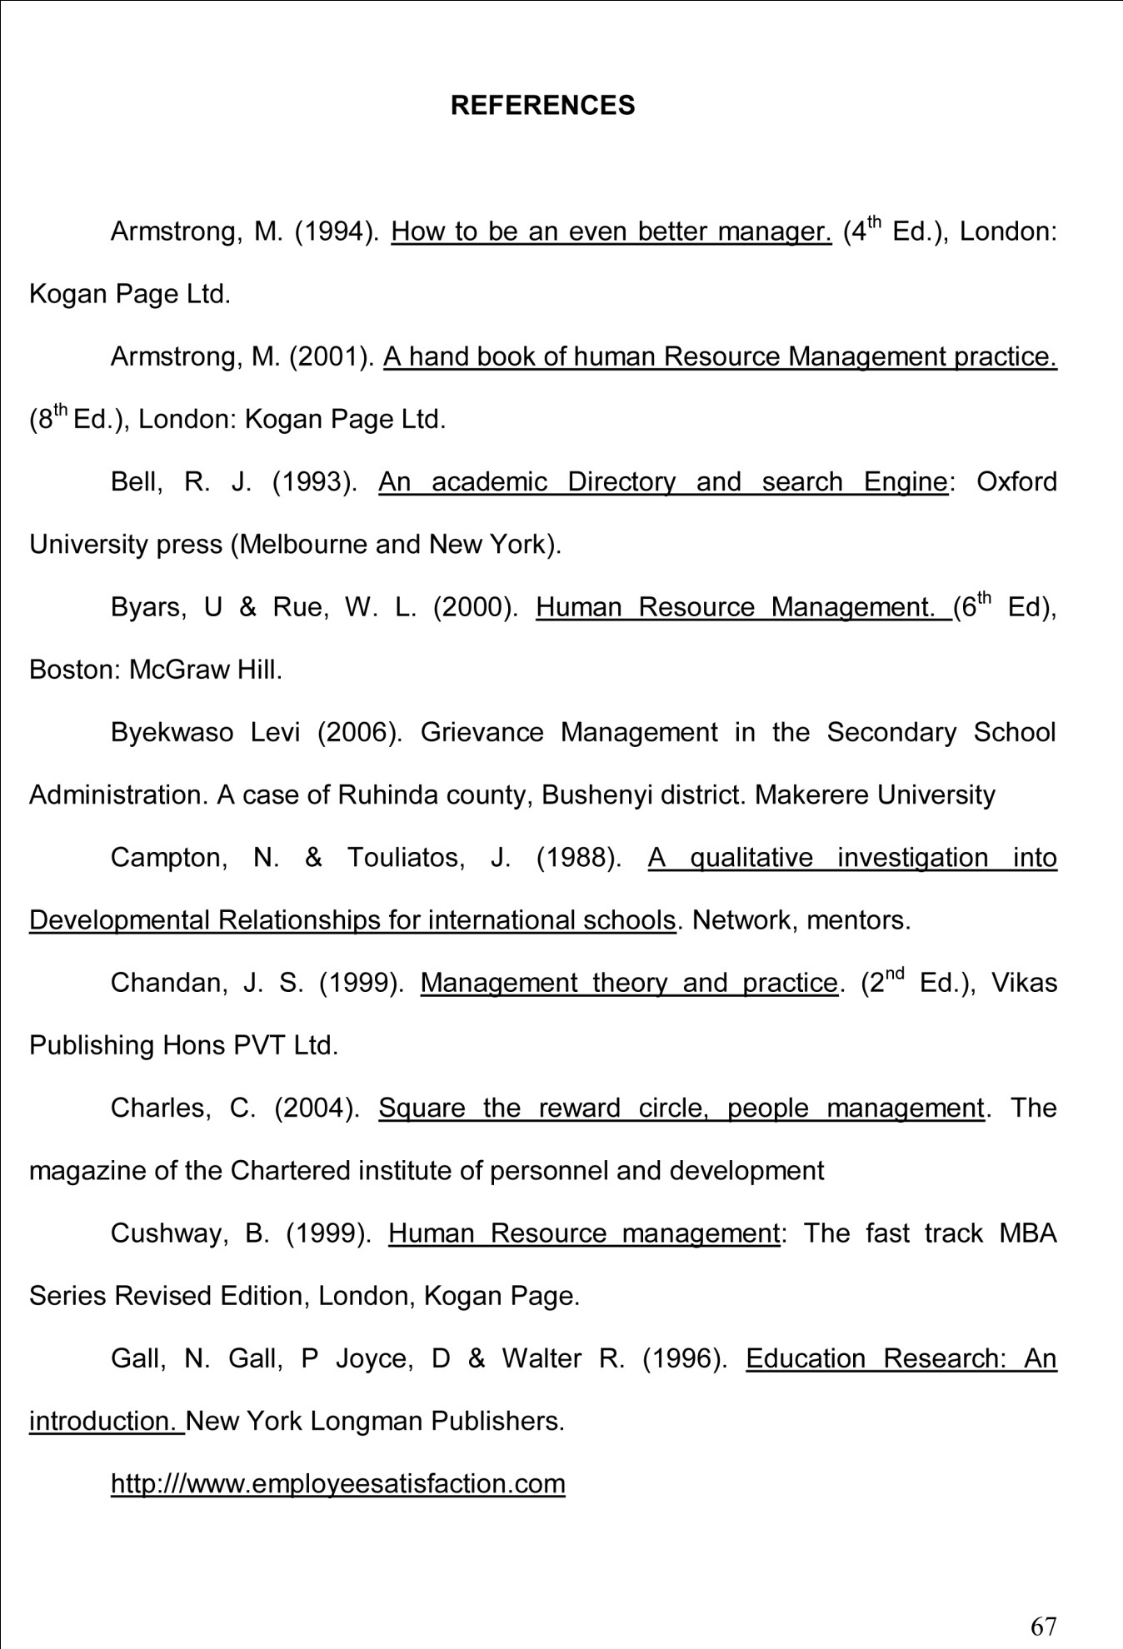

APPENDIX A

INTERVIEW GUIDE FOR TEACHERS
Dear Respondent
The researcher is a graduate student pursuing a Master of Science degree in Human Resource Management (MHRM) of Makerere University. She is conducting a research study on “Factors affecting teacher turnover in private secondary schools in Wakiso District”.
By copy of this questionnaire, you have been selected to participate in the study. You are therefore; kindly requested to answer the questions below displaying utmost good faith. The study is purely for academic purpose and all information provided will be treated confidential. Your prompt response will be highly appreciated.
Instructions: Please fill in or tick where applicable.
Part I:

1. Name of the school: ……………………………………………………………

2. Sex: (a) Male (b) Female
3. Time spent in school (years)
4. Teaching subjects
5. Briefly describe how you joined this school?
6. Approximately how many teachers have left since you joined?

Part II:

7. Briefly explain the reward system in your school
8. Mention some of the employer-related factors that cause teacher turnover in your school.
9. (i) Do you think teachers themselves are responsible for their turnover in your school?
(ii) If yes, mention some of these teacher-related factors.
10. (i) Is it possible that factors outside your school can affect teacher turnover in your school?
(a) Yes (b) No
(ii) If yes, mention some of these factors.
11. Do you think it is important to retain a stable staff?

(a) Yes (b) No
(ii) If yes, why?
12. What recommendations can you make to reduce on teacher turnover?

Thank you for participating in this survey

APPENDIX B

INTERVIEW GUIDE FOR HEADTEACHERS
Topic: Factors affecting teacher turnover in private secondary schools in Wakiso District
Part I:
1. School…………………………………………………..…………….…..……….
2. Qualification………………………………………………………………………
3. Time spent in school………………………………………………………….….
4. Duration of time as headteacher (years) …………………………………………
5. Number of teachers in your school ……………………………………………….

Part II:
6. At least how many teachers leave your school in a year?
7. In your own view what do you think are the main causes of teacher turnover in Wakiso district?
8. Do you think the same causes could possibly explain teacher turnover in your school?
9. Are there specific factors that have led to continued teacher outflow in your school?
10. Do you think it is important to retain a stable staff?
(a) Yes (b) No
(ii) If yes, why?
11. What recommendations can you make to reduce on teacher turnover?
Thank you for your participation

APPENDIX C

QUESTIONNAIRE FOR STUDENTS
Topic: Factors affecting teacher turnover in private secondary schools in Wakiso District.
Dear Respondent
The researcher is a graduate student pursuing a Master of Science degree in Human Resource Management (MHRM) of Makerere University. She is conducting a research study on “Teacher turnover and its impact on students’ academic performance in private secondary schools in Wakiso District”.
By copy of this questionnaire, you have been selected to participate in the study. You are therefore; kindly requested to answer the questions below displaying utmost good faith. The study is purely for academic purpose and all information provided will be treated confidential. Your prompt response will be highly appreciated.

