**ASSESSMENT OF DOMESTIC WASTE MANAGEMENT AND OCCURRENCE OF TYPHOID, CHOLERA AND DYSENTERY AMONG PEOPLE LIVING IN URBAN CENTRES IN NIGERIA: A CASE STUDY OF GWALE LOCAL GOVERNMENT IN KANO STATE.**

**BY**

**MUSTAPHA S. ABDULLAHI**

**2017/AUG/MEH/M222274/WKD**

**A DISSERTATION SUBMITTED TO THE SCHOOL OF SCIENCES IN PARTIAL FULFILMENT OF THE REQUIREMNTS FOR THE AWARD OF A MASTERS DEGREE IN ENVIRONMENTAL HEALTH OF NKUMBA UNIVERSITY**

**SEPTEMBER, 2019**

# DECLARATION

I **MUSTAPHA S. ABDULLAHI,** a student of Nkumba University, hereby declare that this report titled: Assessments of Domestic Waste Management and Occurrence of Enteric Diseases Among People Living in Urban Centres in Nigeria: A Case Study of Gwale local government in Kano State, Nigeria, is my original work and to the best of my knowledge it has never been presented by any other person or institution for any academic award in and outside Nkumba University.

**Student’s name: ……………………………………………………**

**Signature : ……………………………………………………**

**Date : ……………………………………………………**

# APPROVAL

This is to certify that this dissertation titled “Assessments of Domestic Waste Management and Occurrence of Enteric Diseases Among People Living in Urban Centres in Nigeria: A Case Study of Gwale local government in Kano State, Nigeria” has been prepared under my supervision and is ready for submission to the academic board for examination in partial fulfillment for award of Masters of Science in Environmental Health of Nkumba University.

**SUPERVISOR:**

Signature …………………………

**Professor Miph Musoke PhD (NSW)**

Fogarty Fellow (Internat. Res. Bioethics; Infect. Disease Epidem.)

Bloomberg School of Public Health, JHU (USA)

FUNAS (Medical Sciences)

Date: ………………………………

# DEDICATION

I dedicate this work to all my beloved parents especially my mother Hajjati Fatima Ibrahim and my late father Malam Sani Danwaire. Also to all my brothers and sisters for their kind support during the time of my study. May Allah reward you all abundantly.

# ACKNOWLEDGEMENTS

My heartfelt gratitude goes to my supervisor Professor Miph Musoke for his tireless supervision, guidance and encouragement that have resulted in the production of this dissertation.

In general, I convey my appreciation to all the rest of my lecturers in the School of Sciences of Nkumba University, and administration for influencing my success.

I am grateful to the administration and residents of Gwale local government who accepted me to do my research among them and, as such, provided valuable information which enabled me to prepare this research.

A vote of thanks also goes to my family for their moral, spiritual and financial support during my period of study. Without their continued support, it would have been difficult to successfully carry out this research. My love for them endures for a life time.

# TABLE OF CONTENTS

DECLARATION i

APPROVAL ii

DEDICATION iii

ACKNOWLEDGEMENTS iv

TABLE OF CONTENTS v

LIST OF TABLES ix

ACRONYMS x

LIST OF FIGURES xi

LIST OF PLATES xii

ABSTRACT xiii

CHAPTER ONE: INTRODUCTION 1

1.0 Introduction…. 1

1.1 Background to the study 1

1.2 Problem statement 3

1.3 General objective 4

1.3.1 Specific objectives 4

1.4 Research questions 4

1.5 Justification for the study 5

1.6 Significance of the study 5

1.7 Scope of the Study 6

1.7.1 Content scope 6

1.7.2 Geographical scope 6

1.7.3 Time scope 6

1.8 Conceptual Framework 7

1.9 Definitions 8

1.10 Structure of the dissertation 9

CHAPTER TWO: LITERATURE REVIEW 11

2.0 Introduction 11

2.1 Domestic waste management practices 11

2.1.1 Controlled Dumping/landfills 12

2.1.2 Composting 13

2.1.3 Incineration 14

2.2 The occurrence of cholera, typhoid and dysentery among people in Africa 15

2.3 Relationship between domestic waste management and occurrence of enteric diseases 18

CHAPTER THREE: METHODOLOGY 21

3.0 Introduction 21

3.1 Research Design 21

3.1.1 Research Approach 21

3.1.2 Research Duration 21

3.1.3 Research Classification 22

3.2 Study Population 23

3.3 Sample size 24

3.4 Sampling methods 25

3.4.1 Simple random sampling 25

3.4.2 Purposive sampling 25

3.5 Data Collection Procedure 25

3.6 Data Collection Methods 26

3.6.1 Questionnaire 26

3.6.2 Interviewing 26

3.6.3 Document Review 26

3.6.4 Observation method 26

3.7 Data Collection Instruments 27

3.7.1 Questionnaires 27

3.7.2 Interview guide 27

3.7.3 Observational checklist 28

3.8 Validity and Reliability of instruments 28

3.8.1 Validity of instruments 28

3.8.2 Reliability of instruments 28

3.9 Data Processing 29

3.10 Data Analysis 29

3.11 Ethical considerations 29

3.12 Limitations of the study 29

CHAPTER FOUR: DATA PRESENTATION AND ANALYSIS OF STUDY FINDINGS 31

4.0 Introduction 31

4.1 Demographic characteristics 31

4.1.1 Gender of respondents 31

4.1.2 Level of education 32

4.1.3 Age group 32

4.1.4 Duration of stay in Gwale 33

4.2 Domestic waste management practices in Gwale local gogernment 33

4.2.1 Use of landfills to manage waste 34

4.2.2 Use of trash bins to collect waste 36

4.2.3 Decomposing waste in homes 36

4.2.4 Residents of Gwale burn domestic waste 37

4.2.5 Gwale local governmentuses incineration to manage waste 39

4.2.6 Waste recycling 40

4.2.7 Use of rubbish pits in Gwale 42

4.3 Occurrence of cholera, typhoid and dysentery among people living in Gwale local gogernment 45

4.2.8 Illnesses among children in Gwale as a result of water-borne diseases 51

4.4 Domestic Waste Management Practices and the occurrence of cholera, typhoid and dysentery among people living in Gwale local gogernment 52

4.4.1 Poor storage, collection, and disposal of waste 53

4.4.2 Cholera, Dysentery, and Typhoid as a result of contaminated water 55

4.4.3 Garbage pollution is the main reason for various pathogenic bacterial diseases in Gwale 57

CHAPTER FIVE: SUMMARY, CONCLUSION AND RECOMMENDATIONS 63

5.0 Introduction 63

5.1 Summary 63

5.1.1 Domestic waste management practices in Gwale local gogernment 63

5.1.2 Occurrence of cholera, typhoid and dysentery among people living in Gwale local gogernment 64

5.1.3 Relationship between domestic waste management practices and occurrence of cholera, typhoid and dysentery among people living in Gwale local gogernment 65

5.3 Conclusion 65

5.4 Recommendations 66

5.5 consideration for future research 67

REFERENCES 68

APPENDIX A: QUESTIONNAIRE 75

APPENDIX B: INTERVIEW GUIDE 79

APPENDIX C: OBSERVATIONAL CHECKLIST 81

# LIST OF TABLES

Table 3.1: sample size selection methods

Table 4.1: Gender of respondents

Table 4.2: Level of education of respondents

Table 4.3: Age group of respondents

Table 4.4: Duration of stay in Gwale

Table 4.5: People in Gwale decompose waste in their homes

Table 4.6: Residents of Gwale burn domestic waste

Table 4.7: People in Gwale dig rubbish pits in their homes

Table 4.8: Cholera in Gwale

Table 4.9: Water-borne diseases cause illnesses among children

Table 4.10: Poorly stored, uncollected, and poorly disposed waste

Table 4.11: Relationship between domestic waste management practices and occurrence of cholera, typhoid and dysentery.

# ACRONYMS

FCT Federal Capital Territory

FEPA Federal Environmental Protection Agency

HUS Hemolytic Uremic Syndrome

GEPB Gwale Environmental Protection Board

NCDC Nigeria Centre for Disease Control

REMASAB Refuse Management and Sanitation Board

UN United Nations

UNICEF United Nations International Children's Emergency Fund

WASH Water, Sanitation and Hygiene

WHO World Health Organization

WRAP Waste and Resources Action Programme

# LIST OF FIGURES

Figure 1.1: Conceptual Framework

Figure 4.1: Access to basic health care

Figure 4.2: Existence of cases of typhoid in Gwale

# LIST OF PLATES

Plate 4.1: Landfill in Dorayi

Plate 4.2: Landfill in Gadon Kaya

Plate 4.3: A boy collecting waste from shops in Dorayi

Plate 4.4: Burning of domestic waste in Diso, Gwale local government

Plate 4.5: Local incineration in Gadon Kaya, Gwale local government

Plate 4.6: Garbage picking in Kabuga, Gwale local government

Plate 4.7: Indiscriminate dumping of rubbish in Dorayi, Gwale local government

Plate 4.8: Unprotected water source in Kabuga, Gwale local government

Plate 4.9: Garbage in back yard and in residential area of Diso, Gwale local government

Plate 4.10: Infectious diseases Hospital Administrator shows the researcher victims of cholera

# ABSTRACT

The study was about Domestic Waste Management and Occurrence of Enteric Diseases among People Living in urban centres in Nigeria: A case study of Gwale local government in Kano State. It was guided by the following objectives: to assess domestic waste management practices in Gwale local government, to analyze the occurrence of cholera, typhoid and dysentery among people living in Gwale local government, and to relate how domestic waste management practices affect the occurrence of cholera, typhoid and dysentery among people living in Gwale local government.

The researcher used a cross sectional survey design and descriptive research design. The design was qualitative and quantitative in nature. A case study approach was adopted .The study used a population of 362,059 from which a sample of 400 respondents was selected using the statistical formula provided by Yamane (1967).

This study found that there are no professionally constructed landfill sites on ground that are equipped with liner systems and infrastructure to detect, extract and treat/refine leachate or landfill gas. The REMASAB lack an established system for segregation and recycling of waste. Residents use rubbish bins in their homes, businesses and public offices. However, Residents of Gwale have access to basic health care. However, the hospitals in Gwale were expensive for most of the local people. Typhoid, Cholera and dysentery occur and are significant cause of illness in Gwale. There are cases of typhoid reported in health centres in Gwale. Typhoid occurs at an average of 96.0% among people visiting hospitals with feverish conditions. Dysentery occurs at an average of 16.0%. No single case of cholera was reported in hospitals during the three months of this study in Gwale (field data, hospitals records, 2019). Domestic waste management practices and occurrence of cholera, typhoid and dysentery among people living in Gwale local government have significant relationship, correlation r = 0.350, p <0.001.

The researcher recommends that Refuse Management and Sanitation Board (REMASAB) should be facilitated to establish a system for segregation and recycling of waste. The local authorities should support the private garbage collectors in their areas through giving them tax holidays as well as subsidizing their services to the local people. The local leaders should engage in promoting good hygiene practices among communities to prevent transmission of the diseases. The federal government should construct modern incinerators in all growing urban centres to reduce waste volume, convert metal and glass to ash, and install suitable pollution control devices, suitable furnace construction and control of the combustion process.

# CHAPTER ONE: INTRODUCTION

# Introduction

This chapter highlights the background to the study, problem statement, general and specific objectives, research questions and justification for the study, significance of the study, scope of the study, conceptual framework, definition of key terms and the structure of the study.

# 1.1 Background to the study

The study was about Domestic Waste Management and Occurrence of Enteric Diseases among People Living in urban centres in Nigeria: A case study of Gwale local government in Kano State.

The cities of Third World countries are growing at very rapid rates compared to those in the developed nations. For instance, a UN-Habitat report observed that Africa is the fastest urbanizing continent having cities like Cairo, Lagos, Nairobi, Kinshasa, among others, growing at fast rates that would make them triple their current sizes by the year 2050 (UN-Habitat, 2010). Such high rate of growth of cities has implications for the provision of urban infrastructural services to prevent the proliferation of urban slum. The increasing growth of cities, therefore, has implications for municipal waste management among other social services required in the urban communities. According to UN-Habitat report (2010), data from many of the cities shows inadequacy in urban social services such as shelter, provision of safe drinking water and efficient management of solid waste. The cities are therefore littered with ‘mountains’ of rubbish in landfills and open (in most cases illegal) waste dumps which are covered with flies and thus serve as breeding grounds for rodents and mosquitoes which are carriers of diseases.

Enteric diseases such as dysentery, diarrheal diseases, and cholera are life-threatening systemic infections caused by various microorganisms like *bacterium, Salmonella typhi, a Gram-negative, motile, aerobic, nonsporing, intracellular Bacillus* (Sherwal *et al,* 2004). Typhoid for example is a global public health problem with an estimated 21.6 million new cases and 216,500 deaths recorded globally in 2004 (Lucas *et al,* 2004). This is especially worse in the developing nations of the world where it is a significant contributor to morbidity and mortality, especially taking into account the generally low income background.

According to Enteric and Diarrheal Diseases Strategy Overview to end diarrheal disease deaths in children under 5 by 2030, and to eliminate typhoid as a public health problem by 2035 (Gates Foundation, 2015), enteric and diarrheal diseases kill about 500,000 children under 5 each year. Children who survive face repeated infections by gut pathogens in the early years of their life, which can lead to serious, lifelong health problems.

Enteric diseases such as cholera are contracted by drinking or eating the bacteria in contaminated food or water. People with acute illness can contaminate the surrounding water supply through stool, which contains a high concentration of the bacteria. Contamination of the water supply can, in turn, taint the food supply. The bacteria can survive for weeks in water or dried sewage (Keusch *et al,* 2006).

Enteric diseases such as typhoid are spread by the faeco-oral route and commonly presents with nonspecific clinical features such as fever, headache, rigors, joint pain, nausea, vomiting, constipation, and diarrhea, which are indistinguishable from other causes of fever such as malaria (Nsutebu *et al*, 2003).

Typhoid kills about 160,000 people each year, with the highest known burden in South Asia. An effective and affordable vaccine is the best short-term solution for controlling typhoid fever in countries with poor access to clean water, sanitation, and hygiene, as well as high rates of antibiotic resistance (Mara, 2003).

Cholera kills as many as 130,000 people each year and occurs in both epidemic and endemic settings. At least 51 countries in Sub-Saharan Africa and Asia have endemic cholera. Several recent outbreaks in Guinea, Haiti, Sierra Leone, Zimbabwe, and elsewhere have severely strained these countries’ under-resourced health systems (Griffith *et al*, 2005).

According to Burns *et al*. (1994), waste that is not properly managed especially excreta and other liquid and solid waste from households and the community, are a serious health hazard and lead to the spread of infectious diseases. Unattended waste lying around attracts flies, rats, and other creatures that in turn spread disease. Normally the wet waste decomposes and releases a bad odour. This leads to unhygienic conditions and thereby to a rise in the health problems. The plague outbreak in Suratis a good example of a city suffering due to the callous attitude of the local body in maintaining cleanliness in the city (Burns *et al*, 1994). Plastic waste is another cause for ill health. Thus, excessive solid waste that is generated should be controlled by taking certain preventive measures (Cointreau, 2006).

In particular, organic domestic waste poses a serious threat, since they ferment, creating conditions favorable to the survival and growth of microbial pathogens. Direct handling of solid waste can result in various types of infectious and chronic diseases with the waste workers and the rag pickers being the most vulnerable.

Exposure to hazardous waste can affect human health, children being more vulnerable to these pollutants. In fact, direct exposure can lead to diseases through chemical exposure as the release of chemical waste into the environment leads to chemical poisoning. Many studies have been carried out in various parts of the world to establish a connection between health and hazardous waste (Abul *et al*, 2010).

The study was carried out in Gwale local government Area in Kano State, Nigeria within Greater Kano city. Its headquarters are in the suburb of Gwale. It has an area of 18 km² and a population of 362,059 at the 2006 census.

# 1.2 Problem statement

Enteric diseases are a major cause of death worldwide with a major part of the disease burden in developing regions such as Africa. Nigeria is part of this highly endemic region for enteric diseases, yet little is known about the spatial and temporal distribution of these diseases at a regional scale (Adiogo, 2003).

Indiscriminate disposal of domestic waste (including human excreta) in Nigeria contaminates water source leading to spread of communicable enteric diseases such as typhoid, dysentery and cholera. According to Gwale local government Health Report (2015), Gwale local government is overwhelmed with domestic waste because of inadequate preparations for their removal, especially in far away and negligible dumpsites not easily accessible. There are few or no collective household receptacles for tenants and landlords to use for regular waste control disposal. There are very few or no designated zones along neighborhood streets to dispose off household waste. Urban residents dump solid waste carelessly or haphazardly, anywhere they deem fit and there is little sorting of this waste. This has led to high occurrence of enteric diseases such as typhoid, cholera and diarrhea among the people causing deaths (Government Health Report, 2015).

Proper methods of waste disposal have to be undertaken to ensure that it does not affect the environment around the area or cause health hazards to the people living there (Nabegu, 2010).

However, information on how domestic waste management practices affect the occurrence of enteric diseases is not readily available to the different health stakeholders. This has led to high occurrence of enteric diseases such as typhoid, cholera and diarrhea among the people causing deaths especially among people living in urban centres in Africa.

It was against this problem that the researcher sought to assess domestic waste management practices and occurrence of enteric diseases in Gwale local government.

# 1.3 General objective

To examine the impact of domestic waste management on the occurrence of enteric diseases among people living in urban centres in Nigeria, using Gwale local government in Kano State as a case study

# 1.3.1 Specific objectives

1. To identify the domestic waste management practices in Gwale local government.
2. To analyze the occurrence of cholera, typhoid and dysentery among people living in Gwale local government.
3. To relate how domestic waste management practices affect the occurrence of cholera, typhoid and dysentery among people living in Gwale local government.

# 1.4 Research questions

1. What domestic waste management practices exist in Gwale local government?
2. What is the level of cholera, typhoid and dysentery occurrence among people living in Gwale local government?
3. What is the relationship between domestic waste management practices and occurrence of cholera, typhoid and dysentery among people living in Gwale local government?

# 1.5 Justification for the study

Indiscriminate disposal of solid waste has the potentials to cause damage to the environment and the health of people. In Nigeria, waste management is at the lowest ebb in most towns and cities (Talib, 2014). At many inner and peri-urban centres, refuse heaps are left unattended to for two to three weeks, and where the Town authorities do the collection, it is often irregular. The recycling of waste is almost unknown, while methods of collection and final disposal are very much unsatisfactory (Adiogo, 2003).

The alarming rate at which heaps of solid waste continue to occupy cities, coupled with the fact that 87% of Nigerians use disposal method adjudged unsanitary, has not only contributed to visual impairment and odour, but has also encouraged the breeding of rodents, mosquitoes, and other pests raising serious concerns over public health (Onibokum, 2000). Mechanical insect vectors such as *Musca domestica* (house flies), *M. sorbens* (filth flies) and *Blatta sp* (cockroaches) are abundant and worsen the situation.

# 1.6 Significance of the study

The research findings, conclusion and recommendations will be beneficial to different stakeholders in various ways as shown below:

**The management of Gwale local government:** The findings of this study will help the management of Gwale local government to understand the impact of domestic waste management on the occurrence of Enteric Diseases among people. It will further present the proper solid waste disposal strategies that can save the Gwale area from much public health challenges.

**The community members:** The study will help the community members to know the effects of poor waste disposal to their health and provide measures to ensure proper disposal of waste.

**Other researchers:** This study will provide valuable information to other researchers on which they can build to do more research on solid waste management.

**Hospitals:** The study will provide hospital management with information about the occurrence of enteric diseases to assist in decisions about relevant medicines to stock as well as medical personnel required.

**Higher institutions of learning:** This study will act as reference for other researchers in higher institutions of learning to base on for further research into enteric diseases.

# 1.7 Scope of the Study

# 1.7.1 Content scope

This study was about an assessment of the impact of domestic waste management on the occurrence of enteric diseases among people living in urban centres in Gwale local government, Kano State Nigeria and was limited to three objectives which included: assessing domestic waste management practices in Gwale local government; analyzing the occurrence of cholera, typhoid and dysentery among people living in Gwale local government and lastly relating how domestic waste management practices affect the occurrence of cholera, typhoid and dysentery among people living in Gwale local government.

# 1.7.2 Geographical scope

The study was carried out in Gwale local government, Kano State Nigeria. Gwale is a Town Area in Kano State, Nigeria within Greater Kano city. Its headquarters are in the suburb of Gwale. It has an area of 18 km² and a population of 362,059 at the 2006 census.

# 1.7.3 Time scope

The study was conducted from March 2018 to June 2018 and obtained and considered data for domestic waste management and the occurrence of enteric diseases for the years covering the years 2012– 2016 since Gwale faced overwhelming domestic waste management challenges during this period.

1.8 Conceptual Framework

**Independent variables Dependent variables**

**Domestic Waste Management**

* Waste generation
* Waste collection
* Waste transportation
* Controlled dumping (landfill)
* Composting
* Incineration

**Occurrence of Enteric Diseases**

* Rates of cholera occurrence
* Rates of typhoid infection
* Rates of cases of dysentery

**Intervening variables**

* Government policies
* Enforcement agents
* Financial capability
* Community awareness

***Figure 1.1: Conceptual Framework***

***Source: Researcher (2018)***

The independent variables for this study are domestic waste management, which includes waste generation, waste collection, and waste transportation. Controlled Dumping (landfill), Composting, Recycling, and Incineration as variables. The dependent variables are occurrence of enteric diseases, which includes rates of cholera, rates of typhoid infection as well as rates of cases of dysentery. The intervening variables that may influence proper domestic waste management and control of enteric diseases may include Government policies to control waste disposal, availability of enforcement agents, financial capability of local authorities as well as community awareness and sensitization on proper waste disposal.

# 1.9 Definitions

**Enteric diseases**

Enteric diseases are diseases of the intestines caused by any infection. Among bacteria commonly involved in enteric infections are *Escherichia coli, Vibrio cholerae*, and several species of *Salmonella, Shigella*, and *anaerobic streptococci*. Enteric infections are characterized by diarrhea, abdominal discomfort, nausea and vomiting, and anorexia (persistent loss of appetite) (Dolin, 2011).

**Waste**

Wastes are unwanted or unusable materials. Waste is any substance which is discarded after primary use, or it is worthless, defective and of no use. Examples include municipal solid waste (household trash/refuse), hazardous waste, wastewater (such as sewage, which contains bodily wastes (feces and urine) and surface runoff), radioactive waste, and others (Diaz *et al*, 2006).

**Domestic waste**

Domestic waste is waste that is generated as a result of the ordinary day-to-day use of a domestic premise and either: taken from the premises by or on behalf of the person who generated the waste; or collected by or on behalf of a Town as part of a waste collection and disposal system (Wilson *et al*, 2006).

**Domestic waste management**

Domestic waste management is all the activities and actions required to manage waste from its inception to its final disposal. This includes amongst other things collection, transport, treatment and disposal of waste together with monitoring and regulation. It also encompasses the legal and regulatory framework that relates to waste management encompassing guidance on recycling (Davidson, 2011).

**Cholera**

[Cholera](https://www.webmd.com/a-to-z-guides/cholera-faq) is an infectious disease that causes severe watery [diarrhea](https://www.webmd.com/digestive-disorders/digestive-diseases-diarrhea), which can lead to [dehydration](https://www.webmd.com/a-to-z-guides/dehydration-adults) and even death if untreated. It is caused by eating food or drinking water contaminated with a bacterium called *Vibrio cholerae* (WebMD, 2019). Cholera is an infectious disease characterized by intense vomiting and profuse watery diarrhea and that rapidly leads to dehydration and often death (MedicineNet).

**Typhoid**

Typhoid fever, also called enteric fever, is a contagious, potentially life -threatening bacterial infection. Typhoid fever is caused by the *bacterium Salmonella enteric serotyphi* (also known as *Salmonella typhi*),which is carried by infected humans in the blood and digestive tract and spreads to others through food and drinking water contaminated with infected feces. Symptoms of typhoid fever include fever, rash, and abdominal pain. Typhoid fever is the result of systematic infection mainly S. typhi found only in man (Hassan *et al,* 2015).

**Dysentery**

**Dysentery** is an [inflammatory](https://en.wikipedia.org/wiki/Inflammation) disease of the [intestine](https://en.wikipedia.org/wiki/Intestine), especially of the [colon](https://en.wikipedia.org/wiki/Colon_(anatomy)), which always results in severe [diarrhea](https://en.wikipedia.org/wiki/Diarrhea) and [abdominal pains](https://en.wikipedia.org/wiki/Abdominal_pain). Other symptoms may include [fever](https://en.wikipedia.org/wiki/Fever) and a [feeling of incomplete defecation](https://en.wikipedia.org/wiki/Rectal_tenesmus). The disease is caused by several types of [infectious pathogens](https://en.wikipedia.org/wiki/Infections) such as bacteria, viruses and parasites. (Wikipedia). Dysentery is bloody diarrhoea, i.e. any diarrhoeal episode in which the loose or watery stools contain visible red blood. Dysentery is most often caused by *Shigella species* (bacillary dysentery) or *Entamoeba histolytica* (amoebic dysentery) (WHO)

# 1.10 Structure of the dissertation

This study was arranged and structured in five chapters:

**Chapter one - Introduction**

Chapter one contains an introduction to the study, background to the study, problem statement, study objectives, research questions, significance of the study, justification of the study, study scope, definitions of keywords and the research structure.

**Chapter two – Literature review**

This section reviews available literature on domestic waste management and occurrence of enteric diseases. Specific attention is put on waste management practices, enteric diseases and how domestic waste leads to spread of enteric diseases.

**Chapter three – Research Methodology**

Chapter three contains the methodology to be used in the research process including the research design, population of the study, sample size, sampling methods and techniques, data collection procedures, data collection methods and instruments, data processing, data analysis and limitations of the study.

**Chapter four – Data presentation and analysis of findings**

Chapter four presents analyses based on data collected from the research field work.

**Chapter five – Summary, Conclusion and Recommendation**

Chapter five presents the summary of the findings of this study based on specific objectives, the conclusion made on each area of investigation and the recommendations made to improve domestic waste management in Gwale local government in Kano State, Nigeria.

# 

# CHAPTER TWO: LITERATURE REVIEW

# 2.0 Introduction

Problems of waste management and occurrence of diseases are not unique to Nigeria. There has been a subject study by various scholars in other countries. They have come up with various models and theories that are relevant in understanding the issues involving domestic waste management as reviewed below (Diaz *et al*, 2006; Wilson *et al*, 2006; Davidson, 2011; Alex, 1990; Bonnie, 1998; Boyer, 2010; David 2000; Daniel, 2003; Davidson, 2011; Crump *et al*. 2004; Bhan *et al*. 2005; Bhutta 2006; Akinyemi *et al*. 2005; Feng, 2000).

Globally, millions of tons of municipal solid waste are generated every day. Urban waste management is drawing increasing attention Davidson, (2011), as it can easily be observed that too much garbage is lying uncollected in the streets, causing inconvenience, environmental pollution, and posing a public health risk.

The problem of solid, liquid, and toxic-waste management in Africa has come with urbanization in the developing world. An important feature of the urbanization of the developing world is the rapid growth of cities and metropolitan areas. The high rate of urbanization in African countries implies a rapid accumulation of refuse. Social and economic changes that most African countries have witnessed since the 1960s have also contributed to an increase in the waste generated per capita. As a result, municipal waste management constitutes one of the most crucial health and environmental issues facing managers of African cities. Proper waste management is a public benefit and obligation. Improper waste disposal by one individual affects the entire citizenry, so, as a policy, countries have tasked every individual, establishment or institution to contribute significantly to the process of keeping their communities and environment clean.

# 2.1 Domestic waste management practices

According to Diaz *et al,* (2006), waste is unwanted materials. Waste is any substance which is discarded after primary use, or it is worthless, defective and of no use. Examples include municipal solid waste such as household trash/refuse, hazardous waste, wastewater such as sewage, which contains bodily wastes such as feces and urine and surface runoff, radioactive waste, and others.

Wilson *et al,* (2006) define domestic waste as waste that is generated as a result of the ordinary day-to-day use of a domestic premise and either: taken from the premises by or on behalf of the person who generated the waste; or collected by or on behalf of a Town as part of a waste collection and disposal system.

Domestic waste management is all the activities and actions required to manage waste from its inception to its final disposal. This includes amongst other things collection, transport, treatment and disposal of waste together with monitoring and regulation. It also encompasses the legal and regulatory framework that relates to waste management encompassing guidance on recycling (Davidson, 2011).

Domestic waste disposal is an issue that is important to the management of any urban area. Cities without functioning waste-disposal plans face risks of disease running rampant and economic activity grinding to a halt. The majority of cities use the sanitary-landfill method of waste disposal, which has served fairly well for quite a while; however, in situations where space is at a premium, incineration and material-recycling-based waste disposal are more likely to come to the forefront (Wilson *et al*, 2006).

The common waste management practices include the following;

# 2.1.1 Controlled Dumping/landfills

Controlled dumping refers to the use of landfills as terminal endpoints for refuse. It is the preferred method of disposal by most urban centres, because it is the most affordable and requires the least maintenance. Cities are permitted to appoint designated landfill sites, but these sites are more accurately designated as open dumps (Alex, 1990).

Controlled dumping is also called landfill. The modern sanitary landfill is much more than a simple dumping ground, due to the fact that waste materials are handled in a more controlled fashion to preserve the quality of groundwater in the area. Lighter materials are placed at the bottom of the sanitary landfill, which contains the majority of toxic compounds, thereby protecting the local environment. According to the University of Michigan's website, after each day's new waste is added, a new layer of soil is added to cover the waste in the hopes that it will break down before the landfill's barrier between the waste and the groundwater breaks down. Sanitary landfills require continuous maintenance and treatment of wastewater as well as the recovery of toxic gases, making them potentially hazardous if left derelict long enough to allow systems to fail. The main flaw of the sanitary landfill concept is that it continually consumes both land and resources to contain the waste, in addition to being potentially ecologically damaging. Landfills could also stifle the growth of a city, due to the fact that they are usually constructed at present city limits without accounting for potential growth and land-use needs. No one is going to want to buy property on or near a landfill, making the landfill itself and the surrounding area a proverbial no man's land (Bonnie, 1998).

In a sanitary landfill, garbage is spread out in thin layers, compacted and covered with clay or plastic foam. In the modern landfills the bottom is covered with an impermeable liner, usually several layers of clay, thick plastic and sand. The liner protects the ground water from being contaminated due to percolation of leachate (Boyer, 2010).

Leachate from bottom is pumped and sent for treatment. When landfill is full it is covered with clay, sand, gravel and top soil to prevent seepage of water. Several wells are drilled near the landfill site to monitor if any leakage is contaminating ground water. Methane produced by anaerobic decomposition is collected and burnt to produce electricity or heat (Bonnie, 1998).

# 2.1.2 Composting

Composting is a biological process in which micro-organisms, mainly fungi and bacteria, convert degradable organic waste into humus like substance. This finished product, which looks like soil, is high in carbon and nitrogen and is an excellent medium for growing plants (Boyer and Johannessen, 2010).

According to David (2000), due to shortage of space for landfill in bigger cities, the biodegradable yard waste (kept separate from the municipal waste) is allowed to degrade or decompose in a medium. A good quality nutrient rich and environmental friendly manure is formed which improves the soil conditions and fertility.

Organic matter constitutes 35%-40% of the municipal solid waste generated in India. This waste can be recycled by the method of composting, one of the oldest forms of disposal Daniel (2003). It is the natural process of decomposition of organic waste that yields manure or compost, which is very rich in nutrients. The process of composting ensures the waste that is produced in the kitchens is not carelessly thrown and left to rot. It recycles the nutrients and returns them to the soil as nutrients. Apart from being clean, cheap, and safe, composting can significantly reduce the amount of disposable garbage (Daniel, 2003).

David, (2000) stresses that the organic fertilizer can be used instead of chemical fertilizers and is better specially when used for vegetables. It increases the soil’s ability to hold water and makes the soil easier to cultivate. It helped the soil retain more of the plant nutrients.

Composting is the process of turning organic household waste into fertilizer through aerobic fermentation. This fertilizer can be used in lawns, parks, and gardens. In practice, composting is not a widely employed technology. Greater use of composting requires analysis of the different levels of technical sophistication and the potential transport capacity of waste (Daniel, 2003). In theory composting could reduce environmental pollution and provide job opportunities. Compost fertilizer also could help improve agricultural production and improve soil structure – which means it offers a longer-term advantage over other non-compost mineral-based fertilizers. The high percentage of organic material that is disposed as trash suggests that composting could be a viable municipal solid waste technology (Daniel, 2003).

# 2.1.3 Incineration

Incineration is a method of burning waste that is combustible at high temperatures in the range of 1000 degrees Celsius to reduce the waste to ashes. It is used primarily as disposal for biological waste associated with medical care. The term incinerates means to burn something until nothing is left but ashes. An incinerator is a unit or facility used to burn trash and other types of waste until it is reduced to ash. An incinerator is constructed of heavy, well-insulated materials, so that it does not give off extreme amounts of external heat (David, 2000).

The high levels of heat are kept inside the furnace or unit so that the waste is burned quickly and efficiently. If the heat were allowed to escape, the waste would not burn as completely or as rapidly. Incineration is a disposal method in which solid organic wastes are subjected to combustion so as to convert them into residue and gaseous products. This method is useful for disposal of residue of both solid waste management and solid residue from waste water management. This process reduces the volumes of solid waste to 20 to 30 per cent of the original volume (Davidson, 2011).

Incineration and other high temperature waste treatment systems are sometimes described as “thermal treatment”. Incinerators convert waste materials into heat, gas, steam and ash. Incineration is carried out both on a small scale by individuals and on a large scale by industry. It is used to dispose of solid, liquid and gaseous waste. It is recognized as a practical method of disposing of certain hazardous waste materials. Incineration is a controversial method of waste disposal, due to issues such as emission of gaseous pollutants (Diaz *et al*, 2006).

Davidson, (2011) further agree that incineration is a popular garbage-disposal method in locations where space is at a premium or in locations where there is no sanitation service provided by Town. Although incineration can provide relief from dealing with the bulk of material waste, it does not entirely eliminate problems. Anything in the burning incinerator that contains a toxic substance, particularly heavy-metal toxic substances, will be sent up the chimney and cast as ash all over the surrounding area. The toxins from the burning of waste then build up in the local populace, contributing to a variety of health problems ranging from asthma to heavy-metal poisoning and even cancer. Proponents of incineration disposal (David, 2000; Davidson, Gary, 2011; Diaz L. *et al,* 2006) point out that energy can be obtained from the burning of waste materials; however, the health costs quite likely offset any potential gains from burning unsorted waste materials. Incineration coupled with proper waste sorting can be effective in reasonably safe measures, as long as the materials being burned are only simple organic waste and not manufactured goods.

# 2.2 The occurrence of cholera, typhoid and dysentery among people in Africa

Cholera largely eliminated from industrialized countries by water and sewage treatment over a century ago, still remains a significant cause of illness and death in many African countries. In the twenty-first century, sub-Saharan Africa bears the brunt of global cholera. The region is broadly affected by many cholera cases and outbreaks that can spread across countries (Gaffga *et al*, 2007).

The percentage of people who die from reported cholera cases remains higher in Africa than elsewhere. This reflects the lack of access to basic health care because of cholera’s simple treatment of rehydration therapy (WHO Cholera, 2011).

Many African countries face the dual challenges of improving both cholera treatment, that is access to basic health care, and prevention, that is improved water and sanitation systems. Improving global access to water, sanitation and hygiene (WASH) is a critical step to reducing Africa's cholera burden.

In the developing countries in Africa, four-fifth of all the illnesses is caused by water-borne diseases with diarrhea leading to dehydration being the leading cause of childhood death. Cholera, typhoid fever and hepatitis A are caused by bacteria, and are among the most common diarrheal diseases. Other illnesses, such as dysentery, are caused by parasites that live in water contaminated by the feces of sick individuals. The most common manifestation and cause of mortality in water borne diseases were as result of dehydration due to loss of copious amounts of electrolytes either in vomiting or diarrhea.

According to WHO (2014), every year more than 3.4 million people die as a result of water-related diseases, making it the leading cause of morbidity and mortality around the world. Most of the victims are young children, the vast majority of whom die of illnesses caused by organisms that thrive in water sources contaminated by raw sewage. A report by Jamie *et al,* (2005) in the medical journal The Lancet, concluded that poor water sanitation and lack of safe drinking water take a greater human toll than war, terrorism and weapons of mass destruction combined.

According to an assessment commissioned by the United Nations, 4,000 children die each day as a result of diseases caused by ingestion of filthy water. The report says four out of every 10 people in the world, particularly those in Africa and Asia, do not have clean water to drink.

Cholera, typhoid fever and hepatitis A are caused by bacteria, and are among the most common diarrheal diseases. Other illnesses, such as dysentery, are caused by parasites that live in water contaminated by the feces of sick individuals. The most common manifestation and cause of mortality in water borne diseases were as result of dehydration due to loss of copious amounts of electrolytes either in vomiting or diarrhea.

Lakes and streams which people use for drinking water, bathing and defecating are sources of disease, as is water left by natural disasters. People can also contract a diarrheal disease by eating food that's prepared by sick individuals who have not washed their hands, or touching something handled by an infected person and then putting their own hands into their mouths.

Water borne diseases occurrence was observed to follow a seasonal pattern with peaks occurring between the months of January and May followed by drops between June and October and rose again in November. Children below 5 years were found to be more vulnerable to diarrhea of viral origin, gastro-enteritis and amoebic dysentery while persons between 15-44 years were more vulnerable to typhoid and cholera (WHO, 2018).

According to Crump *et al,* (2004) typhoid fever, also known as enteric fever, is caused by the Gram-negative bacterium *Salmonella enterica serovartyphi*. The disease is mainly associated with low socio-economic status and poor hygiene, with human beings the only known natural hosts and reservoir of infection. Estimates for the year 2000 suggest that there are approximately 21.5 million infections and 200,000 deaths from typhoid fever globally each year (Crump *et al*. 2004; Bhan *et al*. 2005; Bhutta 2006). It is thus considered one of the most serious infectious disease threats to public health on a global scale, with particular concern over the rapid and widespread emergence of resistance to multiple antibiotics (Akinyemi *et al*. 2005; Feng 2000). The global concern over typhoid is reflected in perceptions that typhoid is a common and serious disease among children and adults in Kenya, where highly publicized outbreaks have strengthened this view among the public and health professionals. One consequence is the common use of the Widal test to ‘screen’ febrile children and adults in inpatient and outpatient settings, as few centres have the capacity to perform blood or bone marrow culture, the accepted gold standard diagnostic tests (Chart *et al*. 2000; Willke *et al*. 2002).

The global burden of disease estimates for typhoid were based on a total of 22 community-based incidence studies with 19 from continents other than Africa and only three from Africa. On the basis of these data and a prediction rule based on climatic and socio-economic features, continental estimates of disease burden were derived (Crump *et al*. 2004). These estimates suggested a moderate incidence of typhoid of 10–100 cases/100,000 person years in most African countries, with the incidence highest in childhood. In East Africa, incidence was estimated at 39/100,000 person years. Recently, increasing amounts of data on the occurrence of different pathogens found in sick children presenting to health facilities in Africa have been reported. These data have considerably raised the profile of non-typhoidal salmonella infections (Graham *et al*. 2000).

Shigellosis, also known as bacillary dysentery, is acute infectious enteritis of human and subhuman primates caused by bacteria of the genus *Shigellae*. It usually causes frequent passage of small-volume, bloody mucoid stools, accompanied by abdominal cramps and rectal pain (Cahill *et al,* 1966). Life-threatening complications of shigellosis include hemolytic uremic syndrome (HUS), encephalopathies, colonic ulceration and perforation, *Shigellemia*, toxic megacolon, intestinal stenosis and obstruction, persistent diarrhea, severe malnutrition, and wasting (Huppertz, 1986). Disease can result from infection with any one of four known *Shigella* species, but only *Sh. dysenteriae* type 1 (SD1 or *Shiga’s bacillus*) is known to cause outbreaks of epidemic proportions. For reasons not entirely understood, Shiga’s bacillus eventually goes from playing a minor role in the cause of shigellosis to suddenly and dramatically becoming the dominant factor in massive dysentery epidemics. Dysentery epidemics exacerbate the already important burden of endemic shigellosis in developing countries. An estimated 140 million cases and 576,000 deaths occur annually due to *Shigella* infection in children under five years of age worldwide. However, due to the problems in clinical and laboratory diagnosis, these numbers are probably grossly underestimated (Crump *et al,* 2004).

# 2.3 Relationship between domestic waste management and occurrence of enteric diseases

Waste poses a threat to public health and the environment if it is not stored, collected, and disposed of properly. The perception of waste as an unwanted material with no intrinsic value has dominated attitudes towards disposal. Accumulation of the waste products generally results in contamination of air and water and the main reason behind air and water-borne diseases. Many life-threatening diseases are the consequence of contaminated water. Few of the most common diseases are hepatitis, cholera, dysentery, and typhoid (HealthMir, 2017).

Garbage pollution is the main reason for various bacterial diseases. Gastrointestinal, stomach pain, vomiting and diarrhea, cholera, typhoid, malaria skin diseases and respiratory allergies are the diseases which are caused by the garbage. Mosquitoes and other insects sits in the places where there are piles of garbage and ultimately spread various diseases in the area (Daniel, 2003).

Olokor (2001) asserted that the impact of indiscriminate disposal of refuse has been a worrisome health issue for quite some time. One aspect of the problem is the fact that the cause-effect relationship takes a long time to establish in some cases while in other cases, the effects are seen immediately. The environmental risk factors attached to indiscriminate refuse disposal can cause mild to moderate illness and at times severe illnesses that can lead to death. There could also be outbreak of diseases like cholera, typhoid fever, and other diseases, in severe forms causing death, especially in children ages 0-15 years, whose immunity is not as strong as the adult population.

Indiscriminate dumping of refuse promotes the prolific breeding of arthropod-borne diseases like mosquitoes, houseflies, lice, tsetse flies, cockroaches which transmit diseases like malaria, viral encephalitis, typhoid, paratyphoid fever, diarrhea, dysentery, cholera, gastro-enteritis, amoebiasis, conjunctivitis, sleeping sickness, relapsing fever, scabies, Filariasis, enteric pathogens etc (Park 2007).

Andrew (2007) noted that natural water sources provide convenient reservoir for disease agents, whether in their developmental or adult forms, human industrial activities heavily pollute available water sources due to noxious and hazardous chemicals as sullage from industries. There is possibility of water pollution if rain water passes through deposits of fermented refuse to contaminate underground water table through leakage or there is a more serious aspect of water pollution caused by human activity such as indiscriminate sewage and refuse disposal which contain decomposable organic matter and pathogenic organisms Andrew, (2007). Man's health could be adversely affected by the ingestion of contaminated water either directly or through food and by the use of contaminated water for purpose of personal hygiene leading to water-borne diseases like diarrhea and vomiting, hepatitis A, hepatitis E, poliomyelitis, typhoid and paratyphoid fever, bacillary dysentery, cholera, amoebiasis, worm infestations, Schistosomiais and Guineaworm or tape worm Park (2007).

Indiscriminate disposal of refuse of any kind can lead to spread of diseases. Indiscriminate defecation may affect drinking water, which can cause sporadic outbreaks of diseases such as poliomyelitis and typhoid fever among others leading to permanent deformities of the victim and in some cases death. According to Herbeth (2000) poor handling of refuse can cause illness especially when excreta contaminate the refuse and source of drinking water.

Diseases due to poor drinking-water access, unimproved sanitation, and poor hygiene practices cause 4.0% of all deaths and 5.7% of all disability or ill health in the world. About 80% of urban dwellers have access to piped drinking water and 96% have access to improved drinking water sources. However, often the bacteriological quality of this water remains poor; more than 50% of urban residents in developing countries are still affected at one time or another by diseases related to insufficient access to safe drinking-water and improved sanitation (WHO, 2018).

WHO (2018) contends further that contaminated drinking-water is estimated to cause more than 500,000 diarrheal deaths each year. Contaminated water can transmit diseases such as diarrhoea, cholera, dysentery, typhoid and polio. Health costs associated with waterborne diseases such as malaria, diarrhoea, and worm infections represent more than one third of the income of poor households in sub-Saharan Africa (Gaffga *et al,* 2007).

Health risks are often exacerbated by poor sanitation. Some 20% of the urban population still lacked access to improved sanitation in 2012 and 100 million city dwellers still practiced open defecation although gains in access to improved sanitation have generally been much more rapid in cities than in rural areas over the past two decades (Gerba, 2010).

Urban solid waste disposal is another sanitation-related challenge. Recent estimates also suggest that cities generate 1.3 billion tonnes of solid waste per year, a figure expected to rise to 2.2 billion tonnes by 2025. Failure to adequately collect and dispose of solid waste presents can increase the proliferation of disease-carrying vectors, such as rodents and insects. These risks can be exacerbated by other urban conditions, such as overcrowding (Graham *et al,* 2000)

# CHAPTER THREE: METHODOLOGY

# 3.0 Introduction

This chapter describes the methods that were employed in conducting the study. The chapter begins with research design, study population, sample size and selection, sampling techniques and procedure, data collection methods and instruments, and validity and reliability of research instruments that were used. It further describes the data processing and analysis that was employed in the study and concludes with measurement of variables.

# 3.1 Research Design

A research design is a detailed plan which guides the study. Mugenda and Mugenda (2003) defined a research design as the plan and structure of investigation conceived so as to obtain answers from research questions. The current study used a combination of research designs including both cross sectional survey design and descriptive research design.

# 3.1.1 Research Approach

The research used a cross-sectional survey design that was qualitative and quantitative in nature because data collected were both numerical and descriptive in nature. A case study approach was adopted for reasons identified by Kothari (2006) who suggests that the advantage of a qualitative analysis is that it analyses an entire social unit. It also facilitates a thorough understanding of the phenomena.

The case study provided an in depth description and analysis of the impact of domestic waste management practices on the occurrence of enteric diseases in urban centres using a case study of Gwale local government, Kano State, Nigeria.

# 3.1.2 Research Duration

The current study mainly focused on information compiled covering the period of 2012-2016 and a cross sectional survey was conducted to gather the relevant data.

# 3.1.3 Research Classification

The current study was classified in descriptive and explanatory studies. The descriptive research was used in order to ascertain and be able to describe various characteristics of the study variables. Explanatory research was used in explaining the study variables by associating it with the variables and clearly explained the behaviour of the study variables under study.

**3.1.4 Geographical Scope**

The study was administered in Gwale**,** a Town in [Nigeria](https://en.wikipedia.org/wiki/Nigeria) within Greater [Kano](https://en.wikipedia.org/wiki/Kano) city (Map 1). Its headquarters are in the suburb of Gwale. It has an area of 18 km² and a population of 362,059 at the 2006 census.

Gwale is a town within Kano metropolis and Kano is the largest city in the Sudan Region of Nigeria. It is located between latitude 12o 25 to 12o 40 N and longitude 8o 35N to 8o 45E. Gwale particularly is on Latitude: 11° 58' 55.6" (11.9821°) north, Longitude: 8° 29' 53.5" (8.4982°) east.

The climate of Kano Metropolis is the tropical wet and dry Aw by Koppen’s classification. According to Olofin (1987), the seasons in the Kano (Gwale) are determined by two air masses: moist cool southerly air mass known as south-westerlies and a hot and dry northern mass called the north-easterlies. This seasonality influences both agricultural and commercial activities in most part of the area, (Liman *et al*, 2014). Kano metropolis has all the characteristics of dry land regions of high temperature range between 30C and 32C, (Adzandeh *et al*, 2014). It has experienced several drought epidemics and fluctuating rainfall seasons with 694mm/year, (Jidauna *et al*, 2012).

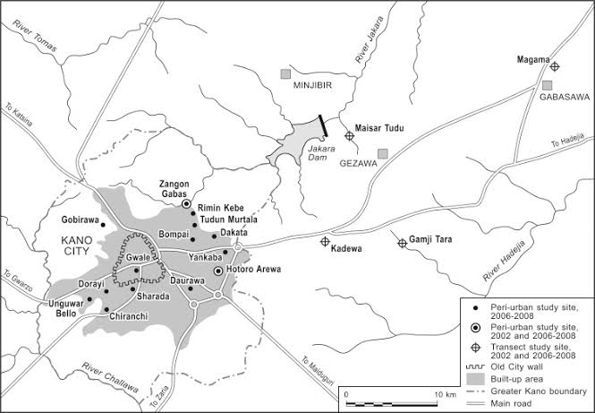

**Map 1: Gwale local government on Kano state Map (Map Source: Mapcarta 2019)**

# 3.2 Study Population

According to Kothari (2006) an accessible population is the population from where the study sample is drawn. A study population should be one that is affected by the problem under investigation and enables generalization of the findings to the entire population and leads to the selection of a sample that will not destroy the characteristics of the elements of the entire population (Amin, 2005). The accessible population of the study was the residents of Gwale local government, health workers in the health facilities, policy makers and local political leaders totaling to 362,059 people (National Census, 2006).

Gwale local government in Kano State has been a commercial and agricultural centre, which is known for the production of millet, sorghum, maize, cowpea, pepper, cassava, mango, tomatoes, lettuce, livestock, poultry, as well as for its solid mineral deposits.

Data was obtained from the residents of Gwale local government, health workers in the health facilities, environmental health workers, political and local leaders who are in strategic positions to provide information about the study.

# 3.3 Sample size

A sample is a collection of some elements of population (Amin, 2005). Kothari (2006) asserts that a sample size of any study must be large enough to give a confidence interval of desired width and therefore the sample size was chosen by a logical process. A sample size of 400 respondents from a population of 362,059 was selected using scientific formula (Yamane, 1967 cited in Mesfin, 2006); Sample size for participatory data collection was determined by the nature of stakeholders related to the study. After using the Yamane’s formula for sample selection, individual elements were selected using purposive and random sampling methods.

Using the statistical formula provided by Yamane (1967)

**n = N**  **n** = 362,059

**1+N (e)2** (1+362,059 (0.052)

**Where:** n = Sample size **n** = 362,059

N = Population (1+ 362,059 *0.0025)

e = 0.05 **n** = 399.55 i.e. approximately 400

**Therefore, n the sample size is 400**

**Table 3.1: Sample size**

|  |  |  |  |
| --- | --- | --- | --- |
| **Category of respondent** | **Study population** | **Sample size** | **Sampling Technique** |
| Political leaders | 5 | 5 | Purposive sampling |
| Traditional leaders | 10 | 10 | Purposive sampling |
| Health workers | 715 | 185 | Simple random sampling |
| Community members | 361,329 | 200 | Simple random sampling |
| **Total** | **362,059** | **400** |  |

**(primary data, 2019)**

However, the actual numbers of respondents who participated in the study from all the categories of respondents and return the filled questionnaire were 325 making response of 75.0%.

# 3.4 Sampling methods

According to Kothari (2006) sampling is defined as the selection of some parts of aggregate of the totality based on which judgment about the aggregate is done. The study used simple random sampling and purposive sampling methods.

# 3.4.1 Simple random sampling

Simple random sampling means that every member of the sample is selected from the group of population in such a manner that the probability of being selected for all members in the study group of population is the same (Moore 2008). Simple random sampling was used for giving everyone chance to be included in the study and reducing biasness. The community members were selected using simple random sampling.

# 3.4.2 Purposive sampling

Purposive sampling is a sampling technique in which researcher relies on his or her own judgment when choosing members of population to participate in the study (Saunders, 2012). Purposive sampling was used to select key respondents with specific information needed for the research based on the nature of their work. This method was appropriate because the sample comprised of informed persons who can provide data that is comprehensive enough to gain better understanding of the study variables.

The researcher used purposive sampling to select key informants from traditional leaders, health workers and political leaders, environmental health workers.

# 3.5 Data Collection Procedure

The researcher acquired an introductory letter from Nkumba University introducing him to the administration of Gwale local government to allow him to undertake research. The researcher then introduced himself to the authorities where the study was to be carried out. Consent of the respondents was sought from them before administering to them the questionnaires and interview guides.

After being granted permission, the researcher proceeded with a pilot study of the questionnaire to test the tool before finally going to the field to collect data from the respondents. The researcher distributed questionnaires and interviewed the respondents. The researcher collected the completed questionnaires from the respondents.

# 3.6 Data Collection Methods

# 3.6.1 Questionnaire

A questionnaire is a research method where a researcher designs a series of questions and presents these to the respondent to answer them for the purpose of gathering information from respondents. Questioning provides standardized answers that make it simple to compile data. The researcher used the questionnaire because it collects large amounts of information from a large number of people in a short period of time, and it was relatively cost effective, quick and easily quantifiable by the researcher that enabled analysis of the data analysis of the data and compared the findings for clarity (Yamane, 1967).

# 3.6.2 Interviewing

Interviewing is the process of asking respondents questions face to face in research, in order to achieve the objectives of the research. The purpose of interviewing is to explore the views, experiences, beliefs and/or motivations of individuals on specific matters. The researcher set questions that guided the oral interaction between the researcher and the respondents.

# 3.6.3 Document Review

The researcher used Document Review Method (as secondary data) to get relevant information about the domestic waste management practices and occurrence of enteric diseases in Gwale local government. The researcher reviewed documents such as the government health reports, hospital medical records, Town regulations and waste management laws, among others.

# 3.6.4 Observation method

Observation is a systematic data collection method where researchers use all of their senses to examine people in natural settings or naturally occurring situations. The researcher developed and used an observational checklist to observe the domestic waste disposal practices in Gwale local government.

# 3.7 Data Collection Instruments

The instruments of data collection the researcher used are questionnaire administered by the researcher, observational checklist, and interview guide for key informants.

# 3.7.1 Questionnaires

A structured questionnaire with closed ended questions was developed and administered to the respondents to extract information on their opinions of the study variables. The researcher developed questions to get information on the domestic waste management practices and occurrence of enteric diseases in Gwale local government.

The reason for selecting the questionnaire is that it is an appropriate method for collecting data because it offers greater assurance of anonymity, could be filled at the respondent’s convenience and hence increasing chance of getting valid information. It is also a cheap way of collecting data from a wide geographical area (Amin, 2005).

# 3.7.2 Interview guide

The researcher used face to face interview method as recommended by Sekaran (2003) to gather in-depth data through direct verbal interaction. The interviews were conducted with the traditional leaders, health workers and selected political leaders in Gwale for the study. Amin (2005) argued that interviews help the researcher in getting first-hand information, clarify the questions by using the appropriate language, clear doubts, and establish rapport and probe more information from the respondents.

This method is preferred as it gives an opportunity to probe the respondents on the study variables in Gwale local government. Some of the questions that were asked in the questionnaire were also asked in the interview guide. This enabled the researcher to triangulate the data collected and facilitate the collection of both qualitative and quantitative primary data (Sekaran: 2003).

# 3.7.3 Observational checklist

An observation checklist is a list of things that an observer looks at when observing a study variable. An observation checklist is a list of questions an observer needed to answer when they are observing and assessing domestic waste management practices in Gwale local government.

# 3.8 Validity and Reliability of instruments

# 3.8.1 Validity of instruments

According to Amin (2005) validity is the measure of accuracy and truth of the data and findings. In order to ensure the validity of the data collection instruments, the researcher after designing the instruments, determined content validity index (0.80) for instruments acceptance and presented it to a judge for comments. Additionally, errors that could have been left out unidentified were detected and removed through pre-testing of instrument by undergoing a pilot study.

The formula for Lawshe was used to measure the validity of research instruments, and is summarized in the formula below: CVR = (n - N/2)/ (N/2) where;

CVR= content validity ratio or Index,

n = number of respondents indicating "essential",

N= total number of respondents.

# 3.8.2 Reliability of instruments

Reliability refers to the degree to which the instruments consistently measure whatever it is measuring (Amin, 2005). The Cronbach’s alpha **(α)** test measured the scale reliability for internal consistency of the items. An instrument is reliable if it produces the same results whenever it is repeatedly used to measure trait or concept from the same respondents even by other researchers.

To ensure reliability of research instruments, the questionnaires were pretested and the necessary adjustments were made. On the reliability issue, 10% of the questionnaires were selected randomly and pre-tested to the few respondents in order to evaluate data collected, and then amendments were done.

# 3.9 Data Processing

French (2006) defined data processing as the collection and manipulation of items of data to produce meaningful information. For purposes of reporting, data collected from the field questionnaires were compiled, sorted, classified and then entered into the computer for analysis.

# 3.10 Data Analysis

Data collected from the field were analyzed using both descriptive and inferential statistics using the SPSS computer package. Frequency tables were used to present the findings and correlation analysis was also used to determine the relationship between the study variables in Gwale local government.

# 3.11 Ethical considerations

The researcher acquired written introductory letter from the University and also sought permission from the administration of Gwale local government in order to allow the researcher collect data. The researcher did not include the names of the respondents in data collected to be disseminated later. The researcher explained the purpose of research to the respondents from the start and made it clear that the research was to be used for academic purpose only and that the information acquired would not be revealed to anybody else but be treated with confidentiality.

# 3.12 Limitations of the study

In the current study, the researcher experienced the following limitations:

**Confidentiality:** Some respondents were hesitant to disclose some information especially to do with health records thinking that it would be used for other purposes. However, the researcher explained the purpose of the study to the respondents and also that the names of respondents were not required.

**Access to records:** Limited access to sensitive records was experienced; the researcher also faced rigidity in accessing the relevant health and medical records of the health facilities. However, the researcher first sought permission from the relevant authorities and explained the objectives of the study to the respondents.

# 

# CHAPTER FOUR: DATA PRESENTATION AND ANALYSIS OF STUDY FINDINGS

# 4.0 Introduction

This chapter presents analyses based on data collected from the research field work. The analyses cover demographic characteristics of respondents, domestic waste management practices, the occurrence of cholera, typhoid and dysentery, and the effect of domestic waste management practices on the occurrence of cholera, typhoid and dysentery among people living in Gwale local government, Kano State. The analysis was done based on data from 325 respondents.

# 4.1 Demographic characteristics

The demographic characteristics such as gender, age, level of education and duration of stay in Gwale of respondents are presented and discussed here.

Out of the 400 respondents who participated in the study, the researcher managed to collect information from 325 respondents due to incomplete return of the questionnaires making a response rate of 81%.

# 4.1.1 Gender of respondents

The respondents were asked to indicate their gender. Responses obtained are shown in table 4.1.

**Table 4.1: Gender of respondents**

|  |  | Frequency | Percent | Cumulative Percent |
| --- | --- | --- | --- | --- |
| Valid | Male | 150 | 46.1 | 46.1 |
| Female | 175 | 53.9 | 100.0 |
| Total | 325 | 100.0 |  |

**Source: Field data (2019)**

Results in Table 4.1 show that, majority of the respondents, 53.9% were females; the male respondents are only 46.1%.

# 4.1.2 Level of education

The respondents were asked to indicate their highest level of education attained and results obtained are shown in Table 4.2.

**Table 4.2: Level of education of respondents**

|  |  | Frequency | Percent | Cumulative Percent |
| --- | --- | --- | --- | --- |
| Valid | Post Graduate | 30 | 9.2 | 9.2 |
| Master’s Degree | 90 | 27.7 | 36.9 |
| First Degree | 100 | 30.8 | 67.7 |
| Diploma | 55 | 16.9 | 84.6 |
| Certificate | 50 | 15.4 | 100.0 |
| Total | 325 | 100.0 |  |

**Source: Field data (2019)**

Results in Table 4.2 show that, majority of the respondents, (30.8%) were first-degree holders and this implies that respondents were educated and therefore could understand the variables of the study in the questionnaire.

# 4.1.3 Age group

The respondents were asked to indicate their age group. Responses obtained are shown in table 4.3.

**Table 4.3: Age group of respondents**

|  |  | Frequency | Percent | Cumulative Percent |
| --- | --- | --- | --- | --- |
| Valid | 20-29 | 60 | 18.5 | 18.5 |
| 30-39 | 150 | 46.2 | 64.7 |
| 40-49 | 50 | 15.4 | 80.1 |
| 50-59 | 45 | 13.8 | 93.9 |
| 60+ | 20 | 6.1 | 100.0 |
| Total | 325 | 100.0 |  |

**Source: Field data (2019)**

Results in Table 4.3 shows that, majority of the respondents (46.2%) were in the age group of 30-39 years and this implies that the respondents are relatively young people and therefore vibrantly involved in issues around them including waste management and health.

# 4.1.4 Duration of stay in Gwale

Understanding the issues that affect a given community requires sufficient experience. In line with this, the respondents were asked to state the period they have spent in Gwale local government. Responses obtained are summarized in Table 4.4.

**Table 4.4: Duration of stay in Gwale**

|  |  | Frequency | Percent | Cumulative Percent |
| --- | --- | --- | --- | --- |
| Valid | 0-5 years | 75 | 23.1 | 23.1 |
| 5-10 years | 150 | 46.2 | 69.3 |
| Over 10 years | 100 | 30.7 | 100.0 |
| Total | 325 | 100.0 |  |
|  |  |  |  |

**Source: Field data (2019)**

Results in Table 4.4 reveal that, majority of the respondents, (46.2%) had spent 5-10 years and this implies that the respondents had experience about the health and the waste management issues in Gwale and could therefore provide reliable information.

# 4.2 Domestic waste management practices in Gwale local government

According to David (2016), commonly practiced waste disposal methods in some parts of Nigeria are burial, open-air burning, and open dumping. He further found these to be ineffective and detrimental to public health and the environment. It was also shown that waste management could not be successfully operated as a social service. Rather, the generator of waste must be held responsible. Problems confronting efficient waste management in Nigeria include the proliferation of unplanned settlements, traffic congestion, insecurity, and ignorance **(**Nabegu, 2009).This study tried to discover the current situation of domestic waste management practices in Gwale local government, Nigeria.

# 4.2.1 Use of landfills to manage waste

The presence and use of landfills in Gwale was determined by the observational and interview methods. From the observational checklist, the researcher found that there are two landfills in Gwale local government.

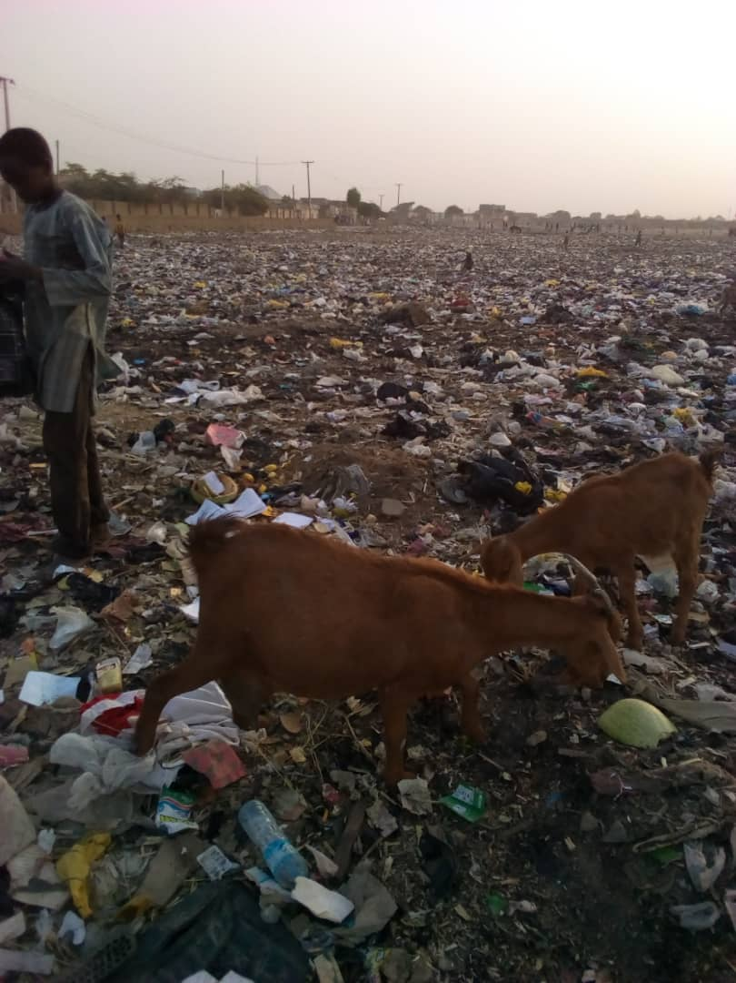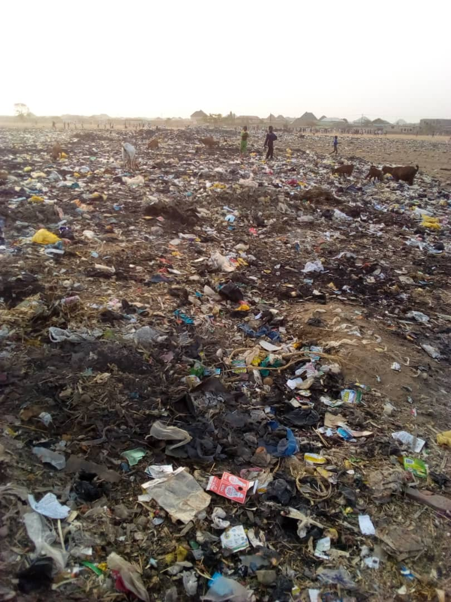

Plate 4. 1: Landfill in Dorayi

***Source: Field photo (2019)***

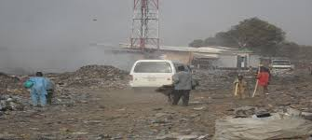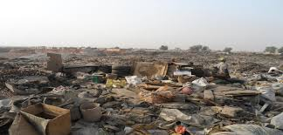

(a) Plate 4.2: Landfill in Gadon Kaya (b)

***Source: Field photo (2019)***

1. **People moving through a landfill in Gadon Kaya**
2. **Waste dumped in a landfill in Gadon Kaya**

During the interviews with Environment health Officer in Gwale, he noted that:

*“There are no organized well engineered landfill sites on ground that are equipped with liner systems and infrastructure to detect, extract and treat/refine leachate or landfill gas. Refuse management and sanitation board (REMASAB) which is the agency responsible for the control, removal and disposal of solid and liquid waste, lacks an established system for segregation and recycling of waste”.*

Managing waste in urban areas is very important especially given the fact that waste generated from these urban areas most likely ends up being transported to rural and low-income areas for disposal (Ni-bin and Davila, 2008) with the full impacts of waste disposal activities to be felt years afterwards. One of such waste management methods is landfilling. Normally landfilling should come after Reuse and Recycling (WRAP, 2012), but in most parts of Africa such as Nigeria, these stages are not as popular or deemed as essential as landfilling. Landfilling has been the most common method of solid waste disposal generated by different communities for many years (Komilis *et al,* 1999). Three types of landfills are important parts of most solid waste systems. These are the open dump, the semi-controlled landfill, and the sanitary landfill. Most of the urban centres in the developing world make use of open dumping as their topmost method of waste disposal (Rushbrook, 1999). According to Agunwamba (1998), in 1998 there were only two landfills in Nigeria. By 2007, the situation had not totally changed as Abuja, the capital city of Nigeria, did not have sanitary landfills for waste disposal, instead deposited their solid waste at the Mpape dumpsite (Imam *et al*., 2008).

Human faecal matter presence in all the solid waste dumpsites in Gwale presents a faecal health problem not only to the waste workers, residents, but also to scavengers, other users of the same municipal drop-off points and even small children who like to play in or around waste containers as shown on Plate 4.2 a and b. The usual disease pathways include placing contaminated hands in the mouth or eating food, through vector insects such as cockroaches or mosquitoes, or by directly inhaling air borne particles contaminated with pollutants.

# 4.2.2 Use of trash bins to collect waste

Using the observational checklist, the researcher found that, 52.7% of the respondents use trash bins in their homes to collect waste, which is taken away every weekend by a private domestic collection company at a fee. It was also discovered that, trash bins are used more by offices, restaurants, schools and hospitals in Gwale local government.

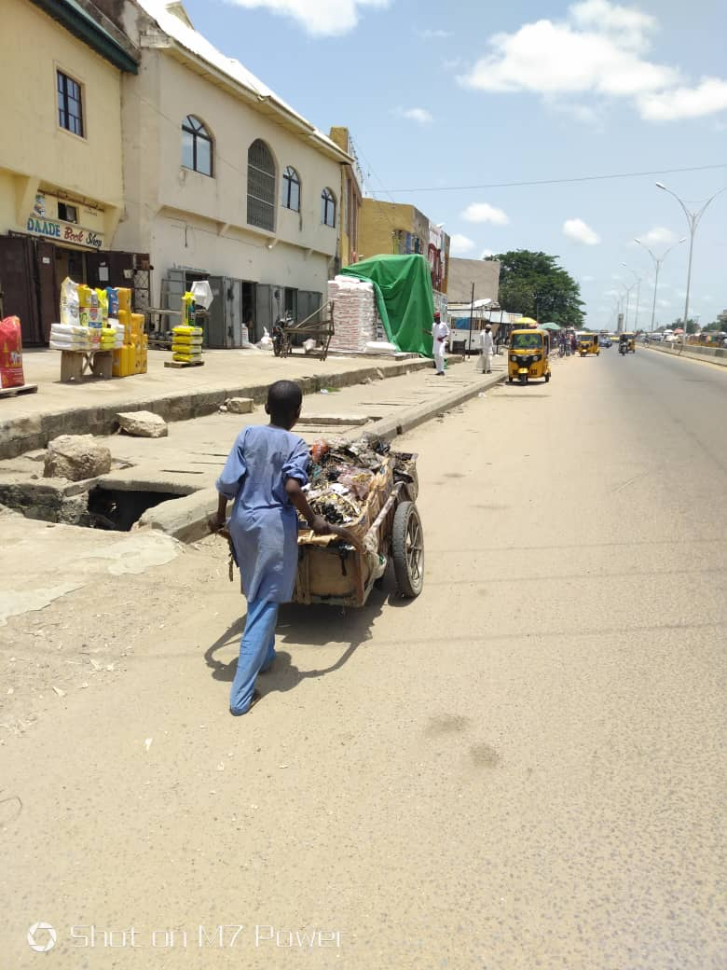

Plate 4.3: A boy collecting waste from shops in Dorayi

***Source: Field photo (2019)***

During the interviews with the local leader in Kabuga, the leader commented that:

*“There’s growing number of people involved in the business of collecting rubbish from people’s houses. People use waste collection bags throughout the week and rubbish collectors come for the rubbish on weekends. Some people pay private companies monthly to collect rubbish from their homes*”.

# 4.2.3 Decomposing waste in homes

The respondents were asked whether they decompose waste in their homes. Responses obtained are shown in Table 4.5.

**Table 4.5: People in Gwale decompose waste in their homes**

|  |  | Frequency | Percent | Cumulative Percent |
| --- | --- | --- | --- | --- |
| Valid | Strongly Disagree | 102 | 31.2 | 31.2 |
| Disagree | 150 | 46.2 | 77.4 |
| Not sure | 35 | 10.8 | 88.2 |
| Agree | 20 | 6.2 | 94.4 |
| Strongly Agree | 18 | 5.6 | 100.0 |
| Total | 325 | 100.0 |  |

**Source: Field data (2019)**

Results in Table 4.5 show that, (31.2%) of the respondents strongly disagreed, (46.2%) disagreed, (10.8%) were not sure, (6.2%) agreed and only (5.6%) of them strongly agreed. Majority of the respondents (77.4%) generally disagreed and this implies that people in Gwale do not decompose waste in their homes in Gwale local government.

# 4.2.4 Residents of Gwale burn domestic waste

During an interview with the political leader in Gwale, he revealed, “*Unlike other states like Lagos State, Gwale does not have a proper waste management scheme that cuts across the corners and openings of the state, people from other parts like Diso and Dorayi resort to waste burning. In cases where the waste collectors charge an amount beyond the means of the residents, they dump the waste along flood paths thus increasing the waste difficulty.*”

However, the researcher’s observation found that, there was rampant burning of waste especially among the homes surrounding Gwale local government. There was daily waste burning in towns like Dorayi, Diso, Gadon Kaya, Hauren Shanu, and Kabuga.

This point is interesting and indicates that people resort to the easiest and available methods of waste disposal if the local authorities do not guide them and do not provide services to the people. This calls for more efforts from the local leaders to sensitize the people and advocate for better waste management practices in their areas.

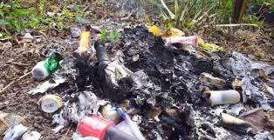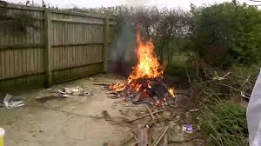

(a) Plate 4.4: Burning of domestic waste in Diso, Gwale (b)

***Source: Field photo (2019)***

1. **A heap of burnt rubbish in Diso**
2. **Rubbish burning in Diso**

In the questionnaire, the respondents were asked whether they burn domestic waste. Responses obtained are shown in Table 4.6.

**Table 4.6: Residents of Gwale burn domestic waste**

|  |  | Frequency | Percent | Cumulative Percent |
| --- | --- | --- | --- | --- |
| Valid | Strongly Disagree | 20 | 6.2 | 6.2 |
| Disagree | 15 | 4.5 | 10.7 |
| Not sure | 30 | 09.2 | 19.9 |
| Agree | 140 | 43.1 | 63.0 |
| Strongly Agree | 120 | 37.0 | 100.0 |
| Total | 325 | 100.0 |  |

**Source: Field data (2019)**

The majority of respondents generally agreed that residents of Gwale burn domestic waste.

# 4.2.5 Gwale local government uses open air incineration to manage waste

During an interview with the Environmental health officer in Gwale local government, it was highlighted that:

“*Although Waste incineration is quite common in many parts of Gwale, it is unfortunately not done in a properly controlled environment such as that of Lagos. It is often done by scavengers and local residents, and when it is carried out by Gwale Environmental Protection Board (GEPB), it is done haphazardly. This poses a huge environmental, human health and safety risk”.*

Modern incinerators can reduce waste volume by 97% and convert metal and glass to ash which is currently being researched to be used in materials development. Incineration is extensively used as an important method of waste disposal; it is associated with some polluting discharges which are of environmental concern, although in varying degrees of severity (Hordoy, 1993). These can fortunately be effectively controlled by installing suitable pollution control devices and by suitable furnace construction and control of the combustion process. The challenges using waste as fuel is poised in the heterogeneous composition of each dumpsite, a Strong variations in the composition which is both regional and seasonal dependent, variations in the calorific value, possibilities of the and presence or production of hazardous substances (Babayemi & Dauda, 2009).

The researcher’s observation found that, incineration in Gwale is done by the local residents around the dump sites. This means that the local authorities have not done enough in using incineration as a method of waste disposal despite its benefits.

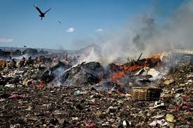

Plate 4.5: Open air incineration in Gadon Kaya, Gwale

***Source: Field photo (2019)***

These findings provide evidence that, majority of respondents know the importance of proper waste disposal. All that is needed is the Town and state interventions in acquiring the necessary infrastructure and technology to manage waste.

The Federal Government of Nigeria laws and regulations, promulgated to protect the environment include the Federal Environmental Protection Agency Act of 1988 and the Federal Environmental Protection Agency (FEPA) was created in 1999. Under the FEPA Act decree, each state and Town in the country was to set up its own environmental protection body for the protection and improvement of the environment within its jurisdiction, thus making waste management a major responsibility of state and Town environmental agencies (Ogwueleka, 2009).

# 4.2.6 Waste recycling

A large segment of the urban population in developing countries finds livelihood opportunities in the recovery and recycling of materials from refuse. Such activities constitute the so-called informal recycling sector. In general, informal recycling refers to the waste recycling activities of scavengers or waste pickers (Wilson *et al.* 2006), and others involved in the processing/transformation and trade of materials recovered from waste. Scavenging or waste picking is the driver of the informal recycling system in Third World cities (Wilson 2007), and this system has been shown to be dynamic in many of these cities (Medina 2000, 2006). Consequently, scholars on informal sector recycling (Birkbeck, 1978, 1979, for example), point out that the garbage picker is the most visible component of a larger industrial system, and that scavengers are perhaps the most notable features of developing countries’ recycling activities (Benitez *et al.* 2002).

In an interview, the Environmental health officer in Gwale local government explained that:

“*The informal recycling system in Gwale is a network made up of waste pickers (locally known as “Jari Bola”), small buyers/middlemen, large buyers/brokers, and small and medium-scale industries.*

*Gwale lacks a formal resource recovery programme. As a result, a significant number of people engage in informal recovery and recycling of waste for a livelihood. It is however pertinent to note that waste recycling activities of informal sector groups have not been given adequate consideration within the framework of waste management in Gwale”.*

Using the observational checklist, the researcher found out that, there are a lot of women and children involved in waste picking for income. They collect recyclable materials from dump sites and streets and sell them to recycling companies in Gwale.

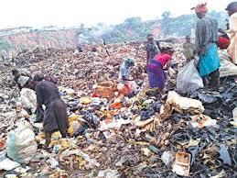

Plate 4.6: Garbage picking in Kabuga, Gwale

***Source: Field photo (2019)***

The researcher further observed that some waste pickers however work at illegal dumps scattered around the State. There are also travelling scavengers who go about the streets of Dorayi, picking recyclable materials from residential areas. Another group in the informal waste recovery and recycling system are the cart pushers. They are primarily waste workers who collect and dispose off household refuse for a fee, from places not served by the formal refuse collection system although they usually make additional money from the sale of recyclables recovered from waste they collect (Afon, 2007).

# 4.2.7 Use of rubbish pits in Gwale

The respondents were asked whether People in Gwale dig rubbish pits in their homes. Responses obtained are shown in Table 4.7.

**Table 4.7: People in Gwale dig rubbish pits in their homes**

|  |  | Frequency | Percent | Cumulative Percent |
| --- | --- | --- | --- | --- |
| Valid | Strongly Disagree | 102 | 31.2 | 31.2 |
| Disagree | 150 | 46.2 | 77.4 |
| Not sure | 35 | 10.8 | 88.2 |
| Agree | 20 | 6.2 | 94.4 |
| Strongly Agree | 18 | 5.6 | 100.0 |
| Total | 325 | 100.0 |  |

**Source: Field data (2019)**

Results in Table 4.7 shows that, (31.2%) of the respondents strongly disagreed, (46.2%) disagreed, (10.8%) were not sure, (6.2%) agreed and only (5.6%) of them strongly agreed. Majority of the respondents (77.4%) generally disagreed and this implies that people in Gwale do not dig rubbish pits in their homes. This is mainly because Gwale is a relatively urban State where people do not have enough land to dig rubbish pits. This can further be explained by the presence of dump sites and waste collectors all over Gwale local government. As such, people do not find the need to dig rubbish pits in their homes.

**4.2.8 Effects of poor solid waste management in Gwale local government**

In Kano metropolis, like most cities in the developing world, several tones of municipal solid waste is left uncollected on the streets each day, clogging drains, creating breeding ground for vectors and spreading diseases and creating a myriad of related health and infrastructural problems. A substantial part of the urban residents in the old Kano city and suburban informal settlements of Kano metropolis have little or no access to solid waste collection services. This is due to lack of proper land use planning which resulted into the creation of informal settlements with narrow streets making it difficult for collection trucks to reach many areas. The result is that a large portion of the population is left without access to solid waste management making them particularly vulnerable (Nabegu, 2008).

The practice of disposing solid waste indiscriminately has a price to pay in terms of collection, transport and disposal costs and loss of valuable raw materials (recyclables, reusable and repairable) and the impact on the environment due to air, water and soil pollutions, and associated health risks that ultimately impact the economic sustainability. This economic impact creates lack of resources for municipal solid waste management and hence a vicious cycle is generated unless remedial measures are taken to break the circuit, the cycle continues and expands leading to further environmental degradation. It is also observed that the low income residential quarters are worst affected with this numerous heaps of refuse. This could possibly be as a result of their socio-economic status. It was also observed that, even the residents that collect and transport the wastes to the collection/transport point from where the waste should be collected immediately, collection is not immediate and this creates not only unhygienic dumpsites but resistance from residents close to the collection points. Furthermore, the attitudes some residents of Kano metropolis in management of municipal solid waste is poor; little or no individuals effort is accorded to the immediate dangers on humans and the environmental impacts it has on the environment. Programmes to disseminate knowledge and to improve behaviour patterns and attitudes regarding waste management are therefore critical.

The environmental consequences of waste in Gwale are enormous. If the solid wastes are not managed properly, decomposition and putrefaction may take place, causing land and water pollution when the waste products percolate down into the underground water resources. The organic solid waste during decomposition may generate obnoxious odours. Stray dogs and birds may sometimes invade garbage heaps and may spread it over the neighbourhood causing unhygienic and unhealthy surroundings.

Pollution: Many areas in Gwale have heaps of domestic solid waste unattended to; and many of the objects that are thrown away contain toxic substances which leach into soil and water as well affecting the health of plants, animal and humans. Electronic waste contains mercury, lead, arsenic cadmium, chromium and other metals that have environmental health implications. Construction waste may contain asbestos, fossil fuel derivatives, and other toxic substances. Measures to control these substances are hampered by the fact that they are dispersed within millions of tons of less toxic trash, making their removal very problematic (Nabegu, 2008).

The huge heaps of refuse dumps that are commonly seen on open spaces and shoulders of the major streets in Gwale local government (as shown in Plates 4.9 b) can also been washed by rainstorm scattering all over most of the environment. Most of these solid waste are been moved by rainstorm into drainage channels that were made for excess runoff thereby preventing easy flow of water and finally lead to flooding of the highways and sometimes people homes. The blockage of most of these gutters or drainage channels by non biodegradable materials such as plastics, tyres and other polythene substances often result into a situation whereby dirty stagnant water runs in front of living quarters and major roads in the metropolis. These blocked drainage channels often contain a lot of materials including decomposable substances with offensive odour which welcomes different types of flies and other harmful bacteria carrying insects which are harmful to humans.

The numerous heaps of refuse that are seen commonly in Gwale have a negative impact on the beauty of the city. In addition to the physical damage on the city look, most of the non biodegradable materials which are mostly synthetic in nature contained some toxic elements which have their origin from the decomposing waste that decorate most of the landscape in Kano metropolis (Mustapha and Getso, 2014).

The huge and numerous heaps of solid waste or refuse dumpsites in the Gwale local government (as shown in plate 4.6) on the other hand serve as a breeding heaven for diseases carrying vectors. Reptiles such as snake sand lizards live comfortably in these wastes. Other dangerous rodents such as rats which transmit *Lassa fever* are also found in these refuse dumps. Insects such as houseflies, cockroaches and mosquitoes also find these refuse dump sites as the best hideouts. These insects spread various diseases such as malaria, cholera, typhoid fever and yellow fever.

Land Degradation as results of poor solid waste management: Many plots of land in Gwale are being claimed for waste disposal, which have made them no longer hospitable for plants, wildlife and humans. Often the fertility cannot be completely reclaimed, even if the indiscriminate disposal activities are capped. In the case of Gwale, there is little or no effort to reclaim or put to use in the near future, the piece of land in use presently for waste collections or dump sites (as shown in plate 4.2 b and plate 4.6), this also has a potential danger on the available land for the fast growing population in the near future.

# 4.3 Occurrence of cholera, typhoid and dysentery among people living in Gwale local government

According to WHO (2014), every year more than 3.4 million people die globally as a result of water-related diseases, making it the leading cause of morbidity and mortality around the world. Most of the victims are young children, the vast majority of whom die of illnesses caused by organisms that thrive in water sources contaminated by raw sewage. A report by Jamie *et al,* (2005) in the medical journal *The Lancet,* concluded that poor water sanitation and lack of safe drinking water take a greater human toll than war, terrorism and weapons of mass destruction combined.

The percentage of people who die from reported cholera cases remains higher in Africa than elsewhere. This reflects the lack of access to basic health care because of cholera’s simple treatment of rehydration therapy (WHO Cholera, 2011). Many African countries face the dual challenges of improving both cholera treatments, which is access to basic health care, and prevention, (largely through improved water and sanitation systems). Improving global access to water, sanitation and hygiene (WASH) is a critical step to reducing Africa's cholera burden (Patricia, 2007).

The research conducted by Ishaq (2017) on Spatio-temporal trends of enteric fever among youths attending Muhammad Abdullahi Wase specialist hospital in Kano metropolis, Nigeria concluded that, The demographic characteristics of youths infected within the period under study (2010-2014) showed that the prevalence of enteric diseases rose as the age increases and peaked at the age of 20 years with the male youths more infected than the females. The temporal analysis showed that there was a decline in the prevalence of cholera, typhoid and dysentery from 2010 to 2014, with peak prevalence in the months of July and August.

Another research on *Salmonella* bacteremia among children in Central and Northwest Nigeria, 2008–2015 by Stephen *et al,* (2015) revealed that; In Kano Metropolis, there were 327 children with bacteremia during the months of April–September (rainy season) and 447 during the months of October–March 2014 (dry season). Of these, 118 of 327 (36.09%) had *Salmonella* *Typhi* bacteremia; 32 of 327(9.8%) and 175 of 327 (53.25%) had *Vibrio cholerae* and other forms of bacteremia, respectively. During the dry season, 215 of 447 (48.1%) had *Salmonella Typhi,* 50 of 447 (11.2%) had nontyphoidal *Salmonella* (NTS), and 181 of 447 (40.5%) had other forms of bacteremia.

To appreciate the occurrence of cholera, typhoid and dysentery among people living in Gwale local government, the researcher obtained responses from health workers and community members about access to basic health care, cases of typhoid reported in health centres, percentage of people who die from cholera, water and sanitation systems in Gwale.

Medical records of clinically diagnosed and blood culture confirmed that patients with typhoid fever were reviewed for the period of this research. Medical records of clinically diagnosed cases of dysentery were reviewed during this research in order to gather all the reliable information.

An investigation on whether there is access to basic health care in Gwale disclosed that almost all residents of Gwale (90%) had access to basic health care (Fig.4.1). However, the challenge is that the health care services are expensive for the local people of Gwale.

Figure 4.1: Access to basic health care

***Source: Field Data (2019)***

It was observed that, there were 20 hospitals both government and private with the largest three being Makkah Specialist Eye Hospital, Hasiya Bayero pediatrics Hospital, and Imam Wali General Hospital. These hospitals are supported by other Town’s health centres and private medical centres in various towns in Gwale.

Observations made by the researcher revealed that the hospitals in Gwale were expensive for most of the local people. This implies that many people despite of the existence of medical facilities in their areas, they cannot afford to pay for the medical care. This raises the need for Kano State Government to set up more government health centres where people can get free medical care.

An enquiry to find out whether cholera, typhoid and dysentery are a significant cause of illness in Gwale received responses and the results in Table 4.8 which showed that 90.6% of the respondents acknowledged to the fact that cholera, typhoid and dysentery occur and are significant cause of illness in Gwale. In line with findings of Figure 4.2, a survey conducted by the researcher on medical records revealed that indeed; there are cases of typhoid and dysentery reported in health centres in Gwale.

In Gwale local government it was revealed that watery stools and vomiting, abdominal pains are common among people. This result is an evidence that local communities’ residents in Gwale are highly exposed to water and food borne diseases hence the occurrence of enteric diseases more of which was diagnosed to be typhoid infection.

**Table 4.8: Cholera, typhoid and dysentery in Gwale**

|  |  | Frequency | Percent | Cumulative Percent |
| --- | --- | --- | --- | --- |
| Valid | Strongly Disagree | 10 | 3 | 3 |
| Disagree | 10 | 3 | 6 |
| Not sure | 11 | 3.4 | 10.4 |
| Strongly Agree | 114 | 35.1 | 45.5 |
| Agree | 180 | 55.5 | 100.0 |
| Total | 325 | 100.0 |  |

**Source: Field data (2019)**

Results in Table 4.8 show that, majority of the respondents (90.6%) generally agreed that cholera, typhoid, dysentery occur and they are significant cause of illness in Gwale, and this implies that people in Gwale have suffered from the diseases.

Further findings also disclosed that, there are cases of typhoid reported in health centres in Gwale as testified by hospital records and 90.6% of the respondents in Fig.4.2

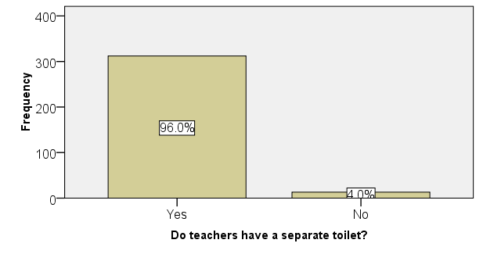

Cases of typhoid reported in health centres in Gwale

Figure 4.2: Existence of cases of typhoid in Gwale

***Source: Field data (2019)***

According to figure 4.2, it was revealed that, there was 96.0% occurrence of typhoid in Gwale local government. This was due to the fact that much of the water sources are contaminated with domestic.

In an interview with medical record assistant officer in Imam Wali General Hospital she revealed that;

“*The figures in their records show that at least 98% of febrile patients visiting Imam Wali General Hospital were diagnosed to have been infected with typhoid, and 20.0% suffered from dysentery usually resulting from taking contaminated water, foods and poor environmental sanitation”.*

This information came in line with result from a research conducted by Hassan *et al,* (2015) in his study to estimate the incidence of typhoid fever among febrile patient visiting Aminu Kano Teaching Hospital laboratory which he concluded that: The incidence of typhoid fever in the month of October, 2011, for patients attending AKTH, Laboratory was found to be 87 per month per 100.

A survey by the researcher on the deaths of people from cholera in Gwale found that no single case or case fatality about cholera was reported in government hospitals within the three months of this study. Although there may be other cases of cholera not documented especially by private health centres (Gwale Medical Fatality Report, 2019). However, last cholera outbreak was reported early in 2018 (NCDC report, 2018)

About the children suffering from Dysentery in Gwale local government, during the interviews, a medical official in Chiranci Community hospital however expressed dissatisfaction in the effectiveness of record keeping system of government hospitals but appreciate the presence the fact that several people were diagnosed with dysentery. He further explained that:

*“It is not easy to provide records on dysentery among children because of poor record keeping. However, we have treated dysentery several times especially in street children who in the areas closer to waste disposal site and drink water that is not so safe for consumption.”*

On water and sanitation systems in Gwale, the Town WASH Officer revealed in an interview that:

“*Gwale local government has piped water for town residents:* However, w*ater is a big challenge in the shanty parts of Gwale. The biggest source of water in these areas is boreholes underground water; however, they are located on low land, where they are easily contaminated by waste from homes and businesses*”.

This agrees with Herbeth (2000) who stated that poor handling of refuse can cause illness especially when excreta contaminate the refuse and source of drinking water. Diseases due to poor drinking-water access, unimproved sanitation, and poor hygiene practices cause 4.0% of all deaths and 5.7% of all disability or ill health in the world **(**Patricia, 2007). About 80% of urban dwellers have access to piped drinking water and 96% have access to improved drinking water sources. However, often the bacteriological quality of this water remains poor; more than 50% of urban residents in developing countries are still affected at one time or another by diseases related to insufficient access to safe drinking-water and improved sanitation (WHO, 2018).

# 4.2.8 Illnesses among children in Gwale as a result of water-borne diseases

WHO (2018) contends further that contaminated drinking-water is estimated to cause more than 500,000 diarrhea deaths each year. Contaminated water can transmit diseases such as diarrhea, cholera, dysentery, typhoid and polio. Health costs associated with waterborne diseases such as malaria, diarrhea, and worm infections represent more than one third of the income of poor households in sub-Saharan Africa (Gaffga *et al,* 2007).

Health risks are often increased by poor sanitation. Some 20% of the urban population still lacked access to improved sanitation in 2012 and 100 million city dwellers still practiced open defecation although gains in access to improved sanitation have generally been much more rapid in cities than in rural areas over the past two decades (Gerba, 2010).

The respondents were asked whether water-borne diseases cause illnesses among children in Gwale. Responses obtained are shown in table 4.9.

**Table 4.9: Water-borne diseases cause illnesses among children**

|  |  | Frequency | Percent | Cumulative Percent |
| --- | --- | --- | --- | --- |
| Valid | Strongly Disagree | 18 | 5.6 | 5.6 |
| Disagree | 20 | 6.2 | 11.8 |
| Not sure | 35 | 10.8 | 22.6 |
| Agree | 150 | 46.2 | 68.8 |
| Strongly Agree | 102 | 31.2 | 100.0 |
| Total | 325 | 100.0 |  |

**Source: Field data (2019)**

Results in Table 4.9 show that, (31.2%) of the respondents strongly agreed, (46.2%) agreed, (10.8%) were not sure, (6.2%) disagreed and only (5.6%) of them strongly disagreed. Majority of the respondents generally agreed and this implies that water-borne diseases cause illnesses among children in Gwale. This is mainly because children are exposed to contaminated water in their homes, towns and schools in most of the parts of Gwale local government. This calls for both parents and the local authorities to ensure that there is safe drinking water in homes and schools.

# 4.4 Domestic Waste Management Practices and the occurrence of cholera, typhoid and dysentery among people living in Gwale local government

Accumulation of the waste products generally results in contamination of air and water and the main reason behind air and water-borne diseases. Many life-threatening diseases are the consequence of contaminated water. Few of the most common diseases are Hepatitis, cholera, dysentery, and typhoid (HealthMir, 2017).

Garbage pollution is the main reason for various bacterial diseases. Gastrointestinal, stomach pain, vomiting and diarrhea, cholera, typhoid, malaria skin diseases and respiratory allergies are the diseases, which are caused by the garbage. Mosquitoes and other insects sits in the places where there are piles of garbage and ultimately spread various diseases in the area.

Indiscriminate dumping of refuse promotes the prolific breeding of arthropod-borne diseases like mosquitoes, houseflies, lice, tsetse flies, cockroaches which transmit diseases like malaria, viral encephalitis, typhoid, paratyphoid fever, diarrhea, dysentery, cholera, gastro-enteritis, amoebiasis, conjunctivitis, sleeping sickness, relapsing fever, scabies, Filariasis, enteric pathogens etc (Park 2007).

Municipal solid waste in Kano are being dumped on the open streets at close proximity to the houses and public places and some very close to rivers, while some are being dumped right into the river especially in the city and the suburban areas this may be detrimental to the aquatic organisms. For examples, waste disposed at Yan Awaki and inside the Jakara Rivers could be washed down by rain and flood into larger water bodies which are used for irrigation and water supply to many communities from the Wasai dam where the Jakara River is impounded posing serious health hazards.

The current study investigated how domestic waste management practices affect the occurrence of cholera, typhoid and dysentery among people living in Gwale local government. Specifically the study scrutinized the storage, collection, and poor disposal of waste, accumulation of the waste products, garbage pollution, indiscriminate dumping of refuse, and indiscriminate open defecation.

The age vulnerability of the cholera, typhoid and dysentery is not homogeneous between age groups: the age groups most affected by typhoid were those aged 20-39 years, followed by those from 10-19 years; those older than 60 years were least affected. Cholera and dysentery incidence rates are highest among children under 5. Overall, it was estimated that about half of all cholera cases occur in this age group, and that the expected annual number of cholera cases in non-endemic countries is about 87 000 (WHO, 2012).

# 4.4.1 Poor storage, collection, and disposal of waste

The respondents were asked whether poorly stored, uncollected, and poorly disposed waste is a threat to public health in Gwale. Responses obtained are shown in Table 4.10.

**Table 4.10: Poorly stored, uncollected, and poorly disposed waste**

|  |  | Frequency | Percent | Cumulative Percent |
| --- | --- | --- | --- | --- |
| Valid | Strongly Disagree | 18 | 5.5 | 5.5 |
| Disagree | 25 | 7.7 | 13.2 |
| Not sure | 30 | 9.2 | 22.4 |
| Agree | 140 | 43.1 | 65.5 |
| Strongly Agree | 112 | 34.5 | 100.0 |
| Total | 325 | 100.0 |  |

**Source: Field data (2019)**

Results in Table 4.10 shows that, (34.5%) of the respondents strongly agreed and (43.1%) agreed. Majority of the respondents generally agreed that poorly stored, uncollected, and poorly disposed waste is a threat to public health in Gwale and this implies that people in Gwale know the dangers of waste in their community.

During an interview with the environmental protection officer of Dorayi in Gwale, it was revealed that:

“*Indiscriminate disposal of refuse is common in Dorayi and it has led to spread of diseases. Indiscriminate defecation is also common in many areas in Gwale and can easily affect drinking water, which can cause outbreaks of diseases*”.

This is in agreement with the results from the observational checklist, which showed a number of cases of indiscriminate open defecation, indiscriminate disposal of rubbish including diapers which contain excreta in the town of Dorayi in Gwale local government as seen in Plate 4.7 and Plate 4.9 (a and b).

According to Herbeth (2000), poor handling of refuse can cause illness especially when excreta contaminate the refuse and source of drinking water.

Herbeth further noted that diseases due to poor drinking-water access, unimproved sanitation, and poor hygiene practices cause 4.0% of all deaths and 5.7% of all disability or ill health in the world. About 80% of urban dwellers have access to piped drinking water and 96% have access to improved drinking water sources.

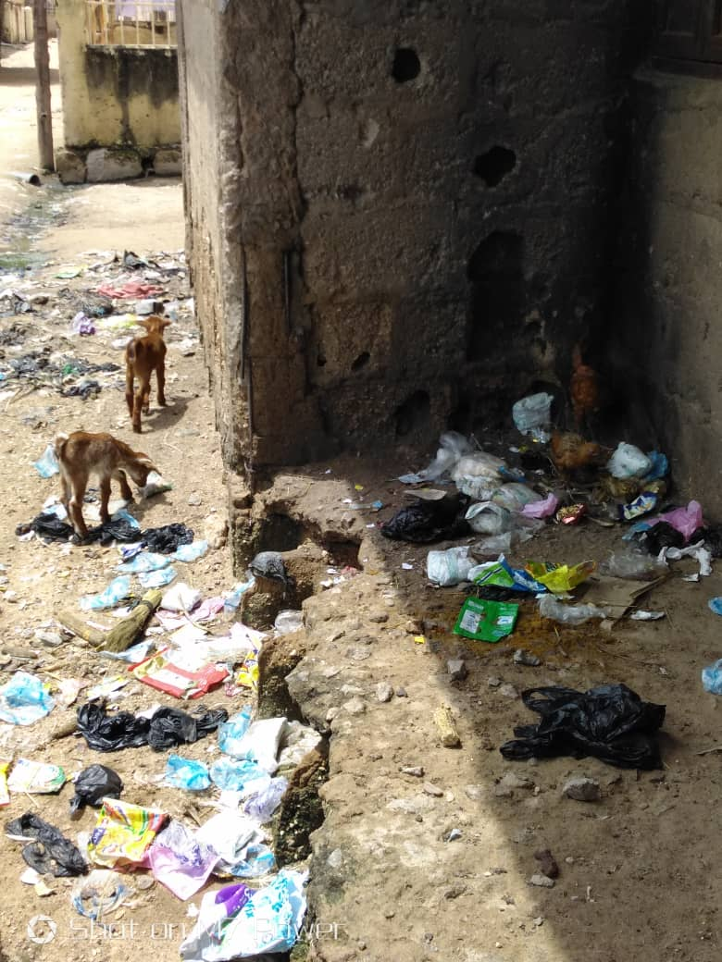

Plate 4.7: Indiscriminate dumping of rubbish in Dorayi, Gwale local government.

***Source: Field photo (2019)***

# 4.4.2 Cholera, Dysentery, and Typhoid as a result of contaminated water

Chika (2018) examined the intricacies behind the consumption of contaminated water and found out that the use of contaminated water for drinking and domestic chores have increased the chances of diarrhea, which is a contributory factor to the deaths of more than 70,000 under five Nigerian children annually.

According to United Nations International Children's Emergency Fund (UNICEF, 2019), 73 per cent of the diarrheal and enteric disease burden is associated with poor access to adequate water, sanitation and hygiene (WASH) that is a common sight among poorer children.

Enteric bacteria enter the body through the mouth and are acquired through contaminated food and water, by contact with animals or their environments likewise the feces of an infected person.

It was found that 87% of the respondents in the study agreed that cholera, dysentery, and typhoid in Gwale are caused by contaminated water (apart from food). This was attributed to a number of unprotected water sources especially in the villages of Hauren Shanu, Kabuga, and Chiranci. The water in Gwale local government is contaminated due to the poor disposal of domestic waste which was discovered to be polluted with fecal matter.

Six bacterial isolates recovered from the waste sample, three were coliform bacterial (*E. coli, Klebsielle sp and Shigella sp*.). Percentage occurrence of Shigella sp, and *Klebsiella sp* did not also differ significantly (p<0.05). *Shigella* sp and Proteus sp had the same percentage occurrence. Presence of coliforms such as *E.coli*, *Klebsiella* *sp* clearly indicates that the waste in the zones, especially the city and suburban areas is contaminated with faecal matter. All the bacterial isolates recovered from the waste samples in the three zones have been directly implicated in food borne infections (Nabegu, 2010).

This we can say is why Nigeria struggled to contend the outbreak of cholera that ravaged 18 states of Adamawa, Anambra, Bauchi, Borno, Ebonyi, Gombe, Jigawa, Kaduna, Kano, Katsina, Kebbi, Kogi, Nasarawa, Niger, Plateau, Yobe, Sokoto and Zamfara likewise the Federal Capital Territory (FCT) in 2018.

This is the major reason President Muhammadu Buhari, had in early 2018 declared a state of emergency on water, sanitation and hygiene (WASH) in the country due to the outbreak of communicable diseases.

A situation report by the Nigeria Centre for Disease Control (NCDC) revealed that about 517 died from cholera outbreak, while 27, 927 cases were recorded between January and September 2018.

The UNICEF, an arm of the UN had in 2017 ranked Nigeria among the top 5 countries globally with large numbers of people without access to safe water, improved sanitation and practicing open defecation.

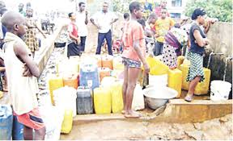

Plate 4.8: Unprotected water source in Kabuga, Gwale State

***Source: Field photo (2019)***

The laboratory record from Dorayi hospital show that in a month of February, March and April 1038 cases of typhoid was reported making the figure as high as 94.0%. Dysentery cases reported were 212 making it 15.0% but no single case of cholera was reported within those three months of reporting. That simply show that typhoid occur more often among people in Gwale local government followed by dysentery with 212 cases in 3 month.

In an interview with in charge of Chiranci community hospital, he explained that:

“*Typhoid is now endemic in Gwale or even the whole of Kano State because in every 100 patient that visits the hospital in a month, you would find that at least 95.0% have blood test that shows the presence of salmonella typhi. Dysentery cases were also at about 13.0% which mean it’s there but not as much as that of typhoid infection. In case of cholera, we had the last case like four months ago which we referred to infectious diseases hospital*”.

This comes in-line with report from Nas *et al,* (2017) in his study of malaria and typhoid fever co-Infection among febrile patients in Kano municipal hospital which he concluded that, Almost 95% of the febrile patient presenting with fever symptoms in this study had malaria, S. typhi, or both the infections. There was a strong association between having fever and that of having malaria or typhoid fever infections.

**4.4.3 Garbage pollution is the main reason for various pathogenic bacterial diseases in Gwale**

Nabegu (2008) concluded that, In Kano metropolis, like most cities in the developing world, several tons of municipal solid waste is left uncollected on the streets each day, clogging drains, creating feeding ground for pests that spread disease and creating a myriad of related health and infrastructural problems. In most of parts of the Kano metropolis such as Gwale and Jakara the garbage is polluted with fecal matter which is the main reason for various bacterial diseases.

In an interview, the Gwale local government Health Inspector explained that:

“*People dump garbage on the roads, outside their homes. The garbage attracts flies and other vector carrying organisms, which end up in their homes. There is a lot of garbage in the middle of houses in Gwale”.*

The inspector added “*No one wants garbage around and this is the reason it is thrown away. Once the material is thrown away, we imagine being away from its harmful effects. Unaware of it adverse impacts on environment, we carry on dumping and disposing garbage in a careless way. This is what leads to improper disposal of household waste creating heaps of garbage. Disposing and dumping garbage carelessly not only contributes to land pollution but also adds to air pollution by emitting harmful gases when burnt. Being immensely hazardous to environment, garbage pollution is one of the major sources of bacterial diseases*”.

The observation results by the researcher confirmed the health inspector’s assertion. The researcher found that, there is garbage in back yards of homes and in the middle of residential houses.

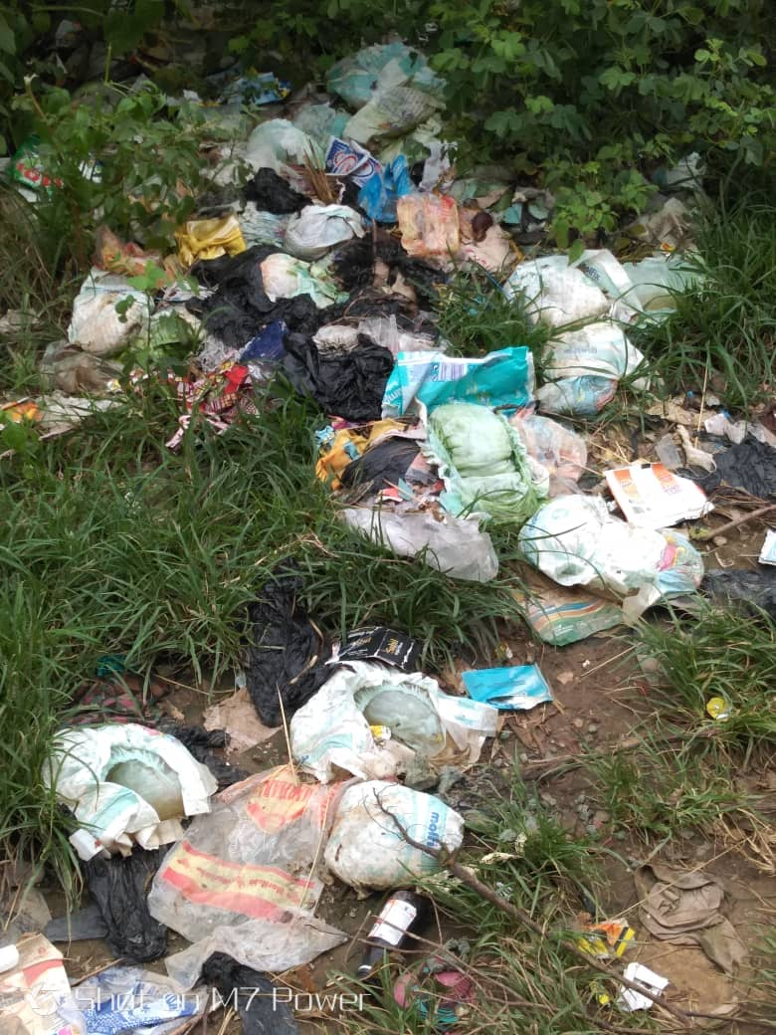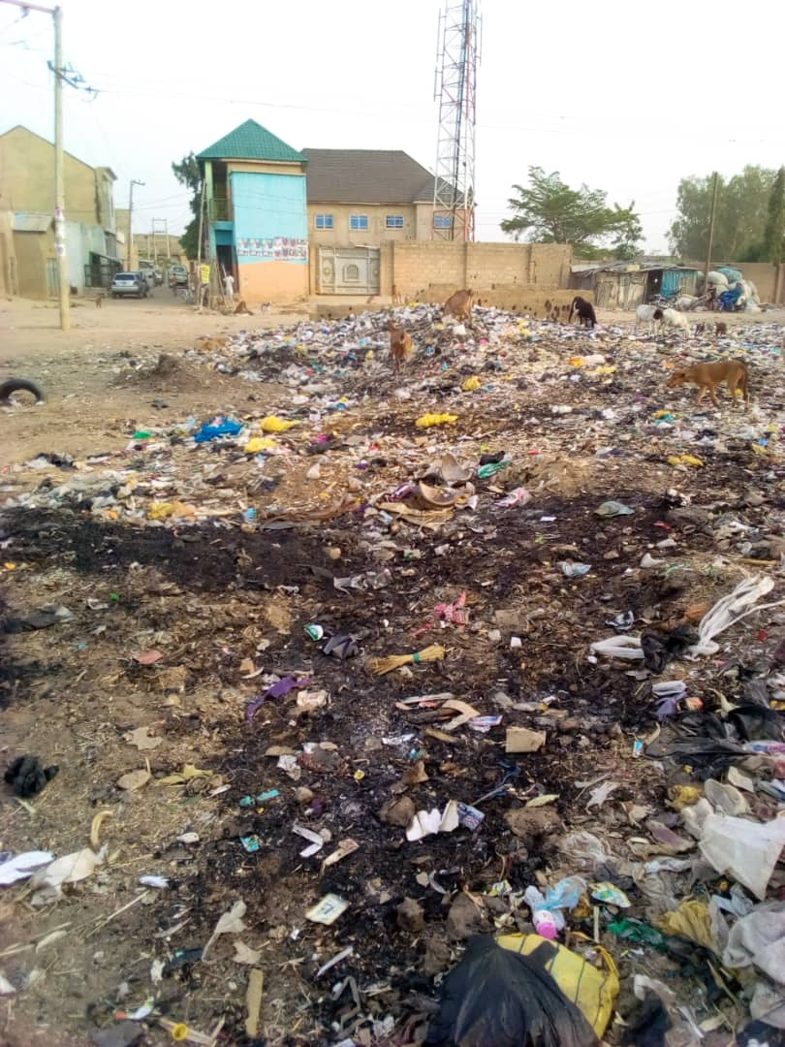

1. (b)

Plate 4.9: Garbage in back yard and in residential area of Diso, Gwale local government.

***Source: Field photo (2019)***

1. **Diapers dumped in a back yard in Diso**
2. **Rubbish dumped in a residential area in Diso**

Moreover, several other diseases including Malaria, typhoid and various infectious diseases are caused by it. One can easily observe the overflowing bins and heaps of garbage beside the roads and in markets. They are an ideal breeding ground for all types of pathogenic bacteria.

Field observation shows that the dumps of waste e.g. household refuse containing used diapers and bags (Plate 4.9 a and b) are common eyesore in these areas. Sometimes, even carcass of dead animals is seen on street sides. Besides the ugly scene they present, these dumps contribute to surface and ground water contamination. They can also be wash away by run-off into the drainage and stream channels which may cause the blockage of the water ways.

From the questionnaire, 82% of respondents agreed that there are a lot of mosquitoes which rest in garbage and can ultimately spread disease in Gwale.

According to Park (2007), indiscriminate dumping of refuse promotes the prolific breeding of arthropod-borne diseases like mosquitoes, houseflies, lice, tsetse flies, cockroaches which transmit diseases like malaria, viral encephalitis, typhoid, paratyphoid fever, diarrhea, dysentery, cholera, gastro-enteritis, amoebiasis, conjunctivitis, sleeping sickness, relapsing fever, scabies, Filariasis, and enteric pathogens.

About lack access to improved sanitation, which is causing many health problems in Gwale, the researcher observed that people use water from unprotected sources.

A review of a UNICEF report (2017) indicated that poor access to improved water and sanitation in Nigeria remains a major contributing factor to high morbidity and mortality rates among children under five. The use of contaminated drinking water and poor sanitary conditions result in increased vulnerability to water-borne diseases, including diarrhea which leads to deaths of more than 70,000 children under five annually.

Seventy-three per cent of the diarrheal and enteric disease burden is associated with poor access to adequate water, sanitation and hygiene (WASH), and is disproportionately borne by poorer children. Frequent episodes of WASH related ill health in children; contribute to absenteeism in school, and malnutrition. Only 26.5 per cent of the population use improved drinking water sources and sanitation facilities. Also, 23.5 per cent of the population defecates in the open **(**UNICEF, 2017**).**

There is relationship between domestic waste management practices and occurrence of Cholera, Typhoid and Dysentery among people living in Gwale local government were the correlation indicated by the use of the Pearson correlation test, the coefficient r = 0.350, p <0.001 (Table 4.11).

During the interviews, the Environmental Health officer in Gwale local government noted that:

“*The way people manage and disposed off domestic waste in their homes affects seriously their chances of getting different types of diseases. Many families in Gwale are visiting the health centres frequently as a result of on and off fevers, which are mainly diagnosed to be enteric fever more of which is typhoid.*”

Nas *et al,* (2017) in his study of Malaria and Typhoid Fever Co-Infection among Febrile Patients in Gwale concluded that, Almost 95% of the febrile patient presenting with fever symptoms in this study had malaria, S. typhi, or both the infections. There was a strong association between having fever and that of having malaria or typhoid fever infections.

Table 4.11: Relationship between domestic waste management practices and occurrence of cholera, typhoid and dysentery.

|  |  | Value | Approx. Sig. |
| --- | --- | --- | --- |
| Interval by Interval | Pearson's R | 0.350 | .000c |
| Ordinal by Ordinal | Spearman Correlation | 0.350 | .000c |
| N of Valid Cases | | 325 |  |

***Source: Field Data (2019)***

There is relationship between domestic waste management practices and occurrence of Cholera, Typhoid and Dysentery among people living in Gwale local government were the correlation indicated by the use of the Pearson correlation test, the coefficient r = 0.350, p <0.001 (Table 4.11).

The Pearson correlation test, the coefficient r = 0.350, p <0.001 shows that there is a moderate relationship between domestic waste management practices is Gwale and occurrence of typhoid, cholera and dysentery. However, there are other causes of those diseases apart from poor domestic waste management in Gwale local government.

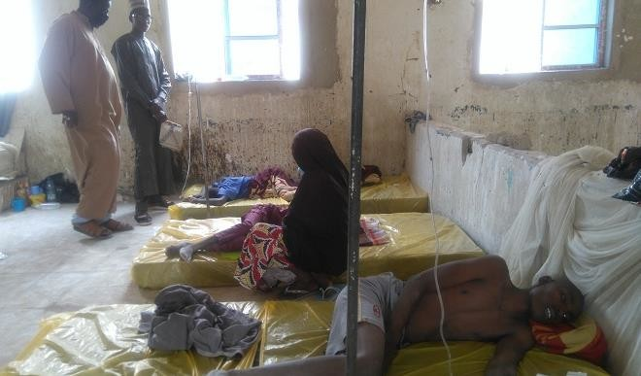

Plate 4.10: infectious diseases Hospital Administrator shows the researcher victims of cholera

***Source: Field photo (2019)***

The improper dumping of domestic waste in Gwale can lead to the pollution of aquatic environment as well as diseases to humans e.g. dysentery, cholera etc.

Infection from fluids usually involves drinking or cooking with water contaminated with unattended domestic waste that contain fecal matter from the used diapers and other human excreta. Flies and cockroaches in houses often thrive on excreta. If they land on food they can transfer fecal matter that can be subsequently ingested by a person. Field (or soil) infection can occur by the ingestion of unwashed raw vegetables and fruit grown in soil and water contaminated with feaces. Contaminated soil also may be transported by feet or shoes for long distances where it can cause infection. Infections can also be transmitted through dirty floors, perhaps if food is dropped on the floor and then picked up and eaten.

# CHAPTER FIVE: SUMMARY, CONCLUSION AND RECOMMENDATIONS

# 5.0 Introduction

This chapter presents the summary of the findings of this study based on specific objectives, the conclusion made on each area of investigation and the recommendations made to improve domestic waste management in Gwale local government in Kano State, Nigeria.

# 5.1 Summary

# 5.1.1 Domestic waste management practices in Gwale local government

From the interviews with Gwale local government officials, it was found out that there are no professionally constructed landfill sites on ground that are equipped with liner systems and infrastructure to detect, extract and treat/refine leachate or landfill gas. Refuse management and sanitation board (REMASAB) lacks an established system for segregation and recycling of waste”.

The researcher found out that, 52.7% of the respondents use trash bins in their homes to collect waste, which is taken away every weekend by a private domestic collection company at a fee. It was also discovered that, trash bins are used more by offices, restaurants, schools and hospitals in Gwale local government.

Majority of the respondents (77.4%) generally agreed that people in Gwale do not decompose waste in their homes in Gwale local government. The researcher’s observation found that, there was rampant burning of waste especially among the homes surrounding Gwale local government. There was daily waste burning in towns like Dorayi, Diso, Gadon Kaya, Hauren Shanu, and Kabuga.

In an interview, it was highlighted that although Waste open incineration is quite common in Gwale; it is unfortunately not done in a properly controlled environment. It is often done by scavengers and local residents, and when it is carried out by Gwale Environmental Protection Board (GEPB), it is done haphazardly. This poses a huge environmental, human health and safety risk.

The informal recycling system in Gwale is a network made up of waste pickers (locally known as “Jari Bola”), small buyers/middlemen, large buyers/brokers, and small and medium-scale industries. The researcher found out that, there are a lot of women and children involved in waste picking or scavenging for income. They collect recyclable materials from dump sites and streets and sell them to recycling companies in Gwale. Majority of the respondents (77.4%) generally agreed that people in Gwale do not dig rubbish pits in their homes.

# 5.1.2 Occurrence of cholera, typhoid and dysentery among people living in Gwale local government

An investigation on whether there is access to basic health care in Gwale disclosed that almost all residents of Gwale (90%) had access to basic health care. It was observed that, there were three referral hospitals with the biggest three being Makkah Specialist Eye Hospital, Hasiya Bayero pediatrics Hospital, and Imam Wali General Hospital. However, observations made by the researcher revealed that the hospitals in Gwale were expensive for most of the local people.

Results showed that 98.4% of the respondents acknowledged to the fact that typhoid, cholera and dysentery occur and are a significant cause of illness in Gwale. In line with findings, an observation conducted by the researcher from medical records revealed that indeed; there are much number of cases of typhoid reported in health centres in Gwale.

The laboratory record from Dorayi hospital show that in a month of February, March and April 1038 cases of typhoid was reported making 94.0% of the occurrence among people with feverish conditions. Dysentery cases reported were 212 making a total of 15.0% but no single case of cholera was reported within those three months of reporting. That simply show that typhoid occur more often among people in Gwale local government followed by dysentery with 212 cases in 3 month.

It was revealed in an interview that Gwale local government has piped water for town residents; however, water is a big challenge in the inner parts of Gwale. The biggest source of water in these areas is boreholes; however, they are located on low land, where they are easily contaminated by waste from homes and businesses. Majority of the respondents generally agreed that water-borne diseases do occur and cause illnesses among people more of which are children in Gwale.

# 5.1.3 Relationship between domestic waste management practices and occurrence of cholera, typhoid and dysentery among people living in Gwale local government

Domestic waste management practices and occurrence of cholera, typhoid and dysentery among people living in Gwale local government have significant relationship, correlation r = 0.350, p <0.001.

Majority of the respondents generally agreed that poorly stored, uncollected, and poorly disposed waste is a threat to public health in Gwale and this implies that people in Gwale know the dangers of waste in their community.

The environmental health officer in Dorayi of Gwale local government revealed that indiscriminate disposal of refuse is common in Dorayi and it has led to spread of diseases. Indiscriminate open defecation has also affected drinking water, this has the potential of causing different diseases such as typhoid fever. Indeed, 87% of the respondents in the study agreed that cholera, dysentery, and typhoid in Gwale are caused by contaminated water and foods. This was attributed to a number of contaminated water sources especially in of Hauren Shanu, Kabuga, and Gadon Kaya.

In an interview, the Gwale local government Health Inspector explained that people dump garbage on the roads, outside their homes. The garbage attracts flies and other vector carrying organisms, which end up in their homes. There is a lot of garbage in the middle of houses in Gwale.

From the questionnaire, 82% of respondents agreed that there are a lot of mosquitoes which sits in garbage and ultimately spread various diseases in Gwale.

# 5.3 Conclusion

This study found that there are no professionally constructed landfill sites on ground that are equipped with liner systems and infrastructure to detect, extract and treat/refine leachate or landfill gas. Refuse management and sanitation board (REMASAB) lacks an established system for segregation and recycling of waste. Residents use rubbish bins in their homes, businesses and public offices.

Residents of Gwale had access to basic health care. However, the hospitals in Gwale were expensive for most of the local people. Typhoid is a significant cause of illness in Gwale as it becomes endemic in the town. Typhoid occur at an average of 96.0% base on the average from the data obtain in the records of three hospitals (Imam Wali general hospital, Dorayi hospital and Chiranci community hospital) The cases of dysentery reported during this research in those three health centres in Gwale shows that; dysentery occur at 16.0%.

Domestic waste management practices and occurrence of cholera, typhoid and dysentery among people living in Gwale local government have significant relationship, correlation r = 0.350, p <0.001. Poorly stored, uncollected, and poorly disposed waste is a threat to public health in Gwale and people in Gwale know the dangers of waste in their community.

# 5.4 Recommendations

Having established that improper waste generation and management can have adverse health effects on human health, the study concludes by recommending that:

1. Refuse management and sanitation board (REMASAB) should be facilitated to establish a system for segregation, sorting and recycling of waste.
2. The local authorities should support the private garbage collectors in their areas through giving them tax holidays as well as subsidizing their services to the local people.
3. The local leaders in Gwale local government should engage in promoting good hygiene practices among communities to prevent transmission of the diseases. Door-to-door visits, awareness raising by youth and women's groups, schools, posters, skits, radio broadcasts should be employed to inform communities about how to avoid infections.
4. Gwale local government should invest in training medical workers who should be stationed in various local health centers to provide sanitation and hygiene related information and services to the local people.
5. Incineration of waste in Gwale should be done in a properly controlled environment by REMASAB to curb the huge environmental, human health and safety risk.
6. The Federal Government of Nigeria should install modern incinerators in all growing parts of Gwale to reduce waste volume, convert metal and glass to ash, and install suitable pollution control devices, suitable furnace construction and control of the combustion process.
7. Gwale local government should recognize informal recycling system made up of waste pickers (locally known as “Jari bola”), small buyers/middlemen, large buyers/brokers, and small and medium-scale industries. Form a formal resource recovery programme and consider waste recycling activities of informal sector groups within the framework of waste management in Gwale.
8. The Federal Government of Nigeria should set up more government health centres where people can get free medical care.
9. The Federal Government of Nigeria should also ensure and invest in access to improved water and sanitation in Nigeria to reduce on the high incidences of water and sanitation related illness

# 5.5 consideration for future research

This study proposes the following further research:

1. The further research is required to assess hand washing practices in public places in Gwale local government.
2. Analysis of the quality of municipal water treatment in Gwale local government.

# 

# REFERENCES

Akinyemi K, Smith S, Oyefolu A, Coker A (2005) Multidrug resistance in Salmonella enterica serovartyphi isolated from patients with typhoid fever complications in Lagos, Nigeria. *Public Health.*119:321–327.

Abul S (2010). Environmental and Health Impact of Solid Waste Disposal At Man Gwaneni Dumpsite: Swaziland. *J. of Sust. Dev. In Africa, 12(7): 64 -78.*

Adiogo (2003) *Recovery and recycling practices in municipal solid waste management in Lagos, Nigeria.* Waste Management (New York, N.Y.), 27(9):1139-1143]

Afon, A.O. and Okewole, A. (2007) Estimating the Quantity of Solid Waste Generation in Oyo, Nigeria. Waste management and research, 25, 371-379.

Alex, P, (1990) How to disposal waste, *Journal of popular culture*, 36.

Amin, M.E. (2005) Social Science Research Conception, Methodology and Analysis. Makerere University Press, Kampala.

Andrew I.O (2007) Water Pollution in Nigeria: Concepts, Causes and Health Implications *Nigerian School Health Journal* 19 (2) 38- 43.

A. W. Butu and S.S. Mshelia, (2014). Municipal Solid Waste Disposal And Environmental Issues In Kano Metropolis, Nigeria. *British Journal of Environmental Sciences* **Vol.2, No.2, pp.10-26, June 2014**

Babayemi, J.O. and Dauda, K.T. (2009) Evaluation of Solid Waste Generation, Categories and Disposal Options in Developing Countries. A Case Study of Nigeria. *Journal of Applied Science and Environmental Management,* **13, 83-88.**

Benitez *et al,* (2002).Biocontrol mechanisms of Trichodermastrains. *Journal Of International microbiology (2004)* **7:249-260**

Ben, Y, (1999), Government responsibility on waste segregation. Nigeria Government Publishers, 32 (1): 116-127.

Bhan M, Bahl R, Bhatnagar S (2005). Typhoid and paratyphoid fever. *Lancet. 2005;366:749–762.*

Bhutta Z (2006). Current concepts in the diagnosis and treatment of typhoid fever. *British Medical Journal.* 2006;333:78–82.

Bonnie, H (1998), Disposal of waste and their effects. *Biocycle,* 16.

Boyer G, Johannessen LM (2010). Observations of Solid Waste Landfills in Developing Countries. Urban Development Division. Waste Management Anchor Team. The WorldBank. http://www.worldbank.org/urban/solid_wm/erm/CWG%20folder/uwp3.pdf Accessed on April 18, 2010.

Burns *et al*. (1994) Solid Waste Quantities and Characteristics. CMC Report. Cape Town, South Africa.

Cahill KM, Davies JA, and Johnson R (1966). Report on an epidemic due to Shigellae dysenteriae type 1 in the Somali interior. *Am J Trop Med Hyg* 1966;15(1):52-56.

Chart H, Cheesbrough J, Waghorn D (2000). The serodiagnosis of infection with Salmonella typhi. *Journal of Clinical Pathology*. 2000;53:851–853.

Cointreau, S. (2006) Occupational and environmental health issues of solid waste management, with special emphasis on developing countries. *The World Bank, Urban Papers*, July 2006.

Crump J, Luby S, Mintz E (2004). The global burden of typhoid fever. *Bulletin of the World Health Organization.* 2004;82:346–353.

Daniel, H, (2003), Importance of segregation of waste to a country, *Journal of recycling*, p.34

David, M, (2000), Right strategies for waste disposal in UK. Biosecurity, p.9.

Davidson, Gary (2011). "Waste Management Practices: Literature Review" (PDF). Dalhousie University - Office of Sustainability. Retrieved 3 March 2017.

Diaz, L. et al (2006). *Solid Waste Management, Volume 2.* UNEP/Earthprint, 2006.

Dolin, Raphael; Mandell, Gerald L.; Bennett, John E., eds. (2010). Mandell, Douglas, and Bennett's principles and practice of infectious diseases (7th ed.). Philadelphia, PA: Churchill Livingstone/Elsevier.

Elliot AJ, Maier MA, Moller AC, Friedman R, Meinhardt J (2007) Color and Psychological Functioning: The Effect of Red on Performance Attainment. *Journal of Experimental Psychology*: General 136: 154–168.

Feng YC (2000). The epidemiology of typhoid fever in the Dong Thap Province, Mekong Delta region of Vietnam. *The American Journal of Tropical Medicine and Hygiene*. 2000;62:644–648.

French (2006) defined data processing as the collection and manipulation of items of data to

Gaffga NH, Tauxe RV, Mintz ED (2007). Cholera: a new homeland in Africa? *Am J Trop Med Hyg.* 2007;77:705-13.

Gates Foundation (2015): <https://www.gatesfoundation.org/What-We-Do/Global-Health/Enteric-and-Diarrheal-Diseases>.

Gerba (2010). Fate of wastewater bacteria and viruses in soil. J Irrig Drain Div.;101(3):157–175.

Government Health Report, 2015).

Graham S, Molyneux E, Walsh A, Cheesbrough J, Molyneux M, Hart C (2000). Nontyphoidal Salmonella infections of children in tropical Africa. *The Pediatric Infectious Diseases Journal.* 2000;19:1189–1196.

Griffith *et al*, (2005) Environmental Improvement Through Solid Waste and Public Health. A Study on Post-Plague Initiatives of Surat Municipal Corporation. Institute for Social Services, New Delhi, India.

Gwale local governmentCensus (2006)

Gwale local governmentHealth Report (2015)

Han AM and Hlaing T. (1989) Prevention of diarrhea and dysentery by hand washing. *Trans R Soc Trop Med Hyg* 1989;83:128-13.

Hardoy J, Mitlin D, Satterthwaite D. (1993) Environmental Problems in Third World Cities. London, UK: Earthscan Publications; 1993.

Hassan M. I. *et al,* (2015). Incidence of Typhoid Fever Among Patients Attending Aminu Kano Teaching Hospital Laboratory, Tarauni Local Government, Kano State, Nigeria. *International Journal Of Scientific Research And Education* **Volume 3 4409-4416 September-2015 ISSN (e): 2321-7545**

[HealthMir](https://www.quora.com/profile/HealthMir-1) (2017), What diseases are caused by garbage? AI-driven Health App India.

Herbeth J. (2000) Environmental Pollution: www.environmentalexpert.com.

<http://sustainability.umich.edu/media/files/Landfill-Waste-Reduction-Committee-Report-2015.pdf>.

<https://ncdc.gov.ng/> Nigeria Centre for Disease Control, situation report.

https://www.medicinenet.com/script/main/art.asp?articlekey=6534 **reviewed on 14/09/2019**

Huppertz HI. (1986) An epidemic of bacillary dysentery in Western Rwanda 1981-1982. *Cent Afr J Med* 1986 Mar; 32(3):79-82.

Imam, *et al,* (2008). Solid Waste Management in Abuja, Nigeria. Waste Management, 28, 468-472. [***Open Journal of Ecology***](http://www.scirp.org/(S(i43dyn45teexjx455qlt3d2q))/journal/Home.aspx?JournalID=614)***,*** [*Vol.6 No.7*](http://www.scirp.org/(S(i43dyn45teexjx455qlt3d2q))/journal/Home.aspx?IssueID=8050), June 14, 2016

Ishaq A. (2017) Spatio-Temporal Trends of typhoid fever among youths attending

Muhammad Abdullahi Wase specialist hospital In Kano metropolis, Nigeria*. Bayero Journal of Pure and Applied Sciences, 10(2): 115 - 121*

Jamie Bartram, Kristen Lewis, Roberto Lenton, Albert Wright, (2005) Focusing on improved water and sanitation for health, *The Lancet*, VOLUME 365, ISSUE 9461, P810-812,

Janovy Matthew G. Bolek, Scott D. Snyder (2009) Parasitology associated with waterborne diseases. The American Society of Parasitologists," *Journal of Parasitology 95(6), (1 December 2009).*

Keusch (2006) Infecting Dose and Severity of Typhoid: Analysis of Volunteer: Data and

Examination of the Influence of the Definition of Illness Used. Epidemiol. Infect. 1995;115(1):23-30

Kothari, C.R. (2009) Research Methodology: Methods and Techniques. New Age International, 401 p.

Leclerc H, Schwartzbrod L, Dei-Cas E (2002) waterborne diseases and its causative agents. *Critical Reviews in Microbiology* 4: 371-409.

Lucas AO, Gilles HM. (2004) Communicable diseases: Infections through the gastrointestinal tract. In: Lucas AO, Gilles HM, editors. Short Textbook of Public Health Medicine for the Tropics. 4th rev ed. London: Arnold Publishers. p. 59.

Mara *et al,* (2003) Sanitation and health. PLoS medicine 2010; 7:e1000363.

Meinhardt (2008) Emerging waterborne diseases in the tropics: Centers for Disease Control and Prevention, U.S. Department of Health & Human Services.

Moore (2008) Research Methodology: A Toolkit of Sampling and Data Analysis Techniques for Quantitative Research.

Mugenda, O.M. and Mugenda, A.G. (2003) Research Methods, Quantitative and Qualitative Approaches. ACT, Nairobi.

Mustapha A. and Balarabe Usman Getso (2014). Sources and Pathway of Environmental Pollutants into Surface Water Resources. *Journal of Environments* **ISSN: 2313-660X Vol. 1, No. 2, 54-59, 2014**

Nabegu, A. (2009) *Municipal Solid Waste Management in Kano and Katsina cities*: A Comparative Analysis BY. Volume 2.

Nabegu, A. (2010) *An Analysis of Municipal Solid Waste in Kano Metropolis, Nigeria* J Hum

Ecol, 31(2): 111-119 (2010)

[Ni-Bin Chang](https://www.semanticscholar.org/author/Ni-Bin-Chang/145963761), [Eric Davila](https://www.semanticscholar.org/author/Eric-D%C3%A1vila/145886081), (2008). Municipal solid waste characterizations and management strategies for the Lower Rio Grande Valley, Texas. *Journal of waste mgt 2008* **Volume 28 5, pages 776-94**

Nabegu A., (2008). Municipal solid waste characteristics in residential zones of Kano metropolis: implications for mgt. *Maiduguri Journal of Art and Social sciences* Volume 6 number 1 June 2008

Nsutebu EF, Martins P, Adiogo D. (2003) Occurrence of typhoid fever in febrile patients with symptoms clinically compatible with typhoid fever in Cameroon. Trop Med Int Health. 2003;8:575–8.

Olokor C.O (2001) Hazardous Wastes: its production, effects, disposal and control in Nigeria Industries; Oyo*: JONAPHER-SD* 2(2) 258-267.

Park K. (2007). Park's Textbook of Preventive and Social Medicine India; Banarsida Bhanot Publishers.

Patricia M. (2007) Surveillance of waterborne diseases in African countries. Nairobi Urban Health and Demographic Surveillance.

# Rushbrook, *et al,* (1999). *Solid waste landfills in middle and lower income countries :* a technical guide to planning, design, and operation (English). World Bank technical paper ; no. WTP 426. Washington, D.C

Saunders, M., Lewis, P. & Thornhill, A. (2012) “Research Methods for Business Students” 6th edition, Pearson Education Limited p.288

Sekaran, U. (2003). Research methods for business (4th ed.). Hoboken, NJ: John Wiley & Sons.

Strausbaugh TJ (1997) Water purification measures as a primary prevention approach in combating water borne diseases. *Journal of Health Education Research & Development*. Volume 14, Issue 5.

Talib Najjar (2014) Role of Community development schemes on the health and wellbeing of households. *J Biosafety Health Educ*, Volume 2, Issue 3.

UN-Habitat (2010). State of African Cities 2010; Governance, inequality and urban land markets. (Nairobi, 2010).

**WebMD** *(*[*https://www.webmd.com/a-to-z-guides/cholera-faq#1*](https://www.webmd.com/a-to-z-guides/cholera-faq#1)*)*

WHO (2010) Statistical Information System. *Journal of Health Education Research & Development.*

WHO (2014) Drastic consequences of Diarrhoeal diseases. *Journal of Health Education Research & Development.*

WHO (2018). Unsafe drinking-water, sanitation and waste management, Health and sustainable development. *Journal of Health Education Research & Development.*

WHO. Cholera 2011.*Wkly Epidemiol Rec*. 2012;87: 289–304.

WHO [https://www.who.int/topics/dysentery/en reviewed on 14/09/2019](https://www.who.int/topics/dysentery/en%20reviewed%20on%2014/09/2019)

WHO (2012). Global burden of cholera. *Bulletin of the World Health Organization* 2012;90:209-218A. doi: 10.2471/BLT.11.093427

Wikipedia<https://en.wikipedia.org/wiki/Dysentery> reviewed on 14/09/2019

Willke A, Ergonul O, Bayar B. (2002) Widal test in diagnosis of typhoid fever in Turkey. *Clinical Diagnostic Laboratory Immunology*. 2002;9:938–941.

Wilson, D.C.; Velis, C.; Cheeseman, C. (2006) "Role of informal sector recycling in waste management in developing countries." *Habitat International* 30 (2006): 797-808.

WRAP report, (2012) Household food and drink waste in the UK 2012. [**http://www.wrap.org.uk/content/household-food-and-drink-waste-uk-2012**](http://www.wrap.org.uk/content/household-food-and-drink-waste-uk-2012)

Yamane (1967) Statistics, an Introductory Analysis, 2nd Ed., New York: Harper and Row.

APPENDIX A: QUESTIONNAIRE

**Dear Respondent,**

I am Mustapha S. Abdullahi a student of Nkumba University conducting an academic research on Domestic Waste Management and Occurrence of Enteric Diseases among People Living in urban centres in Nigeria. A case study of Gwale local government in Kano State. This research is a requirement for the award of a Master Degree in Environmental Health of Nkumba University.

Please, you are kindly requested to answer the following simple questionnaire. The questionnaire is designed for education purposes only and any information obtained will only be used for academic purposes and shall be treated with utmost confidentiality

***Yours sincerely***

..........................................................

**MUSTAPHA S. ABDULLAHI**

***RESEARCHER***

**SECTION A: General background information of the respondents.**

Please tick the appropriate box where applicable

**1. Gender of respondents**

1. Male
2. Female

**2. Level of Education**

1. Post Graduate Diploma
2. Master’s Degree
3. First Degree
4. Diploma
5. Certificate

**3. Time of stay in Gwale**

1. 0 – 5 years
2. 6 – 10 years
3. Above 10 years

**4. What is your age group?**

1. 20-29
2. 30-39
3. 40-49
4. 50-59
5. 60+

**NB:** You are required to respond to each item in subsequent sections using the following scale by ticking the appropriate option.

1 = Strongly Agree, 2 = Agree, 3 = Not sure, 4 = Disagree, 5 = Strongly Disagree,

**SECTION B: Domestic waste management practices in Gwale local government**

|  |  |  |  |  |  |  |
| --- | --- | --- | --- | --- | --- | --- |
| **No.** | **Question** | **1** | **2** | **3** | **4** | **5** |
| 6 | Gwale local government uses landfills to manage waste |  |  |  |  |  |
| 7 | Residents of Gwale use trash bins to dispose off waste |  |  |  |  |  |
| 8 | People in Gwale decompose waste in their homes |  |  |  |  |  |
| 9 | Residents of Gwale burn domestic waste |  |  |  |  |  |
| 10 | Gwale local government uses incineration to manage waste |  |  |  |  |  |
| 11 | The local people in Gwale recycle waste |  |  |  |  |  |
| 12 | People in Gwale dig rubbish pits in their homes |  |  |  |  |  |

**SECTION C: Occurrence of cholera, typhoid and dysentery among people living in Gwale local government**

|  |  |  |  |  |  |  |
| --- | --- | --- | --- | --- | --- | --- |
| **No.** | **Question** | **1** | **2** | **3** | **4** | **5** |
| 13 | There is lack of access to basic health care in Gwale |  |  |  |  |  |
| 14 | Cholera, typhoid and dysentery occur and they are significant cause of illness in Gwale |  |  |  |  |  |
| 15 | There are cases of typhoid reported in health centres in Gwale |  |  |  |  |  |
| 16 | There is a high percentage of people who die from cholera in Gwale |  |  |  |  |  |
| 17 | Children suffer from dysentery in Gwale local government |  |  |  |  |  |
| 18 | There are poor water and sanitation systems in Gwale |  |  |  |  |  |
| 19 | Most illnesses among children in Gwale are caused by water-borne diseases |  |  |  |  |  |

**SECTION D: How domestic waste management practices affect the occurrence of Cholera, Typhoid and Dysentery among people living in Gwale local government**

|  |  |  |  |  |  |  |
| --- | --- | --- | --- | --- | --- | --- |
| **No.** | **Question** | **1** | **2** | **3** | **4** | **5** |
| 20 | Poorly stored, uncollected, and poorly disposed waste is a threat to public health in Gwale |  |  |  |  |  |
| 21 | Accumulation of the waste products generally results in contamination of air and water in Gwale |  |  |  |  |  |
| 22 | cholera, dysentery, and typhoid in Gwale are caused by contaminated water and foods |  |  |  |  |  |
| 23 | Garbage pollution is the main reason for various bacterial diseases in Gwale. |  |  |  |  |  |
| 24 | There are a lot of mosquitoes which sits in garbage and ultimately spread various diseases in Gwale. |  |  |  |  |  |
| 25 | Indiscriminate dumping of refuse in Gwale promotes the breeding of mosquitoes, houseflies, lice, tsetse flies, cockroaches which can transmit typhoid, dysentery and cholera. |  |  |  |  |  |
| 26 | Indiscriminate open defecation is common in Gwale. |  |  |  |  |  |
| 27 | Diseases due to poor drinking-water access, unimproved sanitation, and poor hygiene practices cause deaths in Gwale. |  |  |  |  |  |
| 28 | The urban population in Gwale still lack access to improved sanitation causing a lot of diseases. |  |  |  |  |  |

**Thank you so much for your cooperation**

# APPENDIX B: INTERVIEW GUIDE

**Domestic waste management practices in Gwale local government**

1. Does Gwale local government use landfills to manage waste?
2. Do residents of Gwale use trash bins to dispose off waste?
3. Do people in Gwale decompose waste in their homes?
4. Do residents of Gwale burn domestic waste?
5. Does Gwale local government use incineration to manage waste?
6. Do the local people in Gwale recycle waste?
7. Do people in Gwale dig rubbish pits in their homes?

**Occurrence of cholera, typhoid and dysentery among people living in Gwale local government**

1. How is the access to basic health care in Gwale?
2. Are there frequent cases of cholera in Gwale local government?
3. Are there cases of typhoid reported in health centres in Gwale?
4. What is the percentage of people who die from cholera in Gwale?
5. Do people experience dysentery illness in Gwale local government?
6. Are there poor water and sanitation systems in Gwale?
7. Do children drink unboiled water?
8. How often do people report cases of watery stool in health centers?

**How domestic waste management practices affect the occurrence of cholera, typhoid and dysentery among people living in Gwale local government**

1. Do you agree that poorly stored, uncollected, and poorly disposed off waste is a threat to public health in Gwale?
2. Does accumulation of the waste products result in contamination of air and water in Gwale?
3. Is cholera, dysentery, and typhoid in Gwale caused by contaminated water or foods?
4. Does garbage pollution have any relation with reported cases of bacterial diseases in Gwale?
5. Are there mosquitoes in garbage which spread various diseases in Gwale?
6. Does indiscriminate dumping of refuse in Gwale promote the breeding of mosquitoes, houseflies, lice, tsetse flies, cockroaches which can transmit typhoid, dysentery and cholera?
7. Does indiscriminate defecation result in source water contamination?
8. Does the urban population in Gwale have access to improved sanitation?

***Thank you so much for your cooperation.***

# APPENDIX C: OBSERVATIONAL CHECKLIST

1. Observer’s Name: .............................................................................................

2. Location: ...........................................................................................................

3. Time of the day: ...............................................................................................

4. Weather: …………………………………………………………..................

**Domestic waste management practices in Gwale local government**

4. Presence of landfills

1. Yes [ ]
2. No [ ]

5. Use of trash bins in homes noted

1. Yes [ ]
2. No [ ]

6. Presence of decomposed waste in the homes seen

1. Yes [ ]
2. No [ ]

7. Burning of domestic waste noted

1. Yes [ ]
2. No [ ]

8. Presence of incinerators

1. Yes [ ]
2. No [ ]

9. Recycling of waste present

1. Yes [ ]
2. No [ ]

10. Presence of rubbish pits in homes

1. Yes [ ]
2. No [ ]

**Occurrence of cholera, typhoid and dysentery among people living in Gwale local government**

11. Presence of health centres

1. Yes [ ]
2. No [ ]

12. Records of cholera

1. Yes [ ]
2. No [ ]

13. Cases of typhoid reported in health centres

1. Yes [ ]
2. No [ ]

14. Reported deaths of cholera

1. Yes [ ]
2. No [ ]

15. Records of Dysentery in a health facilities

1. Yes [ ]
2. No [ ]

16. State of water and sanitation systems

1. Poor [ ]
2. Fair [ ]
3. Good [ ]

**How domestic waste management practices affect the occurrence of cholera, typhoid and dysentery among people living in Gwale local government**

17. Waste disposal status

1. Poor [ ]
2. Fair [ ]
3. Good [ ]

18. Presence of contaminated air and water

1. Yes [ ]
2. No [ ]

19. Presence of garbage

1. Yes [ ]
2. No [ ]

20. Presence of mosquitoes, flies, or cockroaches

1. Yes [ ]
2. No [ ]

21. Indiscriminately dumped refuse noted

1. Yes [ ]
2. No [ ]

22. Open defecation observed

1. Yes [ ]
2. No [ ]

23. Record of typhoid fever among residents

1. Yes [ ]
2. No [ ]