## Ocaya to bring his car dream to life

###### Monday May 13 2019

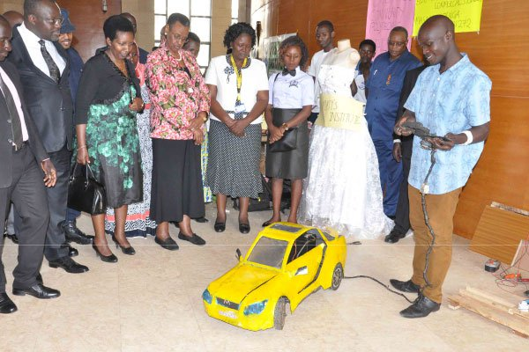

Matthias Ocaya shows how his car works during an exhibition at Parliament in November 2017. He says he needs Shs95m to complete building his bigger solar-driven prototype. Courtsey photo

Advertisement

By Desire Mbabaali

Born to Silverno Orinyo from Zombo, Matthias Ocaya, 25, is one of the innovators in the vocational field, thanks to his persistence. An old student of Otoroga Boys Primary School in Zombo, Ocaya started dreaming about joining vocational education then, but his father would not hear any of it.

“After Primary Seven, I told my father that I wanted to enroll in a vocational institute although he wanted me to continue to secondary school. So, I joined St Aloysius Secondary School in Zombo District and while there, my knowledge on innovation developed,” Ocaya recalls.

He got career guidance and learned that he could actually go enroll in a vocational school after O-Level.   
“Whenever we got holidays, I would go to different people in my village for apprenticeship in plumbing work, building and wiring. I did that from Senior One holidays to Senior Four. In Senior Four vacation, I built myself a house and since I wanted to make a door for it, I went to a certain carpenter in my village to ask him for his equipment,” he says. But the carpenter instead asked him to come and help him at his workshop since he had no one to work with. Ocaya started work the following day.

“I made my door but also learnt more skills, so, next, I made myself a bed but before I could take it home, a buyer asked for it. I told him I could make him one and he paid me Shs200,000. This was the first money I earned and through him, I got many more customers,” he narrates.

Although Ocaya did carpentry work, being a mechanic was his ultimate dream. After Senior Four vacation, he still expressed interest in vocational education but his father still did not want him to go.   
“I joined A-Level at Paidha Senior Secondary School but class things had gotten a bit slow for me. I looked for a garage in the area where I would work at the weekend and during the holiday. It was then that I thought about making a prototype of a car from timber,” he says.

**Realising his dream**  
With six points after A-Level, he joined vocational school.   
Ocaya joined Lugogo Vocational Institute in Kampala in 2016. “Two weeks into the course, I went to my lecturer and told him I wanted to build a car. He asked me how I was going to do it and told me to write a proposal with all the details and to also draw what I wanted to make. He also asked me whether I would be able to pull it off,” Ocaya explains.

#### Also Read

In first year, when real life projects were introduced and they were asked to make stoves, Ocaya had bigger fish to fry in mind.   
“In second year when they told us to build something, I just wanted to build a car. I already had my proposal and I told the teacher that I wanted to make a car, but he said that could not work. I went and talked to the head of department, who gave me a go ahead,” he recalls.

**Financial constraits**  
Ocaya had no money. So during holidays, he went to the village and found work. “I earned Shs150,000 which I used to buy some things such as a motor, magnetar and other things for my prototype.”

Ocaya spent two and a half months building the car in addition to building and designing things such as DC stoves, water pumps and a car heater for friends in order to get money for his prototype.

After completing his prototype, he took it to the teacher and showed off his dream. The prototype was a solar driven car with an external steering wheel which he could use to control its movements.

“But because I had a tuition debt, I went back to the village to look for money. From there, I was called by the principal for a vocational exhibition at Parliament in November 2017. I was also allowed to do my examinations. But when I went back to the village with my Shs400,000 that I had got from people who saw my innovation at the exhibition, I decided to build a big car which I am currently working on but won’t give a lot of details about it for now,” Ocaya asserts.

“I was also recently invited to an exhibition at UBTEB, where I exhibited my car before the Education minister Janet Museveni. But as I work on my big project, I also work in a garage in my village because I still have a debt at school,” he says.   
Ocaya needs about Shs95m to build his first big prototype of a solar driven car.

**Other student innovations**  
Together with his robotics team, the International University of East Africa students built a car surveillance system. Andrew Bakashaba said, this is a smart home surveillance system that will have multiple functions. It will be able to; pick up sound, take videos, see what is at a distance, will be able to detect obstacles and able to control the lighting system in a home using a timer.

It will also be able to pick feedback, move for example in a compound or house and do all those functions. I specifically did the parking coding that detects obstacles.

We have built a control module/app that is connected to a mobile app, so it can connect everywhere, plus the camera module. We are still working on that body to adopt to functions and implement some parts but we want to have a working prototype soon. The surveillance car works as a proof of concept that we can build our own robots without studying a specific course.

dmbabaali@ug.nationmedia.com