CORPORATE SOCIAL RESPONSIBILITY AND CORPORATE IDENTITY OF WORLD VISION UGANDA IN OYAM DISTRICT, NORTHERN UGANDA
A CASE STUDY OF MINAKULU SUB-COUNTY

BY
OGWAL MOSES
(2020/FEB/MPAM/M226448/DIST)

A DISSERTATION SUBMITTED TO THE SCHOOL OF SOCIAL SCIENCES IN PARTIAL FULFILLMENT OF THE REQUIREMENTS FOR THE AWARD OF A MASTERS DEGREE IN PUBLIC ADMINISTRATION AND MANAGEMENT OF NKUMAB UNIVERSITY

DECEMBER, 2021.

DECLARATION
I OGWAL MOSES, of Index No. 2020/FEB/MPAM/M226448/DIST, a student of Nkumba University now carrying out a research study on a topic entitled, “Corporate Social Responsibility and Corporate Identity of World Vision Uganda in Oyam District, Northern Uganda a Case Study of Minakulu Sub-County” do hereby declare that this research is an original study and has never been presented in any University or Higher Institution of learning.

Signature:………………………………………..

Date:………………………………………………

APPROVAL
I hereby recommend that this dissertation has been written under my supervision, and it is now ready for presentation in the School Board of Social Sciences of Nkumba University.

Supervisor: DR. OLOWO GEORGE W’KONGO

Signature:………………………………………..

Date:………………………………………………

DEDICATION
To my dear wife Lynn Ogwal, and my children Ogwal Paul, Naira Ruth Ogwal, Queen Elizabeth Ogwal and Marana Faith Ogwal. I dedicate this piece of work to you all.

TABLE OF CONTENTS
DECLARATION ii
APPROVAL iii
DEDICATION iv
TABLE OF CONTENTS v
ABBREVIATION / ACRONYMS x
LIST OF TABLES xi
LIST OF FIGURES xii
ABSTRACT xiii
CHAPTER ONE 1
GENERAL INTRODUCTION 1
1.0 Introduction 1
1.1 Back Ground of the Study 1
1.1.1 Historical background of the Study. 1
1.1.2 Conceptual Background of the Study 3
1.1.3 Contextual Background of the study 5
1.1.4 Theoretical Back ground of the Study 6
1.2 Statement of the Problem 7
1.3 Main Objectives of the study 8
1.3.1. Specific objectives of the study 8
1.3.2 Research Questions 9
1.4 Scope of the study 9
1.4.1 Content Scope 9
1.4.2 Time scope 10
1.4.3 Geographical Scope 10
1.5 Significance of the study 10
1.6 Justification of the study 11
1.7 Limitations and Delimitations of the Study 11
1.8. Operation Definition of Key Terms 12
CHAPTER TWO 14
LITERATURE REVIEW 14
2.0 Introduction 14
2.1 The Theoretical Review 14
2.2 How human transformation influence corporate identity 16
2.3 How community based development contributes to corporate identity 19
2.4 Promotion of justice, spiritual and social transformation 22
CHAPTER THREE 26
METHODOLOGY 26
3.0 Introduction 26
3.1 Research Design 26
3.2 Study population/ Target population 26
3.3 Sampling strategy 27
3.4 Sample size 27
3.4 Source of data 28
3.5 Data Collection Instruments 29
3.6 Self-Administered Questionnaire 29
3.7 Interview Guide 29
3.8 Research Procedure 30
3.9 Reliability and Validity of Instruments 30
3.10 Data processing and analysis 30
3.12 Ethical Consideration 31
CHAPTER FOUR 32
PRESENTATION, INTERPRETATION, DISCUSSION AND ANALYSIS OF FINDINGS 32
4.0 Introduction 32
Section A: Demographic Information of the respondents 32
section B: How Human Transformation Influences Corporate Identity 38
4.3 How Community Based Development Contribute Corporate Identity 42
4.4 Promotion Of Justice, Spiritual And Social Transformation 46

CHAPTER FIVE 49
SUMMARY OF THE FINDINGS 49
5.0 Introduction 49
5.1 Summary 49
5.2 Conclusion 51
5.3 Recommendation 51
REFERENCES 52
APPENDICES i
APPENDIX 1: SELF -ADMINISTERED QUESTIONNAIRE FOR RESPONDENTS i
APPENDIX II: INTERVIEW GUIDE FOR THE RESPONDENTS vi
APPENDIX III: CHECK LIST FOR GROUP DISCUSSIONS viii
APPENDIX IV: PROPOSED BUDGET FOR THE RESEARCH ix
APPENDIX V: WORK PLAN TIME TABLE xi
APPENDIX VI: LETTER OF PERMISSION……………………………………………..xii
APPENDIX VII: MAP OF LANGO SUB- REGION SHOWING OYAM DISTRICT-MINAKULU SUB COUNTRY ……………………………………………………………xiii
APPENDIX VIII: STATEMENT OF PAYMENT…………………………………………xiv
ACKNOWLEDGMENT
My gratitude goes to the Almighty God through his might and kindness I have managed to reach this far. I congratulate the entire University Administration and the School of Social Science in particular for having nurtured me all this time, and in especial way I would like to express my sincere thanks to Dean of Social Sciences, Dr. Anne Abako for her general focus that has maintain excellence in the school. Furthermore, I salute my supervisor, Dr. Olowo George W’kongo for his tireless effort in threshing and sorting out my dissertation until it became good enough for submission without forgetting my lecturers, I thank you all, and May God Bless you abundantly.
I OWE YOU.

ABBREVIATION / ACRONYMS
CSR: Corporate Social Responsibility
CI: Corporate Image
CI: Corporate identity
CBD: Community Based Development
SPSS: Statistical Package for Social Sciences

LIST OF TABLES
Table 1: Sample size and selection methods 28
Taable (4.1.1) Sex of the respondents 32
Table (4.1.2) Age bracket of the Respondents. 34
Table (4.1.3) marital status of the respondent. 35
Table (4.1.4) Level of Education of the Respondents 37
Table (4.2.1) Do you know what human transformation is all about? 39
Table (4.2.2) Characteristics of Human Transformation Promoted 40
Table (4.3.1) Do you know how World vision area CBD approach to achieve corporate identity. 43
Table (4.3.2) World visions’ community based approach strategy. 44
Table (4.4.1) Are you aware that World Vison promotes justice, Spiritual and social transformation 46
Table 4.4.2 Examples of forms of justice, spiritual and social transformation promoted by World vision 47

LIST OF FIGURES
Figure 1: Conceptual Frame Work of the Study 25

ABSTRACT
This research examines the corporate social responsibility and the corporate Identity of the world vision in Northern Uganda, Oyam District in Munakulu Sub-county. The specific objects that guided the study were to examine how human transformation influences corporate identity of world vision in Minakulu sub-county Oyam District, to examine how community based development contributes to corporate identity of world vision in Minakulu sub-country, Oyam District, to establish how the promotion of justice, spiritual and social transformation has benefitted the people of Minakulu sub-county, Oyam District. The research design upon which the map of the research moved was descriptive research design. the literature was reviewed with an intent to discover the gaps in the study. The major data collection methods and tools used were self-administered questionnaire interviews and group discussions. Data was analysed partly using SPSS and frequency Counts and percentages to determine the findings of the study.
In the data analysis process, demographic information was found to be very useful as the number of participants became instrumental in as far as collection of data was concerned. It was true that the respondent knew about human transformation and they could even state the characteristics of same. For example the respondents were able to point out that education, economic sustainability and awareness were one of the forms of human transformation promoted by World Vision. The respondents of the study also accepted knowledge of community based development activities which was being carried out by world vision in the study area. To this effect they were able enumerate a number of them including the right to participate, protection, partnership, and among others.
On the very note, the respondents were aware that world vision promoted mainly human rights, educational reform, gender equality among others. The study therefore, concluded that the role of world vision was very instrumental in causing the social economic reforms that have brought good life now being enjoyed by the beneficiaries. Nevertheless, it was recommended that much as they are now positive reforms which has greatly made world vision a model organisation because of its corporate social responsibility there is still need to mobilize the community because according to the findings they were still many more people who have not benefited from the World vision.

CHAPTER ONE

GENERAL INTRODUCTION

1.0 Introduction
This chapter was inclined to introduced the entity merit in this study. The chapter was made up of the background of study, statement of the problem, objective of the study, scope of the study, significance of the study, justification of the study, and limitations and delimitations of the study.
  - Back Ground of the Study
The background of the study was spread into four other sub-sections namely the historical background, conceptual background, contextual background and theoretical background of the study.
    - Historical Background of the Study.
As an entry point to the historical background of corporate social responsibility, the corporate social responsibility (CSR) refers to practice and policies under taken by corporations that are intended to a positive influence on the world. They key idea behind CSR was for corporations to pursued other pro-social objectives in addition to maximizing profits.
In order to know the concept, the context and theories inclining to corporate social responsibility, its historical perspective was pre-environment, as asserted by Stirling Myles (2019) Howard Bomen was widely regarded as the father of modern CSR. As are American economist he has been credited with coining the term “Corporate Social Responsibility”. “social responsibilities of the business man” in 1953, he writes, “ CSR refers to the obligation of businessmen, to persue these policies which were desirabled in terms of the objectives and values of our society?’ this became the backbone by which modern CSR principles are based. Myles further contends that even before Bowen, the seeds of CSR ware started to be sown. In the 1940s, with the fall out of the World war II, Companies like Hormel, Kusum for producing Spain, did their part for social good by working closely with the government through lend – lease programme, which provided much needed food supplies for those offered by the war. On the other hand, Nicoleta Farcane e Eusebie Bureana (2015).
Based on the green paper of the European Commission (2001), CSR was described as the concept, by which company’s volubility incorporates social and environmental concerns into their business and they contact with other stakeholders. Impoverishment accelerated the need for corporate responsibility towards society. (Fareane & Vureana, 2015).
On a similar context Rosamaria Moura- Leite and Robert C. Padget (2011) disclosed that the concept of corporate social responsibility CSR has a long history associated with how impacts on organizations behaviors. They further contend that in the 1950s the priority was because responsibilities to society and doing good deeds for society. In the 1960s key events, people and ideas were instrumental characterizing the social changes ushered in during this decade. In the 1970s business managers applied the traditional management function when dealing with the CSR issues, while, in the 1980s, business and social interest came closer and firms became more responsive to their stakeholders. During the 1990s the ideas of CSR became almost universally improvised. While corporate identity was developed in the early 20th Century, it was during the 1960s and 70s that it began to become a necessity for all corporations. The industrial revolution made way for a new generation of corporations across the world and they adopted varying approaches to presenting their brand identities.
Hitesh Bhasim (2019) illustrated a corporate image / identify of a company can be defined as an image that people held in their mind about the company, its products, and its service. The corporate image of a company of a company is the product, and its services. The corporate image of a company was the product of a company’s performance, media courage and its activities. The corporate image of a company keeps changing continuously and can be changed by putting the right efforts in the right directions hence the representation of a company in the market place or how others new it outside the company. Hence the because of the discoveries of venations of madness which took place during the industrial revolution gave to many companies that eater in the 1960s and 70s exposed themselves for competition for market of their goods resulting into corporate image.
    - Conceptual Background of the Study
The terms corporate social responsibility and corporate identity are in changeable used but corporate social responsibility give the corporate image or identity in such a way that despite the fact that there can be companies, corporations or organizations competing in the business circles but one gain fame became of its good name. This depends on the nature and types of products produced by the company and how the company mins favour from the general public to consume their products. This corporate image is very good for the company’s progress more especially in the world of business.
Leeds school of Business (university of Colorado (2018) observed that, consumers and employees have become the driving force behind the CSR movement, putting together pressure on companies to be conscious of their impact on the triple bottom line. In 2015, Nielsen found that 6.6% of global respondents and 72% of millennials are willing to pay more for products that come from companies dedicated to creating positive social and environmental impacts. Additionally, in 2017, cone found that business will drive economic and social change, even in the economic absence of government regulation” basing on this observation, and likewise there are home other local organizations that have thrived through the years and committed to their services delivery which have actually won the good corporate images the case for the world vision which was found in 1950.
For more than 70 years, world vision has been committed to protecting and caring for children and those in need. It is acknowledged that from the founder Robert Pierce giving the last $5 in his pocket to help care for an abandoned Chinese girl in 1947, to then CEO Stan Mooneyham purchasing a large slip in 1779 to rescue refugees families stranded at sea in Vietnam, World vision has gone where others would not. Even in the places where it was hardest to be a child, God is there and we should be there too. So over mission continues”. This extract from the history of world vision ascertains a deeper understanding of the concept of corporate social responsibility and corporate image.
The broad success of World vision was based on the vision of the founder Robert Pierce, Founder President 1950-1967,” we serve every one. We want to be in the world what we think Jesus Christ would be if He were in the middle of all of these problems and needs”. This vision can be formally related to the way/ how Jason Fernando (2021) explained what corporate social responsibility was all about, that corporate social responsibility (CSR) was a self- regulating business model that helps a company be socially accountable to itself its stakeholders, and the public. Buy practicing corporate social responsibility, also called corporate citizenship, companies can be conscious of the kind of impact they are having on all aspects of society, including economic social, and environmental. It was this impact that becomes the success drive for corporate image of the corporation/ organisation.
    - Contextual Background of the study
Despite firm belief in corporate communication practices that CSR efforts are part and parcel of being a good global citizen (sprinkle & Maines, 2010, p.446), marketing of CSR in global business invites pitfalls by employing a self-oriented approach, this courts the possibility of the publics negative responses to CSR (Wertherd Chandier, 2005)
Corporate social responsibility and corporate image was a unique identity give to companies without which a company lags behind and thus means it may not penetrate the market hence big setback for the company. Those companies that cannot prove their business status through (CSR) intend to disappear from market. On the effect of this (Athonasopolous & Selsky 2012); porter & Kramer, 2019) have pointed out that latterly many companies have been stuck in out dated, narrow approach toward CSR as they feel obligated to take “responsibility” for society.
And they call for a new paradigm, for instance, the principle of “shared value”, that was the focus of economic value by creating social values in addressing social issues and needs (Porter & Kramer, 2011). By such a yardstick, CSR has become emerging imperative as dynamic and multiplicity of influences where firms can engage in socially responsible business practices. We are seeing that the company, the market and the individual are very important in business and this explores the social context of the business world. But in terms of operation and manufacturing costs some corporations / organisation cannot attain CSR, hence the poorer and weaker organisation may not afford it, and at the same time the companies involve may put in a lot of money / costs in view of maintaining the standard and once it fails, such companies crumble completely.
    - Theoretical Back ground of the Study
They may have several theories informing the study and for this particular case, this study shall be examined from the critical theory point of view. The critical theory by Timothy Kuhn (2009) argues that values shape corporate decisions in three general ways. Managerial choices, routines and reasoning process; governmental regulating incentives, structures, and oversight and consumption choices within market systems. It shows that, a lone and jointly these sites are fundamentally weak in their capacity to produce greater CSR in the sense of more diverse values and reasoning process. Institutionalized power relations, various forms of systematically distorted communication, and ideology provide insight into different weaknesses and pit falls.
The theory simply explains the reasons why some companies cannot go for CSR neither could they compete with others in the market.
Corporate social responsibility itself was a form of theory that explains the corporate theory that emphasizes both the responsibility to make the money and the responsibility to interact ethically with the surrounding community, it was also recognized that corporate social responsibility is also a specific conception of that responsibility to profit while playing a role in border questions of community welfare.
This study can also be grounded on stakeholders’ theory described by Edward Freeman and others: (2016) it was the morrow image of corporate social responsibility. Instead of starting with a business and looking out into the would what the ethical obligations are there, stakeholders’ theory starts with the world by listing and describing the individuals and groups who will be affected by (or affect) the company’s actions and tasks “what are their legitimate carries on the business.
  - Statement of the Problem
World vision international has a very long corporate history compared to other international non- governmental organisations, the fact that its activities are shared by other international non- governmental organisations. Founded by Robert Pierce in 1950 as a service organisation to meet the emergency needs of missionaries. In 1975, development work was added to work visions objectives, and it was active in more than 90 countries with a total revenue including grants, product and foreign donations of USD 2.90 billion (2019)
World Vision come to Uganda in the year 1986 as a relief organisation in response to the 1981-1986 guerrilla war that ushered in the NRM government and today it was rooted in 49 district around the country. At long term perspective, world vision reaches out to the most marginalized and excluded people in the society such as children- continue to focus on the root comes of poverty and other vulnerability, within malt sectoral approach, world vision was transforming the lives of children and communities of Uganda helping them to reach their full potential. Oyam district and Minakulu sub-county was none – exclusion among the beneficiaries of this broach and multi – sectoral approach of world vision.
Compared with other international non-governmental organisation, world vision has come to stay considering its long term programmes and in Uganda alone it has now lived for 35 years and it was continuing to remain alive. Hence the importance of finding out the root and status of world vision’s corporate social responsibility.
  - Main Objectives of the study
The main objectives of the study were to examine the corporate social responsibility and corporate image of world vision international.

1.3.1. Specific objectives of the study
The study is guided by three specific objectives of the study:
- To examine how human transformation influences corporate identity of world vision in Minakulu sub-county Oyam District.
- To examine how community based development contributes to corporate identity of world vision in Minakulu sub-country, Oyam District.
- To establish how the promotion of justice, spiritual and social transformation by World Vision has benefitted the people of Minakulu sub-county, Oyam District.

1.3.2 Research Questions
- How does human transformation influence corporate identity of World Vision in Minakulu Sub-county, Oyam District?
- How does Community Based Development contribute to corporate identity of World Vision in Minkulu Sub-County, Oyam District
- In which way have promotion of justice, spiritual and social transformation by World Vision benefitted the people of Minakulu Sub-county, Oyam District?
  - Scope of the study
The scope of the study shall be divided into content scope, geographical scope and time scope
    - Content Scope
The study is going to examine how corporate social responsibility influence corporate image. The definition can be approached from all perspectives but all reaching a definite meaning and Fenando Jason (2021) defined corporate social responsibility as a self – regulating business model that helps a company be socially accountable to itself, its stakeholders, and the public. He added that they practicing corporate social responsibility, also called corporate citizenship, companies can be conscious of the kind of impact they are having on all aspects society, including economic, social, and environmental. This corporate image interchangeably used with corporate identity, both refer to the way a company presents itself on the outside world. Esther Ejim Contents that while the two terms might seem the same, they have different meanings and applications for the company. Corporate image on the other hand corporate image was the way a company looks in terms of its colours. Design and other visual stimulation. While corporate identify includes the effects of the type of organizational culture at the corporation in relation to the way if reflects on the company. Thus the study shall be subjecting human transformation community based development and promotion of justice spiritual and social transformation to question as forms of corporate social responsibility to establish as they influence corporate identity.

1.4.2 Time scope
The study will cover a period between the 2016-2021. This five-year period is chosen because it is the latest in the operation of world vision in Uganda and Minakulu District in particular.

1.4.3 Geographical Scope
The study will take place in Minakulu Sub-county in Oyam District, Lango Sub- region, Northern Uganda. Oyam District is approximately 70km of Lira City the Sub-Region Capital, and it is approximately 278km North of Kampala city, the capital city of Uganda.

1.5 Significance of the study
The study was important to the following stakeholders; to the NGOs and other stake holders in such a way that they borrow the administrative skills that world vision has used and is still using to bring them this far, compared to other organisation whether charity public or private, the findings of the study will put World vision as a roles model, an exemplary organisation from which other organisations can learn and borrow ideas.
The findings of the study shall also help people who would like to start organisation of this nature, and even those who have already started would want to build their foundation based on the success of World vision.

1.6 Justification of the study
The outcome of this study was intended to bring to practice the nor foundation upon which other organisation should seek exemplary knowledge and advice without which other organisation and other yet to be started will either loose track or become totally temporal. This was because since NGOs are developmental initiatives they deserve and should exist for noble causes. Since 1948 when for the first NGOs were considered by the UN as a socio – economic entity, they have continued to be part of the world’s socio- economic sectors of human development. Specifically, such international NGOs and others of the kind are very big World’s asset of development and role models in the World’s growing competition to usher into development.

Limitations and Delimitations of the Study
Accessing information is likely to be difficult for the researcher especially from the teaching staffs of primary schools because schools are still closed which might limit data collected. This was because information was limited. The researcher however got data from various staff by giving them ample time to respond.
Balancing the time between work and research is also likely to be difficult for the researcher. The research was going to be completed on time while fulfilling the obligations of the researcher’s office work that may be tiresome since both extremes need time. The researcher however avoided time wasting and to be fast in whatever was being done.
Data collection was likely to be affected by the safety of the researcher and the respondents seeing that we are still under Covid-19 Pandemic lockdown and restrictions of society. The residents or respondents might not cooperate to attend focused group discussions and also giving data very easily. This might affect the quality of the field research.
Some respondents might be busy to give data for example administrators and this might therefore become difficult to collect data from them. This was solved by revisiting the areas of study. Some respondents may also give incorrect answers which might affect the quality of data. This was solved by explaining some questions to the respondents.

1.8. Operation Definition of Key Terms
Corporate Social Responsibility:
Corporate social responsibility (CSR) is a self-regulating business model that helps a company be socially accountable to itself, its stakeholders, and the public (Jason Fernando, 2021)
Corporate Image:
Corporate image is the way a company looks in terms of its logos, corporate colors, design and other visual stimulations.

Corporate Identity.
Corporate Identity includes the effects of the type of organizational culture at the corporation in relation to the way it reflects on the company.
Community.
A community is often a geographical area, for example, a local government region or particular town. Community can also be defined based on share interests, identify or characteristics. (for example particular cultural and linguistically diverse community.
Consultation
In community development, participation refer to the fall involvement and leadership of community members in planning, developing, delivery and evaluating community actions or initiations.
Community members must be participating in a way that is meaningful to them and to community development itself.
Community Planning
The process of planning a future community, or the guidance and shaping of the expansion of a connect community, in an organized manner and with an organized lay cent, taking into account such considerations as convenience for its inhabitants, environmental conditions, social requirements, recreational facilities, aesthetic design, and economic facility, and conditions as well as proposals for the future, and often includes proposals for implementing the plan.

CHAPTER TWO

LITERATURE REVIEW

2.0 Introduction
This chapter reviewed the literature basing on the objectives of the study namely; how human transformation influences corporate identity, how community based development contributes to corporate identity and how promotion of justice spiritual social transformation benefits people.
  - The Theoretical Review
The study finds itself linked to at least three theories that it relates to it very closely. Beginning by critical theory of Timothy Kuhn (2009) which argues that value shape corporate decisions in three general ways which include managerial choices, routine and reasoning process. Kuhn suggest that the social concern primarily impact business decisions through managerial good will and stewardship (often supported through hopes of economic gain or diminished regulation; governmental regulation, and oversight or consumer choices. He further asserts that most CSR promotions agenda rely on some combination of these but more so the study finds its more inclined to stakeholder’s theory of Edware freeman (2016) which categorically states that “shareholders are merely one of many stakeholders in a company. The stakeholders’ ecosystem, this theory says, involves anyone invested and involved in, or affected by, the company employees, environmentalists near the company’s plants, vendors, governmental agencies, and more. Freeman’s theory suggests that a company’s real success his in satisfying all its stakeholders, not just those who might profit from its stock”. And this really the broad truth about the success of the company and it justifies the fact that the companies or organisation cannot live neither prosper at the exclusion of the general publics.
Unless otherwise, but the life span of the company/ organisation should be endless. Thus as the company achieves its goals the involvement of all the stakeholders drives this success. Freeman’s stakeholders’ theory directly agrees with Jason Fernando’s definitions of Corporate social responsibility being the self-regulating business model that helps a company be socially accountable to itself, its stakeholders, and the public.
On the strength and benefits of stakeholder theory, freeman observes that, when you can use the opinions and influence of all your stakeholder to help shape year project, you and the project will be much better positioned from success. The benefits can shape the perception of your project and your company, not only with all of your extended stakeholders, but with the rest of the world.
The study has also seen the corporate identity theory being chose and intertwined with critical theory and stakeholders’ theory. Nathan Clark contends that corporate identity is how a business organisation wants to be perceived by its audience, whereas corporate image is how that business is actually perceived by its audience. He further notes that corporate identify allows companies to build an easily recognizable, brand that employees, potential investors and potential customers can have recognized and rely on. Mention was also about the 3 main elements, which create a business’ corporate identity; corporate design, corporate behaviors and corporate communication.
  - How human transformation influence corporate identity
Marty Resmick (2019) in his research defined human transformation as “the enhancement of the human to increase their capabilities and expand their capacity (physically, cognitively, and behaviorally. Through the use of technology and science. Not very different from Resmilck’s illustration of, human transformation, within the world vision’s theory of change, human transformation includes enabling caring and transformed relationships; thus assuring households and communities. And empowering children and independent communities.
Among the World in 2050 (TW12050) six initiatives the first one being sustainable development rather than environmental challenge. Substantial capacity is needed through improvements of education and health care-resulting, among others, in higher income and better environmental decisions, the fourth initiative, achieving access to nutritional food and clean water for all while protecting the biosphere and occurs, require more efficient and sustainable food system- for example by increasing agricultural productivity and reducing meat consumptions, and initiative five, being Transforming out settlement patterns will benefit the world population and the environment such as through “smart’ infrastructure, deceit housing and high connectivity, are some of the efforts already being implemented by the World vision international, Uganda being a otherworld country where the deep rural communities are characterized by total poverty, and hopelessness .

World vision’s development strategy
World vision’s development strategy is embedded within the United nations programme, the regional and the local efforts to chase away poverty and create a sustainable world suitable for all humanity to live in and enjoy.
The eight minimum development goals (MDGS) which range from having extreme poverty rates to halting the spread of HIV / AIDs and providing universal primary education, all by the date of 2015- form a blue print agreed to by all the world’s countries and all the world’s leading institutions. They have galvanized unprecedented efforts to meet the needs of the world’s poorest. The UN is also working with governments, civil society and other partners to build on the momentum generated by the MDGs and copy on with an ambitious post 2015 development agenda.
No doubt, the world vision is trying to fill up the gaps left behind by the former millennium development goals and now helping new millennium development goals begot 2017 to achieve its strategy, and the whole thing is about humanity and human development.
Scope of the role of world vision
None governmental organisation (NGOs) as a third sector of development which came into international recognition as a UN partner in the socio – and economic development of the world in the 1948.
Accrediting its vast role in the socio- economic development, World vision international was founded two years only of the proclamation of the NGOs as third sectors of development. World vision has moved together with the UN development Plan from the beginning covering all the human needs from spiritual to physical. The fact that World vision is dealing with the lives of children and poverty hence an agent of human development. The concern of world vision for the people work holder is embedded within the human development concept since human development or defined as the process of enlarging people’s freedoms and opportunities and improving their well- being. Thus the reason of children and poverty in entirety.
The world has made huge strides in overcoming global poverty. Since 1990, more than 1.2 billion people have risen rent of extreme poverty. Now, 9.2 % of the world services, on less than 1.90 a day, compared to nearly 36% in 1990. But the Covid -19pandemic threatens to reverse years of progress in the fight against global poverty and income in equalities, and it jeopardizes the future of a generation of children.
Covid – 19 drove an additional 97 million people into extreme poverty in 2020 (according to WB) estimates. More than a year into pandemic the World Bank stresses that “there is still much they don’t know” concerning its impact on global poverty in 2021.
When families more out of poverty, children’s’ health and well-being improves. Since 1990, the number of children under the age of 5 dying mostly from preventable causes such as poverty, hunger, and disease is less than half of what it was, dropping, from about 34,200 a day to 14,200. World vision is committed to ending extreme poverty and laying the foundation for every child to experience Jesus promise of life in all its fullness (John 10:10)
Though eradicating poverty global poverty is hard particularly in fragile contexts world vision believes there is reason to hope (World vision, 2021).
  - How community based development contributes to corporate identity
Also referred to as community driven development (CDD), is a development initiative that provides contribute of the development process, resources, and decision making authority directly to groups in the community. The underlying assumption of CDD projects are that communities are the best judges of how their lives and livelihoods can be improved and, in provided with adequate resources and information, the organize themselves to provide for their immediate needs.
CDD projects work by providing poor communities with direct funding development with the communities then deciding how to spend the money. The planning, building and monitoring of the project is the responsibility of the community. World vision initiates and facilitates such programmes projects in different parts of the world including Uganda.
Interchangeably used, commonly based development (CBD) is an approved to implementing local development projects that advocates for community participation in decision making and management, with a goal of using local knowledge and resources to run more effective project Kate Baldwin et. Al (2006 – 2015), There are multiple pathways that even world vision uses for this participatory approach to contribute to communities’ well-being. These whether it is CDD or CBD, the community people are the central engine from which the development is driven or is facilitated become the drives of development.
In general Community development is a process where community members are supported by agencies to identify and take collective action on issues which are important to them. Commonly development empowers community and creates stranger and more connected communities.
Community development is a holistic approach grounded in principles of empowerment, human rights, inclusion, social justice, self-determination and collective action (Kenny,2007), and these are exactly same of the programmes that are big run by world vision. Community development considers community members to be experts in their lives and communities and values community knowledge and wisdom, and they community programmes should be led by members of the community members themselves at every stage.
Focusing on the outcome of community development, there are potential out comes at both individual and community level. Children and families directly involved in community development initiatives may benefit from increases in skills, knowledge, empowerment and self-efficacy, and community connectedness (Kenny, 2007).
Being aware of the conditions that are responsible for or lending to them dis- empowerment of the roles that is imparted to community members by community development, and so is being aware the condition that negatively impact on there will being (Ife, 2016).
What makes world vision different from other NGOs
Rigarchy this Version, Kretzman & McKnight (2005) contended that Asset Based Community Development (ABCD) is a version of Community development that begins the development process by identifying and building on a community’s “assets’ rather than needs. Assets include physical space, skills, local knowledge, local groups and associations and networks as well as financial resources, and are some of the unique programmes that is remitted to the poor communities by world vision. They seek to build on an individuals’ strength rather than deficits, most importantly, community based Development addresses collective impact approach / network that provides a framework of collaboration between stakeholders (Kania & Kramer, 2011). There are mainly similarities between community development and collective and collective impact and much of the difference or similarly derives how the project is delivered.
Collective impact is an emerging practice and there is ongoing discussion around the role of community engagement and community leadership (Cabaj & Weaver, 201: Christines & Inzeo, 2015). The emphasis is that community development is always driven by the community.
Same and unique NGOs look for areas with unique problems such as disadvantage communities where community development initiatives are likely to work well in disadvantaged communities where they can alleviate some of the impacts of disadvantage on children and families by building social a capital and social inclusion (Ife, 2016; McDonald, 2011: Wallerteen, 2006). But Community development may met be the best approach if; you already know what to do, when you limited time or short term funding and in your focus is improving specific individual skills. (Jessica Smart, 2017). Quite negatively addressing the impact of community based driven projects in Ghana, Kate Baldwin, Dean Karlan, Christopher Udry, and Ernest Appiah (2006- 2015) observed that dispute the fact that community based development is an idea that has gained popularity among governments practitioners, and founders, but evidence on its effectiveness outside of most – conflict contexts is limited. researchers conducted a randomized evaluation to test the impact of community based development on political participation public goods provision, and individual well-being in Ghana. They found out that, although the community engagement programme led to changes in local leadership, it was not an effective way to increase public goods provision or socio economic status.
  - Promotion of justice, spiritual and social transformation
The word justice comes from the Latin Jus, meaning right or law. The Oxford English Dictionary defines the “just” person as one who typically “dees” what is morally right and is disposed to “giving everyone his or her due”, offering the word far as a synonym. Philosophically it is referred to as “moral virtue” applicable in a morally political society with ethical decision making. Where there is justice there is fairness in terms of the socio- political context involving the right of equality in as far as the distribution of resources are concerned. Regarding this study, due consideration is given to those NGOs whose activities include sensitizing the people to know their rights, NGOs don’t give rights to people but they only help them to know their rights and be able to live to their fullness.
World vision for example advocates the clear frame work established by the UN children’s rights convention, which secures protection for children and respect for their rights as well as the calls for governments and parents to take action to ensure.

Child’s rights are protected respectfully and fulfilled.
According to World Vision (20210, despite much progress in recent decades, millions of children are still bringing without their basic rights. Now more than ever, children’s lives are being touched by conflict and the impacts climate change. Globally, on estimated 800 million children live in fragile and conflict affected areas where child rights are often denied and childhoods are stolen by abuse exploitation and slavery. At world vision, they believe that every child deserves a childhood in its fullness, surrounded by protective families and communities, free from violence and with the opportunity to thrive as other children do.
World vision Perseus their mission through integrated, holistic commitment to transformational development that is community based and sustainable, focused especially on the needs of children, promotion of justice hat seeks to change unjust structures affecting the poor among whom we work. World vision also partners with the church to contribute spiritual and social transformation (world vision, 2021)
World vision focusses on improving children’s well-being trough child focused transformational development that aspires to result with “Girls and Boys love God and their Neighbors” this outcome can further be expanded into ranches; “children become aware of and experience god’s love, “Children enjoy positive relationships with peers, family and community members.
Critically loving at the definition of social transformation, is the process by which an individual alters the socially ascribed social status of their pursuits into socially achieve status to themselves (Status transformational). Another definition refers to a large scale social change as in cultural reforms or transformations (societal transformations). In this case World vision deals with the social state of an individual which later impacts positively on the societal social system.
As Marxist theory suggests that changes in the modes of production can lead the changes in class system, which can prompt other new forms of change or in site class conflict. A different view is conflict theory, which operates on abroad base that includes all institutions, the focus is not only the parley divisive aspects of conflict, because conflict, while inevitable also brings about changes that promote social integration. Taking yet another approach, structural function theory emphases the integrating forces in society that ultimately minimize instability.
Hence world vision is dealing with sensitive and important societal developmental issues very much related to trickledown effect of development. This is definitely the re-structuring of all aspects of life, from culture to social relations, from politics to economy, from the way we think to the way we live.
World vision is connected to the historical perspective of development, the trickledown effect whose origin can be traced to the 19th century, with the work of Radplf von Jheruig, who was the first to write about cultural diffusion. The trickledown effect theory can be different perspectives including marketing where it refers to the phenomenon of fashion trends flowing from upper class to lower class in society (Investopedia Team, 2021)
In other words, world vision is securing way through which development can be adopted by the harvest class or the poor people in the society.
Figure 1: Conceptual Frame Work of the Study
INDEPENDENT VARIABLE DEPENDENT VARIABLE
Corporate Social Responsibility
Human Transformation
Community Based Development
Justice and Social Transformation

Corporate Identify/ Image
Quality Service Delivery

Government Policy
Finance / Funding
Expertise

INTERVENING VARIABLE

(source: by the researcher, 2021)
The conceptual frame work above demonstrates the link between the independent Variable and dependent variable both of which are being moderated by the intervening variable. Accordingly, in this case corporate social responsibility is the independent variable which develops into corporate identity with time and activities. The linkage here is that corporate social responsibility, if maximized it results into corporate identity. While as both independent variable and the dependent variable are being controlled, managed or moderated by the intervening variable. Thus Government policy, Finance/funding, and expertise can affect either the independent variable and dependent variable in one way or the other. And if this happens there can be a problem with corporate social responsibility and corporate identity as well.

CHAPTER THREE

METHODOLOGY

3.0 Introduction
This section presents the methodology that was used in the study. It includes the research design, study methods, data collection instruments/methods, validity and reliability of instruments, data processing and analyses population of the study, sample size, sampling techniques and research process

3.1 Research Design
This study used a Descriptive research design. Amin (2005) stated that descriptive research design was generally used to describe a phenomenon and its data characteristics are concerned. (Amin, 2005) Descriptive research design was a scientific method which involves observing and describing the behavior of a subject without influencing it in any way. The subject was being observed in a completely natural and unchanged natural environment. Descriptive research was often used as a pre-cursor to quantitative research designs, the general overview giving some valuable pointers as to what variables are worth testing quantitatively.

3.2 Study population/ Target population
The study populations comprised of the people of Minakulu sub- county, Oyam District. The target population was the administration and workers of the lower caliber of world vision of Minakulu sub-county, Oyam district. Other members of the target population include district leaders, other local / natural NGOs and the general Public.

3.3 Sampling strategy
A purposive sample is a non-probability sample that is selected based on characteristics of a population and the objective of the study. Purposive sampling is also known as judgmental, selective, or subjective sampling.

3.4 Sample size
The sample size was determined by the sample strategies as below;
A sample is a portion of the population whose results can be generated to the entire population (Mugenda & Mugenda, 2003). This method was used because it gives each member equal chances of being part of the sample whose results are generalized to the whole population.

Table 1: Sample size and selection methods
Category | Target population | Sample size (Yamane formula: | Sampling method
Oyam District Local Government officials | 20 | 15 | Simple random sampling
Other NGOs | 10 | 10 | Simple random sampling
Residents of Minakulu Sub-county | 100 | 55 | Purposive sampling
World Vision | 20 | 10 | Purposive sampling
Total | 200 | 90
(Source: Minakulu Sub County, Oyam District, 2021)

3.4 Source of data
The study collected data for both quantitative and qualitative sources. According to Mugenda and Mugenda (2003), primary data is the first hand data collected from the field. The study used primary data because it gives unbiased information and ensures originality of data. Secondary data on the other hand is data collected by the researcher from already existing documents. This study also collected data from secondary sources.

3.5 Data Collection Instruments
Data was collected using the questionnaire and interview guide. The questionnaire aimed at identifying the demographics of the respondents as well as answering the questions of the study that was designed basing on the objectives of the study. The researcher ensured that structural questions are administered. In the research the respondents are in two categories, the key informants who were asked to respond to the general questions by use of interview method and then the general entire community involved.
The interview guide on the other hand was used in this research to acquire data from a specific category of staffs. This was used because it is a great tool for acquiring qualitative data and allows a wider participation of respondents.

3.6 Self-Administered Questionnaire
Self-administered questionnaire shall be drawn following the specific objectives of the study and administered the respondents. The questionnaire is used because of its wide coverage, easy to administer and it gives the respondents to study before registering the responses.

3.7 Interview Guide
Since the study is partly qualitative and quantitative, the interview guide was specifically very useful as far as the gathering the qualitative data is concerned. And specifically the key informants are the ones to be interviewed.

3.8 Research Procedure
An introductory letter was obtained from the School of Social Sciences of Nkumba University to introduce the researcher to the local authorities and the general public.

3.9 Reliability and Validity of Instruments
A pre-test of the questionnaires was done on few non-participating. Members of the public to pre-test the questionnaire. This helped the researcher to edit the tools to suit the proposed objectives. This ensured consistence and accuracy of questions in relation to set objectives. However, if there is no alteration made within the questions, the pretests were included in the study for analysis.
This study ensured validity of the questionnaire using expert judgment of 2-3 where an average of content validity of all members were made to minimize errors. According to Mugenda & Mugenda (2003) a content validity index of 0.7 will be used to qualify the questionnaire and if they are a valid instrument to adopt for use. This CVI according to Amin (2005) will be obtained using the formula CVI = K/N Where, CVI= Content Validity Index, K =Number of items considered relevant/suitable and N = Number of items considered in the instruments.

3.10 Data processing and analysis
Research Statistical tools which were employed to analyze data for this research study included; descriptive statistics such as tables, frequencies and percentages. Generally, Qualitative data was analyzed by scientifically organizing data into rational themes or sub themes for easy Interpretation in a story line manner (Gibbs, 2007).
From the field, data was cleaned, edited, coded and computed using Statistical Package for Social Sciences (SPSS) to facilitate quick analysis of the data.

3.12 Ethical Consideration
In the conduct of the research, the researcher made sure that respondents’ integrity, privacy, and secrecy is safely considered. The researcher sought informed consent and made sure that no part or aspect of the information given would be availed to the public to ensure information confidentiality.
The study ensued only the data that is academic and protected the dignity and personality of the respondents.

CHAPTER FOUR

PRESENTATION, INTERPRETATION, DISCUSSION AND ANALYSIS OF FINDINGS

4.0 Introduction
In this chapter the data collected was analysed following the specific objectives of the study from the proceeding objectives of the questionnaire for the respondents. Namely; how human transformation influences corporate identity, how community based development contributes to corporate identity, and how the promotion justice, spiritual and social transformation benefits people including the demographic information of the respondents.

Section A: Demographic Information of the respondents
This sub-section sex of the respondents, age bracket of the respondents, level of education of the respondents, marital status of the respondents.
Table (4.1.1) Sex of the respondents
Sex | Frequency | Percentage
Male | 50 | 55.6%
Female | 40 | 44.4%
Total | 90 | 100
(Source: Field Date, 2021)
In Table (4.1.1) above the findings revealed that the male respondents represented by 55.6% were the majority compared to woman who were 44.4%. this could be because of the fact that the population of the study comprised mainly who were working with the World vision, other civil society organisations and who were of course educated a priority which was always given mainly to males hence most of the female respondents could have come from members of the public, the study area being in totally rural area.
Figure (4.1.1) Sex of the respondents
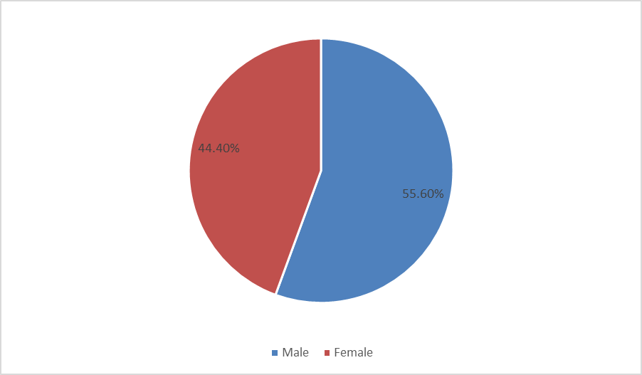

Table (4.1.2) Age bracket of the Respondents.
Age brackets | Frequency | Percentage
(10-18) | 10 | 11.1%
(19-30) | 40 | 44.4%
(41-50) | 35 | 38.9%
(61-71) | 05 | 5.6%
(71 +) | - | -
TOTAL | 90 | 100
(Source: Field Date, 2021)
It has been indicated that there were four age bracket that participated in the study and the dominant one revealed by the study was (19-30) represented by 44.4%fact that could hand arisen because of the fact that world vision employs mainly the youth educated up to university level who must have been among the participants of the study. However, other age brackets also had a big hand in contributing towards the success of the study. Specifically, the respondents of the age group (10-18) forming 11% were some of the children who are being helped by World Vision and so were those 5.6% of the age group (61.70). but respondents of age group (71+) were met available neither did they participate in the study.

Figure (4.1.2) Age bracket of the Respondents.
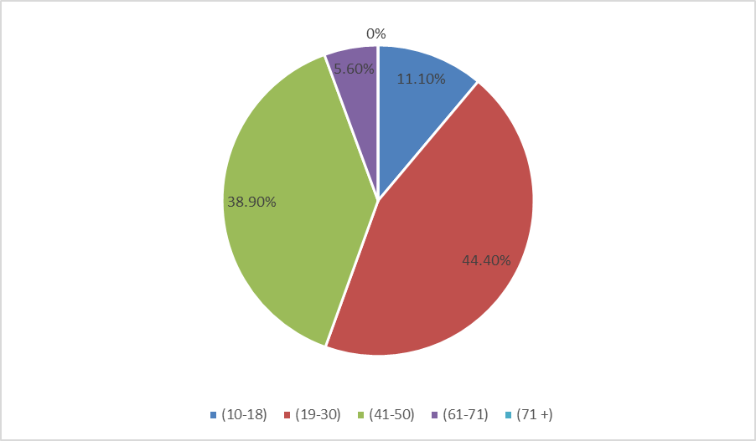
Table (4.1.3) marital status of the respondent.
Marital status | Frequency | Percentage
Married | 45 | 50%
Unmarried | 40 | 44.4%
Others | 05 | 5.6%
TOTAL | 90 | 100%
(Source: Field Date, 2021)
The findings presented in Table (4.1.3) revealed that 50% of the respondents who participated in the study were married people and followed by 44.4% of these who were met married. The other 5.6% respondents could have been spiritual and Bachelors who have never got married, and at the same time they within 5.6%, there could also have been students below or above 18 years who were beneficiaries of the World Vision Project in the study area, and whose views was also good to be used in examining corporate social responsibility and corporate identity.
Figure (4.1.3) Marital status of the respondent.

Table (4.1.4) Level of Education of the Respondents
Level of Education | Frequency | Percentage
Doctorate | - | -%
Masters | 05 | 5.6%
Degree | 25 | 27.8%
Diploma | 20 | 22.2%
Certificate | 40 | 44.4%
TOTAL | 90 | 100%
(Source: Field Date, 2021)
The findings of the study indicated that the majority of the respondents were educated at least up to a certain level. In particular, most of them, 40% had wither a certificate or non. This result addresses the type of all-inclusive participation in the study regardless of the level of education. This was because to examine corporate social responsibility and corporate identity of world vision, at least a representative from al beneficiaries was a participant. This would help clear the doubt about the outcome of the results.

Figure (4.1.4) Level of Education of the Respondents
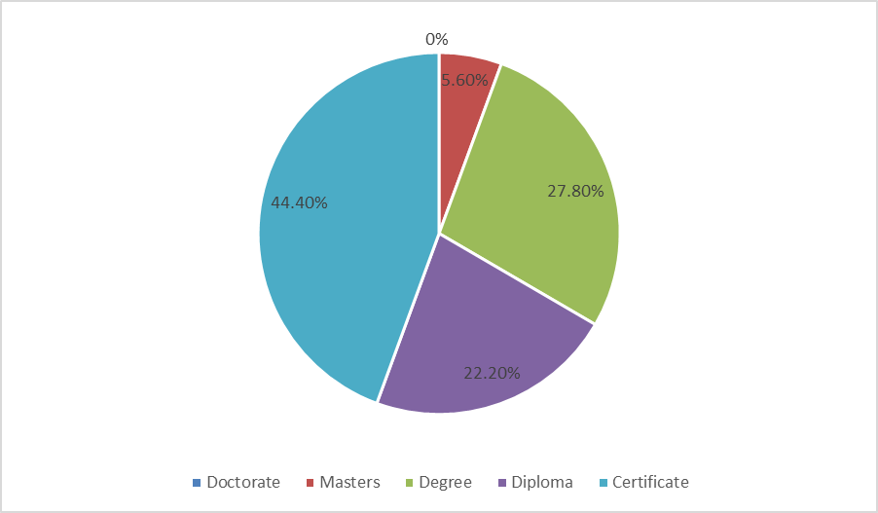

Section B: How Human Transformation Influences Corporate Identity
This section analysed whether the respondents know what human transformation is all about and starting the forms of human transformation.
Marty Resnick (2019) defines human transformation as the “enhancement of the human to increase their capabilities and expand their capacity (Physically, cognitively and behaviorally) through the use of technology and science”. Cognitive is the essence that it is enhancing a human’s ability to think and make decisions.

Table (4.2.1) Do you know what human transformation is all about?
Response | Frequency | Percentage
Yes | 45 | 50%
No | 40 | 44.4%
Others | 05 | 5.6%
TOTAL | 90 | 100%
(Source: Field Date, 2021)
The results presented in the table discloses that most respondents of the study know about human transformation. Although there is also a big number which does not know what it is about and even if it is added to other which is 5.6%, it does not change the results. The other” category would be these respondents who did not have any challenge about the meaning of human transformation and they were totally ignorant about what is going on.

Figure (4.2.1) Do you know what human transformation is all about?
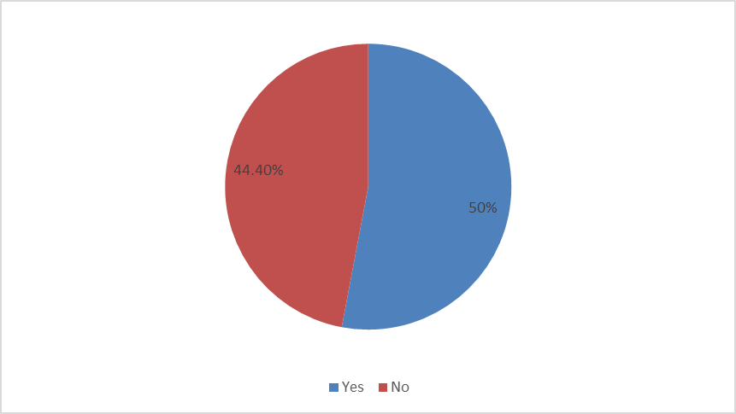
Table (4.2.2) Characteristics of Human Transformation Promoted
Characteristics | Frequency | Percentage
Wealth care | 10 | 11.1%
Economic sustainability | 25 | 27.8%
Awareness | 20 | 22.2%
Education | 30 | 33.3%
Others | 05 | 5.6%
TOTAL | 90 | 100%
(Source: Field Data, 2021)
The findings in Table (4.2.2) has revealed that World vision areas engaged in very many activities that transform the lives of the local people. Accordingly, education which is 33.3% which is the highest percentage shows that world vision give education to the children and this is also in connection with spiritual transformation. The least percentage was indicated by “others’, implying that there are many other activities carried out by world vision that necessitates human transformation. A respondent among others. Reiterated the importance of world vision to the local people saying that, in the World Vision has palled us from far. We were very poor, but now at least are can afford many good things for our lives indulging affording to take our children to school”. This statement really corresponds to world vision’s strategy to help people/ child to live their lives to its fullness. Besides, economic activity awareness and health care with 27.8%, 22.2% and 11.1% respectively are some of the activities that ascertain this achievement.

Figure (4.2.2) Characteristics of Human Transformation Promoted
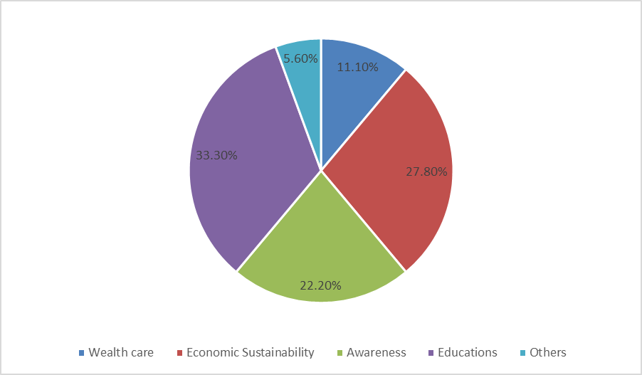

4.3 How Community Based Development Contribute Corporate Identity
In this section, knowledge about community based development and corporate identity area analysed.

Table (4.3.1) Do you know how World vision area CBD approach to achieve corporate identity.
Response | Frequency | Percentage
Yes | 45 | 50%
No | 40 | 44.4%
Others | 05 | 5.6%
TOTAL | 90 | 100%
(Source: Field Data, 2021)
The findings above clearly demonstrated by 50% that people know how world vision uses community based development to achieve corporate strategy. Although a good number of the respondents, 44.4% also denied knowledge of this even if added to the other category, it could not change the views of those who answered offered.

Figure (4.3.1) Do you know how World vision area CBD approach to achieve corporate identity. 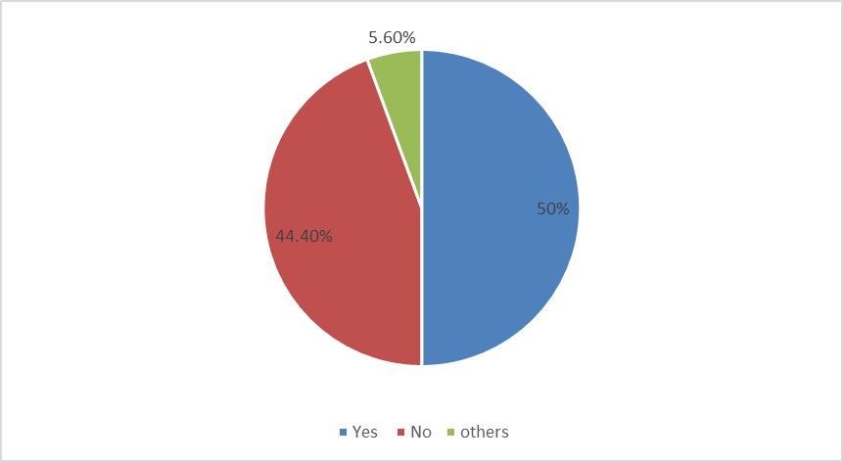
Table (4.3.2) World visions’ community based approach strategy.
CBD strategy | Frequency | Percentage
Partnership | 20 | 22.2%
Protection | 20 | 22.2%
Right to participate | 30 | 33.3%
Effective use of resources | 10 | 11.1%
Others | 10 | 11.1%
TOTAL | 90 | 100%
(Source: Field Data, 2021)
The findings in Table (4.3.2) clearly illustrates how world vision applies community based approach to development and accordingly, the respondents by 30% routed out that right to participate by community is the must practice approach by world vision by world vision. Others in order of the concerns by World vision thus, recognizing the local people has members, presentation of the members of the group, effectiveness of reweness by members, among others were some of the community based approaches used by world vision to achieve corporate identity. And one of the beneficiaries interviewed by the researcher commented that, “in fact this world vision is over own the project because are the planners and decision makes of the project”.
This was further authentication that community based development, was a strategy of World vision.
Figure (4.3.2) World visions’ community based approach strategy.
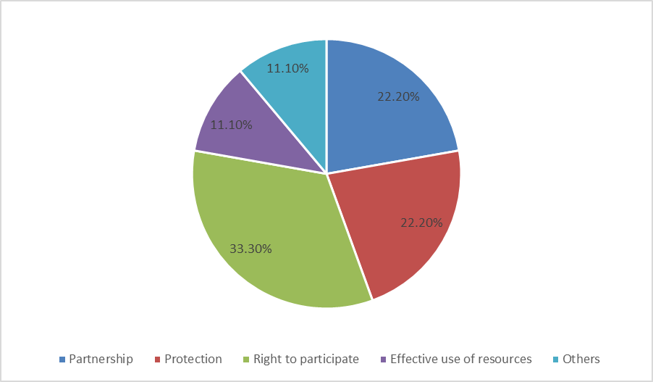

4.4 Promotion of Justice, Spiritual and Social Transformation
Whether the respondents were aware that world vision promotes justice, spiritual and social transformation, and the realization of the same are some of the analysis in this section.
Table (4.4.1) Are you aware that World Vison promotes justice, Spiritual and social transformation
Response | Frequency | Percentage
Yes | 45 | 50%
No | 40 | 44.4%
Others | 05 | 5.6%
TOTAL | 90 | 100%
(Source: Field Data, 2021)
The statistics in Table (4.4.1) above is a clear manifestation, first of all the respondents are conversant with these terms, and secondly, they are aware and empowered by world vision to know their rights. Half of the respondents, 50% indeed acknowledged their awareness of how World vison promotes justice, spiritual and social transformation, and although 44.4% and answered negatively, this did not change the results in any away. The 5.6% of the respondents could be the ones who were just ignorant of whatever of what is going on.
Figure (4.4.1) Are you aware that World Vison promotes justice, Spiritual and social transformation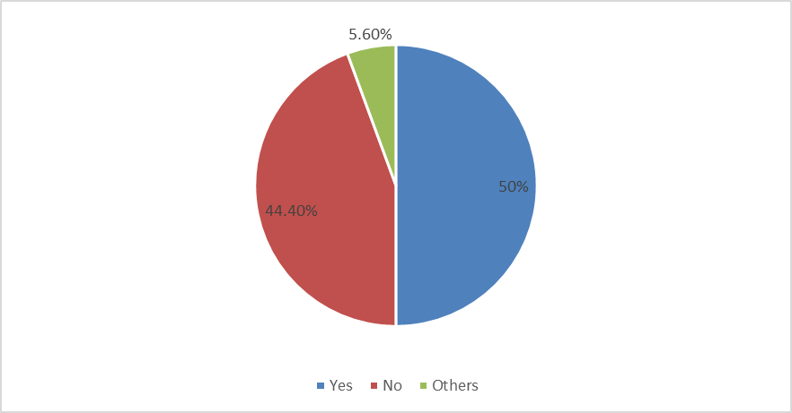
Table 4.4.2 Examples of forms of justice, spiritual and social transformation promoted by World vision
Response | Frequency | Percentage
Education reforms | 45 | 22.2%
Human rights | 40 | 33.3%
Gender Equality | 05 | 22.2%
Empowerment | 10 | 11.1%
Environmental protection | 10 | 11.1%
TOTAL | 90 | 100%
(Source: Field Data, 2021)
The Table above has identified the forms of justice, spiritual and social transformation being exhibited by World vision and according to the respondents 33.3% was the highest form of promotion in the local community by World Vision and this was Human Rights. This was followed by education reform, gender equality, empowerment and environmental protection consecutively by 22.2% and 11.1%. as a sign of evidence of the impact of the work in the study area by world vision, a woman interviewed by the researcher, castigated other none-governmental organisations for having not fulfilled their role in empowering people on gender equality, and she recommended world vision for having made a remarkable turn in that respect.
Figure 4.4.2 Examples of forms of justice, spiritual and social transformation promoted by World vision
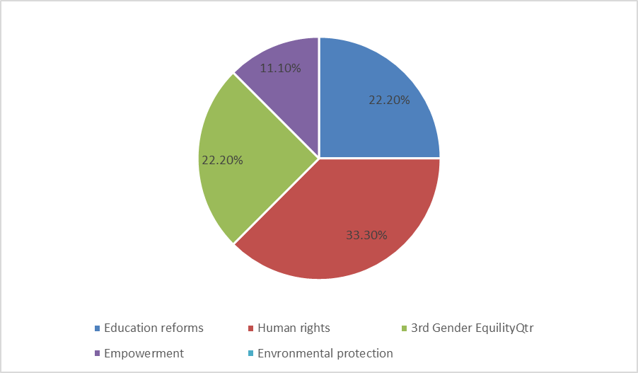

CHAPTER FIVE

SUMMARY OF THE FINDINGS

5.0 Introduction
Having presented, interpreted and discussed the results, this chapter has summarized the results basing on the objectives of the study, namely, Human transformation and corporate identity, community based development and corporate identity, and promotion of justice, spiritual and social transformation. In a nutshell the results have be summarized, concluded and recommendation was made as an afforded remedy.

5.1 Summary
Human transformation and corporate identity
With overwhelming majority, the respondents noted that the knew about, and from nowhere but from the activities of World vision. Given more time, the other respondents were also likely to become aware of human transformation as world vision continue to enrich more people they will also become beneficiaries.
To ascertain their knowledge about human transformation, the respondents were furtherable to enumerate the characteristics forms of human transformations where by education and economic sustainability were now mostly experienced/ realized by the respondents. The form human transformation like awareness, health care were also part and parcel of the positive improvement to the fulfillment of live among the population. In general, to some extent poverty have been because of human transformation now taking place among the local population there is an indicator of poverty reduction taking place and as such societal transformation as well.
Community Based Development Contribution to Corporate Identity
On the local extent, corporate identity is understood by the role and importance of an activity consumed from a corporate body. Thus the local community really cherished the usefulness of world vision in their area, and majority of them accept that the know how World vision’s service to them was very unique and extraordinary good compared to other civil society organisations. In respect to this they even able to narrate world vision’s strategies for community based development, whereby the one that ranked must was the right to participate in the community based development programs. The others mentioned were equally important such as working as partners with the development programs, protection of others of the same category effective use of resources, among others.
Promotion of Justice Spiritual and Social Transformation
The right of justice accomplishes the right to everything and coupled with spiritual transformation, wholly it is the gateway to social transformation, still conforming the role and importance of world vision in the area a bigger percentage of the respondents answer in the affirmative. The only challenges were that world vision could no place itself everywhere at the same time and this could have been the reason as to why also a good member of the respondents alleged they were met aware of the fact that World Vision’s promotes justice, spiritual and social transformation. Before the presence of world vision in the study area, the respondents alleged that the situation was very bad. People did not receive positive information about many things and they were totally ignorant. But now world vision has mobilized, sensitized and empowered people on issues of education, human rights, gender equality among others. Strictly human rights, which according to the respondents was very had in the area has now remarkably improved.

5.2 Conclusion
Without doubt, the study has proved that indeed corporate social responsibility has a big hard in achieving corporate identity. Because of the unique way of responding and handling societal problems by world vision, it has achieved corporate identity compared to other civil society organisations or NGOs. Better services were expected from other organisation also since as a result of this corporate identity competition was created within and from other NGOs and in the process excellence in service delivery prompts development in such areas that has been in total handicapped.

5.3 Recommendation
Therefore, is hereby recommend generally that despite this great success by world vision to achieve corporate identity, there are still so many people who have not benefited from this excellence because of one way or the other, the only effort to be made now is to leave no stone un-turned upside down like to this, world vision should now become an umbrella NGOs to other NGOs more especially to the indigenous ones by teaching them how to go about community development work. As world vision can perform this good tasks every here at the same time, other NGOs would help transfer these strategic skills to some areas as well.

REFERENCES

“Class passing: social Mobility in Film and Popular culture” foster, Cavendiolyn Audrey, Sept. 2005.
“Education and cultural capita’ Harker, R., 1990. An introduction to the work of Pierce Bourdieu: The Practice of theory.
Cabag; M., & Weaker, L. (2015) Collective impact 3.0; An evolving framework for community change. Canada: Tamarak institute
END POVERTY: Millennium Development Goals and Beyond -2015.
Ife, J,. (2016) Community Development in on uncertain World; Vision, analysis and practice (2nd – ed). Port Melbourne: Combridge University Press.
Kania, j., & Krammel, M. (2011). Collective impact. Standard social innovation review Winter, 36-41
Kenny, S. (2007). Developing Communities for the future (3rd ed.,) South Melbourne: Thompson.
Kenny, S. (2010) Developing Communities for the future (4th ed). South Melbourne: Thompson.
Learning to Not labor: How Working Class Individual Construct middle class Identities” Kanfman, Peter, Sociological Quarterly, Vol.44, No. 3, pp 481-504 summer 2003.
Matons Petr 92013).” The making and unmaking of community based – water supplies in Nanila” Development on Practice 92):217-231.
Price- Roberts on, R. (2011). What is community disadvantage? Understanding the issues, overcoming the problems Melbourne. Austration institute of Family studies.
Wallerstein, N. (2005). What is the evidence on effectiveness of empowerment to improve health? Copenhageni World health Organisation.

APPENDICES

APPENDIX 1: SELF -ADMINISTERED QUESTIONNAIRE FOR RESPONDENTS
I am OGWAL MOSES of Index No.2020/FEB/MPAM/M226448/DIST, a student of Masters in Public Administration and Management at Nkumba University carrying out a research study on the topic “Corporate social responsibility and corporate identify in Minakulu Sub-county, Oyam District.” You have been randomly selected to participate in this study and be rest assured that any information you will give, will be taken confidential and will be used for academic purpose only.
(Tick or fill in where necessary)
SECTION A: DEMOGRAPHIC INFORMATION
1. Sex gender of the respondent
a. Male

b. Female
2. Age bracket / Group of the respondents
a. (10-18)

b. (19-30)

c. (41-50)

d. (61 -70)

e. (71 above)

3. Level of Education
a) Doctorate

b). Masters

c) Degree
d) Diploma

e) Certificate
4. Marital Status
a) Single

b) Married

c) Unmarried

Section B: How Human Transformation Influence Corporate Identity
- You know what human transformation is all about?
Yes No Other

- Whether the answer is No or Yes, explain your answer,
………………………………………………………………………………………………………………………………………………………………………………………………………………………………………………………………………………………
- But if the answer is yes, State the forms of human transformation,
(a).………………………………………………………………………………………
(b)…………………………………………………………………………………………
(c)…………………………………………………………………………………………
(d)…………………………………………………………………………………………
- Any other Comment
………………………………………………………………………………………………………………………………………………………………………………………………………………………………………………………………………………………

Section C: How Community Based Development Contribute To Corporate Identity
- Have you ever heard about social corporate identify?
Yes No Other

- If the answer is No.5 above is yes, where did you hear about the two terms social corporate responsibility and corporate identity.
………………………………………………………………………………………………………………………………………………………………………………………………………………………………………………………………………
- If corporate identity is to out compete others or win a name state the signs of corporate identity.
………………………………………………………………………………………………………………………………………………………………………………………………………………………………………………………………………
- So, do you think that social corporate identity can win a name for a competing organisation.
Yes No Other

Section D: Promotion of Justice, Spiritual and Social Transformation
- Are you aware that World Vision promotes justice, spiritual and social transformation?
Yes No Other

- Whether the answer is yes or no, explain your answer,
……………………………………………………………………………………………………………………………………………………………………………………………………………………………………………………………………….
- The following are examples of justice, spiritual and social transformation, tick / chrase in order of priority as you experience it from world vision.
N.B Indicate 1st , 2nd , 3rd , 4th or 5th
a) Education reforms

b) Human rights

c) Gender equality

d) Environmental Protection

e) Empowerment

Any other comment ………………………………………………………………..
………………………………………………………………………………………………………………………………………………………………………………
(thank you for your invaluable support)

Appendix II: Interview Guide for the Respondents
I am OGWAL MOSES of Index No. 2020/FEB/MPAM/M226448/DIST, a student of Masters in Public Administration and Management at Nkumba University carrying out a research study on the topic “Corporate social responsibility and corporate identify in Minakulu Sub-county, Oyam District.” You have been randomly selected to participate in this study and be rest assured that any information you will give, will be taken confidential and will be used for academic purpose only.
(Tick or fill in where necessary)
- Have you heard about world vision?
Yes No Other

- If the answer is yes where did you hear it form?
- If it is here present in your area, when did it last came to this place?
- What activities that it carry out in the area?
- Based on No. 4 above, what negative thing has world vision displayed in the area?
- It there are also positive ones state them.
- Do you the people in the area are positive with world vision being in the area.
Yes No Other

- If the answer is yes give a rating how?

- Very positive Positive Very negative Negative

- Explain your answer ………………………………………………………………
………………………………………………………………………………………
……………………………………………………………………………………………………………………………………………………………………………………………………………………………………………………………………….
- Any other comment …………………………………………………………………..
………………………………………………………………………………………...……...............................................................................................................................
………………………………………………………………………………………..
(Thank you for Your Response)

Appendix III: Check List for Group Discussions
I am OGWAL MOSES of Index No. 2020/FEB/MPAM/M226448/DIST, a student of Masters in Public Administration and Management at Nkumba University carrying out a research study on the topic “Corporate social responsibility and corporate identify in Minakulu Sub-county, Oyam District.” You have been randomly selected to participate in this study and be rest assured that any information you will give, will be taken confidential and will be used for academic purpose only.
Topics for discussion
- Year when world vision came to Minakulu Sub- country.
- Status of Peoples’ Socio- Economic States before the coming of World Vison to Minakulu sub-County.
- The activities the of World Vision from Which the local people have benefitted.
- What problems did the local people have before?
- How has World Vision improved on this problem today?
- Any other comment
(Thank you)

Appendix IV: Proposed Budget for the Research
ACTIVITY | COST/UGX
PHASE 1 : PRELIMINARY  - Internet access  - Photocopying and printing of relevant materials  - Transport and communication | 300,000  300,000  150,000 750,000
PHASE 2 : DATA COLLECTION  - Travel to field  - Visits to offices  - Photography  - Well bound draft research reports | 300,000  150,000  150,000  450,000 1,050,000
ANALYSIS AND PRESENTATION  Access and use of computer at any computer Centre  Purchase of stationary and other relevant materials  Typing and binding of draft copies to final copy  Miscellaneous | 150,000  150,000  600,000  150,000  1,050,000
Total | 2,850,000/=

Appendix V: Work Plan Time Table
ACTIVITIES | DETAILS | PERIOD
Preparation and Data collection | Designing of research proposal | 4 weeks (JULY 2021)
Data processing, analysis and interpretation | Editing and coding | 4 weeks (AUGUST 2021)
Report writing and submission | Writing of report on study findings | 3 weeks (SEPTEMBER-October 2021)
Report Presentation | Draft and Final Dissertation Report | 1 Week (LAST WEEK OF October-December 2021)

