THE ROLE OF FARMING METHODS ON INCOME OF SMALLHOLDER MAIZE
FARMERS IN NAKIFUMA SUB-COUNTY, MUKONO DISTRICT, UGANDA

BY
ISMAIL IDOW OMAR
2019/FEB/MNRM/M224803/WKD

A DISSERTATION SUBMITTED TO THE SCHOOL OF SCIENCES IN PARTIAL FULFILLMENT OF THE REQUIREMENTS FOR THE AWARD OF
MASTERS IN NATURAL RESOURCE MANAGEMENT OF
NKUMBA UNIVERSITY

FEBRUARY 2022
DECLARATION
I, Ismail Idow Omar, declare that this dissertation is my effort and has never been submitted to any other institution for the award of a degree.

Signature………………………………………..
Date……………………………………………

APPROVAL
I hereby declare that this report was directly done under my direct supervision and is authentic.
Supervisor’s Name: Mr. Jjagwe George

Signature…………………………………………. Date………………………………….

DEDICATION
I dedicate this work to my family; thanks for the support extended to me during the practicum period financially, morally, spiritually, and otherwise, without whom it would have been hard.

ACKNOWLEDGMENT
My thanks to the Almighty God, the Father for the kindness and grace He has shown me throughout this entire study period.
I would like to express my sincere thanks to my family members notably; my parents for all the encouragement towards my education especially in the trying period, my sisters and brothers for the moral, financial, and spiritual support without which it would have been hard to achieve this endeavor.
Special gratitude to my supervisor-Mr. Jjagwe George for the research guidance. Notable thanks to Matovu Baker who helped me in data collection and linking me to key informants in Mukono district respectively and Mr. Matovu Baker for the guidance on data analysis and report writing during the time of research

TABLE OF CONTENTS
APPROVAL ii
DEDICATION iii
ACKNOWLEDGMENT iv
TABLE OF CONTENTS v
LIST OF TABLES ix
LIST OF FIGURES/CHARTS/GRAPHS x
LIST OF ACRONYMS AND ABBREVIATIONS xi
Definition of key terms in the research xii
ABSTRACT xiii

CHAPTER ONE: INTRODUCTION 1
1.1 Background of the study 1
1.2 Problem Statement 3
1.3.0 Study Objectives 3
1.3.1 Specific Objectives of the study 4
1.4 Research questions 4
1.5 Scope of the study 4
1.6 Justification of the study 5
1.7 Significance of the study 5
1.8 Conceptual framework 6
1.8.1 Discussion of the conceptual framework 7

CHAPTER TWO: LITERATURE REVIEW 9
2.0 Introduction 9
2.1 Contextual perspectives on the importance of maize 9
2.2 Maize production in Uganda 10
2.3 Recent developments in Maize and Maize production strategies for Uganda 11
2.4 The Traditional and Modern Farming Practices Used By Small Holder Maize Farmers 12
2.5 The Challenges Faced By Small Holder Maize Farmers in Implementing Recommended Farming Practices In Maize Production 12
2.6 The Possible Measures by Farmers and Government to Address Challenges Faced By Farmers to Implement Recommended Maize Farming Practices 14
CHAPTER THREE: RESEARCH METHODOLOGY 17
3.0 Introduction 17
3.1 Research Design 17
3.2 Description of the Study Area 18
3.3 Study Population 18
3.4 Sample Size 19
3.5 Sample selection 20
3.5.1 Inclusion Criteria 20
3.6.0 Sampling techniques 20
3.6.1 Simple Random Sampling 20
3.6.2 Purposive Sampling 20
3.7.0 Data collection instruments 21
3.7.1 Document review 21
3.7.2 Questionnaire 21
3.7.3 Interview Guide 21
3.8.0 Data analysis 22
3.8.1 Quantitative data 22
3.8.2 Qualitative Data 22
3.9 Data Management, Processing and presentation 23
3.10 Validity of instruments 23
3.10.1 Reliability 24
3.10.2 Quality Control Methods 24
3.11.0 Ethical Considerations 24
3.11.1 Institutional consent 25
3.11.2 Informed Consent 25
3.11.3 Privacy and confidentiality 25
3.11.4 Beneficence 25
3.11.5 Re-imbursement/compensation 25
3.11.6 Respect for community and community safety 26
3.12 Limitations of the Study 26
3.13 Dissemination 27

CHAPTER FOUR: RESEARCH FINDINGS, DATA ANALYSIS AND INTERPRETATION 28
4.0 Introduction 28
4.1.0 Demographic characteristics of Respondents 28
4.1.1 Location of participants in the study 28
4.1.2 Gender of participants 29
4.1. 3 Relationship between gender and level of education 29
4.1.4 Age of respondents 30
4.1.5 Tenancy status of smallholder farmers 31
4.1.6 Main maize varieties grown by farmers 32
4.2 Main farming methods used by smallholder maize farmers in Mukono 33
4.3 Effect of a farming methods on yields in Mukono 34
4.4 Income returns of smallholder farmers 35
4.5 Marketing and production challenges facing smallholder farmers 36
4.6 Perceptions farmers and government have advanced for betterment of their productive and marketing of maize. 37
4.6.1 Perceptions on strategies by government to boost farmers’ productivity and incomes 38
4.6.2 Perceptions of other strategies by other stakeholders to boost maize productivity and income 39

CHAPTER FIVE: DISCUSSION OF RESEARCH FINDINGS, RESEARCH CONCLUSIONS AND RECOMMENDATIONS 41
5.0 Introduction 41
5.1 Assessment of the farming methods used by smallholder maize farmers for increased production and income 41
5.2 Effects of maize farming methods on the harvests and incomes of smallholder maize farmers 41
5.3 Challenges faced by smallholder maize farmers during production and marketing 42
5.4 Perceptions being undertaken by farmers and government to address production and marketing challenges facing smallholder maize farmers. 43
5.5 Conclusion 44
5.5.1 Assessment of the farming methods used by smallholder maize farmers for increased production and income 44
5.5.2 Effects of maize farming methods on the harvests and incomes of smallholder maize farmers 44
5.5.3 Challenges faced by smallholder maize farmers during production and marketing 44
5.5.4 Perceptions being undertaken by farmers and government to address production and marketing challenges facing smallholder maize farmers. 45
5.6 Recommendations 45
5.6.1 Areas for further research 45
REFERENCES 46
LIST OF APPENDICES 54
Appendix I: Questionnaire 54
Appendix II: Interview Guide 61
Appendix III: Consent Form 63

LIST OF TABLES
Table 4.1: Location of participants 29
Table 4.2: Main challenges in the last season 38

LIST OF FIGURES/CHARTS/GRAPHS
Figure 1.1: Conceptual framework showing the relationship between the independent and dependent variables 8
Figure 4.1: Gender of participants 30
Figure 4.2: Level of education of respondents 31
Figure 4.3: Age of participants 32
Figure 4.4: Farmland Tenancy 33
Figure 4.5: Main maize varieties planted by farmers 34
Figure 4.6: Assessment of the main farming methods used by maize farmers 35
Figure 4.7: Examining the effect of a farming method on yields 36
Figure 4.8 Cost/Price of harvested maize/Kilogram 37
Figure 4.9: Knowledge of strategies to boost farmers’ productivity and incomes . 39
Figure 4.10: Government strategies to promote smallholder maize production and marketing . 40
Figure 4.11: Other main strategies to boost farmers’ productivity and income 41

LIST OF ACRONYMS AND ABBREVIATIONS
ACF Agricultural Credit Facility
AFI Alliance for Financial Inclusion
ASSP Agriculture Sector Strategic Plan
COVID-19 Corona Virus-2019
EPRC Economic Policy Research Center
FAO Food and Agriculture Organization
IMF International Monetary Fund
MAAIF Ministry of Agriculture, Animal Industry and Fisheries
MDIP Mukono District Investment Profile
MoFPED Ministry of Finance, Planning, and Economic Development
NAADS National Agriculture Advisory Services
NARO National Agriculture Research Organization
NGOs Non Government Organizations
SMEs Small and Medium Enterprises
SSA Sub Saharan Africa
UBOS Uganda Bureau of Statistics
UNCTAD United Nations Commission on Trade and Development
UNDP United Nations Development Program
USAID United States Agency for International Development

Definition of key terms in the research
a. Modern farming
Modern farming refers to any farming activity or practice that involves the use of fairly advanced farming techniques (DFID, 2009). In the developed world, modern farming involves the total use of modern technologies such as machines in the entire agricultural production chain (FAO, 2016). Thus, in the context of Mukono, modern farming will involve any farm activity that involves the use of any form of new technology such as use of watering cans, ox ploughs, or modern maize varieties by local farmers to boost production and income; than merely relying on nature.
b. Smallholder farmers
A smallholder farmer is any agriculturalist whose primary production process is carried out on a small piece of land below 5 acres (Mold, 2014). Thus, any farmer in Mukono who plants maize on a small piece of land of less than 2 acres will be considered a smallholder farmer.
c. Smallholding/Smallholder
It refers to any small farmland or any agricultural farm operating as a smallholder farmer agricultural model. In developing countries, smallholders mainly use less advanced farming practices; well as in developing countries, most smallholder farms use intensive technologies of production (FAO, 2016).

ABSTRACT
Maize farming among rural and urban smallholder farming has historically been the source of livelihood and incomes. Many rural people and governments are increasingly focusing on designing robust strategies to promote smallholder maize production and marketing involving a shift in technologies and reducing bottlenecks along the production chain. However, despite the great effort and frameworks, persistent bottlenecks exist in achieving this target. This conundrum formed the gist of this study that focused on assessing the farming methods used by smallholder maize farmers, effects of such methods on production and marketing, challenges facing smallholder maize farmers during production and marketing and strategies being adopted by farmers and government to reduce production and marketing challenges by farmers in Nakifuma Sub-County, Mukono district.
The study used a mixed research approach involving both qualitative and quantitative methods, where 384 local participants mainly women in smallholder maize farming and 10 key informants in Nakifuma sub-county including the Local Chairperson, and NGOs leaders among others were targeted for interview.
Study findings indicate that women form a higher proportion of the smallholder maize farmers and the traditional methods of farming are the ones mainly used to grow maize. The maize yields are very low (less than 1 ton/hectare per season) as reported by respondents; especially in Kasawo and Nagojje. The study also revealed that maize prices are still very low ranging from Shs. 200/= to Shs. 500/= which amounts to a maximum of Shs. 500,000/= that can be obtained from a hectare. However, despite the informal nature of farming, some farmers are transitioning to fairly modern methods which has been dotted with several benefits such as increased employment, better livelihoods, and increased yields (more than 1 ton/hectare/season). The current COVID-19 pandemic, expensive inputs and local taxes are some of the main challenges hampering smallholder maize farmers’ production and marketing of maize. To this end, stakeholders have developed strategies such as training on financial literacy, formation of SACCOs, setting up of rural farmers’ groups, and increasing rural roads networks for easy accessibility.
The study recommends that farmers should practice mixed methods of farming, growing of better varieties of maize that are favored by the prevailing local conditions and local government providing some easy access to some funds for farmers to enable them easily obtain agricultural inputs. Policies should be developed aimed at boosting on the marketing of the farmers’ produce by lessening on farmers dealing with middlemen who tend to benefit more.
Keywords: Farming methods, Maize, Traditional farming methods, modern farming methods.

CHAPTER ONE

INTRODUCTION

1.1 Background of the study
Maize is among the cereals produced by small holder farmers worldwide due to its demand as well as wider adaptability, hence the name the “queen of Cereals”.⁽¹⁾ Global production of maize in 2017 rose to 1.04 billion tones, with approximately 15% being sold on worldwide markets making maize second most traded agricultural commodity after wheat ⁽²⁾. Furthermore, maize represents one third of international cereals traded ⁽³⁾. As such, increasing the income of small holder maize farmers over the last few years resulted into the global stock-to-use ratio of about 25% leading to stabilizing consequence on maize prices internationally ^{(2,3)}. Meanwhile in the recent years, change has been observed in the pattern of output for maize and there is a divergence to some extent in individual regions of the world resulting from modern farming practices being exhibited by farmers ⁽⁴⁾.
Africa produces about one third of the global maize crop ⁽⁵⁾, and in 2018, maize production in Africa was approximately 75 million tons accounting for 7.5% of world production ⁽²⁾. About 24% of farmland in Africa is occupied by maize and the average yield is stagnated at approximately 2 tons/hectare/year ⁽⁶⁾. The largest African producer is Nigeria with over 33 million tons, followed by South Africa, Egypt, and Ethiopia ⁽⁷⁾. An estimated 208 million people in Sub Saharan Africa (SSA) depend on maize as a source of food security and economic wellbeing ⁽⁸⁾. Maize occupies more than 33 million ha of SSA’s estimated 200 million hectares of cultivated land ^{(2,3)}. Considering the low average maize grain yields that are still pervasive in farmers’ fields, meeting the projected increase demand for maize grain in Africa presents a challenge ⁽⁸⁾. In order to boost maize production new farming practices including; use of quality seeds, soil testing, fertilizer application, water conservation and farming machinery have been recommended ^{(4,9)}.
In East Africa, maize is the most essential cereal crop grown and consumed in the four largest countries found in eastern Africa ⁽¹⁰⁾. In 2016, East Africa attained a combined production of 17.2 million tons even when drought was ongoing ⁽³⁾. This production was nearly 50% more than the production that was being attained a decade ago. Within East Africa, Tanzania and Uganda have had approximately 70% increase in production since 2006 when they had only 27% ⁽¹⁰⁾.
Most studies in developed countries reveal that transition from traditional farm practices to intensive and commercialized farming involving use of modern machinery, value addition and supply chain systems greatly increases agricultural productivity and farmers’ incomes ^{(1, 2, 8, and 10).} Studies in the late 20th century document that the use of improved seed varieties and modern farming practices such as precision farming, advanced and efficient technologies are partly responsible for the rise of USA as a global food power ^{(1, 15).} In developing countries, the use of such technologies, especially on large scale farms mainly suits large investors and foreign capital inflows making it hard for local smallholder farmers fully adopt some technologies ^{(8, 15).} However, studies in sub-Saharan Africa on flexible farm technologies such as drip irrigation and communal use of farm machinery such as communal tractors, have documented that farmers yields increase by 20-30 percent when there is a relative shift to accessible and manageable agricultural technologies such as small irrigation farming, value addition, and use of high yielding crop varieties ^{(1, 2, 3, 7, 9).} Empirical studies in East Africa further show that smallholder farmers using relatively advanced methods of farming such as mixed farming, with relatively modern technologies such as irrigation, use of better seed varieties have increased yields per capita ^{(8, 9).}
This might partly explain the increase in production in East Africa. For instance, in Uganda, the total maize production has increased gradually over the years, from approximately 800,000 tons produced in 2000 to 2,575,000 tons in 2019 ⁽¹⁾. The increase in production is partly due to expansion of maize acreage, and not improved productivity ⁽¹⁾. The maize sub-sector in Uganda provides a livelihood for an estimated 5.7 million Ugandan farm households, approximately 3,000 traders and more than 70 exporters ⁽¹¹⁾. As such, maize is an emergent source of household income as well as foreign exchange through exports ⁽¹²⁾. Low productivity is one of the biggest challenges facing Uganda’s maize industry. The modern farming practices in Uganda such as use of quality seeds, soil testing, use of fertilizers, water drainage systems and mechanization have positively improved maize production among maize farmers ⁽⁹⁾ but unfortunately majority of Ugandan maize farmers live in absolute poverty including those from Mukono district ⁽¹³⁾. Maize productions are low in Mukono as compared to other similar agro-climatic districts in Uganda ⁽¹⁴⁾. Hence, this study will ascertain how modern maize farming practices have been taken up by farmers and how it has affected their income in Mukono district, using Nakifuma sub-county as a case study. The study will assess the different farming practices used to increase maize production the challenges faced, as well as the farmer possible solutions in use.

1.2 Problem Statement
The Agriculture Sector Strategic Plan (ASSP) 2015/16-2019/20 revealed that maize production in 2014 was 2.9 million metric tons with low yield levels that ranged between 2.2-2.5 tons per hectare and Mukono district was among the most affected districts in Uganda. This rate of production was very low when compared to the potential yield of 5 tons per hectare ⁽¹⁵⁾. The above problem is magnified by the ever increasing population which competes for the land which is fixed ⁽¹⁶⁾. Additionally, over 90% of Uganda's maize is produced by smallholders who consume about 60% of their total maize production ^{(8).} Thus, increasing maize production requires farmers to adopt new technology and farming practices ^{(2,8)} as lack of appropriate and feasible technologies coupled with poor operational skills of farmers constrain maize production in Uganda ⁽¹⁾.
However, this can only be achieved by first establishing the production technologies and adoption of better farming methods used by farmers and addressing the production inefficiencies if any.
This study therefore, assessed how farming practices have influenced maize production in Nakifuma sub-county in Mukono, what constraints farmers face during maize production and the likely strategies the central government is putting forth to enable the farmers overcome the faced bottlenecks.

1.3.0 Study Objectives
- The main objective of this study was to understand the role of the different maize farming methods on smallholder farmers’ production and how they have improved income among smallholder farmers in Mukono District.

1.3.1 Specific Objectives of the study
- To find out the farming methods used by smallholder maize farmers for the production of maize and income generation in Mukono District.
- To determine the effect of the different farming methods on the yields of maize in Mukono District.
- To examine the challenges the maize farmers face during the production and marketing of maize in Mukono district.

1.4 Research questions
The following research questions were addressed to achieve the study objectives
- Has the use of different farming methods by smallholder farmers in Mukono improved their yields?
- Is there a relationship between a given farming method used and the level of maize production?
- Which of the said challenges has/ have highly affected maize productivity and farmer incomes?
- Are there strategies by smallholder farmers and government to address the challenges facing smallholder farmers?

1.5 Scope of the study
The study was conducted in Mukono District found in the Buganda Sub-Region of Central Uganda. Mukono District is bordered by Kayunga District to the north, Buikwe District to the east, Kalangala District to the south-west, Kira Town and Wakiso District to the west, and Luweero District to the north-west. The study was conducted from May-July 2021 in Nakifuma Sub-County because the researcher believed the allocated time was ample to collect sufficient data which was useful in answering the research questions and achieving the specific objectives of the study.

1.6 Justification of the study
The inappropriate and rudimentary technologies coupled with the poor operational skills of users remain the main constraints to the production of maize in Uganda ⁽¹⁾. Small holder maize farmers in Mukono continue to count losses due to the low yields from maize production and this could be attributed to underutilization of modern farming practices by the small holder famers ⁽¹⁷⁾. Moreover very little is known about the challenges faced by maize small holder farmers in Mukono district while implementing the recommended maize farming practices. As such, the proposed study is timely to examine the role of the different maize farming methods on farmers’ income and produce in Mukono and what can be done to address the challenges that lead to ineffective adoption.

1.7 Significance of the study
The study will provide empirical evidence on the role of modern farming practices in maize production in Mukono District. The findings will be used by among others National Agriculture Research Organization (NARO), National Agricultural Advisory Services (NAADS), government, MAAIF, academicians, farmers and the development partners to understand the actual modern farming practices used and why, challenges faced by farmers and solutions to the challenges faced by farmers while implementing modern farming practices in maize production. Specifically, the above will benefit from the study as explained below;
NAADS: Findings of the study will help NAADS officials in identifying the actual methods used, why used and what needs to be done and how to help farmers adopt better farming practices to increase maize production and productivity.
Policy Makers: The study will provide deeper insights into challenges being faced by small holder maize farmers in implementation of the recommended maize farming practices. Therefore, the information gained from the study will help policy makers for MAAIF to develop policies that favor farmer adoption of modern farming practices in order to increase maize production.

Academicians: The study findings will also be of practical importance to academicians. When the study results are published in peer review journals, academicians conducting studies on topics related to the current study can benefit by using results obtained from this study as a reference.
Development partners: The study findings would be of importance to some development partners who are the major funders and partners of the government Agricultural programs targeting improvement of maize production among small holder farmers in Uganda. Such development partners will use the findings from the study as bench mark when providing agricultural support to maize farmers in Mukono district. As such, the development partners will benefit by achieving their targets and getting more funds from the donors. Also, the results of the study could prompt the development partners and NGO’s to conduct a wider study which will cover many districts of Uganda.
General public and other stakeholders: The study findings will help to provide information to farmers, local community and general public about the modern farming practices for sustainable production of maize.

1.8 Conceptual framework
A conceptual framework is a diagrammatic representation of variables in a study, their operational definition and how they interact in a study ⁽⁵²⁾. The framework below is an illustration of modern farming practices coupled with other possible underlying factors that influence increased maize production and incomes for small holder maize farmers. The independent variables are grouped together at the top but not in any order of importance. The dependent variable is placed at the bottom, connected with arrows as a sign of direct relationship.

Independent variable
Intervening variables:
Reliable rainfall
Use of new production practices
- Use of improved maize seed variety
- Use of fertilizer/manure
- Use of pesticides
- Using right number of seeds
- Use of machinery
- Planting in lines

Demographic factors
- Age
- Gender
- Education level
- Farm size

Moderating variable:
Government policies
Access to extension services
- Level of adoption of new technologies
- Level of access to information

Dependent variables:
- Increased production and farmer incomes

Figure 2:1 Conceptual framework showing the relationship between the independent and dependent variables
Source: Adopted and modified from Simiyu, 2014 framework on factors influencing maize production among small scale farmers ^{(53).}

1.8.1 Discussion of the conceptual framework
Use of modern farming methods such as application of fertilizer, planting improved maize varieties, use of machines, using the right number of seeds and good spacing among others have a great bearing on yields realized and so farmer incomes.

The influence of farmer characteristics and farm attributes also influence productivity and income. For example, studies in Eastern Africa report a positive and significant relationship between farm yield and access to extension services ^{(8).} This attribute helps farmers to access new information and also adopt new technologies as well as acquire farm inputs for better yields. Age, farm size, gender and level of education of the farmer involved also plays a positive role in increasing household output. Young farmers are more likely to adopt a new technology because they are more open to attitude change than older farmers ⁽⁵³⁾. Similarly, education enhances the allocative ability of decision makers by enabling them to think critically and use information sources efficiently. Farmers with more education should be more aware of more sources of information and more efficient in evaluating and interpreting information about innovations than those with less education.
Other factors though not directly related to the study for example government policies, community attitude and weather conditions will also affect farmer productivity and incomes. For example, a study in Kenya found out that a unit increase in the mean precipitation had a considerably favorable impact on yield while a decrease in precipitation had a negative impact on the yield of maize farmers and so their income ^{(8).}

CHAPTER TWO

LITERATURE REVIEW

2.0 Introduction
In this section the already existing knowledge regarding this research was covered. The aim was to enable the researcher reveal what is already known and the knowledge gaps which the study seeks to fill.

2.1 Contextual perspectives on the importance of maize
In terms of acreage and production, maize is among the most important cereal crops grown worldwide. In the year 2016/2017, global production of Maize was about 1040 million metric tons with 38% and 23% being contributed by USA and China respectively ^{(2,3)}. In India: after rice and wheat, maize is the 3rd most important cereal with nearly 15 million farmers being involved in maize cultivation ⁽¹⁸⁾. Andhra Pradesh is ranked first in maize production in India followed by Karnataka with per cent share of 20.9 and 16.5, respectively ⁽¹⁸⁾.
Maize can be grown successfully in loamy sand to heavy clay, well aerated, neutral pH soils. As such, farmers should avoid cultivating maize in low-lying or poor drainage fields ⁽¹⁹⁾. Furthermore, maize crop is affected by prolonged low temperature which is less than 5°C though 25 - 35°C is the most favorable range of temperature for better crop growth that leads to yield realization ^{(4,8)}. Since it is a day neutral crop, maize has the potential of being planted two times in a year thereby leading to high yield levels within short periods of time ⁽²⁰⁾. This implies that when appropriate technology is used, then the farmers are capable of attaining wide margins of profits from maize production.
Considering the 23 countries globally which have the highest per capita consumption of maize as food, 16 are in SSA. Maize is estimated to provide 50% of the calories in diets in southern Africa, 30% in eastern Africa, and about 15% in west and central Africa. More than 300 million Africans consume maize as their staple food. The maize grains are known to be rich in vitamins A, C and E as well as carbohydrates, essential minerals and contain 9% protein. Important to note is that maize grain is also rich in dietary fiber ⁽²¹⁾.

2.2 Maize production in Uganda
Although maize is among the crops which have been grown for a long time in Uganda, nevertheless, unlike in neighboring countries like Kenya, Tanzania and others it does not constitute a main part of the population’s traditional diet, on the other hand it is grown primarily for generation of income, instead of food security ^{(7,8,10)}. However, the cost of cultivating traditional staple foods like Matooke has impacted on increasing maize consumption, particularly in urban areas as Kampala alone is responsible for approximately 50% of formal trade in maize ⁽²²⁾.
Traditionally, Uganda’s small-scale farmers produced maize both for food and for income generation ⁽²³⁾. The main production agro-ecological zones of maize crop are in the west, east, north and southeast Uganda with the Eastern region accounting for over 50% of annual production ⁽²⁴⁾. Maize occupies around 1.5 million hectares of land being the third most planted crop after banana and beans. Evidence has it that in some regions of the country, the crop has eventually become a staple food, substituting crops such as sorghum, millet, cassava and banana. Maize is considered a major source of income in the districts of Kapchorwa, Mbale, Iganga, Masindi and Kasese, with about 75–95 % of the household harvest being sold for the purpose of earning money ^{(2,25).}
Maize export market for Uganda is predominantly regional, encompassing markets in Eastern and Southern Africa, Southern Sudan and the Democratic Republic of Congo ⁽²⁾. Maize being exported to Kenya alone almost more than doubled from 2010 to 2014 ⁽¹⁵⁾. The export potential for maize in Uganda is estimated between 200,000 and 250,000 MT per annum (USAID, 2010). On the other hand, the country has only been able to formally export half of this amount, which reflects a low level of penetration into the regional markets resulting from poor rural road network, and inadequate business exposure ⁽²⁶⁾ much as maize is sold across borders through Mutukula for Tanzania, Gatuna for Rwanda, and Busia for Kenya which is an opportunity for small holder maize farmers to benefit ⁽³⁾.

2.3 Recent developments in Maize and Maize production strategies for Uganda
Uganda has registered an increment in adoption of agricultural technology but given the high levels of poverty faced by numerous smallholder farmers within the country, farmers may only need to be trained on how to use resources which are locally available to boost production ⁽²⁷⁾. For example, many smallholder farmers may not be in position to afford pesticides or artificial fertilizers. However, they mix shrubs with hot pepper together with animal urine to use as pesticides, and this practice works for them whereas others make use of organic and composted manure on their gardens ⁽²⁸⁾.
A number of productivity-enhancing technologies including high-yielding crop varieties and land management techniques have been developed and released by the Ugandan National Agricultural Research System (NARS) during the past 100 years of agricultural research in Uganda ⁽²⁹⁾. However, because of the low uptake of these technologies, farmers’ yields of most major crops are low (typically less than one-third of potential yields found on research stations) and have remained stagnant or deteriorated during much of the 1990s ⁽²⁹⁾.
Despite the efforts which have been geared towards maize production in Uganda, there still exists low production due to the fact that the technology implemented is not appropriate in maize production ⁽¹⁷⁾. For new technologies to be available to farmers, dynamic agricultural research programmes that take into account the needs of client farmers, as well as extension services that work actively with farmers as they learn about new practices of maize cultivation, are necessary ^{(30, 10)}.
Maize production in Uganda is being held back by numerous problems. Abiotic stress is one set of challenges since most maize cultivation in the developing world relies on rainfall making the crop predominantly vulnerable to drought and heat ^{(5,29)}. According to current estimates, approximately 25% of maize production is susceptible to frequent drought ⁽³¹⁾. It is accepted widely that these stresses are going to become more serious due to climate change, leading to a probable loss of up to 10% in maize production both in Africa and Latin America by 2055 ⁽³¹⁾. Poor/degraded soil quality is another abiotic stress which is also seen as a noteworthy contributor to poor yields ⁽⁵⁾.

2.4 The Traditional and Modern Farming Practices Used By Small Holder Maize Farmers
There has been a recommendation of an array of production technologies for maize crop, ranging from land preparation to harvesting ⁽³²⁾. Small holder farmers are responsible for production of over 90% of Uganda's, with about 60% of the yearly maize output being consumed on the farm ⁽²⁾. The production intensity looks to be a function of the position which the crop holds in the food system and the marketability of the crop ⁽³⁾.
Given the linkage which exists between agricultural productivity and poverty, and since agricultural growth can be augmented significantly through utilization of modern farming methods, the possibility for sustainable reduction of poverty is linked to the capability to transform agriculture so as to escalate productivity ⁽²⁰⁾. Therefore, the agricultural sector offers an enormous opportunity for reduction of poverty in Uganda.
The fluctuating and deteriorating growth of the agricultural sector in Uganda shows the sector’s low level of sustainability ^{(27).} People produce only what can sustain them for a short time, but thereafter go hungry again. This pattern can- not aid the achievement of sustainable development. Efforts need to be made to enable the growth of the agricultural sector beyond mere sustainability towards sustainable development ^{(8, 29).} Per capita food production in Uganda is much more variable than the average for sub-Saharan Africa, largely as a result of lack of irrigation ^{(8, 3).}

2.5 The Challenges Faced By Small Holder Maize Farmers in Implementing Recommended Farming Practices In Maize Production
Global production has not been able to meet the increasing demand for food because food insecurity is principally a problem associated with access to the resources as well as services required by families to produce, buy or to obtain adequate nutritious food ^{(25).} The inadequate production largely owes to the low utilization of modern farming practices in most parts of the world ^{(16, 33)}.
In Africa, the productivity of agricultural sector much lags behind other regions ⁽¹²⁾. There 33 million farms of less than 2 hectares in Africa accounting for 80% of all farms ⁽³⁴⁾. Based on premises that the farming system relies predominantly on family’s capital and labor force for production, the overall productivity is low ^{(12, 34)}. These make it hard for subsistence farmers to significantly implement the recommended farming practices in maize production because they have access to pieces of land which are too small ⁽³⁵⁾.
In developing countries, maize together with rice and wheat offers at least 30% of the required food calories to over 4.5 billion people living in 94 developing countries ⁽³⁶⁾. These comprise of 900 million people who are poor consumers regarding maize as the preferred staple food ^{(8,36)}.
In the developing world, low and lower middle income countries are responsible for about 67% of the total maize; therefore, millions of poor farmers earn livelihoods from maize ^{(5, 2)}. It was projected that by 2020, the world would have around 7.7 billion people and by 2050 the figure will be approximately 9.3 billion between which the demand for maize will double in the developing world ⁽³⁷⁾.
Notwithstanding the farm sizes, the maize yield levels in Uganda’s are low and are usually between 1.0 and 1.8 metric tons/ hectare with up to 80% of losses arising from crop failure due to drought ⁽²⁴⁾. The problem has a high magnitude in districts like Kasese where losses can go to catastrophic levels with other drought-prone regions comprising of eastern, northeastern and northern Uganda ^{(3, 24)}.
Poverty is a big problem barring small holder farmers from implementing recommended farming practices in maize production and it stems from the fact that a vast majority of Uganda’s labor force is employed in agriculture, a sector which receives less than half of the total income (GDP) in the economy ⁽³⁸⁾. As such, this has been mainly ascribed to low productivity of agricultural sector ⁽³⁸⁾.
Finally maize cultivation is faced with a challenge of lack of resources as well as training for smallholders ^{(2, 8, 38)}. These constraints stretch to include limited access to better-quality varieties and improved quality seeds, inadequate access to regularly expensive fertilizers and pesticides, meager dissemination of good agricultural practice, small-scale mechanization aimed at replacing manual labor, and remarkable post-harvest losses resulting from poor storage, attack from pests and spoilage ⁽¹⁷⁾.
There is change being experienced in the nature of the demand for maize as it has been a significant food crop nevertheless its demand as livestock feed over the past decade grown enormously ⁽³⁹⁾. The driving force behind this has largely been the swift economic growth regions which are densely populated in Latin America, Asia and the Middle East thereby resulting to amplified demand for poultry and livestock products from more wealthy consumers ⁽⁴⁰⁾.
Maize grain is a fundamental constituent in animal feed which puts an added demand for maize thereby driving up prices of maize grain on the market ⁽³⁾. As such, poor consumers in various regions of the world are finding maize less affordable for them ⁽⁴¹⁾. There is a tremendous growth in the maize feed market in countries like China and India, having many who are able to afford meat, milk, and eggs due to economic progress ⁽⁴²⁾. Swift development taking place in these countries has also driven up the demand for maize which is used in agro-industries as a raw material and this is evident in USA where maize is a fundamental ingredient in the bioethanol program ⁽⁴³⁾.

2.6 The Possible Measures by Farmers and Government to Address Challenges Faced By Farmers to Implement Recommended Maize Farming Practices
A widely accepted notion is that small holder farmers can achieve increment in production by improving yields as opposed to clearing more land for cultivation ⁽⁴⁴⁾. There is growing competition for land, water, labor and other resources even in those areas where all suitable land is not already under cultivation in addition to increasing concern about the effect of deforestation as well as land clearance on the quality and fertility of land (for example due to problems like erosion, acidification and salinity), climate change and biodiversity ⁽⁴⁵⁾. Consequently, there is need to increase yields by striving to make agriculture more effective, profitable and sustainable, predominantly for smallholders staying in regions such as sub-Saharan Africa which have a mixture of a high dependence on maize for food with low levels of productivity and agricultural systems which are more vulnerable ^{(5, 37)}.
The government of Uganda launched a plan known as the modernization of agriculture (PMA), on a mission to eliminate poverty through changing subsistence agriculture to commercial farming by re-orienting the production of poor subsistence farmers towards the market ⁽²⁷⁾. A recognition from the government is that the success of PMA depends on the acceptance of improved agricultural technologies by a substantial section of farmers in order to increase total factor productivity as well as farm income ⁽²⁷⁾. In this regard, the government has among other things made a resolution to back the process of generation, dissemination and adoption of technologies which are productivity-enhancing ^{(8).}
A measure which can be undertaken by the government is introduction of weather index insurance which partially protects farmers from climate variability as well as partially compensates for the negative impacts of drought. Precisely, the index insurance would cover the costs of irrigations in years when farmers are hit by drought thereby enabling farmers to implement the recommended farming practices leading to high yields ⁽⁴⁶⁾.
The small holder farmers can be connected to large business farmers by means of mutually beneficial contract farming otherwise known as out-grower schemes which enable farmers to access to inputs, end-markets, financing, and their involvement in agriculture value chains ⁽⁴⁷⁾. This is in congruence with a study in 2016 which ascertained that investments in technology and innovation is required for a comprehensive transformation of the agricultural sector in Africa towards agro-industrialization requires so as to improve the productivity of both land and labor ^{(33).}
The use of Internet could be an important measure which would improve integration into value chains the traceability of food and animals. This measure involves displaying the lot number and the name of the production facility on the case of each product and having this information recorded on invoices and bills of lading ^{(33, 8)}.
Commercialization can be facilitated by innovation which would in turn enhance the access of farmers to broader markets and financial systems thereby promoting the utilization of recommended maize farming practices ⁽⁴⁹⁾. According to Moyo, Bah, & Verdier-Chouchane (2015), this innovation will ultimately give room for the formation of modern incorporated agribusiness economies of value chain which is grounded on specialization ^{(33).} Remarkable changes have already been caused in agribusiness in Africa by domestic and international private investment in the agricultural sector with positive effects being observed on revenues of smallholder farmers and productivity ⁽⁵⁰⁾.
Uganda has had low adoption and use of modern agricultural technology, which has contributed to low productivity growth. The government of Uganda is, however, trying to tackle this through the implementation of the National Agricultural Advisory Services (NAADS), established in 2001 as a public-private approach to extension service delivery. One of NAADS’s key objectives is promoting food security, nutrition and household incomes through increased production and market-oriented farming ^{(51).}

CHAPTER THREE

RESEARCH METHODOLOGY

3.0 Introduction
This chapter presents the design, area of study, study population, sampling procedures, data collection methods and tools, quality control methods, data management and analysis, ethical considerations that will be followed in the course of data collection. It further explores the limitations that the researcher encountered in the course of data collection.

3.1 Research Design
A study design is an overall plan and strategy for conducting research; it is a master plan specifying the nature and pattern the research intends to follow while carrying out the research study to ensure that sound conclusions are reached ⁽⁵⁴⁾. This was a descriptive cross sectional study which utilized both quantitative and qualitative methods of data collection. Several authors such as Creswell express that such design seeks to interact with the respondents in their natural situation without altering any of the living conditions ⁽⁵⁵⁾. To achieve the research objectives, descriptive cross sectional design was used to explain the use of the different farming methods in maize cultivation, what has worked well for farmers, establish what has failed and why as well as what farmers have done to change the status-quo ^{(52).} This study design also allowed the researcher to examine the challenges faced by small holder maize farmers in implementing the best farming practices in maize production and the possible solutions.
Additionally, the design was chosen because it allows collecting data from a relatively large number of respondents at a particular time ⁽⁵⁶⁾.
Quantitative methods of data collection were used to gather the data required for this study and Questionnaires were the chief tool for data collection.

3.2 Description of the Study Area
This study was carried out in Mukono district because agricultural statistics and Uganda demographic statistical reports highlight that it is one of the main maize growing areas with a large proportion of people growing maize on small holder farms ^{(57).} Mukono district lies in the central region of Uganda, sharing boarders with the Buikwe district in east; Kayunga along River Sezibwa in the North, Luweero in the North West; Kampala and Wakiso in the south west; Tanzania-lake Victoria in the south with the Island of Buvuma District ^{(58).} The district has a population of 596,804 persons with 289,757 males ^{(59).} Mukono district has a total area of 2,986.47 Sq. Km, most of Mukono District lies on a high plateau (1000-1300 Meters above Sea Level). The rainfall in the district is bi-modal with peaks in March-May and September- November ⁽⁶⁰⁾. Both relief and the climate provide a good potential for investment in cash and food crop, horticulture and floriculture on a commercial basis.
The main economic activity is subsistence agriculture and the major crops grown include; maize, cassava, sweet potatoes, millet, ground nuts, peas, soya beans, bananas, Simsim; yams; fruits and vegetables. Partial commercial agriculture exists with farmers like SCOUL sugarcane plantations, cotton and coffee growers as well as tea estates in Numa and Nagojje sub-counties.

3.3 Study Population
The study population can be defined as the total collection of elements which one would like to study or make inferences ^{(52).} The target population comprised small holder maize farmers in Nakifuma Sub County found in Mukono district. Nakifuma Sub County constitutes the largest proportion of households engaged in maize growing at 30,024 households accounting for 67.2 percent of the agricultural households in the sub-county ^{(61,} ⁶²⁾. Additional information will also be collected from; the Community Development Officers (CDO), Agricultural Extension Officers (AEOs) the parish chiefs and members from Non-Government Organizations (NGOs) that run agricultural and environmental programs in Mukono district. Such organizations included; SSAMBA foundation, CARITAS and Mercy Corps.

3.4 Sample Size
According to authors Cohen, Manion, & Morrison (2013), a sample size is in a way determined by the style of the research ^{(63).} In a survey study, it would be required to obtain a representative sample of the population to help in the generalization of the study findings. For this study the sample size was obtained using Charan & Biswas (2013) sample size method ^{(52).} This method was used in this study because it is accurate in determining single proportion sample sizes most especially when a similar study has not been done before in the same geographic region. The formula was therefore presented as follows.
The following formula was used for determining study sample.
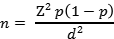
Where: n is the sample size
Z is the standard normal deviate or variant (at 5% p<0.05, Z is 1.96)
P is the expected proportion of characteristic being measured in the target population based on previous studies (For this study, it is estimated at 50% or 0.5) since no similar study was done in a local context
d is the absolute error or level of statistical significance (For this study set at 0.05).
A sample size was determined from statistics that showed that smallholder farmers in Mukono are estimated to be 16,641. This estimate has a confidence level of 99% and margin of error +/-1% (.01), using the standard deviation suggestion of .05.
(2.58)²*0.5(1-0.5)/(0.01)² = 6.656*0.5(0.5)/0.0001= 16,641
However, this sample was large and thus, the confidence level was reduced to 95% and a 5% margin of error. After reducing the confidence level, the obtained sample was 384.16; which is approximately 384 respondents. These were the ones considered in the study.

3.5 Sample selection

3.5.1 Inclusion Criteria
Small holder maize farmers who were 18 years and above were included in the study provided they consent to take part. The term “smallholders” included small farmers who own/control the land they farm and those who do not. Also to be included in the study were be key informants directly dealing with agriculture like Community Development Officer (CDOs), Agriculture Extension Officers (AEOs), Parish chiefs and NGO workers.

3.6.0 Sampling techniques

3.6.1 Simple Random Sampling
Simple random sampling was applied while selecting the small holder maize farmers. According to Creswell (2014) simple random sampling technique is a sampling technique that gives every member of the target population equal chance of being included in the study ^{(55).} Using this technique, the researcher generated a list of respondents who had been selected with the support of the sub county chief to participate in the study. The sub county chief was considered because he is the lead technical person of the sub county. The researcher then assigned codes or numbers that identified each participant. These were written on small equal sized pieces of paper put in a tin; tossed and three hundred and eighty four pieces (384) of paper bearing participants’ codes were randomly picked.

3.6.2 Purposive Sampling
Purposive sampling on the other hand was used to select key informants such as the Community Development Officer, Agricultural Extension Officers, the parish chief and representatives of NGOs that deal in agriculture. (SSAMBA foundation, CARITAS and Mercy Corp). According authors Sekaran & Bougie (2016) purposive sampling enables the researcher to obtain in-depth knowledge of the subject under study ⁽⁶⁴⁾. Ten (10); key informants that were involved in the production of maize were involved in the study. These comprised of; Community Development officer (01); Local Chairpersons (02) Agricultural extension officer (01); the district Agricultural officer; parish chief (01); Agriculture NGO (01); farmer SSACO (01); Women farmer group (01) and the sub county chairperson. Information generated from the key informants helped complement the findings from farmers and also enabled the researcher to seek more explanations of the information collected from farmers.

3.7.0 Data collection instruments
Questionnaires, document review and interview guides were the data collection instruments that were used in this study.

3.7.1 Document review
This involved the review of reports, articles, books and scholarly information on the smallholders farming, maize growing, and agro-related income generation. The main reports and statistical information considered was from the Ministry of Agriculture, Animal Industries and Fisheries, UBOS, and FAO. This information was sourced from online databases on Google scholar.

3.7.2 Questionnaire
A questionnaire is a research instrument consisting of a series of questions for the purpose of gathering information from respondents. This study employed a researcher administered questionnaire because it was less costly and allowed the researcher to gather information from a large audience in a relatively short period of time ⁽⁵²⁾. Questionnaires were administered with the help of field research assistants to participants that were sampled. The questionnaires captured information regarding the farming methods used by the small holder farmers in growing maize. Such information included; Major maize varieties grown in the area; those grown by the respondents and reasons why they prefer growing such varieties. Captured information also included; the yields of maize attained as a result of practicing the different farming methods; challenges faced during the production and marketing of maize as well as the different measures used by farmers and government to address the said challenges.

3.7.3 Interview Guide
To complement the quantitative data generated by questionnaires, qualitative data was collected from key informants using an interview guide. An interview guide is a data collection tool that contains a list of structured questions that the researcher uses to guide the discussion with key informants ^{(52).} This method of data collection enabled the researcher to gain more insights into the traditional and modern farming methods used by the small holder maize growing farmers in the area, commonly grown maize varieties, challenges faced in the production and marketing of maize as well as measures employed to address the experienced challenges. Information collected from key informants served to validate and complement the information given by the maize growing farmers.

3.8.0 Data analysis

3.8.1 Quantitative data
Quantitative data generated through questionnaires was analyzed using the Statistical Package for Social sciences (SPSS). The software package is very good for analyzing survey data and can perform highly complex data with simple instructions ^{(52).} Descriptive statistics such as percentages were computed to determine yields of maize realized in relation to practicing the different farming methods; challenges faced by farmers in the production and marketing of maize, strategies used to address them as well as the maize farming practices used. Chi square tests were run to see whether there exists a relationship between methods used and yield potential as well as methods used and income realized. T- Test were run to establish the strength of the relationship.

3.8.2 Qualitative Data
Content analysis was used to analyze qualitative data. Qualitative research scholars highlight that the method follows a systematic procedure that can easily be replicated by other researchers and also yield results with high reliability ^{(65, 52).} Content analysis was used to describe the different farming methods used by maize growing small holder farmers in Mukono’s Nakifuma sub county; the challenges that farmers do face while producing and marketing their maize as well as the measures employed to address the said challenges. The researcher came up with merging themes that were used to describe farming methods, challenges faced by the small holder farmers while growing maize and the measures used to address the challenges. These were entered into SPSS and analyzed using frequencies and percentages. Frequencies of these themes were used to understand which themes appeared more than the other throughout the study ^{(66).}

3.9 Data Management, Processing and presentation
Data management describes the process of organization, storage, preservation and sharing of collected data which is used in a research project. Data management encompasses the everyday handling of research data throughout the period of a research project ^{(52).} In the present study, field data was edited and entered using SPSS. All data collected was reviewed at two levels prior to data entry into the research database and upon entry prior to analysis. The data collection and entry process was planned in such a way that all data collection sheets completed in a day were reviewed and entered on the same day.
Qualitative data was presented in form of themes and data extracted from questionnaires was coded presented in form of tables, charts, and graphs.

3.10 Validity of instruments
Validity is the measure of how appropriate and the extent how a research instrument quantifies what it is intended to measure ⁽⁵⁴⁾. In order to attain this, the researcher availed the instrument to the supervisor and any other scholars with the understanding of the subject matter to evaluate the appropriateness of the research tool. In this assessment, Content Validity Index (CVI) was obtained. Content validity index was computed as average percentage score of relevant questions using the formula below.
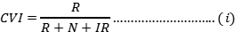
Where CVI=Content Validity Index
R=Relevant Questions
N=Neutral Questions
IR=Irrelevant questions
Interpretation: The CVI value from 0.7 to 1 is interpreted as high, implying that the data collection tool contains highly valid objective questions while <0.7 is low validity.

3.10.1 Reliability
Reliability is the consistency of an instrument to produce the same results each time it is measured under the same conditions with the same subjects. Meaning, the questionnaire administered to the respondents should provide similar information and not differing from the objectivity of the study ^{(52, 54).} Consistency was ensured through the test-retest approach. The questionnaire was administered to a sample of 20 people with characteristics similar to those of the specific study area. That is to say, another sub county in Mukono with maize growing farmers. The sample size was chosen because it is the smallest number that can give meaningful results on data analysis in a survey study ^{(52).} Test–retest reliability was carried out in a lapse of two weeks before carrying out the study. After realizing that instruments produces similar results, the researcher therefore inferred that the instruments are reliable for use and later used them to carry out the study

3.10.2 Quality Control Methods
Data collection tools were pretested in similar setting but in Mityana district and the results were used to review the questionnaire and corrections were made before actual data collection. Strict supervision of the data collection process was carried out at the field level by the researcher; meanwhile any inconsistencies and errors were checked and solved immediately. The researcher ensured that all completed forms from the field are reviewed daily and on-the-spot feedback was provided with follow-up undertaken, where needed. Data collection instruments that are completed were signed by the researcher and were transferred for data entry on that very day. Data collection instruments was coded with unique ID numbers to make them traceable. The researcher verified how data has been coded and entered into the computer.

3.11.0 Ethical Considerations
In undertaking this study, the researcher ensured that the following ethical principles are followed.

3.11.1 Institutional consent
The study was carried out only after approval by the Research and ethical committee of Nkumba University. Approval was also sought from the authorities of Mukono district where the research was conducted.

3.11.2 Informed Consent
In this research autonomy was protected by ensuring that any consent to participate in the study is informed or real. The researcher read out a consent letter to the targeted respondent and when the respondent accepted to participate in the study, a date of the interview was written and then a questionnaire or interview guide was used to fill in the responses of non-purposive and purposive respondents respectively.

3.11.3 Privacy and confidentiality
The researcher assured and ensured that all information collected from the respondents is confidential and was not be used for any other purpose than for academic research. Vital individual information such as names of key informants were replaced with a term ‘a Key informant’.

3.11.4 Beneficence
The researcher ensured that the wellbeing and mental health of the respondents are protected. The researcher ensured that all respondents that may wish not to continue participating in the study due to any reason was not to be forced or coerced but their decision respected.

3.11.5 Re-imbursement/compensation
Neither payment nor any form of compensation was given to those who consented to take part in the proposed study but the participant was encouraged to participate because their participation in the study will contribute to the agricultural sector in this country.

3.11.6 Respect for community and community safety
The procedures involved in this study was not to be against the religion and culture of participants as participation was absolutely consensual.

3.12 Limitations of the Study
The researcher faced the following limitations in the process of data collection.
The researcher did not have sufficient funds to facilitate data collection process. This required the researcher to obtain credit from various sources to enable successful completion of this study.
Some respondents asked for monetary benefits before they participate in the study. The researcher ensured that this was explained before the study was started that; it is purely voluntary and academic, and thus no financial benefits or expectation attached to it.
The researcher undertook data collection during rainy season which disrupted the data collection process. This was solved by purchasing umbrellas and other rain protective equipment so that data collection was done even during the rainy season.
Responses to some questions were considered family secrets by the study participants which hampered the process of obtaining accurate data. This was mitigated by assuring the respondents that this research was purely for academic purposes and confidentiality was assured.
The process of data collection was time consuming since it involved travelling to different famers within the study area and travelling to the different offices of the key informants. This however was mitigated by maximizing the available time and having a good budget and working within the budget.
The study outcome depended on the truthfulness and openness of respondents which implies that if the respondents are not trustworthy then they may lie to the researcher. This was mitigated by encouraging the study participants to say the truth.

3.13 Dissemination
After approval of the final report, the study findings were presented to the Faculty of Science-Nkumba University. The Final Thesis report was submitted to the university library, other copies will be submitted to the officers of the authorities Mukono district. For the rest of the world to access the study findings, publication through a peer review journal will be done.

CHAPTER FOUR

RESEARCH FINDINGS, DATA ANALYSIS AND INTERPRETATION

4.0 Introduction
This chapter presents the findings of the study. Initial emphasis was on the percentage, frequency distribution and tabulation of response(s), bio-data of the respondents, the main methods used by smallholder maize farmers, main maize varieties, challenges faced by smallholder maize farmers during production and marketing and the measures being taken by farmers and government to address production and marketing challenges faced by smallholder maize farmers in Mukono district.

4.1.0 Demographic characteristics of Respondents

4.1.1 Location of participants in the study
The largest number of respondents were from Nagojje parish accounting for 33 percent with a frequency of 127 respondents, with the least number of participants from Kasawo accounting for 6.3 percent of the sample as shown in Table 4.1. This finding corresponds with demographic statistics given by a local key informant in Nakifuma Sub-County during interview; who reported that ‘Nagojje has the largest proportion of smallholder farmers engaged in seasonal maize farming activities.’
 |  | Frequency | Percent | Valid Percent | Cumulative Percent
Valid | Nagojje | 127 | 33.1 | 33.1 | 33.1
Valid | Nabbaale | 44 | 11.5 | 11.5 | 44.5
Valid | Kimenyedde | 94 | 24.5 | 24.5 | 69.0
Valid | Kasawo | 24 | 6.3 | 6.3 | 75.3
Valid | Seeta | 95 | 24.7 | 24.7 | 100.0
Valid | Total | 384 | 100.0 | 100.0

Table 4.1: Location of participants (Primary data)

4.1.2 Gender of participants
Study findings indicate that the largest proportion of participants were women representing 54 percent of the sample population with a frequency score of 207 respondents; a mean of 1.54 and a standard deviation of 499 and the number of male participants is 177 representing a percentile of 46. This primary data finding resonates with secondary data on the sex rations of Mukono and interview data of the key informant of Nagojje who reported that ‘most farm activities are done by women.
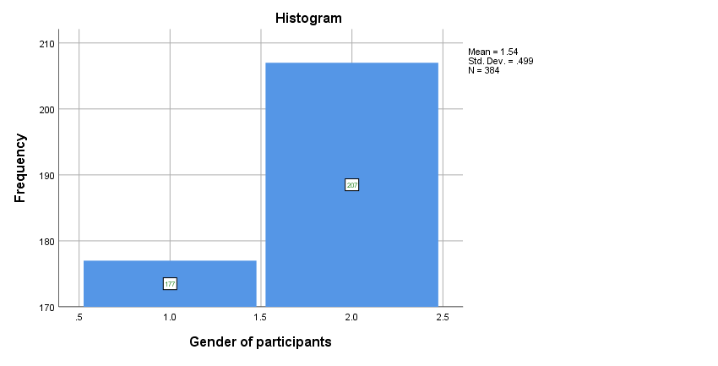

Figure 4.1: Gender of participants (Primary data)

4.1. 3 Relationship between gender and level of education
Primary data findings highlight a high level of semi-literacy in Mukono. The largest proportion of respondents are with formal education up to secondary level. 50 percent of respondents had secondary level education. Only 2 percent of the respondents have attained university education with the largest mean of participants with university education being females in parishes of Kasawo, Seeta, and Kimenyedde.
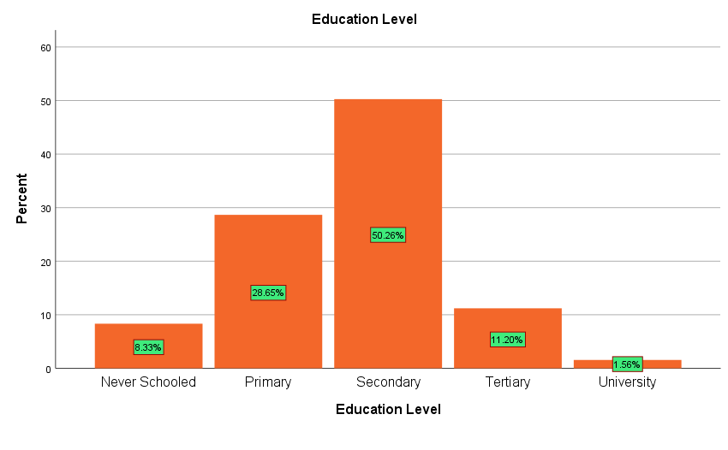

Figure 4.2: Level of education of respondents (Primary data)

4.1.4 Age of respondents
Primary data findings on the age of respondents indicate that the largest proportion of the respondents were adult youth from 28-37 years accounting for 36 percent of the sample population. The least proportion of respondents were young adults 18-27 years who accounted for 11 percent of the sample with a frequency count of 43 respondents as shown in Figure 4.3. This finding correlates with the qualitative response from the Local key informant of Seeta who reported that ‘most of the young people in Mukono detest smallholder farming in preference for white collar jobs in towns.’

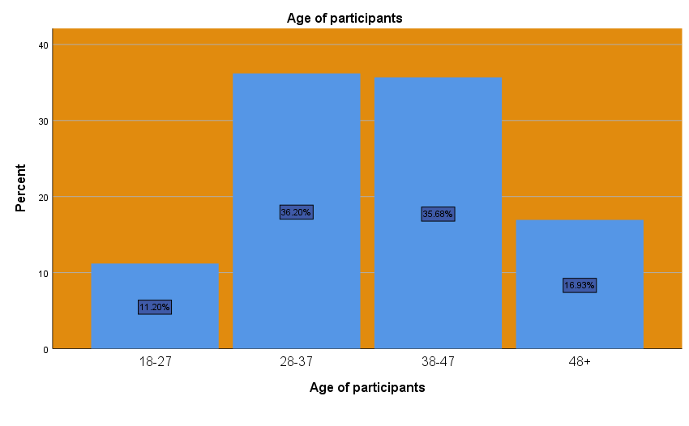

Figure 4.3: Age of participants (Primary data)

4.1.5 Tenancy status of smallholder farmers
Primary field data shows that 59 percent of the sampled participants have ownership/permanent tenancy on land and 41 percent of maize growers practice farming on rented land as shown in Figure 4.4. However, participants owning land; especially women have low/limited permanent tenancy rights as they are considered ‘Bibanja’ owners.
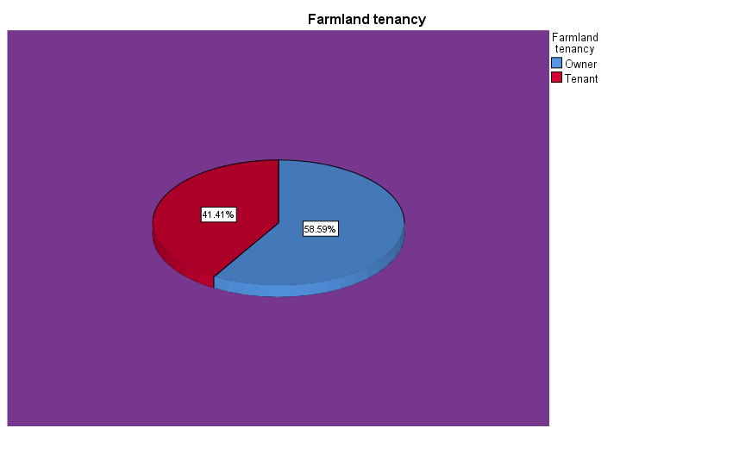

Figure 4.4: Farmland Tenancy (Primary data)

4.1.6 Main maize varieties grown by farmers
Study findings indicated that smallholder maize farmers mainly use three main maize varieties-Bazooka, Longe 9H, and Longe 10H. However, the dominant variety is Bazooka with a percentile of 54 participants reporting use of Bazooka. The least grown variety is Longe 10H; as a paltry 8 percent of sampled smallholder maize farmers plant it. The largest proportion of farmers growing Bazooka, Longe 9H and Longe 10H is in Nagojje with a frequency of 127 respondents.
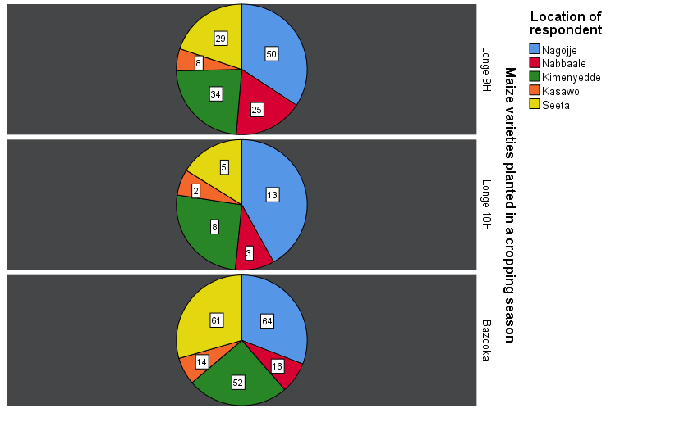

Figure 4.5: Main maize varieties planted by farmers (Primary data)

4.2 Main farming methods used by smallholder maize farmers in Mukono
Participants in the study reported that they use three methods of farming; Traditional, Modern (mainly use of capital intensive technologies), and improved/mixed method (involving use of improved techniques such as watering cans, and generators for pumping). 51% of farmers use traditional methods, 15% use modern methods 34% use mixed methods of farming. In relating a farming method to the maize variety, 57% of farmers planting bazooka use traditional farming methods involving manual labor operations. 31% of farmers using Mixed farming methods mainly grow Longe 9H as shown in Figure 4.6. 18% of farmers are using modern farming methods. In Kasawo for instance, there is no Longe 10H farmer using modern farming methods such as tractors.
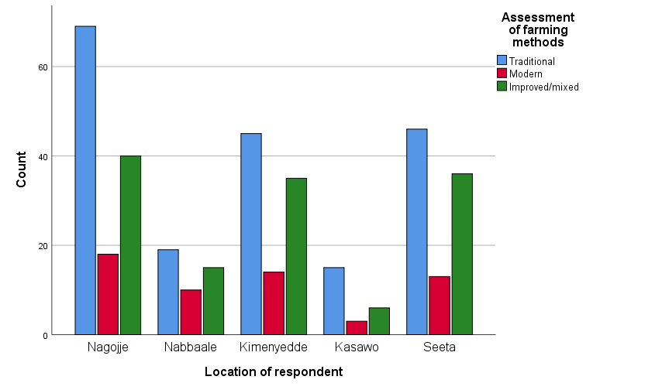

Figure 4.6: Assessment of the main farming methods used by maize farmers (Primary data)
Most farmers reported that the predominance of traditional farming methods mainly involving the use of subsistence tools such as hand hoes for farming is accounted for by the shortage of finances to secure modern tools, small land acreage that hinders mechanization and unscrupulous landlords who seasonally rent land limiting long-term investment.

4.3 Effect of a farming methods on yields in Mukono
The domination of traditional farming methods implies that most farmers still harvest low yields. Farmers yielding maize of less than 1000Kgs/1 ton per harvest, predominantly use traditional farming methods. Generally, adoption of modern methods is low and for the few farmers using it, yields are still low. For instance, in Seeta, out of 42 farmers who harvested yields in excess of 1000KGS/1 ton, only 3 use modern methods. Modern methods of farming have not increased bumper harvests yet. For instance, 10 percent of farmers yielding maize of less than 1000 Kilo grams per hectare per harvest, predominantly use traditional farming methods. 18 percent of farmers using mixed farming practices have experienced a relative increase in farm harvests especially in Kimenyedde where a frequency of 21 participants reported harvesting in excess of 1000KGS due to use of mixed farming methods. Generally, adoption of modern methods is low and for the few farmers using it, yields are still low. For instance, in Seeta, out of 42 farmers who harvested yields in excess of 1000KGS, only 3 use modern methods.
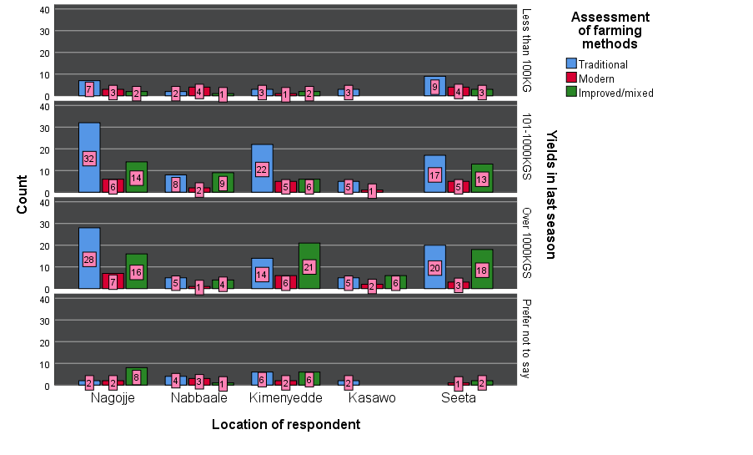

Figure 4.7: Examining the effect of a farming method on yields (Primary data)

4.4 Income returns of smallholder farmers
Farmers reported that most of the maize yields are sold at prices ranging from below 200 Uganda shillings with seasonal high prices ranging from 500 and 100 Uganda Shillings. However, most farmers sell their produce at relatively low price indicating relatively low benefits from maize farming. 57% of respondents reported that they sell a kilogram of maize at prices ranging from 201-500 Uganda Shillings, 33 percent sell at prices of 501-1000 UGX and 10% sell at less than 200 Uganda shillings as shown in Figure 4.9. This means that for an average yield of 1000 Kilograms at a price of 500, farmers gain a revenue of 500,000 Uganda shillings. An interview with a Community key informant related to this finding that, ‘mainly middlemen gain more profit from the produce than primary farmers. ‘
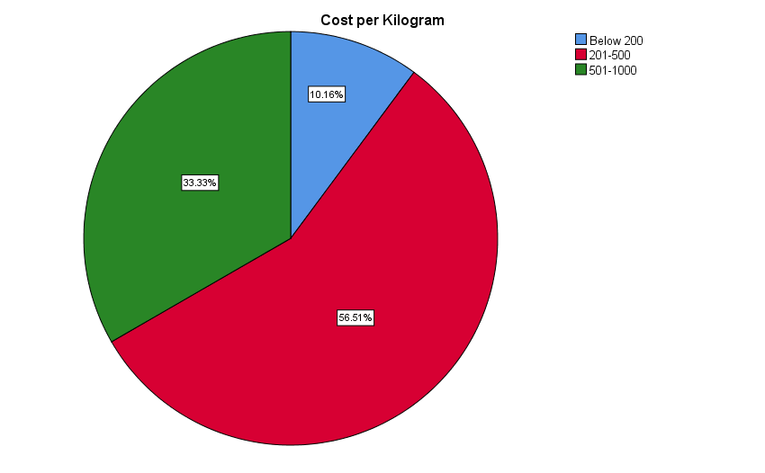

Figure 4.8 Cost/Price of harvested maize/Kilogram (Primary data)

4.5 Marketing and production challenges facing smallholder farmers
Study findings indicated that 99 percent of participants reporting that they find many challenges during marketing and production of maize. Participants reported that there are four main challenges including: price changes, climate change, expensive inputs and manipulation by middlemen.
33 percent of participants ranked price changes as the main challenge facing smallholder farmers as shown in Table 4.3. This correlates with a report by a district key informant who reported that ‘COVID-19 led to a fall in maize prices affecting profitability.’
30 percent of participants reported an increasing threat of climate change that is affecting yields and farming seasons. In fact, another key informant in Nakifuma said that ‘increasing dry spells are leading to stunted maize growth and low yields.’

Table 4.2: Main challenges in the last season (Primary data)
 |  | Frequency | Percent | Valid Percent | Cumulative Percent
Valid | Price changes | 128 | 33.3 | 33.6 | 33.6
Valid | Climate change | 113 | 29.4 | 29.7 | 63.3
Valid | Expensive inputs | 53 | 13.8 | 13.9 | 77.2
Valid | Manipulation by middlemen | 87 | 22.7 | 22.8 | 100.0
Valid | Total | 381 | 99.2 | 100.0
Missing | System | 3 | .8
Total |  | 384 | 100.0

4.6 Perceptions farmers and government have advanced for betterment of their productive and marketing of maize.
Study findings report that 97 percent of participants acknowledge that there are drastic measures by many stakeholders including; government, NGOs, local farmer groups to redress the challenges facing smallholder maize growers. In fact, during an interview with a field team member in Mukono, it was reported that ‘the organization conducts village trainings on the best maize farming practices in Mukono.’
On the other hand however, 3 percent of participants especially in Kasawo reported that they are unaware of any stakeholder involved in promoting or helping smallholder maize farmers address the main production and marketing gaps they encounter.
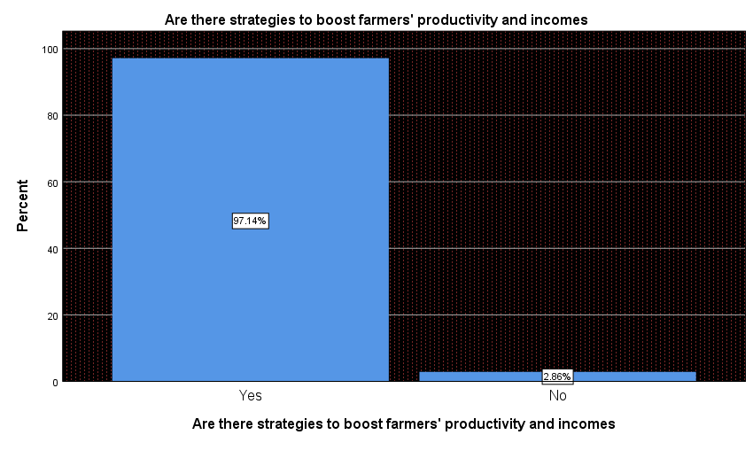

Figure 4.9: Knowledge of strategies to boost farmers’ productivity and incomes (Primary data).

4.6.1 Perceptions on strategies by government to boost farmers’ productivity and incomes
Participants in the study reported that government has designed some measures to boost incomes and productivity ranging from: promoting agricultural finance, rural road extension, encouraging of ‘emyooga’ programme, and rural extension work.
A key informant of Nakifuma reaffirmed this by stating that ‘government is trying to extend agricultural support services to all rural farmers.’
The most commonest and reported government strategy is promotion of agricultural finance as 35 percent of participants reported about it and the least strategy in villages is the encouragement of the emyooga with a percentile of 17 percent.
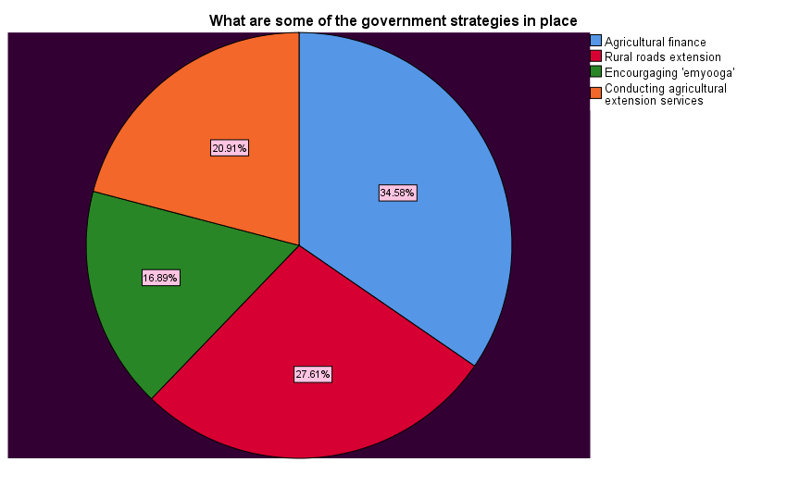

Figure 4.10: Government strategies to promote smallholder maize production and marketing (Primary data).

4.6.2 Perceptions of other strategies by other stakeholders to boost maize productivity and income
Participants reported that other stakeholders including local farmers’ groups have developed complementary strategies including: training of farmers, formation of rural agricultural/farmers’ groups, seasonal savings, seasonal use of manure, and promotion of integrated farming.
An interview with a member of the Twezimbe Women’s SACCO in Nagojje contends that ‘women in farming are encouraged to save through weekly bibiina, and trained on better farming practices.’
The most dominant rural stakeholder strategy is training of rural farmers via local groups sustainable farming practices; and this accounts for 35 percent of the participants’ sample population.
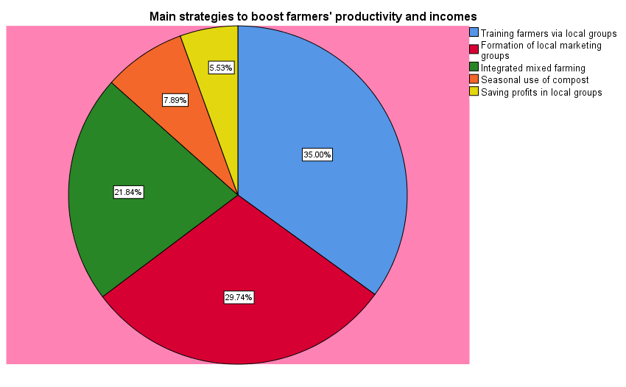

Figure 4.11: Other main strategies to boost farmers’ productivity and income (Primary data)

CHAPTER FIVE:

DISCUSSION OF RESEARCH FINDINGS, RESEARCH CONCLUSIONS AND RECOMMENDATIONS

5.0 Introduction
This chapter involves a summary and discussion of findings, conclusions and recommendations. The summary is based on the findings of the study objectives and the recommendations are based on the discussion of the findings and analyses of the data as well as interpretation of the findings addressing the research questions that the study aimed to explore and explain.

5.1 Assessment of the farming methods used by smallholder maize farmers for increased production and income
Study findings reported that most maize farmers are using traditional farming methods and the few who have adopted modern methods are yet to reap benefits. This finding highly correlates with a study on subsistence farming in sub-Saharan Africa that documented that about 70 percent of rural farmers use traditional farming practices that has led to chronic harvesting of low quality and quantity yields ^{(67, 68, 8)}.
Furthermore, a report by MAAIF on the state of the rural agro-sector reports that though rural farmers are transitioning to better and modern farming practices ^{(69, 29)}, the low levels of technological use and low capital base has led to the underutilization of modern technologies ⁽⁶⁹⁾. This relates to a study finding in Seeta parish that indicates that only 3 maize farmers transitioning to modern farming methods have harvested yields in excess of 1000 Kilograms.

5.2 Effects of maize farming methods on the harvests and incomes of smallholder maize farmers
Field data shows that the domination of traditional farming methods implies that most farmers still harvest low yields. Modern methods of faring have not increased bumper harvests yet. For instance, farmers yielding maize of less than 1000 Kgs per harvest, predominantly use traditional farming methods. A few farmers using mixed/improved farming practices have experienced a relative increase in farm harvests especially in Kimenyedde where a frequency of 21 participants reported harvesting in excess of 1000KGS due to use of improved methods. However, 98 percent of respondents reported that harvested produce is used for household consumption.
This report matches the 2020 EPRC report on food production systems in rural areas that shows that about 70 percent of the produce is meant for subsistence consumption ^{(70, 69, 15)}. A comparative study by the FAO on food chain system in Uganda documents that though most rural farmers aim for selling of produce to meet their household needs ^{(71, 2)}, the huge household demands necessitate the diversion of farm produce for household consumption ⁽⁷²⁾.
However, a regional report on maize markets in East Africa comparatively refutes this observation. In fact, during the recent COVID-19 pandemic, a UBOS survey indicated that most smallholder farmers are focusing on marketing produce to neighboring countries ⁽⁶²⁾ such as Kenya due to a surge in markets ⁽⁷³⁾. This correlates with the field finding that most smallholder farmers owning land in excess of 2 acres and producing harvest in excess of 1000KGS are focusing on marketing produce to reap from the relatively higher prices in regional countries compared to Mukono.

5.3 Challenges faced by smallholder maize farmers during production and marketing
Study findings show that 99 percent of participants experience production and marketing challenges. A breakdown on occurrence of challenges exposed that 51 percent of the challenges are experienced during production including climate change, and unfavorable land tenure. This positively relates to a study by MAAIF on bottlenecks to Agricultural financing that revealed that over 60 percent rural smallholder farmers in Central Uganda have insecure tenure ^{(15, 69, 70)} and are increasingly becoming vulnerable to climate and environmental shocks ⁽⁷⁴⁾.
Furthermore, a report by the Bank of Uganda on structural bottlenecks in rural farming revealed that gendered disempowerment affects women financing and also access to agricultural support services ^{(72, 70)}. A financial stability report in Uganda’s agribusiness marketing chains documents that increasing domination of maize monopolies and middlemen has led to artificial price changes and falls leading to low profits among smallholder maize farmers ⁽⁷⁰⁾.

5.4 Perceptions being undertaken by farmers and government to address production and marketing challenges facing smallholder maize farmers.
Participants in the study reported that government has designed some measures to boost incomes and productivity ranging from: promoting agricultural finance, rural road extension, encouraging of ‘emyooga’ programme, and rural extension work. Furthermore, participants reported that other stakeholders including local farmers’ groups have developed complementary strategies including: training of farmers, formation of rural agricultural/farmers’ groups, seasonal savings, seasonal use of manure, and promotion of integrated farming.
An interview with a member of the Twezimbe Women’s SACCO in Nagojje contends that ‘women in farming are encouraged to save through weekly bibiina, and trained on better farming practices.’
These observations are in tandem with the National Development Plan III and government targets on promotion of smallholder farming ⁽⁷⁴⁾. Through the parish model, the government is using the ‘emyooga’ programme to boost rural farming and promote value addition so as to boost markets ^{(75, 78)}. The 2020 Agricultural Credit Facility (ACF) report further confirms that government is embarking on women and smallholder rural farmers’ financing though waiving and developing alternative collateral to promote rural farming and agribusiness ^{(70,} ⁷⁵⁾. Through the Bank of Uganda, the ACF has been refinanced with over 120 billion Uganda Shillings to support smallholder farmers ⁽⁷⁰⁾.
The observation that rural stakeholders are designing strategies to support farmers rhymes with a study recommendation on reviving agri-business in Africa that observed that the merging of government efforts with local initiatives by stakeholders ^{(15, 68)} and civil society leads to increased knowledge ^{(2, 3, 72, 71, 76)} and skilling of smallholder farmers better farming practices (Lusembo, 2004) that boost yields, quality and marketability ^{(72, 67)}. A quantitative finding by Northern Uganda revealed that rural agricultural support services have a 60 percent probability of reviving farmers’ yields and incomes ^{(77, 78).}

5.5 Conclusion

5.5.1 Assessment of the farming methods used by smallholder maize farmers for increased production and income
There is increasing evidence that smallholder maize farmers in Mukono are increasingly engaging in both small and medium production and marketing for agro-income generation. However, practical insights in Mukono and Nakifuma on the nature of maize marketing and production chain evidences that most farmers are involved in informal production and marketing using rudimentary methods such as subsistence hand farming methods such as use of hoes, manual harvesting, and planting that are prone to socioeconomic shocks such as the current COVID-19 pandemic, minimum chances of business expansion and economic disincentives that increasingly reduce the profitability of businesses and insecure production mechanisms dotted with insecure tenure and ignorance on lucrative marketing channels

5.5.2 Effects of maize farming methods on the harvests and incomes of smallholder maize farmers
Study findings show that the increased use of traditional farming methods among smallholder farmers in Mukono partly due to low incomes, poverty, limited extension services, and insecure land tenure system has led to low productivity and low incomes generated from maize farming, production, and selling. This has led to reduced economic benefits for socioeconomic development and livelihood improvement. On average, smallholder maize farmers in Mukono produce about 500-1000 kilograms of maize per season which is comparatively low compared to the amount of inputs.

5.5.3 Challenges faced by smallholder maize farmers during production and marketing
Smallholder maize farmers in Mukono face a multitude of challenges both natural and human that affect the production and marketing of their produce. Findings from the study reveal that this low return is mainly attributed to climate change, increased soil infertility partly due to continuous farming using pesticides, presence of middlemen who manipulate farmers and use of traditional farming methods.

5.5.4 Perceptions being undertaken by farmers and government to address production and marketing challenges facing smallholder maize farmers.
Most farmers in Mukono revealed that current maize production and marketing challenges could be reduced through a number of collaborative and affirmative actions both monetary, social, and infrastructural. The main perception amongst farmers is a need for a new collaborative, inclusive and feasible empowerment and inclusive strategy that needs to be systematically developed and incorporated into local governance systems in Mukono to boost the maize production and marketing value chain to boost smallholder farmers’ incomes

5.6 Recommendations
- Mixed methods of farming should be promoted to improve on the yields of maize in Mukono district.
- Government should setup local maize or agricultural stores to store the produce during bumper harvests. This can also help in eliminating middlemen who exploit farmers during bumper harvesting seasons.
- Subsidies on agricultural inputs like the seeds, machines should be provided by the government to encourage farmers buy the inputs that can lead to increased yields and incomes.

5.6.1 Areas for further research
- Examining the perceptions of smallholder maize farmers towards transitioning from traditional to modern maize farming technologies and methods in rural Uganda.
- A comparative analysis of the costs and benefits of using modern farming methods and technologies among smallholder maize farmers in Uganda.

REFERENCES
- Lee, H. (2020). Why more Ugandan farmers aren’t adopting drought tolerant maize. The Conversation. https://theconversation.com/why-more-ugandan-farmers-arent-adopting-drought-tolerant-maize-144583
- FAO. (2018). Maize markets in Eastern and Southern Africa (ESA) in the context of climate change. Food and Agriculture Organization of United Nations. http://www.fao.org/3/ca2155en/CA2155EN.pdf
- FAO. (2017). Agricultural Market Information Sytem; Report on Wheat, Maize, Rice and Soybeans. Food and Agriculture Organization of United Nations. https://menacommodities.files.wordpress.com/2017/09/amis_market_monitor_-september-2017.pdf
- Jaidka, M., Bathla, S., & Kaur, R. (2019). Improved Technologies for Higher Maize Production. In Maize-Production and Use. IntechOpen.
- Mulungu, K., & Ng’ombe, J. N. (2016). Climate Change Impacts on Sustainable Maize Production in Sub-Saharan Africa: A Review. Intech, tourism, 13. https://www.intechopen.com/books/advanced-biometric-technologies/liveness-detection-in-biometrics
- Cairns, J. E., Hellin, J., Sonder, K., Araus, J. L., MacRobert, J. F., Thierfelder, C., & Prasanna, B. M. (2013). Adapting maize production to climate change in sub-Saharan Africa. Food Security, 5(3), 345–360.
- Soare, E., Chiurciu, I.-A., Bălan, A.-V., & David, L. (2018). World Market Research on Maize. “Agriculture for Life, Life for Agriculture” Conference Proceedings, 1(1), 216–222. https://doi.org/10.2478/alife-2018-0032
- Obua, J., Agea, J. G., Kambugu, R. K., & Lugangwa, E. (2018). Role of indigenous knowledge in enhancing household food security: A case study of Mukungwe, Masaka District, Central Uganda. Indilinga African Journal of Indigenous Knowledge Systems, 7(1), 64–71.
- Thierfelder, C., Baudron, F., Setimela, P., Nyagumbo, I., Mupangwa, W., Mhlanga, B., Lee, N., & Gérard, B. (2018). Complementary practices supporting conservation agriculture in southern Africa. A review. Agronomy for Sustainable Development, 38(2), 16.
- McKee, D. (2016). Maize production soaring in eastern Africa. World Grain. https://www.world-grain.com/articles/7172-maize-production-soaring-in-eastern-africa
- Fowler, M. (2019). Agro- industrialisation in Uganda pressing challenges. Ministry of Finance, Planning and Economic Development, November.
- Chauvin, N. D., Porto, G., & Mulangu, F. (2017). Agricultural Supply Chains, Growth and Poverty in Sub-Saharan Africa: Market Structure, Farm Constraints and Grass-root Institutions. Springer.
- UNDP. (2017). Income Inequality Trends in sub-Saharan. In Undp. http://www.africa.undp.org/content/dam/rba/docs/Reports/Overview-Income inequality Trends SSA-EN-web.pdf%0Aafrica.undp.org
- Kalema, S. (2016). Mukono farmers reaping more fruits from team work. New Vision. https://www.newvision.co.ug/news/1427986/mukono-farmers-reaping-fruits-team
- MAAIF. (2015). Agriculture Sector Strategic Plan 2015/2016-2019/2020. Ministry of Agriculture, Animal Industry and Fisheries, April 2016, 1–100. http://npa.go.ug/wp-content/uploads/2016/08/ASSP-Final-Draft.pdf
- Kumar, D., & Kalita, P. (2017). Reducing Postharvest Losses during Storage of Grain Crops to Strengthen Food Security in Developing Countries. Foods, 6(1), 8. https://doi.org/10.3390/foods6010008
- FAO, WFP, & IFAD. (2019). Food loss analysis : causes and solutions - The Republic of Uganda. Food and Agriculture Organization of the United Nations, World Food Programme, International Fund For Agricultural Development. http://www.fao.org/3/ca4524en/ca4524en.pdf
- Singh, C. (2018). Modern techniques of raising field crops. Oxford and IBH publishing.
- Mutekanga, D. (2019). The Modern Methods Of Farming Adopted By Small Scale Farmers And How They Have Impacted Indigenous Knowledge : The Case Of Kagadi District , Uganda. May.
- Bhat, I. F., Husain, N., Baba, S. H., & Majeed, M. (2020). Huge technological gaps in maize cultivation : is it an outcome of extension deficit in tribal areas of Kashmir valley. The Pharma Innovation Journal, 9(4), 110–113.
- Dao, A. (2013). Genetic Characterization, Association Mapping and Evaluation of Feterotic Patterns of Tropical Maize (Zea mays L.) Inbred Lines Under Drought and Non-Drought Conditions. University of Ghana.
- Ahmed, M., Ojangole, S., & Xenakis, M. (2014). Analysis of price incentives for rice in Uganda. Technical Notes Series, MAFAP. The UN Food and Agriculture Organisation, Rome.
- Smith, S. C., Sulaiman, M., & Smith, S. C. (2015). Agricultural Extension and Technology Adoption for Food Security : Evidence from Uganda. 9206.
- FAO. (2012). Analysis of incentives and disincentives for maize in Uganda. Monitoring Aricanf Food and Agricultural Policies, December, 7–9.
- FAO. (2014b). Technical note : Analysis of price incentives for rice in Uganda for the time period 2005 – 2013 Technical note : Analysis of price incentives for rice in Uganda for the time period 2005 – 2013. Food and Agriculture Organization of United Nations.
- USAID. (2010). Market Assessment and Baseline Study of Staple Foods: Country Report for Uganda. January, 1–14. http://pdf.usaid.gov/pdf_docs/PNADW642.pdf
- MAAIF. (2016). Plan for Modernisation of Agriculture: Eradicating Poverty in Uganda: Government Strategy and Operational Framework. Ministry of Agriculture, Animal Industry and Fisheries, 167. http://scholar.google.com/scholar?hl=en&btnG=Search&q=intitle:Plan+for+Modernisation+of+Agriculture:+Eradicating+Poverty.+Government+Strategy+&+Operational+Framework#3
- Watuleke, J., Afrikainstitutet, N., & Watuleke, J. (2015). The Role of Food Banks in Food Security in Uganda The Case of the Hunger Project Food Bank , Mbale Epicentre.
- Kasenge, V., Taylor, D. B., Kyamanywa, S., Bigirwa, G., & Erbaugh, J. M. (2018). Farm-level evaluation of monocropping and intercropping impacts of maize yields and returns in Iganga District. IPM CRSP Working Paper 00-3 (October 2000), Virginia Tech, Blacksburg ….
- Abbeam, G. D., Ehiakpor, D. S., & Aidoo, R. (2018). Agricultural extension and its effects on farm productivity and income : insight from Northern Ghana. Agriculture & Food Security, 1–10. https://doi.org/10.1186/s40066-018-0225-x
- Wang, C., Linderholm, H. W., Song, Y., Wang, F., Liu, Y., Tian, J., Xu, J., Song, Y., & Ren, G. (2020). Impacts of drought on maize and soybean production in northeast China during the past five decades. International Journal of Environmental Research and Public Health, 17(7). https://doi.org/10.3390/ijerph17072459
- Snyder, K. A., Sulle, E., Massay, D. A., Petro, A., & Qamara, P. (2020). “ Modern ” farming and the transformation of livelihoods in rural Tanzania. Agriculture and Human Values, March. https://doi.org/10.1007/s10460-019-09967-6
- Verdier‐Chouchane, A., & Boly, A. (2017). Introduction: Challenges to Africa’s Agricultural Transformation. African Development Review, 29(S2), 75–77.
- Blein, R., Bwalya, M., Chimatiro, S., Faivre-Dupaigre, B., Kisira, S., Leturque, H., & Wambo-Yamdjeu, A. (2017). Agriculture in Africa: transformation and outlook.
- Kolawole, O. D. (2012). Agrarian reforms and the African green revolution. World Journal of Science, Technology and Sustainable Development.
- Shiferaw, B., Prasanna, B. M., Hellin, J., & Bänziger, M. (2011). Crops that feed the world 6. Past successes and future challenges to the role played by maize in global food security. Food Security, 3(3), 307–327. https://doi.org/10.1007/s12571-011-0140-5
- Rosegrant, M. R., Ringler, C., Sulser, T. B., Ewing, M., Palazzo, A., Zhu, T., Nelson, G. C., Koo, J., Robertson, R., & Msangi, S. (2009). Agriculture and food security under global change: Prospects for 2025/2050. International Food Policy Research Institute, Washington, DC, 145–178.
- Barungi, J. (2013). Agri-Food System Governance And Service Delivery In Uganda: A Case Study Of Mukono District. In ACODE Policy Research Series (Vol. 61, Issue 61).
- Ranum, P., Peña-Rosas, J. P., & Garcia-Casal, M. N. (2014). Global maize production, utilization, and consumption. Annals of the New York Academy of Sciences, 1312(1), 105–112. https://doi.org/10.1111/nyas.12396
- USDA. (2020). Livestock and Poultry:World Markets and Trade. United States Department of AgricultureForeign Agricultural Service. https://apps.fas.usda.gov/psdonline/circulars/livestock_poultry.pdf
- Hellin, J., & Cox, R. (2017). Maize Diversity , Market Access , and Poverty Reduction in the Western Highlands of Guatemala. 37(2), 188–197.
- Jakobsen, J. (2020). The maize frontier in rural South India: Exploring the everyday dynamics of the contemporary food regime. Journal of Agrarian Change, 20(1), 137–162. https://doi.org/10.1111/joac.12337
- Susmozas, A., Martín-Sampedro, R., Ibarra, D., Eugenio, M. E., Iglesias, R., Manzanares, P., & Moreno, A. D. (2020). Process strategies for the transition of 1G to advanced bioethanol production. Processes, 8(10), 1–45. https://doi.org/10.3390/pr8101310
- Maurice, B., Ogada, J., & Nyangena, W. (2015). Impact of Improved Farm Technologies on Yields : The Case of Improved Maize Varieties and Inorganic Fertilizers in Kenya. International Conference of Africultural Economists, 1–31.
- Mujuru, N. M., & Obi, A. (2020). Effects of Cultivated Area on Smallholder Farm Profits and Food Security in Rural Communities of the Eastern Cape Province of South Africa. Sustainability, 12(3272), 1–17. https://doi.org/10.3390/su12083272
- Shimeles, A., Verdier-Chouchane, A., & Boly, A. (2018). Building a resilient and sustainable agriculture in sub-Saharan Africa. Building a Resilient and Sustainable Agriculture in Sub-Saharan Africa, 1–302. https://doi.org/10.1007/978-3-319-76222-7
- Meemken, E., & Bellemare, M. F. (2019). Smallholder farmers and contract farming in developing countries. Pnas, 117(28), 259–264. https://doi.org/10.1073/pnas.1909501116
- Verdier-Chouchane, A., & Karagueuzian, C. (2016). Moving Towards a Green Productive Agriculture in Africa: The Role of ICTs. Africa Economic Brief, 7(7), Côte d’Ivoire: African Development Bank.
- Stewart, R., Rebelo, N., & Silva, D. (2016). Effects of training , innovation and new technology on African smallholder farmers ’ economic outcomes and food security July 2016 Systematic Review Summary 6. July.
- Kanu, B. S., Salami, A. O., & Numasawa, K. (2014). Inclusive growth: an imperative for African agriculture. African Journal of Food, Agriculture, Nutrition and Development, 14(3), A33–A33.
- MoFPED (2012). Agricultural Sector Review Report 2011/2012. www.mofped.go.ug.
- Neuman, L. (2014). Social Research Methods: Qualitative and Quantitative Approaches (7 ed.). Essex, UK: Pearson New International Edition.
- Simiyu, L. (2014). Advances in Agricultural practices in sub-Saharan Africa: A Case study of Eastern Africa. Development, 2 (21), 40-48.
- Oso, W. K., & Onen, D. (2008). A General guide to writing research proposals and report. Kampala: Makerere University.
- Creswell, J. W. (2018). Research Design; Qualitative, Quantitative, and Mixed Methods Approaches (4th Editio). SAGE Publications India Pvt. Ltd.
- Charan, J., & Biswas, T. (2013). How to calculate sample size for different study designs in medical research? Indian Journal of Psychological Medicine, 35(2), 121.
- Uganda Bureau of Statistics (UBOS). (2018). The National Population and Housing Census 2014 – Area Specific Profile Mukono District. National Population and Housing Census, April, 1–75.
- Mukono District Profile (2020). Demographic statistics of Mukono District 2014-2019. www.ubos.org
- Uganda Bureau of Statistics (UBOS). (2017). The National Population and Housing Census 2014 – Area Specific Profiles. National Population and Housing Census, April, 1–75.
- MWE. (2012). Uganda National ClimateChange Policy, Ministry of Water and Environment. Kamapla, Final Version for Approval, 18 July 20, 2.
- World Bank (2021). Maize yields among smallholder farmers in Uganda. Washington DC, USA.
- UBOS (2020) Uganda Demographic Statistics: A Snapshot. UBOS, Kampala, Uganda.
- Cohen, L., Manion, L., & Morrison, K. (2013). Research methods in education. routledge.
- Sekaran, U., & Bougie, R. (2016). Research methods for business: A skill building approach. John Wiley & Sons.
- Bengtsson (2016). Approaches to Social Research. Pearson, New York, USA.
- Barifaijo, K. M., Basheka, B., & Oonyu, J. (2010). How to write a good dissertation. thesis: A guide to graduate students.
- AU (2020). The impact of the Coronavirus (COVID-19) on the African Economy. AU, Addis Ababa, Ethiopia.
- Aiyepeku, W. O. (1992). “Developing Information Technologies in Africa. Nairobi, Kenya: PAN/NAN Monthly Forum.
- MoFPED/EPRC (2019). Agriculture sector quarterly report 2018/2019. MoFPED, Kampala, Uganda
- EPRC. (2020). How has the COVID-19 pandemic impacted Ugandan businesses? Results from a business climate survey. Kampala, Uganda: Economic Policy Research Centre.
- FAO/UNEP. (2007). The future of our land. Facing the challenge. Guidelines for integrated planning for sustainable management of land resources. Rome: FAO.
- AFI. (2021). Agricultural MSMEs Financing in Uganda: A Response to CIVD-19. Kuala Lampur, Malaysia: Alliance for Financial Inclusion.
- Asiimwe&Odomaro, B. (2014). How to make Agricultural Finance work: Uganda Experience. Journal of Management and Social Sciences, Vol.4: 3-12.
- MAAIF. (2018). Performance Evauation of NAADS. Kampala: ITAD.
- FAO. (2020). Coronavirus Food Supply Chain under Stress! What to do? Rome, Italy: Food and Agriculture Organization.
- IFAD. (2002). Managing for Impact in Rural Development: A Guide for Project M&E (1 ed.). Rome, Italy: International Fund for Agricultural Development (IFAD).
- Akungo, D. (1999). Constraints to Agricultural development and their implications to rural planning: A Case study of Mbita division, South Nyanza district, Kenya. Nairobi, Kenya: University of Nairobi.
- Lusembo, P. K. (2004). Smallholder integrated crop management (CM) research planning: A Case for Mukono and Kayunga districts. Journal of Agricultural Sciences, 9, 701-706.

LIST OF APPENDICES

Appendix I: Questionnaire
Modern Farming Methods and their role in improving income for smallholder maize farmers in Mukono district.
Household level questionnaire
Introduction
Dear sir/madam, I am Ismail Idow Omar a student of Nkumba University, school of sciences. As part of the requirements of the University, I am required to undertake research as a fulfillment for graduation. As such, I am here to learn more about how you grow maize in this area, the maize varieties you plant, the challenges you face in the production and marketing of maize and the strategies you use to manage the said challenges. You are one of the participants that have been selected to participate in this study. I kindly request you for your time to enable me learn more about maize production in your area. Your confidentiality is highly assured.
Section I: Demographic characteristics of respondents
- Name of the respondent……………………………………………………………………
2. Gender of the respondent:
a. Male……………………b. Female…………
3. Age of the respondent
a. 18-27 b. 28-37 c. 38-47 d. 48
4. What is your marital Status? a. Single……..b. Married……..c. Widowed……d. Divorced………….

5. What is the highest level of education obtained by the respondent?
a. No formal education… b. Primary……c. Secondary…….d. Tertiary…e. University…
Section11: Assessment of the farming methods used by smallholder farmers growing maize
2. (a).Which main varieties of maize do you know that are mainly planted in your village? .......................................................................................................................................................................................................................................................................................................................
2. (b) On your farmland, which type (s) of maize did you plant in the last cropping season?
………………………………………………………………........................................................
2. (c) And which type (s) of maize did you plant in the current cropping season?
…………………………………………………………………………………………………….
Production practice used | First season  - Yes, b. No | Second season  - Yes, b. No
Used improved seed variety
Added mineral fertilizer
Added manure/Compost
Used right number of seeds
Used pesticides
Planted in lines
Used machines (Tractor/ ox-plough)
Others specify
2. (d). What is the occupancy status of the farmland where you grow maize?
a. Owner b. Tenant

2. (e). On average, what amount of land have you allocated to maize growing for the current cropping season?
a. Less than 1 acre b.1-2.5 acres c. 2.5-5.0 acres
2. (e) Which of the following maize production practices have you practiced on your farm during these two recent cropping seasons? (1st and 2nd season of 2021)
2. (f) Why do you prefer using the production practices mentioned in 3 (e) above?
- Better prices
- High yielding
- New opportunity to sell
- Land is less productive
- Land is more productive
- Limited land
- More land
- Lack of inputs/seeds
- More resistant to pests and diseases
- Government/ Project told us to
- Government/ Project showed us to
Others. Please specify……………………………………………………………………..
Section III: Yields and income obtained by farmers as a result of practicing the different maize farming methods.
3. (a) On average, how many kilograms of maize did you get in the last cropping season?
……………………………………………………………………………………………………
……………………………………………………………………………………………………
3. (b) How many of the obtained kilograms were consumed by your household?
……………………………………………………………………………………………….
3. (c) How many kilograms did you sell off in order to get income?
……………………………………………………………………………………………………..
3. (d) What was the cost price per kilogram? (Please compute for all the kilograms sold)
…………………………………………………………………………………………………….
3. (e) Where did you sell your maize harvest?
……………………………………………………………………………………………………
3. (f). Where did you get information about the market?
a. A group that you are a member of
b. Friend, relative, neighbor
c. Extension worker
d. NGO
e. Other
Section IV: Challenges faced by maize farmers during the production and marketing of maize
4. (a) In your view, have you encountered some challenges in the production of maize?
a. Yes b. No
4. (b). What are some of the main challenges that you have encountered in the recent two seasons of this years?
……………………………………………………………………………………………………………………………………………………………………………………………………………………………………………………………………………………………………………………………………………………………………………………………………………………………………………………………………………………………………………………………………..
4. (c). Do you know of other challenges faced by other maize farmers in your village?
a. Yes b. No
4. (d). If yes, what are some of the challenges that have been faced by other maize farmers in your village?
……………………………………………………………………………………………………………………………………………………………………………………………………………..
4. (e). Which of the challenges has or have mostly affected maize productivity and farmer incomes? ………………………………………………………………………………………………………………………………………………………………………………………………………………………………………………………………………………………………………………………
4. (f). Have you encountered some challenges in the marketing of maize in this village?
a. Yes b. No
4. (e). If yes, what major challenges have you faced while marketing your maize in the recent two seasons of this year?
………………………………………………………………………………………………………………………………………………………………………………………………………………………………………………………………………………………………………………………………………………………………………………………………………………………………………………………………………………………………………………………………………
4. (f). Do you know of other challenges faced by other maize farmers in this area?
a. Yes b. No
4. (d). If yes, what are some of the challenges that have been faced by farmers in your village?
………………………………………………………………………………………………………………………………………………………………………………………………………………………………………………………………………………………………………………………………………………………………………………………………………………………………
4. (e). Which of the challenges has or have greatly affected maize marketing and farmer incomes?
…………………………………………………………………………………………………………………………………………………………………………………………………………………………………………………………………………………………………………………………………………………………………………………………………….......................................
4. (f). If you are to categorize the challenges, have these challenges been more during production or marketing?
a. During production b. During marketing
4. (g). Depending on your answer in (question 4 (f)) above, what specific challenges in the mentioned category have greatly hindered your ability to gain more income?
………………………………………………………………………………………………………………………………………………………………………………………………………………………………………………………………………………………………………………………
Section V: Measures used by farmers and government to address the production and marketing challenges faced by small holder farmers.
5. (a). Are there some strategies being undertaken to boost productivity and farmer incomes in your village?
a. Yes b. No
5. (b) .Who are the main stakeholders involved in the process of helping maize farmers boost productivity and incomes?
a. Government b. NGOs c. Farmer groups d. None
5. (c). Basing on your knowledge, what are some of the strategies that farmers in your village use to increase maize productivity and incomes?
Strategies to increase maize productivity | Strategies to improve farmers’ income
5. (d). Are there some strategies that have been put in place by government to boost maize production and farmer incomes?
a. Yes b. No
5. (e). If yes, what are some of the strategies that government has put in place?
……………………………………………………………………………………………………………………………………………………………………………………………………………………………………………………………………………………………………………………… 5. (f). Do you use the strategies mentioned in 5 (e) above?
- Yes b. No
5. (g). If No, What difficulties do you face in using the government strategies?
…………………………………………………………………………………………………………………………………………………………………………………………………………………………………………………………………………………………………………………

END

Appendix II: Interview Guide
Role of modern farming methods on farmer harvest and incomes
Interview guide
Introduction:
Dear sir/madam, I am Ismail Idow Omar a student of Nkumba University, school of Sciences. As part of the requirements of the University, I am required to undertake research as a fulfillment for graduation. As such I am here to learn more about how you grow maize in this area, the maize varieties you plant, the challenges you face in the production and marketing of maize as well as the strategies you use to address the said challenges. You are one of the participants that have been selected to participate in this study. I kindly request you for your time to enable me learn more about maize production in your area. Your confidentiality is highly assured.
Farming methods used by farmers in the production of maize
1. Could you tell me the major maize varieties grown by farmers in this area and why?
2. Describe the different farming methods used by farmers in growing maize? (Please remember to ask why a particular practice is used)
3. Could you tell me some of the new practices that farmers in this area use in the growing of maize?
4. Why do you think farmers use these new practices?
5. For those farmers that do not use the new farming practices, what hinders them from using the said practices?
6. Why do you think some farmers prefer using the traditional farming methods?
Effects of the farming methods on farmers’ yield and income
1. Based on your experience, which maize farming methods have helped farmers get more yield and income?
2. Where do farmers in this area sell their maize harvest?
3. Could you tell me where maize farmers in this area access market information?
Challenges faced by farmers in the production and marketing of maize
1. What challenges do farmers in this area face during the production of maize?
2. What strategies do small holder farmers in this area use to boost maize harvest and incomes?
3. What measures has the government put in place to help farmers increase on their harvests and incomes?
4. Based on your experience, what constraints farmers from using the measures put in place by government to boost farmers’ harvest?
5. What challenges do farmers in this area face during the marketing of their maize harvest?
6. What strategies do they use to address the marketing challenges mentioned in question 5 above?
7. Could you tell me some of the measures that government has put in place to help farmers’ access market for their maize produce and also get better incomes?
8. In your view, what constraints farmers from using the strategies mentioned in question 7 above?

Appendix III: Consent Form

Introduction:
Dear sir/madam, I am Ismail Idow Omar a student of Nkumba University, school of Sciences. As part of the requirements of the University, I am required to undertake research as a fulfillment for graduation. As such I am here to learn more about how you grow maize in this area, the maize varieties you plant, the challenges you face in the production and marketing of maize as well as the strategies you use to address the said challenges. You are one of the participants that have been selected to participate in this study. I kindly request you for your time to enable me learn more about maize production in your area. Your confidentiality is highly assured.
If you are OK to be one of the respondents for this research, your responses are highly welcome.
Date: ……………………………………………………………
Time: …………………………………………………………..

