COMPARATIVE CATCHABILITY CHARACTERISTICS OF NYLON MONOFILAMENT AND MULTIFILAMENT GILLNETS,
CASE STUDY AT KIYINDI FISHING GROUND, LAKE VICTORIA
BUIKWE DISTRICT, UGANDA.

BY
ANYAKA AGAPTIUS
FEB/2018/MNRM/M 222725/WKD

A DISSERTATION SUBMITTED TO THE SCHOOL OF SCIENCES IN
PARTIAL FULFILLMENT FOR THE AWARD OF MASTERS
DEGREE OF SCIENCE IN NATURAL RESOURCES AND
MANAGEMENT OF NKUMBA UNIVERSITY

NOVEMBER, 2021

DECLARATION
I Anyaka Agaptius the undersigned candidate hereby declare that this dissertation was done by myself. It is original in context and has never been duplicated, reproduced or presented or published elsewhere.

Signature Date
…………………………….. ………………………….
ANYAKA AGAPTIUS
FEB/2018/MNRM/M 222725/WKD

APPROVAL
I certify that this dissertation entitled “comparative catchability characteristics of monofilament and multifilament gillnets, case study at Kiyindi Fishing Ground, Lake Victoria, Buikwe district , Uganda and prepared by Mr. Anyaka Agaptius is ready for examination.

Signature Date
…………………………….. ………………………….
Prof. Faustino L. Orach-Meza.
SUPERVISOR

DEDICATION
I dedicate this project work to my mother Mrs. Ssikolastica Kabejja, my eldest brother Mr. Ariong Charles in appreciation of their love, care and provision of positive environment in my studies

ACKNOWLEDGEMENT
I wish to acknowledge Prof. Faustino. L. Orach-Meza, University Researcher for the technical guidance and also for being so professional in supervising this project. I am very humbled for Prof. Faustino. L. Orach-Meza, the university researcher guidance, provision of reading materials and his inspiration.
I also wish to thank the government of Uganda for posting Uganda Peoples Defence Forces Soldiers on waters of Lake Victoria for allowing to use illegal gears to carry out my practical work. I am also grateful for the Olingha Anyaka Okaale foundation for the provision of financial support, cooperation rendered to me on this project.
I am indebted to Mr. Katali James, District Fisheries Officer, Buikwe District , Kafuba Jimmy, Assistant fisheries officer, in charge Kiyindi fishing ground for their moral and materials support on this project and the entire fishing ground community is thanked for their good generosity
My special appreciations goes to my mother Mrs.Ssikolastica Kabbejja, my brothers Ariong Charles, Omale Alex, Atenya Godfrey, Olinga Robert, Okia Francis and my sisters Atin Maritha, Ajoge Isabite, Katooko Mary, Isolite Anna, Acham Cecilia and Kataike Harriet for their support and encouragement in my research.
I further extend my acknowledgement to my friends, Sherry Awino, Mubiru David, Micheal Kasinga, Olupot Stephen, Mathew Kasan Beatrice and Watentena Amos.
I express my sincere thanks to entire School of Sciences Nkumba University for cordial relationships.
Finally, I register my appreciation for the excellent work done by Mathew Musoke, Fred Tumushime, Osmath Johnson who typed this dissertation and Fredrick Joel Wajje for proof reading and editing.

TABLE OF CONTENTS
DECLARATION i
APPROVAL ii
DEDICATION iii
ACKNOWLEDGEMENT iv
LIST OF FIGURES x
LIST OF PLATES xi
LIST OF ABBREVIATIONS xii
ABSTRACT xiii
CHAPTER ONE: INTRODUCTION 1
1.0 Introduction 1
1.1 Background to the Study 1
1.2 Statement of the Problem 5
1.3 Study objectives 6
1.3.1 General objective 6
1.4 Specific Objectives 6
1.5 Research Questions 6
1.6 Scope of the study 7
1.6.1 Geographical scope 7
1.6.2 Content Scope 7
1.6.3 Time Scope 8
1.7 Significance of the Study 8
1.8 Conceptual Frame work 8
CHAPTER TWO: LITERATURE REVIEW 10
2.0 Introduction 10
2.1 Literature Review 10
2.2 Design, Construction and Operation of Nylon Monofilament and Multifilament Gillnets 10
2.2.1 Design and Construction of a Gillnets 10
2.2.2 Operation of Gillnets 11
2.3 Catchability Characteristics of Nylon Monofilament and Multifilament Gillnets 12
2.4 The Efficiency and Suitability of Nylon Monofilament and Multifilament Gillnets 13
2.5 Research gaps 14
2.6 Theoretical review 15
CHAPTER THREE: METHODOLOGY 16
3.0 Introduction 16
3.1 Research Design 16
3.2 Study Area 16
3.3 Study Population 18
3.4 Sample Size 18
3.4.1 Sampling Techniques 19
3.5 Data Collection Methods 19
3.5.1 Visits to planned areas 19
3.5.2 Questionnaires and interviews 19
3.5.3 Physical Observation 20
3.5.4 Subjects/ Research Sample 20
3.6 Procedures/ Experimental Fishing 20
3.7 Data Analysis 20
3.8 Reliability and Validity of the Instruments 21
3.8.1 Validity 21
3.8.2 Reliability 21
3.9 Research Ethical Consideration 21
3.10 Limitations of the Research. 22
CHAPTER FOUR: DATA PRESENTATION AND ANALYSIS OF FINDINGS 23
4.0 Introduction 23
4.1 Fish Catch Data of the Research Project 23
Source: Field Data, 2020 24
4.1.1 Characteristics of the Monofilament and Multifilament Fishing Gears 25
4.2 The Demographic Characteristics of Respondents 26
4.2.1 Sex of respondents 26
4.2.2 Age of respondents 27
4.3 Findings on the Design and Construction of Nylon Monofilament Compared to Multifilament Gillnets 29
4.3.1 Findings on whether Designs of the Nylon Monofilament are Efficient and Effective Compared to Multifilament 29
4.3.2 Construction of Nylon Monofilament help the Fishing Practices Compared to Multifilament 30
4.3.3 Operations Carried out using Nylon Monofilament have enabled fishermen to Improve their Fishing Practices Compared to Multifilament 30
4.3.4. The Construction and Design of Nylon Gillnet 31
4.2.5 Qualitative Analysis on the Design of Nylon Monofilament and Multifilament Gillnets 32
4.4 Findings on Determination of the Catchability Characteristics of Nylon Monofilament Compared to Multifilament 33
4.4.1. Nylon Monofilament Increased the Rate of Fishing Compared to Multifilament 33
4.4.2 The Nylon Monofilament Work Best when Fishing Compared to Multifilament 33
4.4.3 Nylon Monofilament Gillnets have More Catchability Characteristics than the Nylon 34
4.4.4 Qualitative Analysis on Determination of the Catchability Characteristics 35
4.5 Findings on Efficiency and Suitability of Nylon Monofilament 35
4.5.1 Nylon Monofilament and Multifilament Gillnet Fibres 35
4.5.2 A comparison of Tensile Strength of Nylon Monofilament and Multifilament Gillnet Fibres 36
4.5.3 Efficiency and Suitability of the Nylon Monofilament and Multifilament Fibres 36
4.5.4 Qualitative Analysis on the Efficiency and Suitability of Nylon Gillnets 37
4.6. Assessment of the Impacts of Nylon Gillnets on the Fish Stocks 38
4.6.1 Nylon Monofilament are Productive Compared to Multifilament 38
4.6.2 Fish is Heavily Exploited When Fishermen use the Nylon Monofilament Compared Multifilament Gillnets 38
4.6.3 The Nylon Monofilament are More Dangerous Compared to Multifilament 39
Respondents were 39
CHAPTER FIVE: DISCUSSION OF FINDINGS 41
5.0 Introduction 41
5.1 Design and Construction of Nylon Monofilament and Multifilament Gillnets 41
5.2 Determination of the catchability characteristics 41
5.3 Assessment of the efficiency and suitability of nylon gillnets 42
5.4. Determination and Assessment of the Impact of Nylon 42
CHAPTER SIX: CONCLUSION 43
CHAPTER SEVEN: RECOMMENDATIONS 44
REFERENCES 46
APPENDICES 51
APPENDIX I: RESEARCH QUESTIONNAIRE 51
APPENDIX II. INTERVIEW GUIDE TO THE OPINION LEADERS AND ELDERS 55
APPENDIX III. INTERVIEW GUIDE TO THE LOCAL FISHERMEN 56
APPENDIX IV: SELECTED PICTORIALS OF THE FIELD STUDY 57

LIST OF TABLES
Table 1: Sample size and sampling technique 18
Table 2: Fish catch data of the Nylon Monofilament and multifilament gillnets at Kiyindi fishing ground 24
Table 4: Showing the age of the respondents 27
Table 5: Designs of the Nylon Monofilament are Efficient and Effective Compared to Multifilament Gillnets 29
Table 6: Construction of Nylon Monofilament helps the Fishing Practices Compared to Multifilament 30
Table 7: Operations Carried out using Nylon Monofilament have Enabled Fishermen to Improve their Fishing Practices Compared to Multifilament. 31
Table 8: The construction and design of nylon gillnet 31
Table 9: Nylon Monofilament have Increased the Rate of Fish Caught at Kiyindi Fishing Grounds Compared to Multifilament 33
Table 10: Nylon monofilament work best when fishing compared to multifilament 34
Table 11: Nylon monofilament gillnets have more catchability characteristics than the nylon multifilament gillnets 34
Table 12: Nylon monofilament and multifilament gillnet fibres 35
Table 13: The Nylon monofilament and multifilament gillnet fibres are excellent when it comes to tensile strength 36
Table 14: Efficiency and Suitability of the nylon monofilament and multifilament fibres 37
Table 15: Impact of nylon monofilament are productive compared to multifilament 38
Table 16: Fish is heavily exploited when fishermen use the nylon monofilament compared to multifilament 39
Table 17: The nylon monofilament are more dangerous as compared to multifilament 39

LIST OF FIGURES
Figure 1: Map showing the location of Kiyindi fishing 7
Figure 2: Conceptual framework of the study 9
Figure 3: Relative abundance of fish catches by monofilament and multi filament gillnet 25
Figure 4: Sex of respondents 26
Figure 5: Respondents’ educational level 27
Figure 6: Occupation of respondents 28
Figure 7: Marital status of respondents 29

LIST OF PLATES
Plate 1: Location of Kiyindi fishing ground 17
Plate 3: Showing the student preparing the monofilament and multifilament nets ready for fishing 57
Plate 4: Showing student setting off from the shore for fishing 58
Plate 5: Showing the student drawing deeper into the Lake for fishing 59
Plate 6: Showing the student at the fishing point ready to lower the monofilament net in the water for fishing 59
Plate 7: Showing the student removing the fish from the monofilament net after catching it. 60
Plate 8: Showing the student back to the shores after fishing 61
Plate 9: Showing the student accessing the fish and sorting them 62
Plate 10: Showing the student weighing the fish after sorting the fish 63
Plate 11: Showing the student packing the fish which is recommended for harvest 64
Plate 12: Showing the fisheries officer weighing the fish after sorting them out 65

LIST OF ABBREVIATIONS
A.F.O: Assistant Fisheries Officer
ACR: Catchability Average Rate
BMU: Beach Management Unit
C.R: Catchability Rate
CAS: Catch Assessment Surveys
CPUE: Catch Per Unit Effort
D.F.O: District Fisheries Officer
D.F.R: Department of Fisheries Resource
D.F.R: Directorate of Fisheries Resources
F.O: Fisheries Officer
FAO: Food Agricultural Organizations
NaFRrI: National Fisheries Research Resource Institute
FS: Frame Surveys
FTI: Fisheries Training Institution
L.C: Local Community
LGA: Local Government Authority
MAAIF: Ministry of Agriculture, Animal Industry and Fisheries
R A: Relative Abundance
S.W.F.G.C Second World Fish Gear Congress
UBOS: Uganda Bureau of Statistics
UPDF: Uganda People Defence Forces
Y/R: Yield Per Recruit

ABSTRACT
The major purpose of this research was to examine the comparative catchability characteristics of nylon monofilament and multifilament gillnets at Kiyindi fishing ground, Buikwe District, Uganda, with the view of furthering understanding of the use of these gears and recommend appropriate fisheries management measures on their usage. The more legally acceptable gear for use. The study was guided by the examination of the design and construction of nylon monofilament and multifilament gillnets, experimental fishing to determine the catchability characteristics of nylon monofilament and multifilament gillnets, and assessing the efficiency and suitability of nylon monofilament and multifilament gillnets used at Kiyindi fishing ground, Uganda.
The researcher used both qualitative and quantitative research design while methods of data collection included questionnaire administration, experiment, observations, and interviews. The sample population of 67 was drawn from fishermen (25), local communities (17), vendors (20), and key informants (5) from the Directorate of Fisheries Resources, Department of Fisheries Resources Management & Development (DFRMD), and Buikwe District Local Government.
Findings from questionnares and interviews revealed that nylon monofilament gillnets caught fish of all types (species) and size indiscriminately while the multifilament gillnets, on the other hand, were more selective and caught specific fish sizes and fish types. Findings from experimental fishing revealed that monofilament nets caught more fish at a catch rate of 5.2 kg of fish per net because of its characteristics than multifilament gillnets which caught 2.3 kg of fish per net. The findings demonstrated that monofilament gillnets had higher catchability rate of 69% but were exploitative and indiscriminate compared to multifilament gillnet which was at the rate of 31% and were selective of the types and sizes of fish caught.
It was, therefore, concluded that the nylon monofilament gillnets were highly destructive since they caught indiscriminately irrespective of species and their sizes whereas multifilament gillnets were more selective and caught the desired target species of fish and sizes. Based on the catchability characteristics of the two fishing gears, the already legal ban on the use of nylon monofilament gillnets should be enforced strongly on all the waters of Lake Victoria in order to avoid the destruction of the fish stocks and promote sustainability of the fisheries resources for the benefit of resource users, partner states and internal trade and tourism.

CHAPTER ONE: INTRODUCTION

1.0 Introduction
The study investigated the comparative catchability characteristics of nylon monofilament and multifilament gillnets at used Kiyindi fishing ground, on the shores of Lake Victoria in Buikwe district, Uganda. These have been found among the most selective gears in terms of targeting both fish species caught and the size range retained and thus used to target desired species and size of fish on Lake Victoria. The two gears differ in their nature of the fibre, design, and construction, catchability making then the most widely used fishing gear on Lake Victoria. In this study, the difference in terms of nature of fibre, design of the nets and their construction was well researched on.

1.1 Background to the Study
Like any other country, the developments of fishing methods and gears in Uganda have evolved through centuries. Hand catching of fish in shallow waters of wetlands and lakes used to be quite pronounced. Fish poisoning with local herbs and other toxins used to be practiced practically in the many rivers in Uganda. Traditionally, spears, arrow, and traps of various designs were widespread up to the 20 twentieth century. These fishing technologies were however rated very low, unproductive and generally inappropriate for exploitation of various fish species in the waters. The situation changed by the coming of foreign traders (Italians, British, Indians and Belgians) who introduced gillnets made of various fibres such as cotton, hemp and flax, (the mid-1950s) marking local gears with important introduction into the country of the said modern fishing gears. The Japanese gillnets were then used and they outmatched in their texture and quality. These nylon nets later became popular and proved to be more durable, adoptable and effective than any other artisanal gears. After the introduction of gillnets, other types of gears have found their way into waters such as cast net, and trawls of various designs (Simasiku, 2017).
Gillnetting (as elsewhere) began with cotton or hemp nets, and a major technological change has been the progression among several net types from cotton to woven nylon multifilament nets and then to monofilament nets. A multifilament net is one where each ‘string’ or filament making up the net mesh is a thin braided or twisted twine (like very thin rope),while a monofilament net is one where the net is made of single strands of a synthetic material that looks like a stand of modern fishing line. Polyamide (nylon) became the first synthetic material to replace cotton or hemp for fishing gear construction; initially as multifilament and later as monofilament. Following the adoption of monofilament nets, thinner filaments have been adopted over time to further improve catching efficiency. Globally the conversion from multifilament to monofilament nylon netting occurred in some places in the early 1970s, (FAO, 2019).
Further, a total of 845 monofilament gillnets were first recorded in the Ugandan waters of Lake Victoria in 2004, (Brainerd, 2009). This category of gear was also recorded in 2006 but its code was not in the queries used to obtain the data for analysis from the SAMAKI database. In the 2008 survey, 11,203 monofilament nets were recorded in Uganda, giving an increase of 1,226% since the 2004 survey. The 2010 Frame survey recorded 12,115 monofilament nets, an increase of 8.1% from 2008, (Brainerd, 2009). The use of these nets is a very serious problem in the lake that should be decisively dealt with (Brainerd, 2009). Therefore the study assessed the comparability characteristics of nylon monofilament and multifilament gillnets at Kiyindi fishing ground.
World over, the fishing industry is passing through a critical situation, with new technologies bringing about drastic changes in the management of fisheries and hence enhanced access and significant expansion of effort and production (FAO, 2014). Today, the industry is twice as large as it is required, technological changes, such as the introduction of motorization and monofilament nets, have enabled fishermen to exploit near shore and offshore fisheries resources more intensively than was ever imagined a few decades ago. These technological advances have led to increased conflicts in overexploitation of some fisheries (Cabra, 2014) .The unrestrained development resulted in overexploitation consequently depleting certain fish species (Bjoringsoy, 2015) and disturbance in the natural ecosystem threatens biodiversity (Balik, 2008).
The earliest known vertebrate fossils of fish like organisms date from Cambrian 530 million years before present. These organisms were part of the Cambrian explosion at time when increasing oxygen concentrations in the atmosphere allowed for calcium carbonates formation leading to emergence of shelled structures. Fish did most of their evolution between Silunian period (1438 to 408 million years ago (Holmes 1913), and the (Veronion periods 408 to 360 million years ago, (Holmes, 1913 and Kalge 1997). The Devonian period is actually referred to the age of fish “therefore, since the man appeared on the earth during the Pleistocene period 1.8m to 0.01 million years ago, (Holmes, 1913), man has interacted with fish using different primitive artisan techniques to modern highly advanced industrial technological methods.
This study relates to the Yield Per Recruit (Y/R) model which is based on two basic assumptions: (1) independent of the combination of fishing mortality (F) and mesh size (if beyond size at maturity of fishing target), there will be sufficient recruits coming into the fishery every year and fishing is not expected to affect recruitment substantially; (2) gear selection follows a sigmoid selection curve, with all fish larger than the size at first capture (inflection point of the curve) being retained by the net. The model further states that gillnets with small mesh sizes are not necessarily destructive and may rather promote sustained production by allowing a higher proportion of the spawning biomass, (Nadiope, 2010).
A monofilament fishing line is made from a single fibre of plastic, as opposed to braided fishing line constructed from multiple fibres of material (Nadiope, 2010). Most fishing lines are now monofilament because they are cheap to produce and are produced in a range of diameters which have different tensile strengths (called "tests" after the process of tensile testing). Monofilament lines are also manufactured in different colors, such as clear, white, green, blue, red, and fluorescent. They are made by melting and mixing polymers and then extruding the mixture through tiny holes, forming strands of line, which are then spun into spools of various thicknesses. The extrusion process controls not only the thickness of the line but its test as well. A monofilament net is one where the net is made of single strands of a synthetic polyethylene material that looks like a stand of modern fishing line.
A multifilament net is a thin braided or twisted twine (very thin rope) where ‘strings’ or filaments are weaved, making up the net mesh Multifilament works best on conventional and bait casting reels and on spinning and spin casting reels, and the line's limpness can make sure for awkward manipulation, as it doesn't "spring" off the reel like monofilament. Consequently, knot-tying is more difficult with multifilament. Certain knots work better with superline, like the palomar knot. Applying a type of super glue will help to prevent other types of knots from slipping, (Namisi, 2005).
In Uganda, the Frame surveys conducted from 2000 to 2006 recorded continuous increase of number of multifilament gillnets from 297,663 to 589,777, an overall increase of 81% (FAO, 2010). However, the following two surveys in 2008 and 2010 registered decreases to 404,006 and 327,098 gillnets respectively. The decrease was in both nets of legal mesh sizes (≥5 inch) and illegal ones (<5 inch). Nevertheless, the decrease of the illegal gillnets were in 3½ to 4½ inch mesh sizes while those of very smaller mesh sizes <2½ to 3½ inch mesh size increased by 94% from 2006 to 2010. Gillnets with very small mesh sizes are often used in shallow near shore waters to catch haplochromine bait for the long line Nile perch fishery. Thus the increase observed may be related to the large long line fishery in the lake. In the process of catching haplochromine bait, the small mesh gillnets catch large quantities of juveniles of other untargeted fishes like Nile perch and tilapia (FAO, 2010)
Multifilaments are more than monofilaments, and as a result they have a greater specific strength and a higher modulus. Because of the very small diameters of the filaments in multifilament yarns, their bending stiffness is much lower than that of monofilaments. This leads to much more flexible end-products. Furthermore, using multifilament yarns, denser fabrics can be obtained yielding smaller pores. For instance in Uganda, the use of monofilament nets was banned as part of the measures to prevent depletion of stocks arising from the catches of immature fish and other water species. This is because the lines of monofilament nets are too small and difficult to spot when submerged in water. Other prohibited nets are seine nets, cast nets, and trawl nets (Gradner, 2020).
In Uganda, there is a lot of information on fish biomass in the lake but there is some data on fishing intensity, collected through Frame Surveys (FS) and Catch Assessment Surveys (CAS). Frame surveys are a direct enumeration of all fishing inputs, including fishing grounds on a regular basis and provide information on their location as well as the numbers, types, sizes and mode of propulsion of fishing boats, and the number, types and sizes of fishing gear. Frame survey information also helps in identifying the primary and secondary sampling sites and appropriate sampling strata for the Catch Assessment (Mbabazi, 2012).
Since 1950s when nylon gillnets were introduced into artisanal fisheries of Uganda Gillnet have remained a popular and universal gear used on Kiyindi fishing ground in Buikwe district for exploitation of various fish species, such as Tilapias (Oreochromis niloticus), Nile perch (Lates niloticus), Clarias (Clarias gariepinus), and Bargrus. (MAAIF, 2009). A total of 126,575 multifilament gillnets representing 31% increased from 96,655 recorded in 2007 Frame survey were enumerated on the main lake during the May 2012 Frame survey. Albert Nile had a total of 30,769 multifilament gillnets 93% of them below 5” and likewise, 85% of the multifilament gillnets fell below 5 inches stretched mesh size. In addition, 386 and 3774 monofilament gillnets were recorded on Albert Nile and Lake Albert respectively. The 2 inch mesh size gillnets were the most common constituting 30% of the multifilament gillnets. The 4 inch mesh size was also the most common among monofilament gillnets constituting 43%.
The nylon multifilament gillnets have remained economically viable and affordable by a majority of fishermen to date. However, in the early 1990s, the illegal nylon monofilament gillnet came into use and outmatched the multifilament gillnets because of their efficiency. Management decisions on the Lake Victoria fishery began with the native gillnet fishery of Oreochromis variabilis and Oreochromis esculentus, where a minimum gillnet mesh size regulation of 5 inches was adopted due to intensive fishing pressure in the late 1920s by nylon gillnets (Graham, 1929). A minimum gillnet mesh size regulation to protect the indigenous Tilapines was set at 5 inches, which was later adopted to protect the large exotic predatory species, nile perch (Lates niloticus). This was done through studies by Ogutu-Ohwayo et al, 1990; Schindler et al. 1997 on gillnet selectivity studies based on experimental studies.
According to Luwaga (2020), the use of monofilament nets was banned as part of the measures to prevent depletion of stocks arising from the collection of immature fish and other water species. This is because the lines of monofilament nets are too small and difficult to spot when submerged in water meaning that fish have no option in evading capture.

1.2 Statement of the Problem
The study investigated comparative catchability characteristics of Nylon Monofilament and multifilament gillnets at Kiyindi fishing ground on Lake Victoria, in Buikwe district, Uganda. Both gears are among the most selective gears in terms of fish species caught in terms of the numbers and the size range, the numbers, and the size range. Because of their highly usage in artisanal fishing, it is important to find out the catchability characteristics of the two gears so that the less destructive to fish stocks would be recommended for use in fishing and the more destructive condemned.
Gillnets are most important fishing gears in the small-scale fishery in Uganda and they are operated in almost all major water bodies. They are made from either polyethylene monofilament or nylon multifilament. Catches from gillnets contribute between 15% and 20% of the total annual fish landings from Lake Victoria. However, monofilament gillnets according to (FAO, 2011) are unselective of which fish they catch, a reason which lead to some countries, including Uganda, to ban their use for fishing.
According to Uganda Bureau of Statistics (UBOS, 2018), 65% of Buikwe’s population directly or indirectly depends on fish for their survival. A variety of illegal fishing activities have been persistently present in the district despite the existence of laws and regulations, (the Fisheries Act, Cap 1 and campaigns against the vice especially the use of monofilament fishing nets (State of Environment Report for Kalangala District, 2015). This therefore motivated the researcher to undertake this study on how monofilament gillnets are destructive, as the law states, compared to multifilament gillnets used on Lake Victoria, particularly at the Kiyindi fishing ground in Buikwe District .

1.3 Study objectives

1.3.1 General objective
The general objective of this research was to compare the catchability characteristics of monofilament and multifilament gillnets that are currently used at Kiyindi fishing ground on Lake Victoria in Buikwe District with the view to identify the less destructive gear to fish stocks.

1.4 Specific Objectives
- To examine the design and construction of nylon monofilament and multifilament gillnets used at Kiyindi fishing ground.
- To experiment catchability characteristics of nylon monofilament and multifilament gillnets used at Kiyindi fishing ground.
- To assess the efficiency and suitability of nylon monofilament and multifilament gillnets used at Kiyindi fishing ground.

Research Questions
- What is the design and construction of nylon monofilament and multifilament gillnets at Kiyindi fishing ground?
- What are catchability characteristics of nylon monofilament and multifilament gillnets used at Kiyindi fishing ground?
- How efficient and suitable are nylon monofilament and multifilament gillnets used at Kiyindi fishing ground.

1.6 Scope of the study
This was sub-divided into three categories including; geographical, content and temporal scope.

1.6.1 Geographical scope
The study was carried out in Buikwe District Najju sub-county, Kiyindi parish at Kiyindi fish fishing ground. It is located 30km off the Jinja-Kampala highway at Lugazi-Najja sub-country. It boarders Jinja in the north, Buvuma district in the East and west Mukono District. Human population at Kiyindi fishing ground is estimated between 25,000 and 35,000. People with a sex ration of 3 men: 5 women. The study was carried out for 6 months between July and December 2020 including data collection, data analysis and write up.
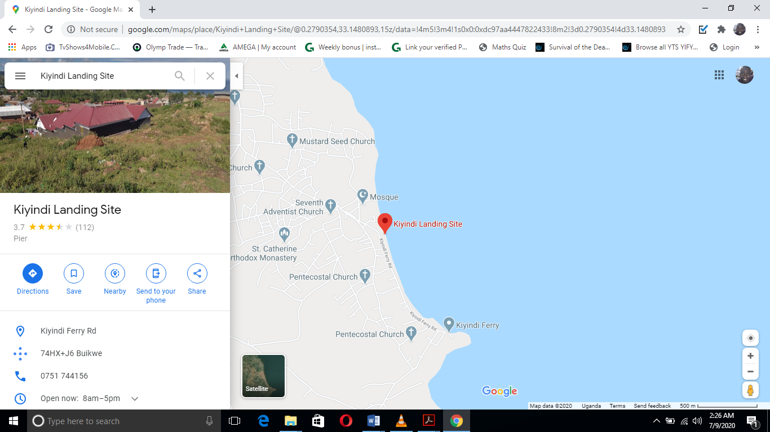
Source: Google Maps

Figure 1: Map showing the location of Kiyindi fishing
Scale: 1hr: 41.65km (from Mukono Town to Kiyindi fishing ground)

1.6.2 Content Scope
The study was limited to two variables, the independent and dependent variables. The independent variables were the catchability characteristics while the dependent variable include; use of illegal fishing gear (fish nets) including the monofilament and multifilament gillnets.

1.6.3 Time Scope
The study relied on data collected from respondents and analyzed between the months of January and July 2020 when the monofilament gillnet usage have been under strong enforcement operations in the fishing ground, but though they are still being used by fishermen at Kiyindi fishing ground in illegal practice.

1.7 Significance of the Study
Government of Uganda: Findings from this study provide important clues on how to curb down persistent illegal fishing in Buikwe District and on Lake Victoria as a whole. Thus at community level, the individual fishermen will benefit in that recommended strategies and intervention are focused on reducing illegal fishing and increase fish stocks in the long run and household incomes hence promoting personal and community development.
Policy makers: The Fisheries Department and Buikwe District Local Government benefited from this study since the findings provided fisheries officers the opportunity to make informed decisions based on evidence adduced hence guiding them in designing interventions against illegal fishing.
The Researcher: The researcher also believes that the findings of this study will also benefit him as the study is a requirement for a partial fulfillment for an award of a Master’s Degree of Natural Resources and Management.
Future Researchers and Academicians: The study also adds to already existing body of knowledge at Nkumba University as it is a reference to students intending to make studies in the fisheries sector. It is possible that the findings can lay the basis for further research in the same field. It is also further hoped that the findings and recommendations of this study will contribute to generation of new knowledge which may be useful to academicians.

1.8 Conceptual Frame work
The research investigated the comparative catchability of multifilament and monofilament gillnets in Lake Victoria in an effort to assess the quality of fish catch by each type of net. The indices of the effectiveness of catchability were treated as independent variables. According to this study, the efficacy of the nets for different species and sizes of fish were treated as dependent variables. The following diagram represents the study variables.
The conceptual frame work below was reflected in research questions and specific objectives with independent, dependent, intervening variables. The independent variable consists of fishing gears used including; monofilament and multifilament gillnets. These affect the independent variable which is catchability characteristics with monofilament that catches all fish sizes and fish types whereas multifilament is selective in terms of fish types and sizes. However, intervening variables like government policies, laws and regulations affect both independent and dependent variables as shown below in figure 1.
INDEPENDENT VARIABLES
Effectiveness of the Monofilament and Multifilament Gill Nets (catchability, suitability and efficiency)

INTERVENING VARIABLES
Fisheries Policies, Laws, regulations, and enforcement

DEPENDENT VARIABLES
Poor quality of fish caught
Good quality of fish caught

Legally acceptable species of fish
Illegal species of fish

Figure 2: Conceptual framework of the study

CHAPTER TWO: LITERATURE REVIEW

2.0 Introduction
This chapter synthesized the principles and concepts that have been explored and brought out by various authors in the existing literature on quality of comparative catchability characteristics of nylon monofilament and multifilament gillnets.

2.1 Literature Review
Extensive research has been done in various areas in the world (different countries) on the catchability of nylon monofilament and multifilament gillnets. In Asian countries such as Vietnam, the nylon monofilament and multifilament gillnets were used with comparative advantages as reported by Director of Fisheries, Vietnam Ha-khal-chu at the Second World Fish Gear Congress (Krisstjonsson, 1999). Some of the advantages attributed by a cross-section of fishermen in different parts of the world where nylon monofilament gillnets retain fish and other debris drifting around in the fishery waters, easier to operate, in susceptible to damage when the net becomes snagged at a given hanging ratio, and during daytime fishing they are invisible while multifilament gillnets given a bright reflection (Baranov, 1996).
Further, in comparison, monofilament gillnets are used in heavy fishing vessels and tend to blow around during the operations, and tend to be stiff at low temperature (Klust, 1982).
In Uganda, the nylon multifilament gillnets gained popularity way back in 1950s, for they replaced monofilament gillnets which were by then rated inferior in the fishing industry (Prado, 1991). In early 1990s, the nylon monofilament gillnet came into use on Lake Victoria and a decade later became popular due to their higher efficiency.

2.2 Design, Construction and Operation of Nylon Monofilament and Multifilament Gillnets

2.2.1 Design and Construction of a Gillnets
By design a gillnet is a rectangular panel of a net webbing that suspended vertically like a curtain in the water column (Prado, 1991). It is rigged with a number of floats attached to the float line and sinkers attached to the sinker – line (ground line) such that the up thrust forces caused by the floats and down thrust forces caused by the sinkers maintain the vertical stretch of the marker buoy on the water surface and the anchor-line carrying the anchor of the water bottom, while stakes support the frame-lines along the width (depth) of the net. In this form, the gillnet appears set rigged and stiff and does not collapse.
Nadiope (2010) designed a paired experiment using five monofilament and five multifilament nets with stretched mesh sizes of 76 inch, 89, 102, 114, and 127, a depth of 76 meshes and a hanging ratio of 0.5. The nets were set on 45 nights during monthly surveys conducted between March 2020 and Oct 2020. Gillnets were set in three zones (A- C) at approximately 17:00h and retrieved at 06:00h. To minimize the soak time difference, nets were hauled in the order in which they were set. The location of the nets was changed each night to minimize depletion effects. The findings from this experiment indicated that fish caught in each net were identified to species level and measured to the nearest mm total length and weighed to the nearest gram. Also water temperature (ºC), depth (m) and % moon phase were recorded daily during the experimental sampling. Several gillnet can be joined together to make a fleet and set to target either surface, mid-water or bottom-water swimming fish.
2.2.2 Operation of Gillnets
Gillnetting principle; the gillnetting principle consists in placing of fleet of gillnets in the path of the fish such that any fish which attempts to pass through the mesh by thrusting its head through becomes caught by gills or gill covers hence the essence of the name gillnet (Yokota, 2002)
Pre-Setting operations; Preparation for setting the gillnet (plate) are normally undertaken at the fishing ground at convenient hours of the day (morning or evening fleet of gillnets is prepared for setting by identifying damages on the net-webbing and replacing any missing accessory in the rigging.
The fleet is then assembled in the canoe. Normally, the float-line and buoy-line astern the sinker-line and anchor-line a fore and the netting in the middle of the canoes. The canoes set off to a pre-determined fishing ground to set the gears.
Setting the gear; the gear is normally set at dusk on the lee ward to avoid fleet entanglement in the water. The anchor line is set by lowering the anchor to the water bottom while the stakers support the frame lines the width of the net. Target fish can be caught either by surface-set mid water – set or bottom water set gillnet.

Hauling the gear; the gear is normally hauled at down by disengaging the anchor-line and hauling nets in a fleet one by one while carefully removing the catches from the gillnet. The last in the fleet is hauled and the maker-buoy removed, the gear is eventually packed into the canoe ready.
Disposal of the catch; the catch disposal is done either at the fishing ground to the waiting transport canoes or remove ground to the waiting transport canoes or remove from the canoe (Photo plate 4). The canoe is dried before another fishing operation commences (plates).

2.3 Catchability Characteristics of Nylon Monofilament and Multifilament Gillnets
Monofilament thickness affected not only the numbers of individuals caught, but also the diversity of the catch as a whole. The thicker diameters of monofilament caught fewer species likely due to the fact that stretchability and flexibility decrease continuously as twine is made thicker, reducing the probability of retention for some species. Similarly, (Reis and Pawson, 2008) found that a monofilament diameter might affect the species-selection of gillnet, which is strongly related to the species’ characteristic morphology. Gillnets are widely used in small-scale fisheries because they require little investment in labour and equipment, and are effective in catching widely scattered fish populations.
(McClanahan, 2000) reported that as catches decline, the gear that extracts the smallest size and most diverse fish resources may be the ‘better competitor’ and will reduce the catch of other gear types that select larger and more species-specific targets. Kurkilahti and Rask, 2001 suggest that the slightly different twine diameter and mesh size combination has no effect of catches of roach and perch of different gillnet types.
On the other hand, while Jennings et al; 2004 indicated that fishing causes a decrease in not only biomass but also diversity such that those gears with low selectivity will certainly decrease diversity more so than other gears. Balik & Cubuk, 2003; found that a thin monofilament twine caught significantly larger fish than a thicker twine of the same mesh size, and postulated that this was due to the greater elasticity of the thinner twine. For instance, they found that monofilament trammel nets caught 2.08 times more Tincatinca than multifilament nets in Lake Beysehir.
The efficiency of gillnets is largely influenced by the behaviour of fish in relation to the visibility of the gear, which in turn is related to the type of materials selected for its fabrication. As reported by (Pravin & Ravindran, 2005), multifilament gillnets showed better catch efficiency than monofilament gillnets.
Stewart 2009 compared the nets used in the United Kingdom for cod and found that multifilament nets captures better than monofilament. The differences can be attributed to how the fish is caught in the net, so monofilament nets capture better by yoking, the multifilament captures and entangling/ suspension because the monofilament nets are more soft and elastic. Banda (1999) pointed out that small-meshed monofilament are increasingly becoming popular as a result of decreased catch rate of target fish species though they are technically illegal. According to Simasiku, et al. 2003 Catch per Unit Effort (CPUE) of monofilament gillnets was 2.7 folds higher than that of multifilament.
Concurring with Machiels et al, 2003 who found that monofilament nets were more effective for zander (Sander lucioperca) and multifilament nets effective for bream. This is further in agreement with (Henderson and Nepszy, 2002), who found a higher total catch in monofilament nets, but captures a 7 of 23 species was higher in multifilament nets. On the other hand, Ayaz et al. 2003 indicated total catch rates of monofilament gillnets were significantly higher than multifilament gillnets probably due to higher visibility of multifilament nets.

2.4 The Efficiency and Suitability of Nylon Monofilament and Multifilament Gillnets
Economic efficiency of the monofilament and multifilament gillnet fishery: Multi-species and multi-fleet fisheries are generally open-access with low operating costs, which make fish resources more susceptible to overfishing. In this setting, one critical point to improve management requires considerable technical changes to the gear to increase its selectivity. In India, specific studies were initiated by (Sathiadhas et al. 2006), (Najmudeen and Sathiadhas, 2007) in which they analysed the economic impact of juvenile fish in multi -gear multispecies fishery of Kerala.
The study carried by (Faife, 2009), indicate that the monofilament gillnets catch better than multifilament at the same time the catch decreases with increasing number of filament and that this may be related to the visibility or friction of materials. It was revealed that the mean length of Nile perch increases as bigger mesh sizes are used. The lowest length estimate in the different mesh sizes is observed from gillnets 2.5 inches where the length of fish that was caught using this mesh size was 18.5 inches smaller than the average length estimates in each year. According to Emmanuel et al 2004 monofilament nylon caught more fish than the multifilament but the multifilament had longer life span than the monofilament.
The efficiency of monofilament gillnets was derived by using the ratio of monofilament mean CPUE to multifilament mean CPUE for each of the compared mesh size. Monofilament versus multifilament catch ratios by number ranged from 2.5 for S. macrocephalusup to nine times for O. andersonii. All catches were adjusted to CPUE by dividing the catch by the effort. Effort is expressed herein as fish biomass per 100-meter net length. Significant differences in catching efficiency of monofilament and multifilament gillnet were found to be significant. Monofilament gillnet efficiency was 2.7 times than multifilament gillnet (Hamley, 2007)
The greater efficiency of nylon monofilament gillnet is because of its fibre having high elasticity, greater tensile strength and stiffness, resistance to deteriorate, less hydrodynamic resistance and high resistance abrasion, and non-attack by fungi or bacteria, moisture and alkalis of the mounted nets (Hamley, 2007).
Effective mounting is done by complete stapling method which entails stringing normally 2 or more meshes between points of attachment (staple) (Baranov, 1996) and the distance between staple/ stapling interval is determined by formula:-
Where I = a x u x m
a = mesh-size of gillnet in inches
u = hanging ration (normally 0.5: 0.6)
m = number of meshes string loosely between staples
A demersal gillnet is rigged with more sinkers to ballast the gear and a pelagic gillnet is rigged with more floats to provide buoyancy to the gear.

2.5 Research gaps
According to the literature reviewed, the catchability characteristics effects of monofilament and multifilament gillnets should be recommended on fishing grounds by use of recommended fishing gears and more sensitization about right gears should be carried out to all fishermen in order to address the identified gaps in fishing activities.
Also the underlying gap of the study is by catch, or the capture of non-target species, is a global concern particularly from gillnet fisheries, as by catch species can include protected or endangered species, immature fish or species targeted by other fisheries

2.6 Theoretical review
This study relates to the Yield Per Recruit (Y/R) model, the mode is based on two basic assumptions: (1) independent of the combination of fishing mortality (F) and mesh size (if beyond size at maturity of fishing target), there will be sufficient recruits coming into the fishery every year, so fishing is not expected to affect recruitment substantially; (2) gear selection follows a sigmoid selection curve, with all fish larger than the size at first capture (inflection point of the curve) being retained by the net. Both assumptions were quite reasonable for the target stocks of the North Atlantic trawl fishery at that time (such as plaice and haddock in the North Sea), (Taylor, 2015).
Classical Fisheries Management Theory
Classical fisheries management is premised on a single stock paradigm which essentially argues that the productivity of a stock is a function of its size and its reproductive potential. Subsequently, it is argued that the basic objective of fisheries management is to exploit this stock at a level where its reproductive ability is equal to its natural mortality, through mesh regulations/ selective fishing, (Holt 2012). Therefore, the classical approach to fisheries management necessitates the need to estimate growth and mortality parameters from exploited populations, which are then used as input parameters to estimate fish caught, which is the key objective of fisheries management. This fisheries management philosophy is codified in Beverton and Holt’s Yield-Per-Recruit Model which is a major seminal work in fisheries literature.
Over time, regulations were gradually introduced to manage fisheries resources to achieve optimum utilization (i.e. maximum sustainable yield) of the fish resources. According to Pauly (2005), some of these include reducing fishing effort, mesh regulations, closed fishing seasons, and fishing gear restrictions. Welcomme (2006) defines these as technical measures (like mesh and gear limitations, closed seasons), input controls (for instance licensing to control effort and access, ownership), and output controls (quotas, size limits on fish landed). These classical regulations have subsequently been assiduously implemented in floodplain fisheries.

CHAPTER THREE: METHODOLOGY

3.0 Introduction
According to Katebile (2007) Methodology is defined as the technical or scientific activities, tools and procedures taken to plan gather and analyze data. This chapter provides methods of research applied when collecting and analyzing data research designing and sampling size determination, sampling procedures and design, methods of data collection, and limitations of the study, and visit to planned areas (secondary sources of data). Questionnaires (Primary sources) Subjects/ research sample, instruments/ tools, materials, procedures/ experimental fishing limitations were used.

3.1 Research Design
This study used a case study research design using a descriptive and analytical method. The quantitative approach was used to quantify incidences in order to describe current conditions and to assess comparative catchability characteristics of nylon monofilament and multifilament gillnets used at Kiyindi fishing ground on Lake Victoria in Buikwe District using information gained from the questionnaires. The qualitative approach was used to explain the events and describe findings got from interview guide and documentary analysis. All this enabled the researcher to gain in-depth information that was used to find solutions for the research questions of the study.

3.2 Study Area
The study focused on Kiyindi fishing ground. This fishing ground is found on Lake Victoria at latitude 00⁰4’N and longitude 33⁰00’E (Ref map) 30 km off the Jinja – Kampala highway at Lugazi in Kiyindi Town Council, Buikwe District.
The mean surface temperature is about 26⁰C while that of the deeper waters is about 24⁰C. The area receives rainfall throughout the year, which is almost entirely balanced by evaporation. The current total population of Kiyindi Town Council was estimated to be 25,000 people with a sex ratio of 2 men: 3 women (UBOS National Population Statistics Report, 2014).

Source: Buikwe District Geographical Map Abstract (2018)
Plate 1: Location of Kiyindi fishing ground
Map of Uganda showing the geographical location of Buikwe District
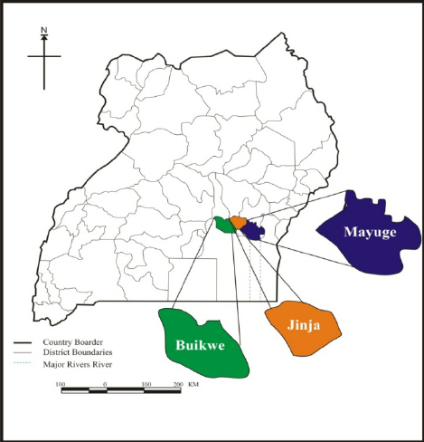
Source: Google Maps

3.3 Study Population
According to the Buikwe District Hazard, Risk and Vulnerability Profile (2020), the estimated population for Lugazi where the fishing site located was 39,483 constituting of 19,057 males and 20,426 females in particular. Kiyindi fishing ground in particular has an estimated population of over 25,000 people and a target population of 80 people was considered, consisting of (30) fishermen, (05) fisheries officers, (20) local community members and (25) market vendors. However due to the limited resources and time that were available to the researcher, a sample size of 67 respondents was selected from the target population constituting of (25) fishermen, (05) fisheries officers, (20) market vendors and (17) local community members and these were selected using appropriate sampling techniques as indicated in table 1.

3.4 Sample Size
A sample is a selection of a small group, individuals, objects or even units representing a bigger portion or a whole. The target sample size of 67 out of the 80 (target population) was determined by a Yamane’s (2002) Formula below;
Therefore; 𝑛 = 𝑁
1 + (𝑒)²
Where;
n is the sample size;
N is the total population;
𝑒 is the 0.05 standard error
n = 80
1+80(0.05)²
n = 67
Table 1: Sample size and sampling technique
Category | Total population | Target Population | Sample size | Sampling technique
Fishermen | 10,000 | 30 | 25 | Simple random sampling
Fisheries officers | 05 | 05 | 05 | Purposive sampling
Market vendors | 400 | 25 | 20 | Simple random sampling
Local community | 14,595 | 20 | 17 | Simple random sampling
Total | 25,000 | 80 | 67
Adopted from: Buikwe District Hazard, Risk and Vulnerability Profile (2020)

3.4.1 Sampling Techniques
The researcher used both purposive and simple random sampling techniques. According to (Lavrakas, 2008) purposive sampling is used an attempt to list all elements in a group and to measure one or more characteristics of those elements. Purposive sampling was used to select fishermen, and fisheries officers because they had relevant information as far as catchability characteristics of fishing gears was concerned. However, simple random sampling was used to select market vendors and local community because they were large in number and they also possessed knowledge on the fishing gears used since they are also consumers of fish caught from the waters.

3.5 Data Collection Methods

3.5.1 Visits to planned areas
Visits were made to specific libraries at Nkumba University, Fisheries Training Institution, Directorate of Fisheries Resources, to collect necessary information and data for the project. Further, visits were made to relevant government offices where literature materials based on the research topic were scanned. Hence the researcher conducted focus group discussions with 5 fishermen, 10 market vendors and 10 local community members

3.5.2 Questionnaires and interviews
Self-administered questionnaires covering all the aspects of the study variables and accompanied with a five-point Like scale response continuum, that is 1 = strongly agree, 2 = agree, 3 = undecided, 4 = disagree and 5= strongly disagree, was used for this study to collect data from small business enterprises owners. Questionnaires were administered to fishermen (05), fisheries officers and (15) fishermen because they were able to read and write and were also the target respondents.
The Oral interviews were also conducted to specific target respondents that qualitative and quantitative data for the project was recorded. Interviews were held with 5 fishermen, 10 market vendors and 7 members of the local community hence their responses were recorded and analysed respectively.

3.5.3 Physical Observation
Observations were made on the spot on physical technical characteristics of the gear (e.g. gear design, and their constructional materials, color of the gears) and operation of the gears at the fishing ground.

3.5.4 Subjects/ Research Sample
The sample of fish species were weighed and data were recorded for analysis. Research equipment and facilities include assortment of nylon monofilament and multifilament gillnets which were mandated and rigged for use, stationery, weighing scale for determining the weight of the landed fish, statistical data forms for recording fishery data, and meter ruler or tape measure for lineal measurements. The canoe and crew were hired for research purposes.

3.6 Procedures/ Experimental Fishing
Fishing was carried out using nylon monofilament and multifilament gillnets following the technological processes discussed above. The catches that land by monofilament and multifilament gillnets were sampled and sorted out according to species and the data was collected and recorded on the data forms. Mesh – sizes and other gear parameters were determined by direct measurement using a ruler or tape measure.

3.7 Data Analysis
Quantitative data from the questionnaires was analyzed with the use of descriptive statistics such as percentages and frequencies. Qualitative data was analyzed using content analysis where the researcher tried and build some categorization into the data collection with the intention of collecting patterns related to the themes of the study, it involved gathering data and analyzing data based on content related objectives.
Regarding the design and construction of both monofilament and multifilament gillnets, data was basically analysed using quantitative analysis through field surveys to understand the construction materials used, the design, the size and the tangibility characteristics of the fishing gears used at Kiyindi fishing ground. Also the catchability characteristics was analysed basing on the size and the quantity of fish caught by each gillnet whereas the efficiency and suitability of the gillnets was analysed basing on the impact of each gillnet.

3.8 Reliability and Validity of the Instruments

3.8.1 Validity
The concept of validity ensures that the instruments were used to yield relevant and correct data. To ensure validity data collection instruments were constructed in such a way that they have an adequate number of items and that each items or question on the scale has a link with the objectives of the study and were covered in a full range of issues that was measured. Where necessary, questionnaires were revised accordingly to suit the objectives of the study.

3.8.2 Reliability
Reliability was used to measure the degree to which the instrument is the same if put under the same conditions. To ensure reliability, the research instruments were pretested to selected 20 respondents to ensure consistency and comprehensiveness. Further, consultations with other researchers, supervisors and peers were done to review the research instruments. The respondents who participated in the study were informed.
The researcher used alpha co-efficient to establish the degree to which the questions are internally consistent. According to Cronbach (1950), coefficient alpha of 0.7 and above is considered significant.
Reliability Test
Variable | Anchor | Number of items | Cronbach Alpha Value
Design and construction  Catchability  Efficiency and suitability | 5 point Likert Scale  5 point Likert Scale  5 point Likert Scale | 13  12  14 | .821  .814  .794
Source: Primary data, 2021
According to Cronbach (1950), coefficient alpha of 0.7 and above is considered significant. From the results all the Cronbach alpha coefficients ranged from .794 to .821, therefore meeting the acceptable standards.

3.9 Research Ethical Consideration
Mendez et.al, (2009), ethical considerations refer to the norms or standards for conduct that distinguish between right and wrong. They help to determine the difference between acceptable and unacceptable behaviors. The researcher got an introductory letter from Nkumba University, school of sciences which showed that he was a student from the University. This was taken to the administration of Kiyindi fishing and fishing ground so that the researcher could be allowed to conduct his research. Respondents were assured that research was strictly for academic purposes and information was kept with utmost confidentiality.

3.10 Limitations of the Research.
The researcher got problem with language barrier since most of fishermen use Luganda and could not easily interpret questions clearly. To overcome this challenge the researcher hired an interpreter to explain in the language that could be clearly understood by the respondents
The researcher was also faced with a problem of transport costs since the study involved travelling to and from the field to collect the required data and also the outbreak of covid-19 Pandemic which made transport costs hike to abnormal charges. This was overcome by soliciting financial assistance from family and friends.
Hoarding of information was also a challenge since most of respondents feared to be approached due to Covid- 19 Pandemic, however the researcher endavoured to observe the Standard Operating Procedures (SOPs) to collect data.
There was also a challenge of limited time since the researcher had to collect data, analyse and interpret the results along with other busy schedules. To overcome this the researcher designed ad followed a time frame time table to complete the research process.
Some respondents also refused to give information with the assumption that the study was for personal benefit, thus to overcome this, the researcher assured them that the study was for academic purposes by presenting authorization documents like recommendation letter obtained from Nkumba University.

CHAPTER FOUR: DATA PRESENTATION AND ANALYSIS OF FINDINGS

4.0 Introduction
This chapter contains presentation and discussion of the study as per the study objectives to find out comparative catchability characteristics of nylon monofilament and multifilament gillnets used at Kiyindi fishing ground on Lake Victoria in Buikwe district in Uganda to establish design, construction and operation of nylon monofilament and multifilament gillnets, their characteristics and efficiency plus their impact on the fish exploited.

4.1 Fish Catch Data of the Research Project
The researcher first analysed the fish catch data at Kiyindi fishing site and the results obtained are presented in Table 2.

Table 2: Fish catch data of the Nylon Monofilament and multifilament gillnets at Kiyindi fishing ground
Sampling date September 2020 | Canoe  No. | Gear specification | Qty/No. of gillnets | Fish species |  |  |  |  |  |  |  |  |  | %equi-  valent | Degree equivalent
 |  |  |  | Lates nilotics mputa |  |  | Oreochromis Nilotics |  |  | By-catches |  | Total Fish
1st -2nd | 1 | Monofi210d/0.6 mmx6” |  | No. | Wt(kg) | Length | No. | Wt(kg) | Length | No. | Wt(kg) | No. | Wt(kg)
 |  |  | 3 | 1 | 2 | 11” | 56 | 40.4 | 4” | 3 | 2.9 | 60 | 45.3
 |  | Multifi210d/6” | 3 | 0 | 0 | 0 | 28 | 21.2 | 5” | 0 | 0 | 28 | 21.2
5th – 6th | 2 | Monofi210d/0.6 mmx6” | 3 | 1 | 1.2 | 9” | 43 | 32.4 | 6” | 1 | 0.9 | 45 | 34.5
 |  | Multifi210d/6” | 3 | 2 | 2 | 15” | 21 | 17 | 9” | 0 | 0 | 23 | 19
7th – 9th | 3 | Monofi210d/0.6 mmx6” | 3 | 4 | 8.7 | 8” | 28 | 11.6 | 2” | 2 | 17 | 34 | 37.3
 |  | Multifi210d/6” | 3 | 1 | 1 | 20” | 7 | 3 | 10” | 1 | 0.6 | 13 | 4.6
14th – 15th | 4 | Monofi210d/0.6 mmx6” | 3 | 2 | 1.6 | 13” | 34 | 25.7 | 7” | 1 | 1.3 | 37 | 28.6
 |  | Multifi210d/6” | 3 | 3 | 4.4 | 28” | 19 | 7.9 | 6” | 0 | 0 | 22 | 12.3
17th – 18th | 5 | Monofi210d/0.6 mmx6” | 3 | 0 | 0 | 0 | 26 | 18.3 | 9” | 0 | 0 | 26 | 18.3
 |  | Multifi210d/6” | 3 | 0 | 0 | 0 | 21 | 11.5 | 11” | 3 | 4.2 | 21 | 11.5
25th – 26th | 6 | Monofi210d/0.6 mmx6” | 3 | 0 | 0 | 0 | 39 | 30 | 4” | 3 | 4.2 | 42 | 35
 |  | Multifi210d/6” | 3 | 1 | 1.5 | 6” | 20 | 23.4 | 12” | 1 | 2.5 | 22 | 15
29th – 30th | 7 | Monofi210d/0.6 mmx6” | 3 | 2 | 4 | 19” | 28 | 14.5 | 11” | 4 | 5 | 34 | 23.5
 |  | Multifi210d/6” | 3 | 2 | 1.1 | 4” | 13 | 4.8 | 7” | 0 | 0 | 15 | 5.9
TOTAL |  | Monofilament (monof/gn) | 21 | 10.5 | 17 | 60” | 254 | 172.9 | 43” | 14 | 31.3 | 278 | 221.7 | 69%
 |  | Multifilament(multif/gn) | 21 | 8 | 10 | 73” | 129 | 88.4 | 69” | 2 | 3.1 | 144 | 101.9 | 31%
GRAND TOTAL |  |  | 42 | 18 | 27.5 | 133” | 383 | 261.3 | 112” | 16 | 34.4 | 422 | 323.6 | 100%
 |  | % composition |  | 8% |  |  | 81% |  |  | 11%
Source: Field Data, 2020

4.1.1 Characteristics of the Monofilament and Multifilament Fishing Gears
Table 2 above indicates that monofilament catches were much of fish with less length (43 inches) while multifilament catches had less fish of high length (69 inches). Monofilament catches had more weights (221.7 Kgs) whereas multifilament catches had less fish weight (101.9 Kgs). Monofilament nets caught more fish (278) compared to multifilament nets (114). Monofilament catches mainly had fish species of small size (77 inches) whereas multifilament catches fish were composed of big size (84 inches).
Relative abundance of Fish Catches by Monofilament and Multifilament Gillnets (RA)
Formula/ method
RA = Total fish catch wt (kg) by a particular gear x 100%
Grand total fish catch wt(kg) of all gears
OR Total fish catches wt (kg) by a particular gear x 360⁰
Grand total fish catch wt. (kg) of all gears

Figure 3: Relative abundance of fish catches by monofilament and multi filament gillnet
Results from Figure 3 shows that there are more monofilament gillnets (69%) and less multifilament gillnets (31%) used at Kiyindi fishing ground. This is an implication that there are more monofilament gillnets (illegal) compared to multifilament gillnets.

Impacts of Monofilament and Multifilament Gillnets on the Fish Stocks Exploited.
Findings from the study indicates that drift gillnetting destroys aquatic macrophytes and .other organisms by entanglement and indiscriminate fishing of aquatic sources. Gillnetting associating with the use of "tycoons" disrupts the fish ecosystem.
Gillnets bearing less than 5(127mm) mesh size caught immature Nile perch and Tilapia species and others such as Clarias, Synodontis, Protopterus aethiopicus and Bagrus. Monofilament gillnets were reported to inflicts pain or bodily harm to the fish by gripping them firmly or mutilating their bodies thus causing post-harvest losses to the catches.

4.2 The Demographic Characteristics of Respondents
This section highlights the biography of the respondents which includes sex, age, level of education levels, marital status and respondents’ occupation among others, the information is provided in the tables below;

4.2.1 Sex of respondents

Figure 4: Sex of respondents
Results from the survey above indicate that 37 (55.2%) of the respondents were male while 30 (44.8) % were females (Figure 4), suggesting that the majority of the people engaged in fishing activities were males. The study population included fish mongers, however both gender were involved in the study to avoid biased results.

4.2.2 Age of respondents
Table 3: Showing the age of the respondents
Age | Frequency | Percent
Below 20 yrs  20-25yrs  26-30 yrs  31-35 yrs  36-40yrs  Above 40yrs | 4  14  21  17  8  3 | 6.0%  20.9%  31.3%  25.4%  11.9%  4.5%
Total | 67 | 100

According to the results, respondents aged below 20 years’ accounted for (6%) whiles those with 20-25 years accounted for (20.9%), 31.3 aged between 26-30 years, 25.4 aged between 31-36 years, (11.9%) aged between 36-40 years and the minority (4.5%) aged above 40 years (Table 4).
The results above show that highest number of the respondents in the study sample were youth of ages 26-30 years representing 31.3%. The study shows that only 4.5% of the respondents were above 40 years. The findings from the study imply that the majority of people engaged in fishing are youth. This also means that interventions aimed at controlling illegal fishing especially the use of monofilament gillnets should target young people.
4.2.3 Highest Educational Level Attained

Figure 5: Respondents’ educational level
Both Male and female illiterate respondents constituted (27%) of the population and up to (34%) constituted the population with primary education. Respondents with secondary education accounted for (22%) while respondents with tertiary/University education constituted 12% at diploma and 5% at degree level (Figure 5).
It was important to involve all categories of people including the illiterate, semi-literate and the literates because it gives a clear picture of the understanding of the subject of illegal fishing and whether it is understood by all people irrespective of the education background. The findings show that the majority of respondents are relatively educated meaning that they can read and write. This means that it is easy for the fisher folk to read and interpret awareness messages a strength that policy makers rely on to undertake effective community awareness and progress.
4.2.4 Occupation of respondents other than fishing

Figure 6: Occupation of Respondents
The results revealed that the majority of the respondents were traders (33%), followed by farmers (28%), local council leaders (12%), civil servants (11%), were students (10%) and the minority (6%) comprised of those who were unemployed each. This means that majority of people living and working at Kiyindi fishing ground are traders since they sell fish caught and other fishery related services.

4.2.5 Marital Status of Respondents

Figure 7: Marital Status of Respondents
According to the survey, majority of the respondents (61.2%) were married while (25.4%) were single, (10.4%) widowed and (3%) divorced/separated. The majority of respondents being married implies that the married men had more needs to attend to than the singles. This is justified by the fact that most of the respondents interviewed had ever been involved in illegal fishing.

4.3 Findings on the Design and Construction of Nylon Monofilament Compared to Multifilament Gillnets

4.3.1 Findings on whether Designs of the Nylon Monofilament are Efficient and Effective Compared to Multifilament
Respondents were asked whether the designs of the nylon monofilament were efficient and effective compared to multifilament gillnets and the following were the responses.
Table 4: Designs of the Nylon Monofilament are Efficient and Effective Compared to Multifilament Gillnets
Responses | No. of Responses | Percent
Strongly Agree  Agree  Not sure  Disagree  Strongly Disagree | 17  28  0  12  10 | 25.4%  41.8%  0%  17.9%  14.9%
Total | 67 | 100

Table 5 shows that (25.4%) of the respondents strongly agreed that designs of the nylon monofilament were efficient and effective compared to multifilament gillnets. Atleast (41.7%) agreed, none was not sure and (17.9%) disagreed, while (14.9%) strongly disagreed. This implied that the gillnets especially multifilament gillnets as mentioned above can do more good for the fishermen. This has enabled the management of Kiyindi Fishing Grounds to be more productive and effective in regards to the operations conducted around the ground.

4.3.2 Construction of Nylon Monofilament help the Fishing Practices Compared to Multifilament
Respondents were asked whether the construction of nylon monofilament help the fishing practices at Kiyindi Fishing Grounds compared to multifilament gillnets and the following were the responses.
Table 5: Construction of Nylon Monofilament helps the Fishing Practices Compared to Multifilament
Responses. | No. of Responses | Percent
Strongly Agree  Agree  Not Sure  Disagree  Strongly Disagree | 25  21  0  13  8 | 37.3%  31.3%  0%  19.5%  11.9%
Total | 67 | 100

Table 6 above indicates that construction of nylon monofilament helped the fishing practices at Kiyindi Fishing Grounds compared to multifilament and this was supported by (37.3%) of the respondents who strongly agreed and (31.3%) who agreed while 19.5% disagreed and (11.9%) strongly disagreed. Since the majority of the respondents (68.6%) generally agreed with the statement, it is therefore true that the construction of these fishing gears especially monofilament are appropriately done at Kiyindi Fishing Grounds.
4.3.3 Operations Carried out using Nylon Monofilament have enabled fishermen to Improve their Fishing Practices Compared to Multifilament
Respondents were asked whether the operational practices using the nylon monofilament at Kiyindi Fishing Grounds and made fishing easier for the fishermen compared to multifilament gillnets and the response were as follows;
Table 6: Operations Carried out using Nylon Monofilament have Enabled Fishermen to Improve their Fishing Practices Compared to Multifilament.
Responses | No. of responses | Percent
Strongly Agree  Agree  Not sure  Disagree  Strongly Disagree | 20  29  0  12  6 | 29.9%  43.3%  0%  17.8%  9.0%
Total | 67 | 100

From the Table 7 above, (29.9%) of the 67 respondents strongly agreed that the operational practices using the nylon monofilament in Kiyindi Fishing Grounds helps them in better fishing practices as, (43.3%) agreed, (17.8%) disagreed, (9%) strongly disagreed, and none was not sure. This implies that the operations carried out along Kiyindi Fishing grounds using nylon monofilament have enabled fishermen to improve their fishing practices compared to multifilament gillnets.
4.3.4. The Construction and Design of Nylon Gillnet
Respondents were asked whether the, construction and design of nylon monofilament improve on the catch per day compared to multifilament and the response was computed as follows;
Table 7: The construction and design of nylon gillnet
Responses. | No. of responses | Percentage
Strongly Agree  Agree  Not sure  Disagree  Strongly Disagree | 27  25  -  10  5 | 40.3  37.3  -  14.9  7.5
Total | 67 | 100

Table 8 indicates that (40.3%) of the respondents strongly agreed that design, and construction of nylon monofilament in fishing along Kiyindi Fishing ground is enhanced by the nylon monofilament gillnets that are used rather than other gillnet types. (37.3%) of the respondents agreed, (14.9%) disagreed, (7.5%) strongly disagreed, and none was not sure. This therefore implied that the above applied as asked since the majority agreed with the statement.

4.2.5 Qualitative Analysis on the Design of Nylon Monofilament and Multifilament Gillnets
Results show that monofilament and multifilament gillnets are among the most selective gears in terms of both species caught and the size range retained and are thus used to target desired species and size of fish. The principles behind gillnetting have not changed over the years but equipment and materials have changed. It is widely recognized as an efficient and selective type of gear. Today, the fishing industry is twice as large as it is required.
In an interview with one of the respondents, he was quoted;
“Due to technological changes, such as the introduction of motorization and monofilament nets, have enabled fishermen to exploit near shore and offshore fisheries resources more intensively than was ever imagined a few decades ago. These technological advances have led to increased conflicts and overexploitation of some fisheries such as in Kiyindi Fishing Grounds”.
Another respondent was quoted:
“We use single monofilament yawn, to make a curtain like piece while multifilament we use double yawn of any colour either in terms of cast net fashion to make the gear. However, sometimes we just buy the already made from Kenya”.
“Also a single yawn of monofilament is designed in square structure until a curtain like formed and on top there is a thicker line and bottom there is a thinner line. The yawn of a monofilament is bigger than that of a multifilament, when designing it you make sure those plastic yawns are stronger (thicker)”.
Most of the respondents agreed that the design, construction and operations of the monofilament and multifilament gillnets determined to be used by the fishermen at Kiyindi Fishing ground are effective and efficient in fishing at the grounds. Weber (1994) identified overfishing, destructive fishing practices, pollution and coastal development as the major causes for fish species decline. The type and structure of gillnet used by a fishermen is what contributes to the catch and effectiveness to make a living but at the same time it’s also the cause of depletion of the fish species within Lake Victoria and other water bodies elsewhere.
Hence according to objective one much of the designs, construction and operations carried out within the fishing grounds are generally boosting and efficient due to the nylon and multifilament compared to monofilament gillnets used by fishermen and this makes them get more fish species.

4.4 Findings on Determination of the Catchability Characteristics of Nylon Monofilament Compared to Multifilament

4.4.1. Nylon Monofilament Increased the Rate of Fishing Compared to Multifilament
Response on whether the nylon monofilament gillnets have increased the rate of fish species caught at Kiyindi fishing grounds compared to multifilament is as follows;
Table 8: Nylon Monofilament have Increased the Rate of Fish Caught at Kiyindi Fishing Grounds Compared to Multifilament
Responses | Frequency | Percent
Strongly agree  Agree  Not Sure  Disagree  Strongly Disagree | 18  22  4  14  9 | 26.9%  32.8%  6.0%  20.9%  13.4%
Total | 67 | 100.0

Table 9 indicates that most of the respondents believed that nylon monofilament gillnets have increased the rate of fish caught at Kiyindi fishing ground compared to multifilament gillnets to which the majority, (32.8%) agreed and also the 26.9% respondents strongly agreed, unlike the 20.9% that disagreed and 13.4% that strongly disagreed while 6% were not sure. This therefore, implies nylon multifilament gillnets have increased the rate of fish species caught in a classified manner as the majority of respondents agreed with the statement.

4.4.2 The Nylon Monofilament Work Best when Fishing Compared to Multifilament
Response on whether the nylon monofilament work best when fishing compared to multifilament the results were computed as follows;

Table 9: Nylon monofilament work best when fishing compared to multifilament
Responses | Frequency | Percentage
Strongly Agree  Agree  Not Sure  Disagree  Strongly Disagree | 10  21  0  23  13 | 14.9%  31.3%  0%  34.3%  19.5%
Total | 67 | 100.0

Table 10 shows that most of respondents (34.3%) disagreed that nylon monofilament gillnets both work best when fishing at the fishing grounds compared to multifilament gillnets where (31.3%) agreed, (19.5%) strongly disagreed, (14%) strongly agreed, and none of the respondents were not sure. This implied that the nylon multifilament works better when fishing at the fishing ground compared to monofilament. This was due to the fact that monofilament gillnets were banned, though many fishermen still illegally use them to catch fish.
4.4.3 Nylon Monofilament Gillnets have More Catchability Characteristics than the Nylon Multifilament Gillnets
Response on whether nylon monofilament gillnets have more catchability characteristics than the nylon multifilament gillnets used at Kiyindi Fishing ground and was computed as follows;
Table 10: Nylon monofilament gillnets have more catchability characteristics than the nylon multifilament gillnets
Responses | Frequency | Percent
Strongly Agree  Agree  Not sure  Disagree  Strongly Disagree | 10  08  07  23  19 | 14.9%  11.9%  10.4%  34.3%  28.5%
Total | 67 | 100.0

From Table 11, some of the respondents believed that nylon monofilament gillnets have more catchability characteristics for example designs, efficiency and catchability rate than the nylon multifilament gillnets used at Kiyindi Fishing ground in that (14.9%) of the respondents strongly agreed, (11.9%) agreed, (34.3%) disagreed, (28.5%) strongly disagreed while (10.4%) were not sure. This therefore implied that nylon monofilament gillnets do not have more catchability characteristics than the nylon multifilament gillnets used at Kiyindi Fishing ground.

4.4.4 Qualitative Analysis on Determination of the Catchability Characteristics
Findings revealed that determination of the catchability characteristics of nylon monofilament gillnets and multifilament gillnets is mainly based on so many factors that the gillnets had and possessed in nature, this on one hand has enabled many fishermen to take them into consideration and get more productive in terms of fishing.
Interviewees were quoted;
“with monofilament, all fish sizes, species are caught compared to multifilament and in addition, multifilament can easily be seen by fish in water compared to monofilament. Also monofilament catches small and immature fish compared to multifilament”.
Another respondent stated in the questionnaire survey that monofilament is weaker when it comes to catching a lot of fish with much weight whereas multifilament is stronger in catching fish with heavy weight.

4.5 Findings on Efficiency and Suitability of Nylon Monofilament
Assessment of the efficiency of nylon monofilament and multifilament gillnets basing on the nylon fibre properties was analysed as follows;

4.5.1 Nylon Monofilament and Multifilament Gillnet Fibres
Respondents were asked whether nylon monofilament and multifilament gillnet fibres were efficient in fishing at Kiyindi Fishing ground.
Table 11: Nylon monofilament and multifilament gillnet fibres
Responses | Frequency | Percent
Strongly Agree  Agree  Not Sure  Disagree  Strongly Disagree | 12  11  0  20  24 | 17.9%  16.4%  0%  29.9%  35.8%
Total | 67 | 100.0

The information provided in the Table 12 above indicates that (17.9%) of the respondents strongly agreed that nylon monofilament and multifilament gillnet fibres were not efficient in fishing at Kiyindi Fishing grounds and (16.4%) agreed, (29.9%) disagreed, (35.8%) strongly disagreed, and none were not sure. This implies that nylon monofilament and multifilament gillnet fibres were not efficient in fishing at Kiyindi fishing grounds as the majority (35.8%) strongly disagreed with the statement.

4.5.2 A comparison of Tensile Strength of Nylon Monofilament and Multifilament Gillnet Fibres
Response on whether the nylon monofilament fibres are excellent when it comes to tensile strength compared to multifilament was computed as follows;
Table 12: The Nylon monofilament and multifilament gillnet fibres are excellent when it comes to tensile strength
Responses | Frequency | Percentage
Strongly Agree  Agree  Not sure  Disagree  Strongly Disagree | 23  27  5  7  5 | 34.3%  40.3%  7.5%  10.4%  7.5%
Total | 67 | 100.0

From the Table 13, it is clear that (34.3%) of the respondents strongly agreed that nylon monofilament and multifilament gillnet fibres were excellent when it comes to tensile strength, (40.3%) agreed, (10.4%) disagreed, (7.5%) strongly disagreed, and (7.5%) were not sure. This implies that the nylon monofilament fibres are excellent when it comes to tensile strength compared to multifilament as the majority 50 (74.6%) of the respondents generally agreed to the statement.

4.5.3 Efficiency and Suitability of the Nylon Monofilament and Multifilament Fibres
Respondents were asked whether the efficiency and effectiveness of the nylon monofilament fibres are generally based on resistance to wrinkles and sunlight compared to multifilament results are contained in table 14;

Table 13: Efficiency and Suitability of the nylon monofilament and multifilament fibres
Responses | Frequency | Percent
Strongly Agree  Agree  Not Sure  Disagree  Strongly Disagree | 26  30  7  4  0 | 38.8%  44.8%  10.4%  6.0%  0%
Total | 67 | 100.0

The Table 14 shows that (38.8%) of the respondents strongly agreed that the efficiency and effectiveness of the nylon monofilament and multifilament gillnet fibres are generally based on resistance to wrinkles and sunlight, (44.8%) agreed, (6%) disagreed, none strongly disagreed, while (10.4%) were not sure. This implied that efficiency and effectiveness of the nylon monofilament fibres are generally based on resistance to wrinkles and sunlight compared to multifilament as majority of the respondents 56 (83.6%) generally agreed.

4.5.4 Qualitative Analysis on the Efficiency and Suitability of Nylon Gillnets
Most of the respondents noted that there is relative efficiency and suitability of nylon monofilament and multifilament gillnets basing on the nylon fibre properties. Hence the gillnets have fibre properties that are quite evident in making them strong and durable for them to withstand all sorts of environments even under strong sunlight and bad weather.
Results further revealed that assessment of the efficiency of nylon monofilament and multifilament gillnets basing on the nylon fibre properties and the analysis of the gillnets has been evident that they can withstand long life and this is all due to their fibre properties that enhance their life span both when and after fishing is done at the fishing grounds by the fishermen.
The study findings showed that with monofilament it is more destructive because it catches young fish of all fish types and sizes and leads to the destruction of fish biomas in the lake. Once it is lost in water it disrupts fish movement and damages its body. Compared to multifilament, it is less destructive as it catches its specific fish types and sizes. For example monofilament catches small fish species like tilapia while multifilament is famous for Nile perch.
The above findings were aligned with Wahab (1998) who illustrated that the assessment of the efficiency of nylon monofilament and multifilament gillnets basing on the nylon fibre properties can be generally entrusted on the side of the gillnets composition to do what they are supposed to do as regards fishing and also the fact that they are strong in their fibre composition.

4.6. Assessment of the Impacts of Nylon Gillnets on the Fish Stocks
Respondents were asked whether the impacts of nylon monofilament are productive compared to multifilament and the results were as follows;

4.6.1 Nylon Monofilament are Productive Compared to Multifilament
Table 14: Impact of nylon monofilament are productive compared to multifilament
Responses | Frequency | Percentage
Strongly Agree  Agree  Not Sure  Disagree  Strongly Disagree | 11  15  5  20  16 | 16.4%  22.4%  7.5%  29.9%  23.9%
Total | 67 | 100.0

Findings in Table 15 indicate that (16.4%) of the respondents strongly agreed that the impacts of nylon monofilament were not productive compared to multifilament, (22.4%) agreed, (29.9%) disagreed, (23.9%) strongly disagreed, and (7.5%) were not sure. This means that the impacts of nylon monofilament are productive compared to multifilament.
However respondents revealed that illegal boats were also somehow using other fishing gears like fish traps and hooks among others. The research findings indicated that, illegal fishing gears were common, meaning in simple terms that the presence of these gears has led to persistent illegal fishing on Kiyindi fishing ground.

4.6.2 Fish is Heavily Exploited When Fishermen use the Nylon Monofilament Compared Multifilament Gillnets
Respondents were asked if fish was heavily exploited when fishermen use the nylon monofilament compared to multifilament gillnets and the results were tabulated in table 16;

Table 15: Fish is heavily exploited when fishermen use the nylon monofilament compared to multifilament
Responses | Frequency | Percent
Strongly Agree  Agree  Not Sure  Disagree  Strongly Disagree | 18  17  7  15  10 | 26.9%  25.4%  10.4%  22.4%  14.9%
Total | 67 | 100.0

Table 16 indicates that (26.9%) of the respondents strongly agreed that their fish is heavily exploited when fishermen use the nylon monofilament and multifilament gillnets, (25.4%) agreed, (22.4%) disagreed, (14.9%) strongly disagreed and (10.4%) were not sure. This implied that fish is heavily exploited when fishermen use the nylon monofilament rather than multifilament gillnets.
One of the respondents was quoted;
“Monofilament is very dangerous fishing gear since it collects whatever is in water both living and non-living things leading to the loss of other biodiversity and exploitation leading to massive destruction and reduction of fish stock”.

4.6.3 The Nylon Monofilament are More Dangerous Compared to Multifilament
Respondents were asked whether the nylon monofilament were more dangerous compared to multifilament and the results were as follows;
Table 16: The nylon monofilament are more dangerous as compared to multifilament
Responses | Frequency | Percent
Strongly Agree  Agree  Not Sure  Disagree  Strongly Disagree | 16  20  0  17  10 | 23.9%  29.9%  0%  25.3%  14.9%
Total | 67 | 100.0

Table 17 indicates that (23.9%) of the respondents strongly agreed that the nylon monofilament gillnets were more dangerous compared to multifilament and (29.9%) agreed, (25.3%) disagreed, (14.9%) strongly disagreed and none was not sure. This implied that the Nylon monofilament is more dangerous as they tend to get lost in water during fishing activities at the fishing ground.

CHAPTER FIVE: DISCUSSION OF FINDINGS

5.0 Introduction
This chapter presents the discussion of findings in line with the research objectives.

5.1 Design and Construction of Nylon Monofilament and Multifilament Gillnets
Findings revealed that monofilamanent gillnets were constructed using single monofilament yawn, to make a curtain like piece while multifilament use double yawn of any colour either in terms of cast net fashion to make the gear. Also a single yawn of monofilament is designed in square structure until a curtain like is formed and on top there is a thicker line and bottom there is a thinner line. The yawn of a monofilament is bigger than that of a multifilament, and when designing one should make sure those plastic yawns are stronger (thicker).
The findings agree with Nadiope (2010) who designed a paired experiment using five monofilament and five multifilament nets with stretched mesh sizes of 76 mm, 89, 102, 114, and 127, a depth of 76 meshes and a hanging ratio of 0.5. The nets were set on 45 nights during monthly surveys between March 2020 and Oct 2020. Gillnets were set in three zones (A- C) at approximately 17: 00h and retrieved at 06: 00h. To minimize the soak time difference, nets were hauled in the order in which they were set. The location of the nets was changed each night to minimize depletion effects. The findings from this experiment indicated that fish caught in each net were identified to species level and measured to the nearest mm total length and weighed to the nearest gram.
5.2 Determination of the catchability characteristics
Findings further revealed that; nylon monofliamanet gillnets catch fish types of all sizes, and fish with less weight (Table 9) multifilament hence its ineffeciency and unsuitable fishing gear. On the other hand a mutifilament gillnet catch fish of specific types, sizes with more weight hence its effeciency and suitability. It was revealed that gillnets bearing less than 5(127mm) mesh size catch immature nile perch and tilapia species and others such as Clarias, Synodontis, Protopterus aethiopicus and Bagrus.
Further the above findings concurs with (McClanahan, 2000) who reported that as catches decline, the gear that extracts the smallest size and most diverse fish resources may be the ‘better competitor’ and will reduce the catch of other gear types that select larger and more species-specific targets. McClanahan further suggested that the slightly different twine diameter and mesh size combination has no effect of catches of different gillnet types.
5.3 Assessment of the efficiency and suitability of nylon gillnets
Findings showed that the efficiency of nylon monofilament and multifilament gillnets (Table 12) basing on the nylon fibre properties was not very important as the fibre helps improve the strength and versatility of the gillnets in so many ways than one as observed in the findings above. It was found out that the effeciiency of the monofilamant gillnet was not good and not suitable because it was more destructive compared to multifilamant gillnet.
The above findings agrees with Stewart (2009) who compared the nets used in the United Kingdom for cod and found that multifilament nets captured better than monofilament. The differences can be attributed to how the fish is caught in the net, so monofilament nets capture better by yoking, the multifilament captures by entangling/ suspension because the monofilament nets are more soft and elastic in nature. Therefore fishermen at Kiyindi Fishing ground have taken into account the impact that the nylon fibres and how they differ from the ordinary fishing nets used by other fishermen and they have made their evaluation that these nets fibre properties was good and well composed for long lasting fishing nets.
5.4. Determination and Assessment of the Impact of Nylon Gillnet
Findings showed that the impact of nylon monofilament gillnets on the fish stocks is exploitative (Table 15) because the gillnets have destructive fish catchability characteristics compared to multifilament gillnets which are less destructive and in turn they are both good for business and to the fishermen at the fishing ground.
In reference to (Sathiadhas et al., 2006), the findings relate to the economic efficiency of the multifilament gillnet in a fishery who stated that multi-species and multi-fleet fisheries are generally open-access with low operating costs, which make fish resources more susceptible to overfishing. In this setting, one critical point to improve management requires considerable technical changes to the gear to increase its selectivity.

CHAPTER SIX: CONCLUSION
The study concludes that the characteristics of nylon monofilament gillnets in terms of size, width and length makes them exploitative as they catch immature and very young fish compared to multifilament gillnets that enable high fishing loads at Kiyindi fishing grounds since it catches mature fish of big sizes. In turn this helps the fishermen to earn a better living. The nylon fibre properties such as withstanding sunlight and harsh weather have made these fishermen to handle their fishing activities in and around the fishing grounds.
Findings concluded that nylon monofliamanet catches fish types of all sizes, with less weight hence making it an ineffecient and unsuitable fishing gear. On the other hand a mutifilament gillnet catches fish of specific types, sizes with heavier weight hence its effeciency and suitability.
Findings showed that the impact of nylon monofilament gillnets on the fish stocks is exploitative because the gillnets have destructive fish catchability characteristics compared to multifilament gillnets which are less destructive and in turn they are both good for business and to the fishermen at the fishing ground.
The impact of the gillnets especially monofilament gilInets has also been exploitative to the fish stocks in the waters around the fishing grounds and this has led to decrease or reduction low in volumes of some of the fish species in the Lake Victoria, compared to multifilament that is less exploitative and less destructive in nature.

CHAPTER SEVEN: RECOMMENDATIONS
7.0 Introduction
This section presents the researcher’s recommendations according to the conclusions and summary drawn from the research findings;
7.1. Recommendations.
From the study findings above, the following recommendations were made in accordance to the study objectives;
- The catchability charcteristics of the fishing gears should be thoroughly checked by professionals in fisheries in the line ministries deparment and other stakeholders responsible before they are authorized to catch fish in the fishing grounds.
- The design and construction of nylon gillnet should be put into consideration aim of ensuring that the gears do not affect the fish stock sustainability.
- Appropriate time of catch data should be always collected kept and analysed to ensure that the fishing gears are catching the right size, types of fish as recommedned by Fish Act Cap 197 and existing statutory instruments.
- The combined effort should be put together by the government and stakeholders to ban the use of monofilament gillnets through the use of government policies, laws and strategies in order to ensure no use of such destructive gears.
- There should be extensive training of all fishermen on the dangers of monofilamant gillents since it is highly destructive and reduces the biomas of fish stocks. This should involve continous senstitization of fishermen about the dangers of nylon monofilament. In addition the ministry responsible for fisheries should organize fishing symposia which involves people showcasing best practices in fishing, skills in value addition, and awareness messages on the dangers of using monofilament fishing gears. This will encourage people not to take part in illegal fishing and conserve the lake biodiversity.
7.2 Areas for Further Research
More and extensive research should be carried under the following study areas;
- The effects of other hazardous chemical contents of fishing gillnets that may eventually find themselves in fishing grounds
- The effectiveness of cage fishing on improving household incomes of fisher folk communities; and
- the effectiveness of gazetted and protected fishing grounds in fighting illegal fishing and promoting fish conservation and sustainability.

REFERENCES
Ayaz et al. (2003). Ghost fishing by monofilament and multifilament gillnets in IzmirBay, Turkey. Fish Res. 2006; 79(3):267-71.
Balik & Cubuk, (2003). Fisheries research unit research plan. Government of Malawi. Fisheries Bulletin; 44:28.
Balik I, C. H. (2008). Efficiency of capture of tench, Tinca tincaL. by trammel nets of monofilament and multifilament net twine combinations. Cambridge, UK : ambridge University Press.
Banda (1999). Managing small- scale fisheries: Alternative directions and methods. IDRC. Ottawa. 2001:320pp.
Baranov, (1996). Fish stocks and fisheries of Malawian waters: Resource report. Government of Malawi. Fish Depart: 54.
Buikwe District Hazard, Risk and Vulnerability Profile (2020), The changing trends of demographics in Buikwe District. Kampala, Uganda.
Cabra R, A. P. (2014). Ensuring sustainable fisheries development. Economics of Fisheries and Aquaculture in the Coral Triangle, 147.
Emmanuel R.K (2004). Relative efficiency of multifilament and monofilament nylon gill nets towards Lake white fish (Coregonus clupeaformis) in Lake Huron. Journal of the Fisheries Research Board of Canada.1180- 1185.
Environmental Impact Assessment Report for Kalangala District (2015)
Faife, (2009), Gillnet ting-the selective fishing method. Info fish Int.1996; 4:67-70.
FAO (2010).Sustainable Fishing Methods and Conservation o: Food and Agriculture Organization of the United Nations.
FAO, (2011). Assuring sustainable fisheries development. Economics of Fisheries and Aquaculture in the Coral Triangle: 147.
FAO. (2014). The state of world fisheries and aquaculture. Food and Agricultural Organization. Rome.
FAO. (2019). Fisheries and aquaculture technology: Gillnets and Entangling Nets . Paris .
Fish Act Cap 197 of the Republic Of Uganda: The Fish (Fishing) Rules.
Graham, (1929). Effect of mesh size and twine type on gillnet selectivity of cod (Gadusmorhua) in Icelandic coastal waters. The United Nation University. 2003.
Grander (2020). Investigations of productivity of multifilament trammel nets, multifilament gillnets and monofilament gillnets that used on fishing pikeperch (Stizostedion lucioperca) in Turkey. Fisheries Symposium, Erzurum, 645-649.
Hamley, J. M. (2007). Sampling of monofilament and multifilament Gillnets. Ontario : Canada.
Henderson and Nepszy, (2002). Catch & by catch: The qualitative effects of fisheries on population vital rates of Atlantic croaker. Trans Am Fish Soc.1999; 128:1085-105.
Holmes, 1913 and Kalge (1997). Modeling and quantitative methods in fisheries. Chapman and Hall/CRC.2001
Independent, T. (2020, July 8). Fisheries unit struggles to eradicate monofilament nets. Kampala.
Jennings et al (2004). Comparison of catches in mono- and multifilament gillnets in Lake Erie. N Am J Fish Management; 12:618-24.
Kalge (1994). Monofilament gillnets in freshwater experiment and practice. In: Kristjonsson, H. (Ed.), Modern Fishing Gear of the World. Surrey England: Fishing News Books Ltd. 1964, 111-115.
Katebile (2007). Concerning the proposed introduction of Nile perch into Lake Victoria. East African Agricultural Journal, 25: 267–270.
Kerlin, Blant. (2009). Report of the National Task Force for defining and measuring fishing capacity. Maryland: Silver Spring.
Klust (1982). The effect of twine thickness on the size selectivity and fishing power of Baltic cod gillnets. Fish Res. 2002; 56:303-12.
Krisstjonsson, (1999). Structural change in an exploited fish community: a consequence of differential fishing effects on species with contrasting life histories. J Anim Ecol; 68:617-27.
Kurkilahti M, R. M. (2017). Report on the shores of Lake Victoria. Chicago.
Lambert, B. (2015). Gillnet ting-the selective fishing method. Fish Res, 23-34.
Larvrakas (2008). Research methodology; a tool to managing change in environment diversification and nature, Prentice Hall.
MAAIF, (2009). The state of world fisheries and aquaculture. Food and Agricultural Organization. Rome. 2014.
Machiels et al, (2003). A comparative study of the usefulness and catchability of multimesh gillnets and gillnet series in sampling of perch (PercafluviatilisL.) and roach (RutilusrutilusL.). Fish Res.1996; 27:243-60
Mbabazi, D. (2012). The past, present and projected scenarios in the Lake Albert. Uganda Journal of Agricultural Sciences, 13 (2): 47-64.
McClanahan, (2000). Introduction - Modern trends in fishing. In H, Kristjonsson (editor) Modern fishing gear of the world. Pub. (xxxv) – (xxxi) fish news international London.
Mendez et.al, (2009). Catch efficiency of gillnets in shrimp filtration farm sat V ypeenIsland, Kerala, South India. Indian J Fish; 58(2):153-7.
Mosepele K, e. a. (2014). Classical Fisheries Theory and Inland (Floodplain) Fisheries Management;. Fisheries and Aquaculture Journal, 11-13.
Nadiope, (2010). Tropical modeling of the Arabian sea ecosystem off Karnataka and Simulation of fishery yields. Cent Mar Fish ResInst.2008; 51:140.
Najmudeen and Sathiadhas, (2007). Economic impact of juvenile fishing in a tropical multi-gear fishery. Fish Res. 2008; 92:322-32.
Namisi, (2005). Gillnets as fishing gear for the small white fish (Coregonusabula).DtschFischZtg; 10:123-8.
Njoku, (2006). Comparison of efficiency of monofilament and multifilament gillnet in Lake Liambezi, Namibia. Int J Fish Aquat Stud.2017;5(3):350-5.
Njoku, D. (1997). Comparative efficiency and technoeconmics of multifilament and monofilament gillnets . Fisheries Research Journal, 23-30.
Ogutu-Ohwayo et al. (1990). Comparative analysis of production costs and revenues of small scale fisheries in Lagos Lagoon, Nigeria. Afr J App Zoo Environ Biol. 2004; 6:41-5.
Prado (1991). Gear and species selectivity of the gillnet fishery in Lake Malawi. Proceedings of the Lake Malawi Fisheries Management Symposium. Cambridge Press. UK
Pravin & Ravindran, (2005). Comparative efficiency and techno-economics of multifilament and monofilament gillnets on the Oguta Lake, Nigeria. Fish Res.1991; 12:23-30.
Reis and Pawson, (2008). Introduction to tropical fish stock assessment. Part I: Manual. FAO Fisheries Technical Paper 306(l). Rome
Sathiadhas et al. (2006). Monofilament gillnet in freshwater experiment and practice. Mordern fishing gear of the world. FAO fishing gear congress. Fishing News Book Ltd. London.1964; 11-115.
Schindler et al. (1997). Gillnet catchability and selectivity of whitefish (CoregonuslavaratusL. s.l.): seasonal effect of mesh size and twine diameter. Arch Hydrobiol Spec Issues AdvLimnol; 50:429-37.
Simasiku EK. (2017). Comparison of efficiency of monofilament and multifilament gillnet in Uganda . Int J Fish Aquat Stud, 5(3):350-5.
Simasiku, et al. (2003). Annual frame survey. Fisheries Bulletin No.42.Fisheries Department. Lilongwe. Malawi.
Taylor, (2015). Species extinction and concomitant ecological changes in Lake Victoria. Netherlands Journal of Zoology, 42(2): 214-234.
Thomas, S. (2005). The effect of natural sunlight on the strength of polyamide 6 multifilament and monofilament fishing net materials. Fisheries Economics Joournal , 114-117.
UBOS (2018): Assessment of the illegal fishing methods on water bodies in Uganda: Curbing down the rapture of fish species on Lake Victoria, Kampala Uganda.
Working, N. (2010). National Report Of The Frame Survey On The Uganda Side Of Lake Victoria. Kampala.
Yamane (2002): Statistics, an introductory analysis to sample size determination for applied Research, Harper and Row, New York.
Yokola (2002). Monofilament gillnets in freshwater experiment and practice: Modern Fishing Gear of the World. Surrey England: Fishing News Books Ltd., 111-115.
Yokota, K. F. (2002). Effect of thin twine on gillnet size selectivity analyzed with the direct estimation method. 38-40.

APPENDICES

APPENDIX I: RESEARCH QUESTIONNAIRE
QUESTIONAIRE TO THE MANAGEMENT AND ADMINISTRATIVE STAFF, OPINION LEADERS AND ELDERS, LOCAL FISHERMEN AROUND KIYINDI FISHING GROUND.
Dear respondent, I am ANYAKA AGAPTIUS, a student of NKUMBA UNIVERSITY pursuing a MASTERS DEGREE OF SCIENCES IN NATURAL RESOURCES AND MANAGEMENT; you are kindly requested to participate in the research project. You are not obliged to provide your name for purposes of confidentiality of the responses given. The information you give in response to this survey will provide me with valuable information and insight in this research.
Instructions: (Please tick against the box provided).
SECTION A: DEMOGRAPHIC DATA
- Sex of the respondent
Male 2. Female
- What is your age category?
Below 20 yrs 20-25yrs 26-30 yrs 31-35 yrs 36-40yrs
Above 40yrs
- Highest education level attained
No formal education Primary level Secondary level
Diploma Degree
- What is your other occupation apart from fishing?
Civil servant Farmer LC official Trader
Student Unemployed

- Marital status:
Single Married Widow/widower Divorced/separated
Others specify
Please note that for section B - E, fill the box that best describes your answer based on the following scale.
1= Strongly Disagreed (SD) 2= Disagreed (D) 3= Not sure (NS) 4=Agree (A)
5=Strongly Agreed (SA)
SECTION B. DETERMINATION OF THE DESIGN, CONSTRUCTION AND OPERATION OF NYLON MONOFILAMENT AND MULTIFILAMENT GILLNETS AT KIYINDI FISHING GROUND
Statements | 1 | 2 | 3 | 4 | 5
Designs of the nylon Monofilament are efficient and effective compared to multifilament gillnets
Construction of nylon monofilament help the fishing practices at Kiyindi Fishing Grounds compared to and multifilament
Operations carried out along Kiyindi Fishing Grounds using nylon monofilament and compared to multifilament have enabled fishermen to improve their fishing practices.
The use of nylon monofilament improve on the catch per day compared to multifilament gillnets

SECTION C: DETERMINATION OF THE CATCHABILITY CHARACTERISTICS OF NYLON MONOFILAMENT GILLNETS AND MULTIFLAMENT GILLNETS AT KIYINDI FISHING GROUND
Statements | 1 | 2 | 3 | 4 | 5
Nylon monofilament gillnets increase the level of fishing at Kiyindi fishing grounds compared to multifilament gillnets have
The nylon monofilament gillnets work best when fishing compared to multifilament gillnets
Nylon monofilament gillnets have more catchability characteristics than the nylon multifilament gillnets used at Kiyindi Fishing ground

SECTION D: ASSESSEMENT OF THE EFFICIENCY AND SUITABILITY OF NYLON MONOFILAMENT AND MULTIFILAMENT GILLNETS AT KIYINDI FISHING GROUND
Statements | 1 | 2 | 3 | 4 | 5
Nylon monofilament net fibres efficient in fishing at Kiyindi fishing grounds compared to multifilament gillnet fishing
The nylon monofilament gillnet fibres work excellent when it comes to tensile strength compared to multifilament gillnets
Efficiency and effectiveness of the nylon monofilament t fibres are generally based on resistance to wrinkles and sunlight compared to and multifilament gillnets

SECTION E: DETERMINATION AND ASSESSEMENT OF THE IMPACT OF NYLON MONOFILAMENT GILLNETS ON THE FISH STOCKS EXPLOITED.
Statements | 1 | 2 | 3 | 4 | 5
The impacts of the fishing gear at the fishing site are productive compared to multifilament
Fish is heavily exploited when fishermen use the nylon monofilament compered to multifilament gillnets
The nylon monofilament are more dangerous as they tend to get lost in water during fishing activities at the fishing ground compared to and multifilament gillnets
The gillnets have negatively impacted activities at the Kiyindi Fishing ground in relation to the working economy of the area.

APPENDIX II. INTERVIEW GUIDE TO THE OPINION LEADERS AND ELDERS
How and when was this fishing ground established?
………………………………………………………………………………………………………………………………………………………………………………………………...…………….
What other economic activities are carried out at this fish fishing ground?
……………………………………………………………………………………………………………………………………………………………………………………………………………....
How do you assess the past and present fish catch trend at this fish fishing ground?
………………………………………………………………………………………………………………………………………………………………………………………………………………
What fishing methods and fishing gears are used for catching the various fish species?
………………………………………………………………………………………………………………………………………………………………………………………………………………

APPENDIX III. INTERVIEW GUIDE TO THE LOCAL FISHERMEN
How do you design Nylon monofilament and multifilament gillnets?
………………………………………………………………………………………………
………………………………………………………………………………………………..
When do you set and haul the Nylon Monofilament gillnets?
…………………………………………………………………………………………………
…………………………………………………………………………………………………
What fish species are targeted by monofilament compared to multifilament gillnets?
…………………………………………………………………………………………………
…………………………………………………………………………………………………
What crucial problems do you face when using monofilament compared to multifilament gillnets?
…………………………………………………………………………………………………
…………………………………………………………………………………………………
What’s your perception on the use of nylon monofilament and multifilament gillnets at Kiyindi fishing ground?
…………………………………………………………………………………………………
…………………………………………………………………………………………………

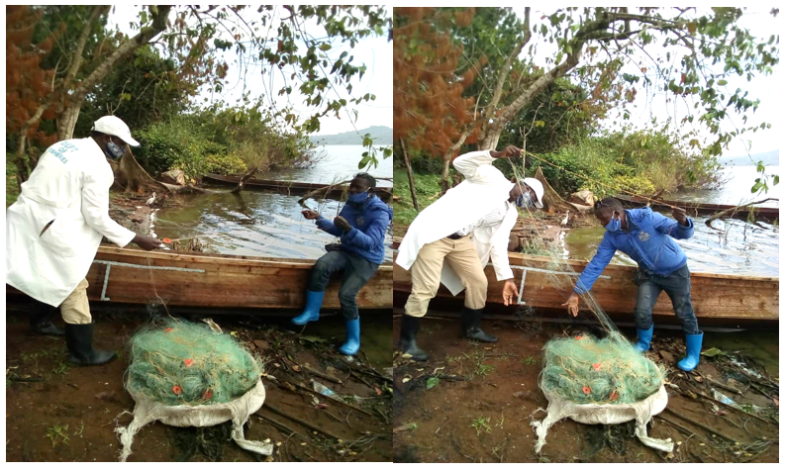
APPENDIX IV: SELECTED PICTORIALS OF THE FIELD STUDY
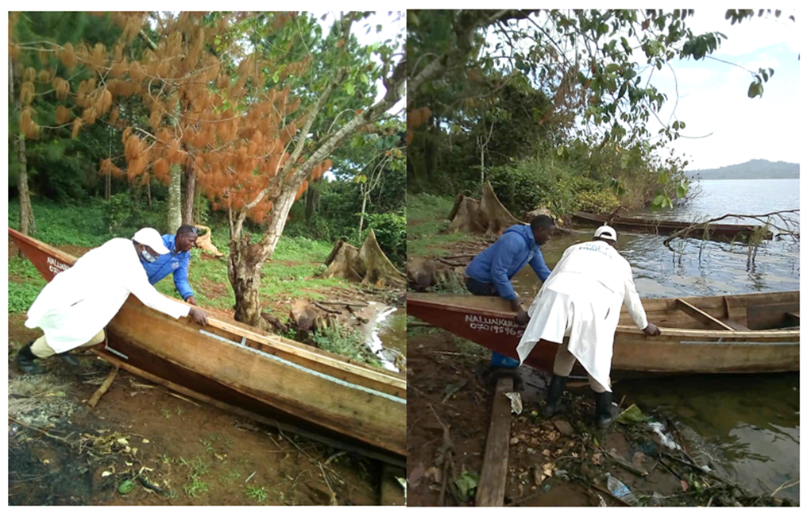
Plate 2: Showing the student preparing the monofilament and multifilament nets ready for fishing

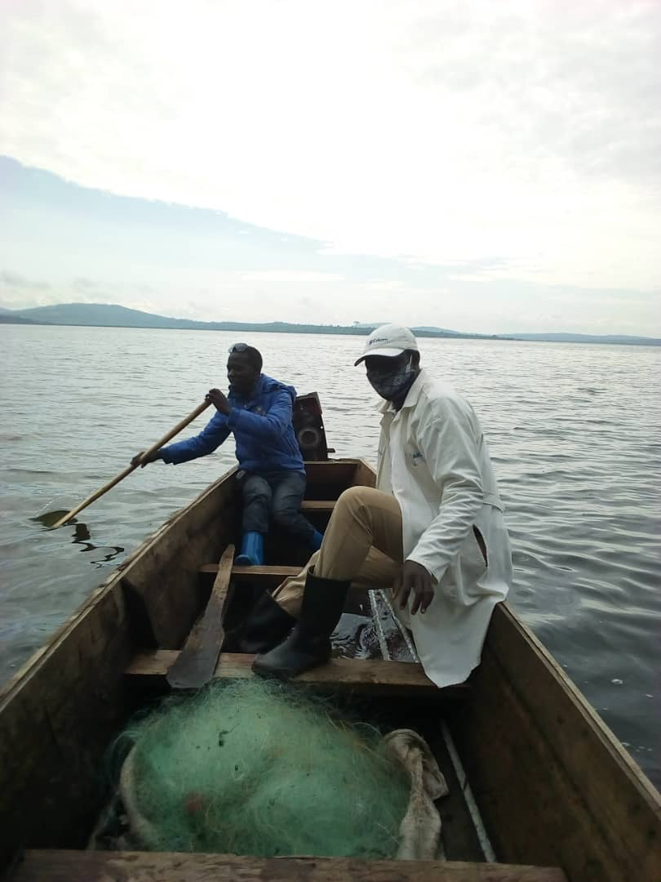

Plate 3: Showing student setting off from the shore for fishing

Plate 4: Showing the student drawing deeper into the Lake for fishing
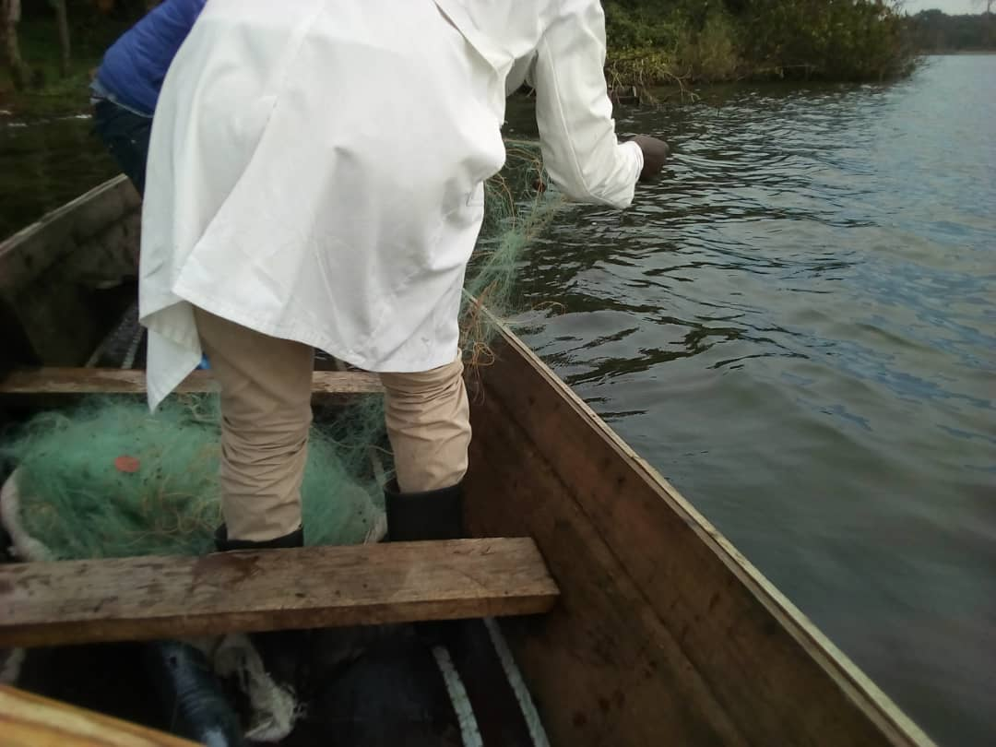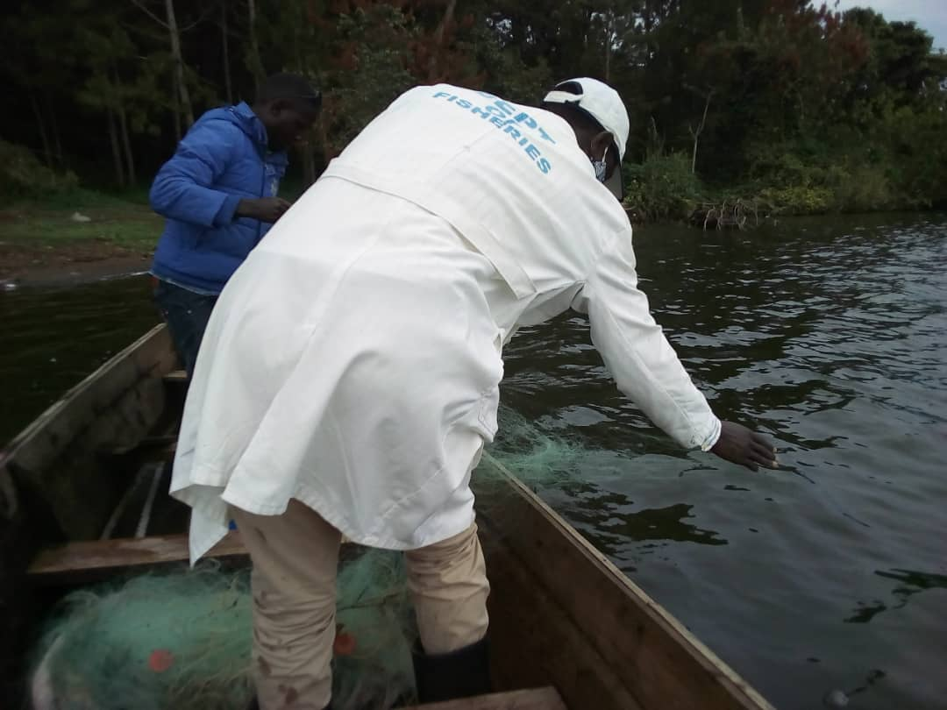
Plate 5: Showing the student at the fishing point ready to lower the monofilament net in the water for fishing

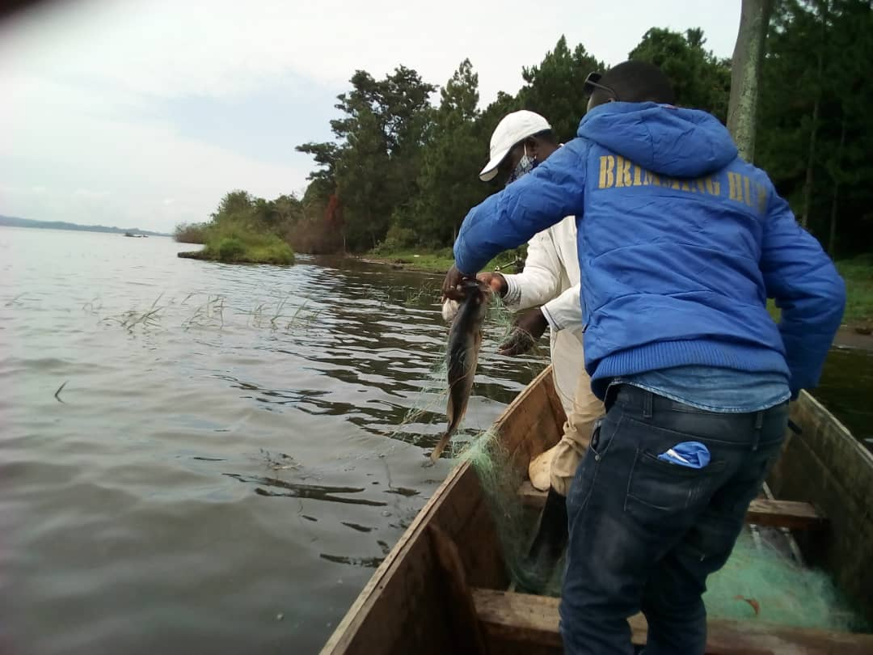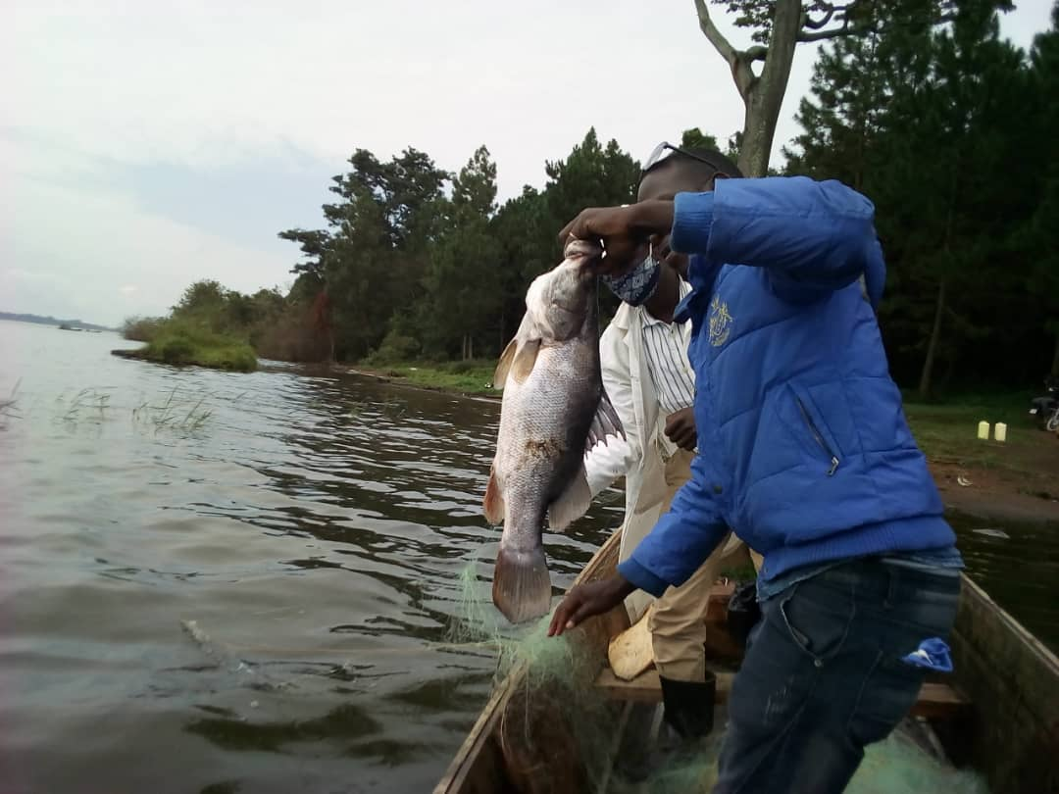
Plate 6: Showing the student removing the fish from the monofilament net after catching it.
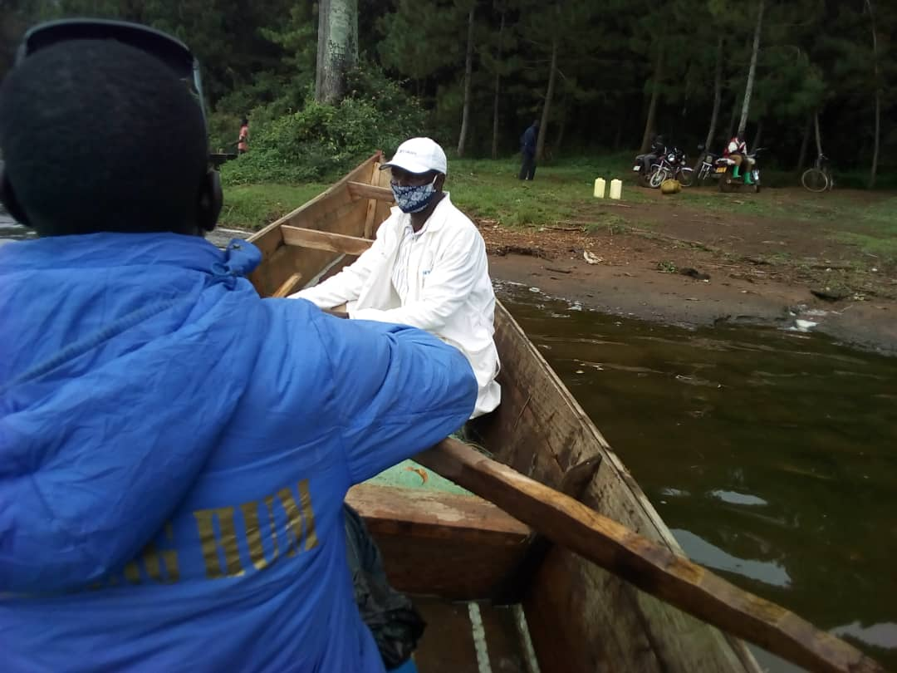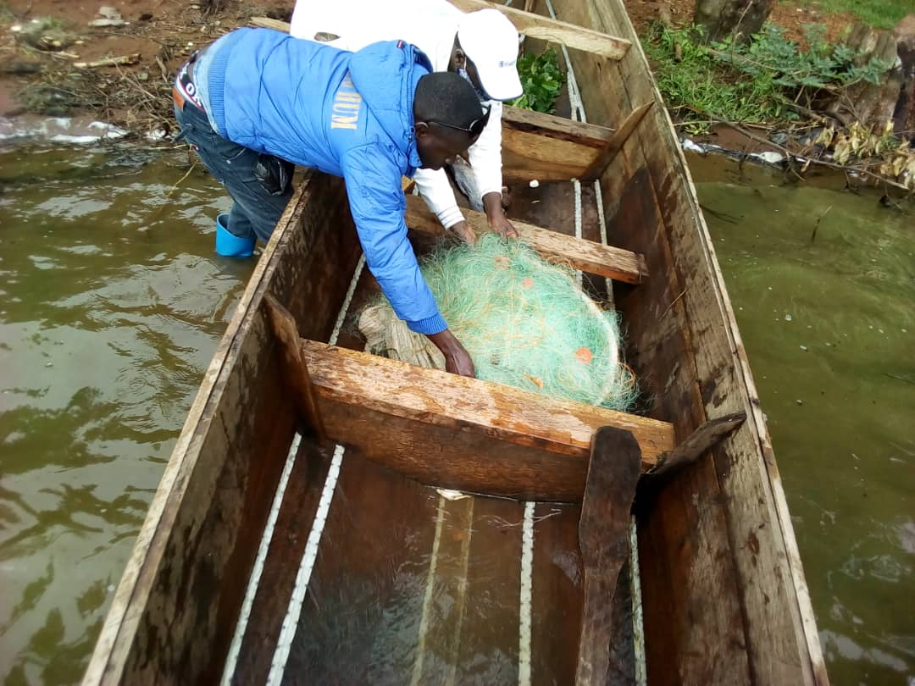
Plate 7: Showing the student back to the shores after fishing
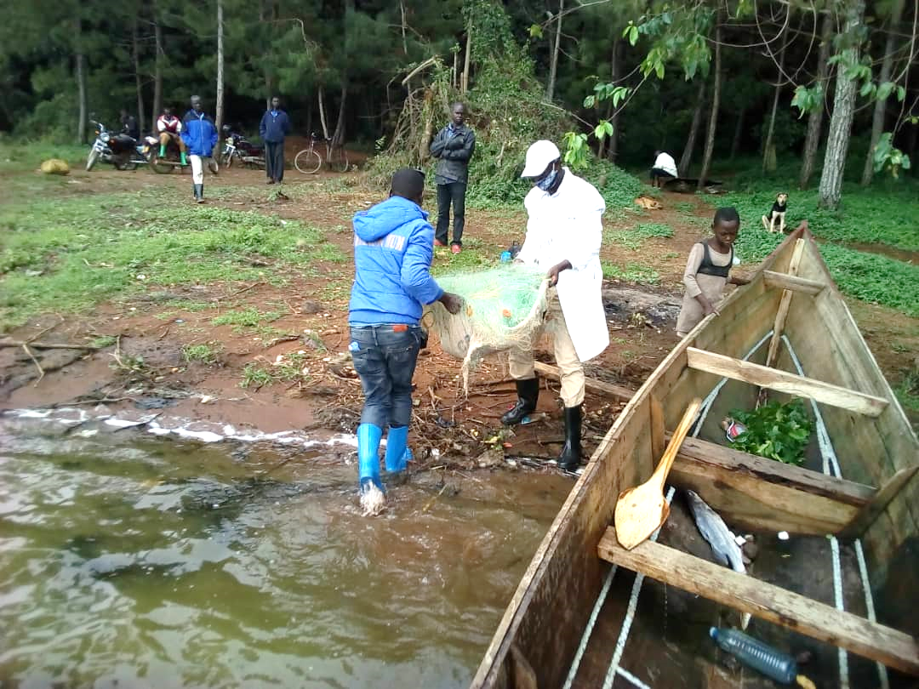
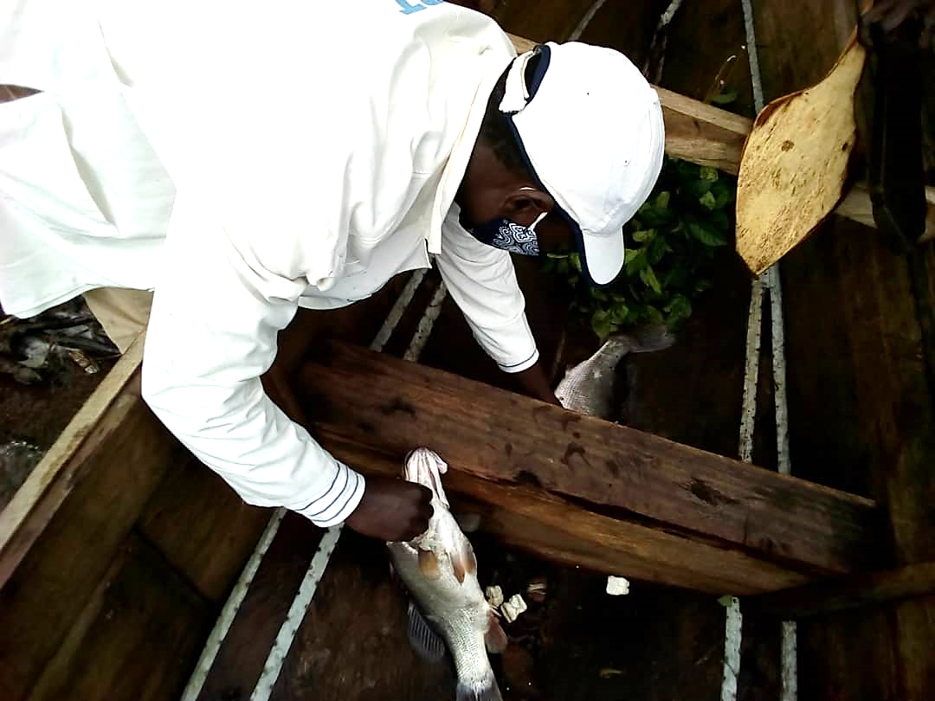
Plate 8: Showing the student accessing the fish and sorting them
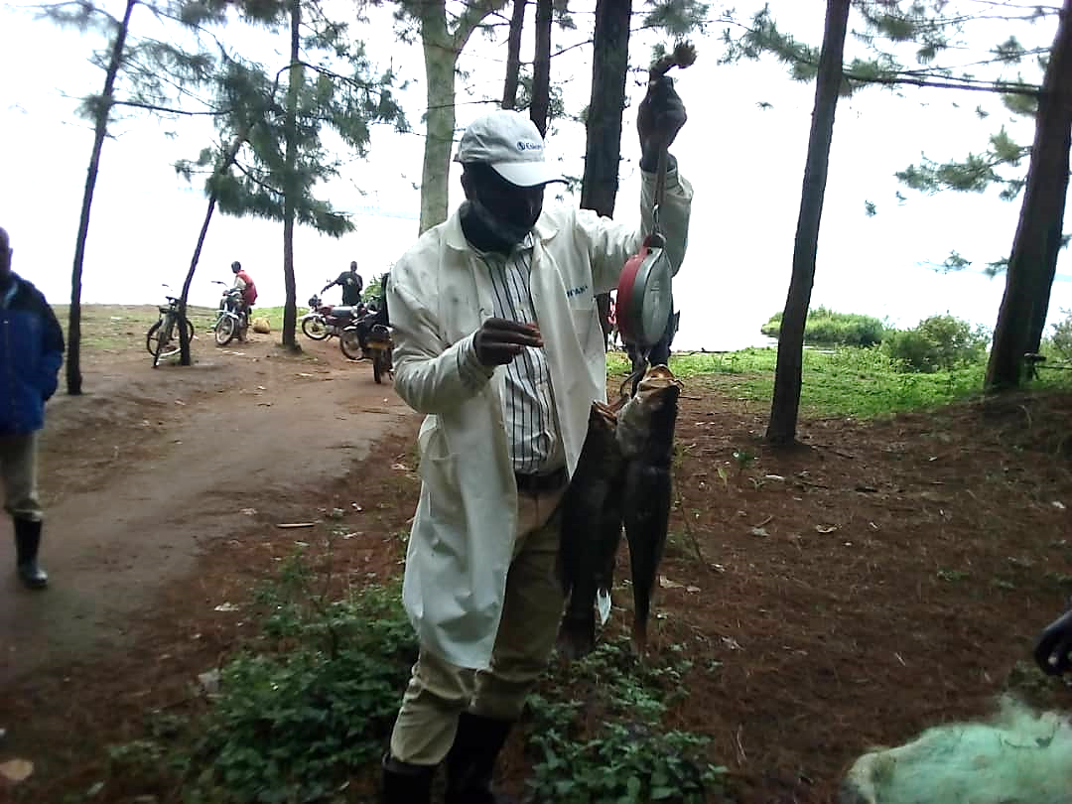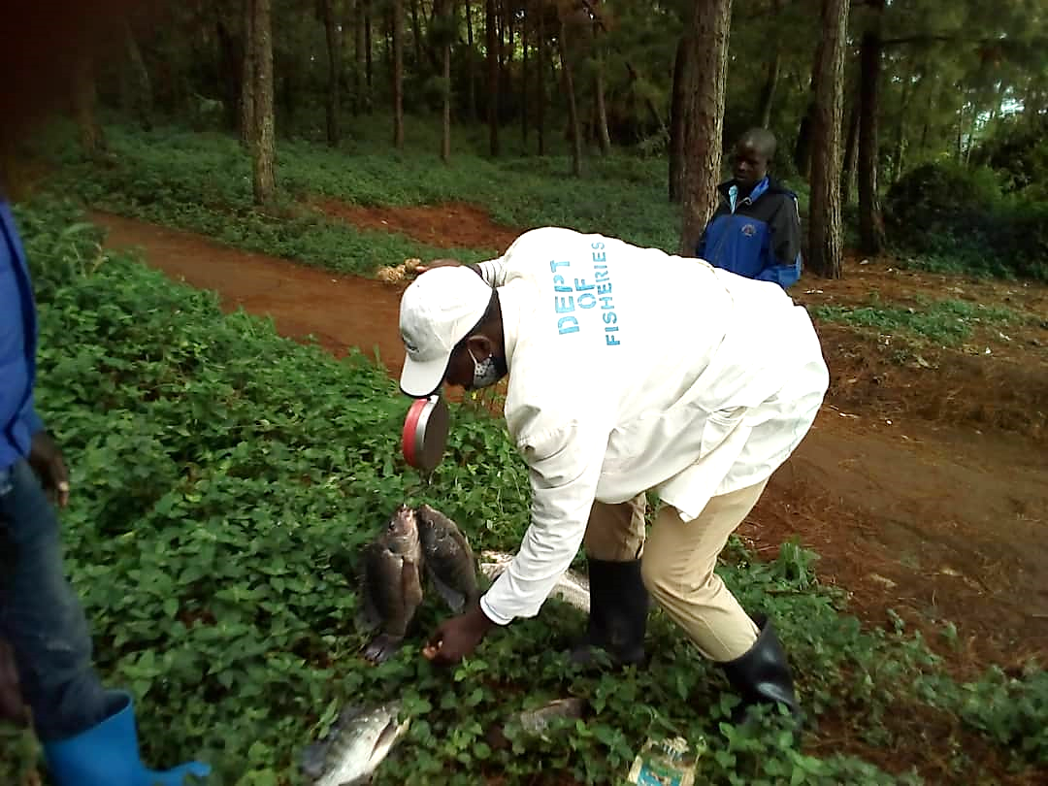
Plate 9: Showing the student weighing the fish after sorting the fish
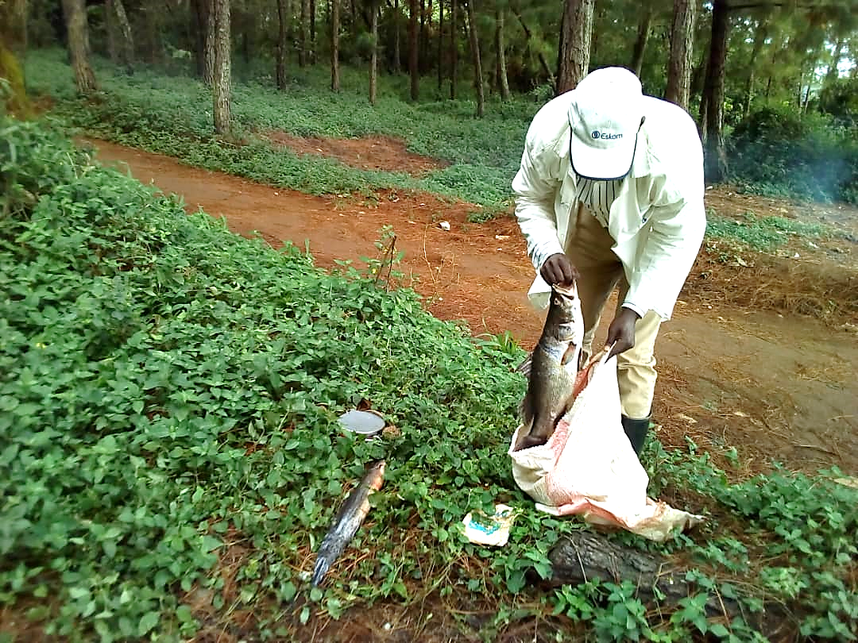
Plate 10: Showing the student packing the fish which is recommended for harvest
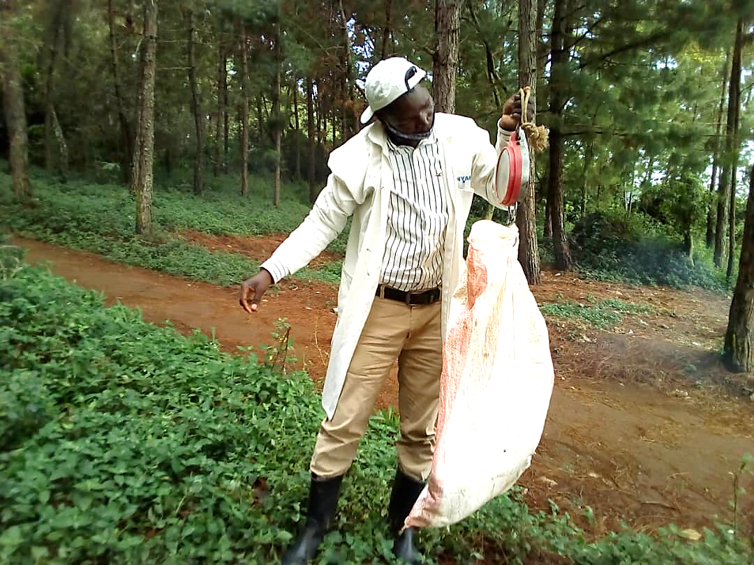

Plate 11: Showing the fisheries officer weighing the fish after sorting them out
