**Africa Tobacco Industry Monitoring (ATIM)**

***Country Report: Uganda***

6/20/2018

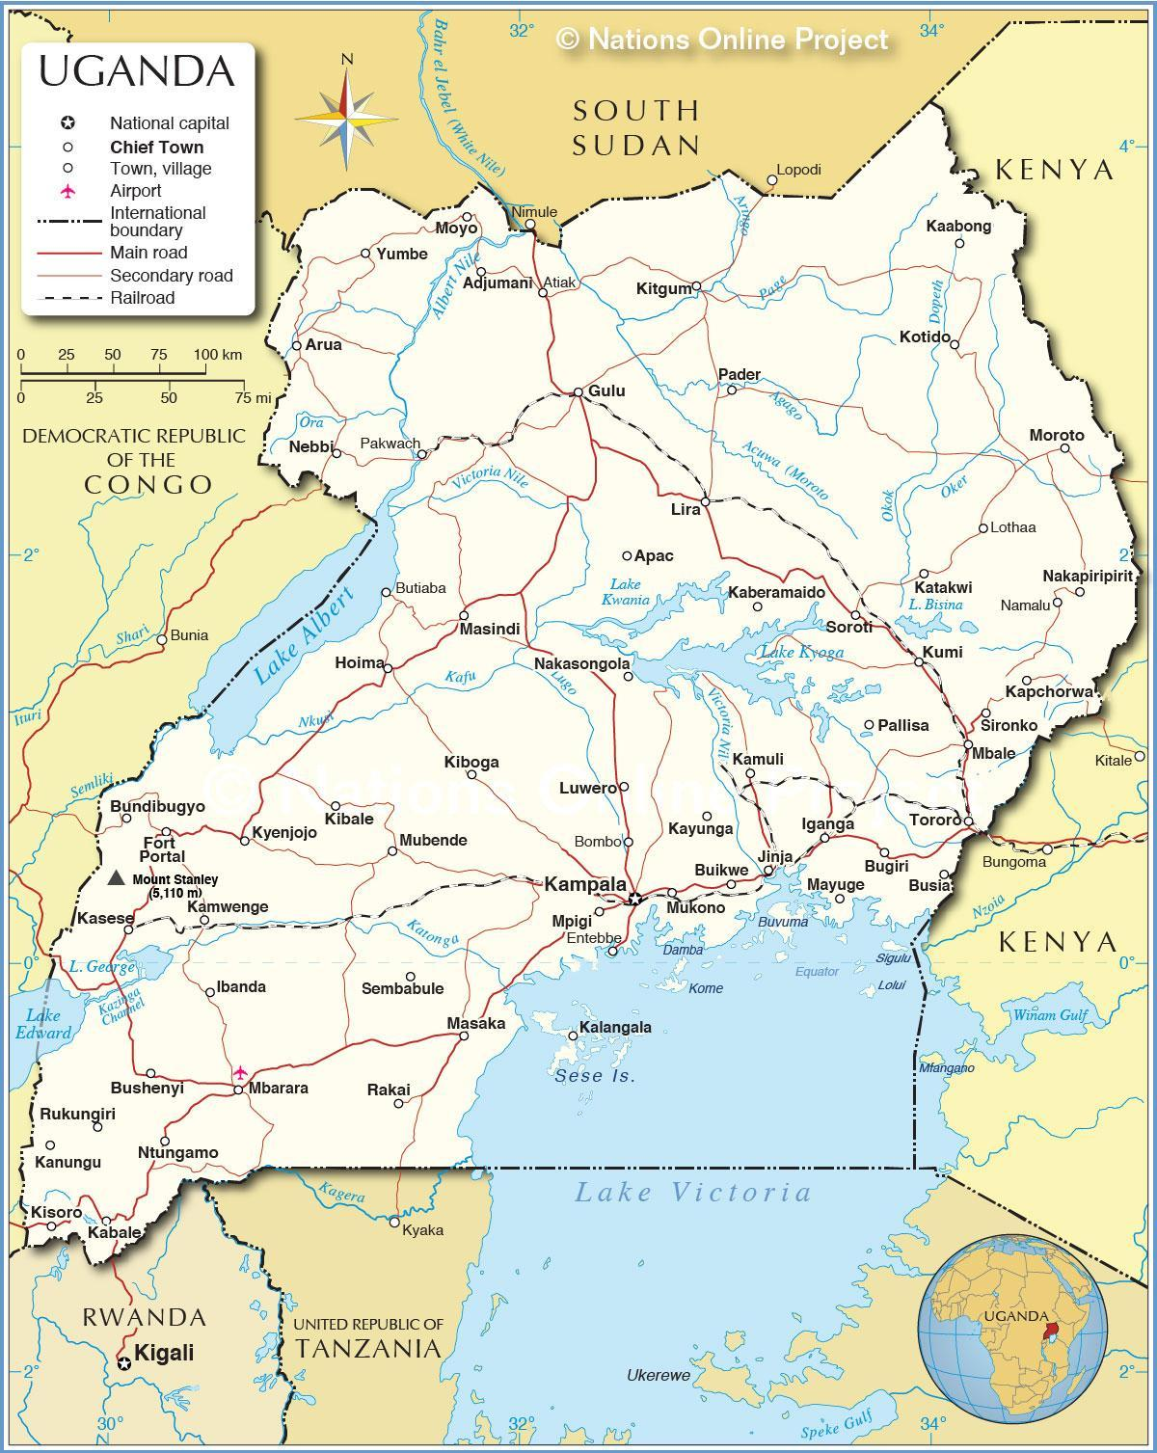

**Authors: E. Wanyonyi, M. Talibita, M. Kirigwajo, T. Rusoke**

**Edited by: Olalekan Ayo-Yusuf, PhD, Petronella Chirawu**

CONTENTS

GLOSSARY OF ACRONYMS AND ABBREVIATIONS 5

FOREWORD 6

EXECUTIVE SUMMARY 8

Introduction and background 8

Approach/conceptual framework 8

Environmental scan of tobacco industry activities 8

Conclusion 9

Recommendations 9

CHAPTER 1: INTRODUCTION 11

CHAPTER 2: BACKGROUND 13

2.1 Country demographics and economic profile 13

2.2 The burden of tobacco use 13

2.3. Description of Uganda’s political system 14

2.3.1 Type and independence 14

2.3.2 Constitution and legal system 14

2.3.3 Political structure (legislative, executive, and judiciary) 15

2.4 Framework and approach 15

CHAPTER 3: MAPPING THE TOBACCO INDUSTRY 16

3.1. Farming 16

3.2. Manufacturing 17

5.3. Retail 17

CHAPTER 4: MAPPING TOBACCO CONTROL LEGISLATIVE EFFORTS IMPLEMENTATION OF THE WHO *FCTC* 18

4.1 Past 18

4.2 Present 19

4.3 Tobacco control coordination 27

4.4 Research and surveillance 28

CHAPTER 5: ENVIRONMENT SCAN OF TOBACCO INDUSTRY TACTICS 29

5.1 Tobacco industry lobbying political influence/policy or legislative interference 29

5.1.1 Prior to enactment of the Tobacco Control Bill 29

5.1.2 After the enactment of the Tobacco Control Act, 2015 31

5.2. Manipulating public opinion including the use of “CSR” and media control 34

5.3. Front groups 36

5.4 Economic manipulation 37

5.4.1 Tobacco taxes 37

5.4.2 Illicit trade/smuggling 38

5.5. Litigation threats or actual legal challenge 38

CHAPTER 6: CONCLUSION AND RECOMMENDATIONS 39

Conclusion 39

Recommendations 40

REFERENCES 42

APPENDICES 46

Appendix 1: Timeline of industry interference concerning the *Uganda Tobacco Control Bill* (*UTCB*) 2014 46

Appendix 2: Implementation of the WHO Framework Convention on Tobacco Control in Uganda as of August 2018 50

**LIST OF TABLES**

Table 1: Tobacco retail value from 2014 to 2018 17

Table 2: Tobacco Control Legislation in Uganda 19

Table 3: Timeline of tobacco control-related activities/events 21

Table 4: Comparison of Uganda’s existing tobacco control law and the WHO FCTC 22

Table 5: Tobacco industry manipulation of public opinion 36

Table 6:Tobacco industry front groups 37

**LIST OF FIGURES**

Figure 1: Tobacco Control Milestones for Uganda 18

Figure 2: Extract of confidential documents of BAT key concerns regarding the UTCB 30

Figure 4: Promotional material – branded calendar and dirt bin in Kampala 31

Figure 3: Extract of Confidential BAT letter to sponsor of UTCB 31

Figure 5: Newspaper cutting of industry complaint against enforcement of shisha ban in Kampala 32

Figure 6: Poster adverts for prices in single sticks and display with open cigarette packs 33

Figure 7:Form in which cigarettes are sold near schools 33

Figure 8:Retail entities selling tobacco products near schools 33

Figure 9: Images from the BATU “Think and Win” competition targeting children and youth 34

Figure 10: BAT congratulatory message as self promotion 35

# GLOSSARY OF ACRONYMS AND ABBREVIATIONS

|  |  |
| --- | --- |
| ATIM | Africa Centre for Tobacco Industry Monitoring and Policy Research |
| BATU | British American Tobacco - Uganda |
| BETA | Building Effective Tobacco Control Advocates |
| CSR | Corporate Social Responsibility |
| FCTC | Framework Convention on Tobacco Control |
| GDP | Gross Domestic Product |
| SMU | Sefako Makgatho Health Sciences University |
| TAPS | Tobacco advertising, promotion and sponsorship |
| TB | Tuberculosis |
| TCA | Tobacco Control Act |
| UTCB | Uganda Tobacco Control Bill |
| VAT | Value Added Tax |
| WHO | World Health Organization |

# FOREWORD

Unless there is suitable intervention, smoking prevalence is predicted to increase significantly in Sub-Saharan Africa. This situation is likely to increase the growing burden of non-communicable diseases in the region. As would be expected in an epidemiological model, the vector remains an important target for disease control. The vector for tobacco-induced diseases is the tobacco industry.

The focus of these report series on tobacco industry monitoring (TIM) in Sub-Saharan Africa is prompted by the reality that the multinational tobacco industry has shifted efforts to growing its market in this youthful region, where about one in five people is an impressionable youth between the age of 15 and 24 years. Sub-Saharan Africa has become a target, not only because the tobacco industry sees future significant economic growth in the region, thus increasing its purchasing power, but also because it regards the socio-political system in the region as open to corruption. Having worked in tobacco control across the region for almost two decades, I identified a need to provide a structured report of country experiences of tobacco industry interference in tobacco control to garner concerted efforts at both the national and regional levels to counter these activities in order to prevent the initiation of the use of tobacco and other nicotine products.

The tobacco industry applies similar tactics across various countries, as can be observed from several of the country reports. The most frequently reported interference strategies include using the media to shape public opinion or promote tobacco products, and lobbying policymakers to influence the legislative/regulatory process. This observation highlights the need for a whole-of-government or multi-sectoral approach to the implementation of Article 5.3 and related guidelines in the WHO’s Framework Convention on Tobacco Control (WHO FCTC). Civil society organisations can also play a role in holding the tobacco industry accountable. This series of reports provides examples of how this has been done in some of the countries that have successfully passed tobacco control legislation. A compilation of country-specific experiences of tobacco industry interference and civil society organizations’ responses in holding the tobacco industry and government accountable not only helps parties to the WHO FCTC to realize that their situation is not unique, but also shows them that the problems are not insurmountable.

The Africa Centre for Tobacco Industry Monitoring and Policy Research (ATIM) at the Sefako Makgatho Health Sciences University, in collaboration with the African Capacity Building Foundation is working to **B**uild capacity for **E**ffective **T**obacco industry monitoring & **A**ccountability (**BETA**) in Sub-Saharan Africa. ATIM is an observatory that has been created to monitor and maintain a repository of the tobacco industry’s activities in the region. It has produced monitoring tools that can be used to log daily industry activities. The ATIM has developed training programmes targeted at both governmental and nongovernmental organisations. These reports have been created by the instructors/mentors on the training programme, in collaboration with some instructors/mentors who have already been trained and/or in consultation with key tobacco control stakeholders in the countries. The total population of the 11 countries covered in this series of reports comprises approximately half of the entire population in Sub-Saharan Africa. The Uganda report identified salient tobacco control issues from 1990 to September 2018. I trust that tobacco control stakeholders will find this report a compelling read and helpful in supporting their endeavours.

**Professor Olalekan Ayo-Yusuf**

**Deputy Vice Chancellor Research, Postgraduate Studies and Innovation**

**Director: African Centre for Tobacco Industry Monitoring and Policy Research (ATIM)**

**Sefako Makgatho Health Sciences University (SMU)**

# EXECUTIVE SUMMARY

## Introduction and background

Uganda ratified the World Health Organization’s (WHO) Framework Convention on Tobacco Control (WHO FCTC) in 2007 and domesticated it in the form of Uganda’s comprehensive *Tobacco Control Act* (*TCA*) in 2015. However, to date, the National Tobacco Control Policy has not been operationalized and the Tobacco Control Regulations for the implementation of the *TCA* are awaiting a certificate of compliance from the Solicitor General. Furthermore, the corresponding Tobacco Control Strategic Plan (TCSP) is yet to be finalized.

The *TCA* provides a comprehensive framework for the protection of tobacco control policies from the tobacco industry’s commercial and other vested interests. However, tobacco industry influence continues. This report provides information on the status of tobacco industry interference in Uganda under the Building Effective Tobacco Advocates (BETA) project, under the Africa Centre for Tobacco Industry Monitoring (ATIM) and Policy Research project.

## Approach/conceptual framework

A comprehensive desk-top review of the published literature was undertaken, and searches of news media were done. The results of these searches were augmented by a search of documents in the Truth library (<https://www.industrydocumentslibrary.ucsf.edu/tobacco/>), where documents relating to tobacco industry interference in Uganda are mapped. A three-day country visit was also made, during which interviews were conducted with Ugandan stakeholders to cross-validate the information gathered through the desk-top reviews and to collect more information. The report was drafted in collaboration with the country trainees and forms part of the BETA country report series.

## Environmental scan of tobacco industry activities

Uganda has developed a legislative framework for the implementation of Article 5.3 of the WHO FCTC to protect public health policies from influence by the commercial and other vested interests of the tobacco industry. However, tobacco industry interference continues. Tobacco companies have at various times opposed the implementation of some provisions of the *TCA*, and some have violated these provisions, including tobacco advertising promotion and sponsorship (TAPS) bans. For example, companies are providing advertising/promotional materials such as branded merchandise and posters, and use brand marking on physical structures.

Other documented tobacco industry interference strategies in Uganda include corporate social responsibility (CSR) programmes, legal challenges to key policies, which have included a petition to the High Court of Uganda challenging the *TCA*, and one to the East Africa Court of Justice (EACJ), challenging the country’s tobacco tax measures. In some instances, tobacco industry interference is achieved via front groups and other secondary stakeholders. The impact of this interference process has been to slow and even defeat effective implementation of tobacco control policies in Uganda.

## Conclusion

Uganda has one of the most comprehensive pieces of tobacco control legislation in the region, which includes strong provisions on the implementation of Article 5.3 of the FCTC. While the law has had some positive effects on tobacco control in the country, the tobacco industry continues to circumvent the provisions of the law and interfere with the implementation of tobacco control policies.

The tobacco industry invests heavily in approaches intended to influence public opinion, as well as policy processes and outcomes. Tobacco industry interference focuses on policies that have the biggest impact on their profits, including tax and price measures. In addition, interference strategies range from subtle measures to aggressive and intimidating strategies, such as legal challenges and litigation at the domestic and international levels, as has been experienced in Uganda.

The knowledge and skills of tobacco control advocates regarding tobacco industry monitoring and corresponding responses in Uganda are not commensurate with the rapid pace of industry interference. The scope and effectiveness of advocates’ activities are also constrained by the limited financial and human resources available for tobacco control work in the country.

## Recommendations

* Uganda should sensitize all relevant parts of the government to be aware of how the tobacco industry is trying to undermine legislation, regulations, and policies, so that they do not fall prey to these strategies. This will ensure that no government ministry, department or agency is used by the tobacco industry to interfere with relevant policies.
* Tobacco control focal points are needed to continue to focus on tobacco control, and resources should be dedicated to this end. More support should be given to growing the pool of actors trained in tobacco industry monitoring and accountability measures to enhance the reach and effectiveness of such interventions, in addition to support offered by ATIM/BETA.
* Newer non-traditional tobacco control actors should be sensitized regarding tobacco industry accountability. This includes actors such as researchers, media, policy-makers and politicians, who are vulnerable to industry interference. The Foundation for a Smoke-Free World (FSFW) in Africa is a deceptive role-player in this arena controlled and funded by the tobacco industry.
* The media should be educated on tobacco control issues so that they are also able to write about industry interference tactics (a key strategy for countering tobacco industry interference).
* Local (African and country-specific) research should be promoted by incentivizing research on tobacco control among academics.

# CHAPTER 1: INTRODUCTION

Uganda ratified the World Health Organization’s (WHO) Framework Convention on Tobacco Control (WHO FCTC) in 2007. The FCTC was domesticated in 2015 by means of a comprehensive *Tobacco Control Act* (*TCA*), which includes provisions such as tobacco smoke-free environments, a comprehensive ban on tobacco advertising, promotion and sponsorship (TAPS), and the use of tobacco products by limiting sale and display, and the prohibition of tobacco product sales to and by minors, the regulation of product contents, emissions and disclosures, as well as protection of tobacco control policies from influence by the commercial and other vested interests of the tobacco industry. However, the national tobacco control policy has not yet been operationalized. Moreover, the Tobacco Control Regulations for the implementation of the *Act* are awaiting a certificate of compliance from the Solicitor General and the Tobacco Control Strategic Plan has yet to be finalized.

The *TCA* provides a comprehensive framework designed to protect tobacco control policies against interference by commercial and other vested interests of the tobacco industry. Tobacco industry influence in Uganda ranges from tobacco growing and cultivation, to manufacturing, importation, distribution and sale. British American Tobacco – Uganda (BATU) has instituted a legal challenge against tobacco control legislation, delaying effective implementation and enforcement of the law.

Tobacco industry interference in tobacco control-related policy in Uganda can be traced back to the period before the enactment of the comprehensive tobacco control legislation in 2015. The industry took various steps to prevent the passing of tobacco control legislation, or to weaken such legislation as much as possible. Such action included presenting arguments against the Bill and secretly meeting with members of parliament from tobacco-growing areas to lobby against the legislation. When this failed and the law was enacted in 2015, the industry shifted its focus to weakening the impact of the *Act* by violating some of its provisions, including TAPS bans, targeting children and the youth, running what are proclaimed to be CSR programmes, challenging tax and price measures and suing the government to slow down and/or completely defeat the implementation of the law.

Uganda is one of the Building Effective Tobacco Control Advocates (BETA) project target countries. The project is coordinated by the Africa Centre for Tobacco Industry Monitoring and Policy Research (ATIM) observatory at the Sefako Makgatho Health Sciences University (SMU) in South Africa. BETA-trained “mentees” are expected to implement effective tobacco industry monitoring and accountability initiatives in their respective countries with the guidance of the ATIM team at SMU and in-country “mentors”.

The BETA project has played a critical role in equipping a group of advocates with knowledge and skills in tobacco industry monitoring and response. After the training, the current advocates carried out some activities in-country, mostly mainstreamed into running organizational tobacco control activities.

# CHAPTER 2: BACKGROUND

## 2.1 Country demographics and economic profile

Uganda is an East African country with a population of around 37.7 million people, the majority of whom are under 24 years old.1 According to government statistics, the population can be broken down by age as follows: 48.1% are 0 to 14 years old, 21.1% are 15 to 24 years old, 26.3% are 25 to 54 years old, 2.6% are 55 to 64 years old and 1.98% are 65 years and over.7

As of 2017, Uganda’s GDP was US$ 26.39 billion.7 The GDP Annual Growth Rate averaged 4.25% from 2011 to 2017, reaching an all-time high of 8.2% in the fourth quarter of 2014, and a record low of 1% in the first quarter of 2012.7The GDP, Purchasing Power Parity, for Uganda increased from US$ 83.67 billion in 2015, to US$ 87.61 billion in 2016 and to US$ 91.5 billion in 2017.7 The GDP per capita, Purchasing Power Parity, stood at US$ 2,300 in 2015 and US$ 2,400 in 2016. Based on 2016 estimates, agriculture contributed 25.8% of the GDP, while the industry and services sector contributed 23.2% and 51% respectively.7,12

According to the WHO, life expectancy in Uganda in 2018 was 60.2 for males and 64.8 years for females.8 Non-communicable diseases (NCDs) accounted for five of the leading ten causes of death (HIV/AIDS, influenza and pneumonia, strokes, coronary disease, diarrhoeal diseases, prostate cancer, road traffic accidents, tuberculosis, hypertension and malaria, in that order). The implication of these statistics is that tobacco use, which has been implicated in strokes, coronary disease among tobacco product users, and exacerbates tuberculosis in smokers, will continue to foster the double burden of disease, which means that the government has to simultaneously fight infectious diseases and tobacco-induced non-communicable diseases.8 The Centre for Tobacco Control in Africa (CTCA) reports that in Uganda, the total health cost of tobacco use, including the direct cost of treatment and the indirect costs of loss of income and productivity from death and disability, is UGX 328.82 billion (equivalent to US$126.48 million).10

## 2.2 The burden of tobacco use

The Global Adult Tobacco Survey (GATS) 2011 shows that in Uganda 11.6% of men, 4.6% of women, and 7.9% overall (1.3 million adults) currently used tobacco (smoked or smokeless). It showed that 10.3% of men and 1.8% of women (5.8% overall, 0.9 million adults) currently smoked tobacco.2 Results from the 2011 Global Youth Tobacco Survey (GYTS) suggest that amongst young people (aged 13 to 15 years), the prevalence was 17.3% (19.3% of young men and 15.8% of young women). The survey showed that 4.8% currently smoked cigarettes and 15.6% currently used other tobacco products. Additionally, 21.6% were exposed to smoke at home.3 The 2014 WHO STEPwise approach to surveillance (STEPS) survey estimated the prevalence of smoking in adults in Uganda at that time to be 16.7% in men and 3.4% in women.56 Furthermore, 13.1% of adults (2.2 million adults) were exposed to tobacco smoke at home, 20.4% of adults were exposed in indoor workplaces, 62.3% of adults were exposed in bars and nightclubs, and 7.8% of adults were exposed in public transportation.21 The Centre for Tobacco Control in Africa estimated that 13,500 Ugandans die every year from smoking-related causes, and that 75% of all patients with oral cancers reported in Mulago Hospital in 2008 had a history of tobacco smoking.22.

In Uganda, the youth forms the largest percentage of the population, providing fertile ground for tobacco industry marketing. In 2013, the Uganda National Tobacco Control Association reported that BATU was actively marketing to underage children and youths through advertising and marketing at promotional events known to appeal to them. Furthermore, the 2011 Global Youth Tobacco Survey (GYTS) showed that one in ten students had been offered free cigarettes by a representative of a tobacco company, and the same proportion had been given merchandise with tobacco company logos.3 Additionally, over half had seen pro-cigarette advertising on billboards in the 30 days preceding the survey, and nearly half had seen pro-cigarette advertising in magazines and newspapers.3

## 2.3. Description of Uganda’s political system

### ***2.3.1*** Type and independence

Uganda is a presidential republic that achieved independence from Britain on 9 October 1962.7 There are administrative units, comprised of 121 Districts and the Capital City (Kampala).

### 2.3.2 Constitution and legal system

Uganda’s third and latest constitution was adopted on 27 September 1995 and it was promulgated on 8 October 1995. Uganda has a mixed legal system of English common law, statutory law, doctrines of equity and customary law. The *Constitution* is the supreme law in Uganda and any law that is in conflict with it is null and void to the extent of the inconsistency. The other written law comprises of statutes, Acts of Parliament and Statutory Instruments, published in the *National Gazette*. The *Constitution* provides for some level of independence between the three arms of government (the Executive, the Legislature and the Judiciary).23

A number of institutions are involved in the provision of legal services, the administration of justice and the enforcement of legal instruments or orders.  These include the Ministry of Justice and Constitutional Affairs, the Ministry of Ethics and Integrity, the Judiciary, the Parliament, the Uganda Police Force, the Uganda Law Reform Commission, the Uganda Human Rights Commission, and the Director of Public Prosecution. These institutions are relevant in the provision of legal services and enforcement of tobacco control laws in Uganda.

### 2.3.3 Political structure (legislative, executive, and judiciary)

The Legislature is made up of a unicameral National Assembly/Parliament. It has 445 seats. A total of 290 members are directly elected in single-seat constituencies by simple majority vote; 112 seats are reserved for women directly elected in single-seat districts by simple majority vote; 25 seats for “representatives” are reserved for special interest groups (the army 10, the disabled 5, youth 5, labour 5), and up to 18 *ex officio* members are appointed by the president. Members serve five-year terms.7 Elections are held every five years. The last was held in 2016, and the next is expected in 2021.

The Executive arm of government is made up of an executive president, elected every five years, a vice-president, a Prime Minister and a Cabinet. The highest court in the Judiciary of Uganda is the Supreme Court of Uganda, consisting of the Chief Justice and at least six Justices appointed by the President in consultation with the Judicial Service Commission and approved by the National Assembly. Lower level courts are the Court of Appeal Constitutional Court, the High Court, the Industrial Court, the Chief Magistrate’s courts, Kadhis courts, local council courts, family and children’s courts.7

## 2.4 Framework and approach

Data for this report were collected between July and August 2018 using various approaches. A comprehensive desk review of the published literature and searches of news media was done. This was augmented with a search of the Truth library (<https://www.industrydocumentslibrary.ucsf.edu/tobacco/>) database, where documents relating to tobacco industry interference in Uganda have been mapped. The information from the desk-top review was used to construct a historical and thematic narrative based on a standard report template developed by the ATIM team. Furthermore, the country was visited for three days in July 2018, and discussions were held with selected purposively sampled key informants and the trained tobacco control advocates to fact-check the information collected and gather supplementary information.

# CHAPTER 3: MAPPING THE TOBACCO INDUSTRY

Uganda has a strong legislative framework for the implementation of Article 5.3 of the WHO FCTC, which concerns the protection of public health policies from the commercial and other vested interests of the tobacco industry. This legislative framework complies with the provisions of the Guidelines to the Article. The law places the duty on governments to ensure that any interactions with the industry are transparent, prohibits partnerships, endorsements and voluntary contributions, as well as incentives and privileges to tobacco businesses. It also provides guidance on the prevention and management of conflicts of interest.26 One key interviewee explained:

…we have legislated Article 5.3 and we have developed strong regulations. We have put down how they should behave, how they should conduct themselves, how they are supposed to give us information, where they should deposit it, in which format, how detailed should it be, it is a very tough regulation, to the extent that it was the number one Article that they contested in the Act when they were suing. We say that if a government employee is leaving and wants to join a tobacco company, they should spend two years so that the knowledge they have, has degenerated, and if they don’t, then they are suable.

This regulation is expected to be implemented under the direction of a multi-stakeholder tobacco control committee with representation from key relevant line ministries and government agencies, including civil society and the Prime Minister’s Office. The committee is also expected to monitor the tobacco industry and ensure that any engagement with that industry occurs within the set rules and regulations.

It is expected that the established framework will contribute to easy public access to tobacco industry information and will act as a mechanism for exchanging this information between relevant stakeholders for the purposes of effective tobacco control.

## 3.1. Farming

Tobacco farming was introduced in Uganda in 1920. Tobacco was grown largely in north-west Uganda, but it is now also grown in parts of south-western Uganda, in Kanungu and Kabale. British American Tobacco-Uganda (BATU), a subsidiary of British American Tobacco, opened its first tobacco processing factory in 1928, in Jinja, and eventually closed it only in 2005.4 BATU currently controls 85% of the market share for tobacco products in Uganda,5 producing 16.8 million kilograms of tobacco in 2013, using 18,000 contracted farmers.6

Currently, tobacco is also grown in the Bunyoro and the West Nile regions, accounting for 0.14% of agricultural land by 2014.29 The area under tobacco cultivation is gradually increasing, reaching 24,469 hectares (ha) in 2014 (up from 23,536 ha in 2013, 23,320 ha in 2012, 20,671 ha in 2011 and 20,598 ha in 2010). The production volumes have fluctuated between 27,138 metric tonnes in 2010 to 31,700 metric tonnes in 2018. Tobacco growing constituted 0.17% of agricultural land use by 2018.28

Leaf buying and processing is done by major companies, including BAT, Mastermind, Leaf Tobacco and Continental Tobacco.32 At the start of the 2017 tobacco season, the Ministry of Trade, Industry and Cooperatives licensed the following six companies to sponsor growers to produce and market tobacco:33

* Alliance One Tobacco
* Leaf Tobacco & Commodities
* Uganda Tobacco Services Ltd
* Nimatabac Uganda
* Global Leaf Holdings Uganda Ltd
* Continental Tobacco Uganda Ltd

Tobacco farmers have not participated actively in tobacco discussions and therefore their interests have been largely ignored, leaving room for tobacco industry influence to dominate.

## 3.2. Manufacturing

Cigarettes are the leading manufactured tobacco products in Uganda. The main tobacco companies in Uganda are British American Tobacco – Uganda (BATU), Leaf Tobacco & Commodities, Continental Tobacco and Mastermind Kenya Limited.25

## 5.3. Retail

The tobacco retail value for Uganda increased from US $660.8 million in 2017 to $735.8 million in 2018 (see Table 1, below).34 Popular retail channels include street vendors, independent small grocers, kiosks, supermarkets, bars and clubs. The sale of single sticks by street vendors, small grocers and kiosks is common.

Table 1: Tobacco retail value from 2014 to 2018

|  |  |  |  |  |  |
| --- | --- | --- | --- | --- | --- |
|  | 2018 | 2017 | 2016 | 2015 | 2014 |
| Tobacco retail value (USD$) | 735.8m | 660.8m | 598.8m | 577.3m | 667.0m |
| Cigarette retail volume (millions of sticks) | 6,370.3 | 6,248.4 | 6,172.5 | 6,145.7 | 6,148.3 |
| Value in USD | 696.9m | 660.8m | 632.2 m | 643.4m | 926.5m |

Source: Adapted from Euromonitor International. Tobacco market sizes for Uganda (2018)34

# CHAPTER 4: MAPPING TOBACCO CONTROL LEGISLATIVE EFFORTS IMPLEMENTATION OF THE WHO *FCTC*

## 4.1 Past

The *Tobacco (Control and Marketing) Act, Cap 35* was enacted in 1967 to control the production and marketing of leaf tobacco and related matters, and it is still in force where it does not conflict with the more recent *Tobacco Control Act* (*TCA*) of 2015. Other tobacco control-relevant laws in use before the enactment of the comprehensive *TCA* in 2015 are the *Public Health Act* (1964), the *National Environment Act* (1996), and the *National Environment Regulations* (2004).24

Article 39 of the *Constitution of Uganda* (1995) provides for the right to a clean and healthy environment. This right is operationalized through the enactment of the *Environmental Regulations – Control of Smoking in Public Places Regulations* in 2004.25 Uganda signed the WHO FTCT on 5 March 2004 and ratified it on 20 June 2007,21 in line with Article 123 of the *Constitution* and section 3(b) (ii) of the *Ratification of Treaties Act*. The country later enacted the comprehensive *TCA* in 2015.26 The objective of the *TCA* is to protect the present and future generations from the devastating health, social, economic, and environmental consequences of tobacco use and exposure. The *Tobacco Control Regulations*, 2019, were issued under the *TCA* and contain detailed requirements related to packaging and labelling, additives, signage, and disclosure. The requirements related to packaging and labelling entered into force on 1 February 2020. The laws are presented in Figure 1 and summarised in Table 2, below. Table 3 presents a timeline of tobacco control-related activities and events.

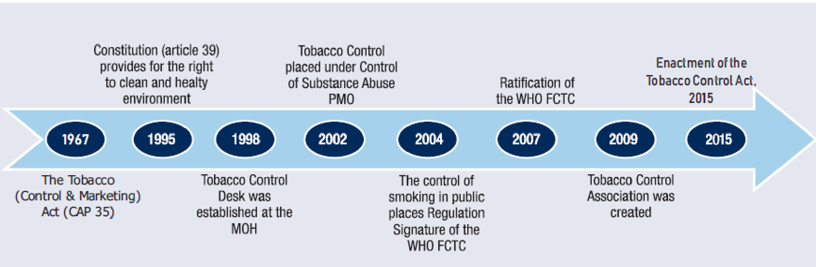

Figure 1: Tobacco Control Milestones for Uganda

Source: Adopted from the report of the Joint National Capacity Assessment on the implementation of effective tobacco control Policies in Uganda.

Table 2: Tobacco Control Legislation in Uganda

|  |  |  |
| --- | --- | --- |
| Year | Title of legislation | Type of legislation |
| 2019 | *Tobacco Control Regulations, 2019* (S.I.2019 No66) | Regulation |
| 2015 | *Tobacco Control Act, 2015* | Law |
| 2004 | *The National Environment (Control of Smoking in public places) Regulations 2004* (S.I. 2004 No. 12) | Regulation |
| 2002 | *Uganda Standard 31*3:2002, Cigarettes- Specification (as amended) | Regulation |
| 1967 | *Tobacco (Control and Marketing) Act*, *1967* | Law |

## 4.2 Present

The *TCA*26 was passed by Parliament and assented to by the President on 19 September 2015, gazetted on 18 November 2015, and entered into force on 17 May 2016. The transitional period expired on 17 May 2017, which coincided with the Constitutional Court’s dismissing, with costs, the BATU injunction application that sought court orders to stop implementation of the *TCA*, pending disposal of the constitutional petition that challenged the constitutionality of the greater part of the *TCA* sections.

The objectives of the Act are

* To control demand, supply and consumption of tobacco and tobacco products
* To protect the environment from the effects of tobacco production, consumption and exposure to tobacco smoke
* To promote people’s health and reduce tobacco-related illnesses and death
* To protect people from the socio-economic effects of tobacco production and consumption
* To promote research, surveillance and exchange of information on tobacco control
* To insulate tobacco policies, laws and programmes from interference by the tobacco industry
* To strengthen coordination, partnerships and collaboration for tobacco control
* To establish a tobacco control committee; and
* To fulfil Uganda’s obligation and commitment as a party to the WHO FCTC

Some of the major provisions of the Act are the following:

* **Smoke-free environments and protection from exposure to tobacco smoke**

The *TCA* prohibits smoking in public places, workplaces, public transport and outdoor spaces that are within 50 m of a public place.

* **Ban on Tobacco Advertising Promotions and Sponsorship (TAPS)**

The *TCA* provides for a comprehensive ban on all forms of TAPS.

* **Tobacco products packaging and labelling**

Tobacco control law in Uganda provides for text and pictures occupying not less than 65% of each principal display area of the unit packet, package or outside packaging. The *TCA* also prohibits false, misleading, deceptive or erroneous terms or descriptors.

* **Restrictions on the sale, supply and use of tobacco products**

The *TCA* controls access to tobacco products by minors in various ways. It sets the minimum age at 21 years and prohibits access to tobacco products by anyone under that age, including their involvement in tobacco cultivation, manufacture, importation and distribution. Sales through channels where the age of purchaser cannot be confirmed (vending machines and mail/internet delivery) are restricted, as well as sales in places frequented by children and youths.

* **Regulation of tobacco contents and emissions disclosure**

The implementation of the relevant sections of the *TCA* requires engagement with the national standards body and development of the necessary regulation for the testing and measuring of constituents and emissions.

* **Protection of tobacco control policies from commercial and other vested interests of the tobacco industry**

The *TCA* makes strong provision for the protection of tobacco control policies from tobacco industry interference, in line with the guidelines to Article 5.3 of the WHO FCTC.

* **Price and tax measures**

Tobacco tax and price policies form part of fiscal policies (not explicitly in the *TCA*) that have an impact on tobacco control. The cigarette tax structure in Uganda is still evolving, with excise tax currently accounting for 40% of the retail selling price. Tobacco tax policy in Uganda is also influenced by tax policy obligations under East Africa Community agreements.

Enforcement of the law is ongoing, albeit slow, due to the pending legal petition, human and financial resource capacity gaps. The timeline is given in Table 3, overleaf.

Table 3: Timeline of tobacco control-related activities/events

| Date (most recent to earliest) | Activities/Events |
| --- | --- |
| 11 September 2018 | Repeat hearing of the legal challenge to the *TCA* |
| 2018 | Kampala Capital City Authority (KCCA) declares Kampala a smoke-free city |
| 2017 (Pending) | Tobacco Control Regulations |
| 2016 (pending) | National Tobacco Control Policy |
| 2015 | Enactment of the *TCA* |
| 2007 | Ratification of the WHO FCTC |
| 2004 | Signing of the WHO FCTC  Enactment of *Smoking in Public Places Regulations* |
| 2002 | Tobacco control placed under control of substance abuse |
| 1998 | Tobacco control desk established at Ministry of Health |
| 1995 | The *Constitution of Uganda* (article 39 provides the right to a clean and safe environment) |
| 1967 | *The Tobacco (Control and Marketing) Act* (Cap 35) |

A comparison showing the compatibility of Uganda’s existing law with the WHO FCTC is set out in Table 4 (overleaf). Appendix 2 details the implementation of the WHO FCTC in Uganda, highlighting the current situation and priority action for the future.

Table 4: Comparison of Uganda’s existing tobacco control law and the WHO FCTC

|  |  |
| --- | --- |
| WHO FCTC Requirement | Provision in Ugandan tobacco control law and regulations |
|
| Article 5: General obligations | |
| Essential infrastructure for tobacco control | National Tobacco Control Committee |
| National coordinating mechanism | National Tobacco Control Committee, established in 2019, supervises the implementation of the *TCA* of 2015 and coordinates and monitors tobacco control interventions |
| Multi-sectoral tobacco control strategies | National Tobacco Control Committee is responsible for multisectoral Tobacco Control Strategies |
| Plans and legislation to prevent and reduce tobacco use, nicotine addiction and exposure to tobacco smoke | There are health warnings on tobacco products to quit smoking  No quitline number or website is available |
| Article 5.3: Protect tobacco control and public health policies from commercial and other vested interested of the tobacco industry | In the implmentation of the *TCA* and any public health policy related to tobacco control, it shall be the duty of the government to:  (a) protect the public against the influence of and interference by the commercial and other vested interests of the tobacco industry; and  (b) ensure that there is trasparency in the interactions of the government with the tobacco industry |
| Article 6: Price and tax measures to reduce the demand for tobacco | Not captured by law. Tobacco excise taxes in Uganda are well below the WHO recommendations |
| Article 8: 100% Smokefree public places* | |
| Educational facilities with minors | 100% Smoke FreeA |
| Workplaces | 100% Smoke FreeA |
| Aeroplanes | 100% Smoke FreeA |
| Passenger trains and ships | 100% Smoke FreeA |
| Motor vehicles with children less than 12 years old | No provisions |
| Pubs and bars, nightclubs, restaurants, hotels, guest houses and hospitality venues | 100% Smoke FreeA |
| Article 9: Regulation of the contents of tobacco products | |
| Testing and measuring the contents and emissions of tobacco products | No provisions |
| Regulating the contents and emissions of tobacco products | The *TCA* prohibits the sale of a tobacco product unless the tobacco product conforms to standards on contents and emissions prescribed by the Minister of Health. However, the Tobacco Control Regulations do not contain further details regarding the regulation of cigarette emissionsA |
| Article 10: Regulation of tobacco product disclosures | |
| Disclosure of information about the contents of tobacco products | Requires manufacturers, importers, suppliers, and distributors to report to the Tobacco Control Committee on the contents and emissions of the tobacco product in terms of the sixth schedule of the *TCA* |
| Disclosure of information about the emissions of tobacco products | Requires manufacturers, importers, suppliers, and distributors to report to the Tobacco Control Committee on the contents and emissions of the tobacco product in terms of the sixth schedule of the *TCA* |
| Article 11: Packaging and labelling of tobacco products | |
| Prohibit misleading tobacco packaging and labelling | A person shall not label or package a tobacco product by any means including a term, descriptor, trademark, figurative or other sign that is false, misleading, deceptive or likely to directly or indirectly create an erroneous impression about the product's characteristics, health effects, hazards or emissions.A |
| Health warnings required | The text and pictures comprising the health warnings and messages shall appear together and shall occupy no less than 65% of each principal display area of the unit packet, package of tobacco product or outside packing and shall not include the space taken up by any border surrounding the health warnings and messagesA |
| Large, clear rotating health warnings | The current tobacco packaging standard (NIS 313) (Uganda Standard 313:2002, Cigarettes - Specification (as amended)) requires that the following single text warning appear on packets of cigarettes: “HEALTH WARNING: CIGARETTE SMOKING CAUSES LUNG CANCER, HEART DISEASES AND DEATH.” In both English and Kiswahili and 8 point font1  Four warnings have been issued and are required to be rotated equally within each batch of a tobacco product brand over a 24-month period (new warning requirements enter into effect on 1 February 2020) |
| Health warnings occupy not less than 30% | The text and pictures comprising the health warnings and messages shall appear together and shall occupy no less than 65% of each principal display area of the unit packet, package of tobacco product or outside packing and shall not include the space taken up by any border surrounding the health warnings and messagesA |
| Health warnings in principal language(s) | The warnings should appear in English and Kiswahili1 |
| Information on constituents and emissions required on packages | NIS 313 requires that cigarette packages be marked with the tar, nicotine, and carbon monoxide content1 |
| Article 12: Education, communication, training and public awareness | |
| Education, communication, training and public awareness | No provisions |
| Article 13: Tobacco advertising, promotion and sponsorship | |
| Ban on all tobacco advertising, promotion and sponsorship (TAPS) instituted | All forms, methods and means of TAPS, including cross-border tobacco advertising, promotion or sponsorship prescribed in the Fourth schedule to the *TCA* are prohibitedA |
| Ban covering cross-border advertising entering the country | All forms, methods and means of TAPS, including cross-border tobacco advertising, promotion or sponsorship prescribed in the Fourth schedule to the *TCA* 2015 are prohibitedA |
| Use of direct or indirect incentives restricted | The Fourth Schedule of the *TCA* specifically prohibits the provision or offer of gifts or discounted products with the purchase of tobacco products, such as key rings, T-shirts, baseball hats, cigarette lighters, CDs, other trinkets or tobacco products and incentive promotions or loyalty schemes, such as redeemable coupons provided with purchase of a tobacco productA |
| Disclosure of advertising expenditures required | Not applicable. |
| Ban on sponsorship of international events and activities | All tobacco industry sponsorship prohibited. The Fourth Schedule of the *TCA* prohibits the provision of financial or other support to events, activities, individuals or groups, such as sporting or arts events, individual sportspeople or teams, individual artists or artistic groups, welfare and other public interest organisations, government institutions or organisations, politicians, and political candidates or political parties, whether or not in exchange for attribution, acknowledgement or publicity, including corporate social responsibility activities of any kind. |
| Article 14: Demand reduction measures concerning tobacco dependence and reduction | |
| Implemented media campaigns on the importance of quitting | No provisions |
| Implemented telephone quit lines | No quitline number or website available |
| Designed programmes to promote cessation of tobacco use | No provisions |
| Primary health care providing programmes on diagnosis and treatment | No provisions |
| Accessibility and affordability of pharmaceutical products facilitated | No provisions |
| Article 16: Sales to and by minors | |
| Sales of tobacco products to minors prohibited | The law prohibits the sale of tobacco to a minor (person below 21 years of age)A |
| Required that sellers request evidence that potential purchasers have reached full legal age | * No provisions |
| Ban of sale of tobacco in any directly accessible manner | A person shall not prominently display or make visible a tobacco product at any point of sale, other than being visible momentarily at the time of a sales transactionA |
| Manufacture and sale of any objects in the form of tobacco products prohibited | A person shall not import, manufacture, distribute, sell or offer for sale a sweet, snack, toy, or any other object in the form of tobacco or a tobacco product including an object which resembles, mimics or imitates a tobacco product which may appeal to a minorA |
| Sale of tobacco products from vending machines prohibited | ProhibitedA |
| Distribution of free tobacco products to the public prohibited | The fourth Schedule of the *TCA* prohibits the supply or offer of free samples of tobacco including in conjuction with marketing surveys and test tastingA |
| Sale of cigarettes individually or in small packets prohibited | A person shall not import, manufacture, distribute, sell, or offer for sale a unit packet of a tobacco product unless the packet is intactA |
| Penalties against sellers stipulated | Any person who contravenes or fail to comply with the law or any regulations made in terms of the *Act* shall be guilty of an offence and liable on conviction to a fineA |
| Sale of tobacco products by minors prohibited | Prohibited. A person shall not employ or involve a minor in the, cultivation, harvesting, growing, curing, manufacturing, importation, distribution, selling or offering for sale or purchasing of tobacco or a tobacco product or in any other tobacco related activityA |

**TC LAW/REGULATIONS REFERENCE**

A*Tobacco Control Act* 2015

1Uganda Standard 313:2002, Cigarettes - Specification (as amended)

2Tobacco Control Regulations, 2019 (S.I.2019 No 66)

*The law aligns with the *WHO* *FCTC* Article 8 and *FCTC* Article guidelines in respect of smoking. It prohibits smoking in other public places in addition to indoor workplaces and indoor public places.

### 

## 4.3 Tobacco control coordination

Tobacco control in Uganda is coordinated through the National Focal Point situated at the Mental Health and Substance Abuse Control section of the Clinical Services Department. The National Focal Point also heads the Secretariat of the Tobacco Control Committee, established under the *TCA*.

The *TCA* establishes that the Tobacco Control Committee is chaired by a representative from the office of the Prime Minister of Uganda and must be comprised of representatives from the relevant government ministries and civil society. Members of the committee are prohibited from having any affiliation with the tobacco industry or its agents.26

Other government ministries and agencies are involved on a need basis and include the Ministry of Finance Planning and Economic Development (dealing with tax policy and illicit trade control), the Ministry of Trade, Tourism and Industry (trade aspects), the Ministry of Agriculture, Animal Industry and Fisheries (alternative livelihoods), the Ministry of Education and Sports (school health programmes), the Ministry of Information and Guidance (regulation on TAPS), Internal Affairs (police enforcement), local governments (implementation and enforcement), the Bureau of Standards (packaging, labelling and product regulation), the National Environmental Management Authority (control of air pollution/second-hand smoke), and the Uganda Revenue Authority (URA, tax and revenue).25

Civil society organizations in Uganda also play an active role in advocacy for the enactment and implementation of tobacco control in Uganda. Tobacco control civil society organizations include advocacy groups, legal professional groups, and local branches of international non-governmental organization.25 In addition, media has also contributed in putting tobacco control in the public domain by raising awareness and educating the public on tobacco control issues.

All tobacco control actors and interventions in Uganda are controlled through the National Coordination mechanism. Coordination of tobacco control actors was lively during the development of the legislation, but has slowed down due to inadequate financial and human resources. The Tobacco Control Focal Office has only one staff member dedicated to tobacco control (and the person is also working on other non-tobacco control areas), although some support is provided through the Division of Mental Health and Control of Substance Abuse, and research fellows sponsored by the United States-based Centres for Diseases Control (CDC).

## 4.4 Research and surveillance

Tobacco control research in Uganda is limited due to the low prioritization of tobacco control in the country’s research agenda, limited resources, and capacity. However, several organizations or institutions have some involvement in tobacco control research.25 Tobacco control research is undertaken by different stakeholders, including the government, civil society, universities and research institutions.

Some of the relevant research, monitoring and surveillance initiatives include research and record-keeping on cancers and cancer patients by the Uganda Cancer Institute, and on cardiovascular diseases by the Uganda Heart Institute. There is an annual tobacco control report to the WHO FCTC Secretariat (Ministry of Health). Periodic Global Adults Tobacco Surveys (GATS), Global School Personnel Surveys (GSPS) and Global Youth Tobacco Surveys (GYTS) are run by the Uganda Bureau of Statistics and the Ministry of Health). Demographic and Health Surveys are done by the Uganda Bureau of Statistics, tuberculosis (TB) surveillance is done by the National Tuberculosis and Leprosy Programme and the International Union against TB and Lung Diseases. The Joint National Capacity Assessment on the Implementation of Effective Tobacco Control Policies in Uganda is also done by WHO and the Ministry of Health. Taxation to control tobacco consumption in Uganda is monitored by the Economic Policy and Research Center, healthcare costs of tobacco use in Uganda is done by the Centre for Tobacco Control in Africa, as well as compliance with smoke-free laws in hospitality venues in Kampala. Compliance monitoring studies of tobacco advertising, promotion and product display at points-of-sale in Uganda are done by the Uganda Health Consumers Association.

# CHAPTER 5: ENVIRONMENT SCAN OF TOBACCO INDUSTRY TACTICS

## 5.1 Tobacco industry lobbying political influence/policy or legislative interference

### 5.1.1 Prior to enactment of the Tobacco Control Bill

The tobacco industry has been active in influencing the enactment and implementation of tobacco policy and legislation in Uganda. In March 2014, when the first draft of the *Uganda Tobacco Control Bill* (*UTCB*) was tabled before the National Parliament of Uganda, the industry was outspoken in its opposition to the proposed legislation and it used various methods to stall the process.35

***Public arguments against some provisions of the Bill***

Tobacco companies have sought to lobby directly to affect tobacco control legislation. In a letter dated 14 April 2014 to the Health Committee of Parliament, BAT argued the following:35

* There is no evidence that the Bill would work, as there was no supporting evidence to link the proposed provisions with changes in smoking prevalence or cigarette consumption.
* The Bill would promote illicit trade of tobacco products by “driving legal tobacco sales under the counter”.
* Implementation of the Bill would threaten the livelihoods of tobacco farmers and small-scale retailers.
* The proposed measures were “unreasonable” and “draconian”*.*

Their arguments are summarised in Figure 2 (overleaf).

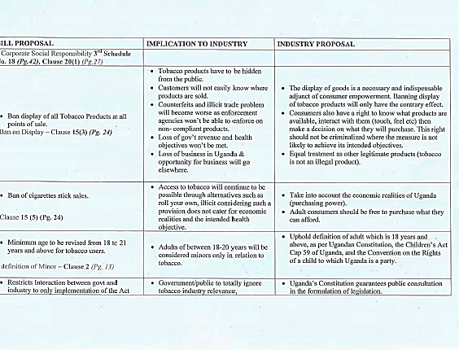

Figure 2: Extract of confidential documents of BAT key concerns regarding the UTCB

Source:<http://www.tobaccotactics.org/index.php?title=Uganda_BAT%27s_Tactics_to_Undermine_the_Tobacco_Control_Bill>

***Meeting with Parliamentarians to discuss Bill***

BAT, through Parliament, requested and was granted a meeting with Members of Parliament from tobacco-growing regions. Presentations from the meeting show that BAT raised concerns over the Bill, and lobbied against proposals, including a ban on displays of tobacco products, restrictions on smoking in public, large and graphic health warnings, limiting communication between industry and government representatives, regulation of TAPS, and setting of the legal smoking age at 21 years.35 Local media further reported more meetings with Members of Parliament in the course of the discussion on the Bill in Parliament.22 This is viewed as a breach of the WHO FCTC, which sets guidelines for interaction between governments and the tobacco industry, to limit industry interference with tobacco control and health policies.

***Threats to the mover of the Bill***

In 2014, BAT attempted to blackmail the mover of the Bill by threatening withdrawal of contracts for tobacco farmers in his home constituency, if the legislation was to be enacted (see Figure 3, overleaf).

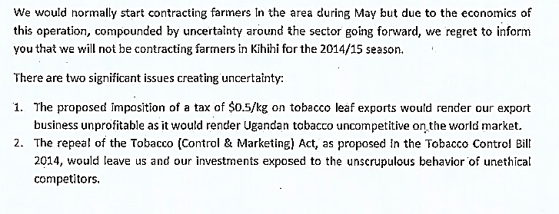

Figure 4: Promotional material – branded calendar and dirt bin in Kampala

Figure 3: Extract of Confidential BAT letter to sponsor of UTCB

Source:<http://www.tobaccotactics.org/index.php?title=Uganda_BAT%27s_Tactics_to_Undermine_the_Tobacco_Control_Bill>

A full chronology of the industry’s attempts to influence the passage of the Tobacco Control legislation as compiled by the University of Bath Tobacco Tactics initiative35 is described in Appendix 1 of this report.

### 5.1.2 After the enactment of the Tobacco Control Act, 2015

***Violation of provisions of the law***

* **Targeting traders**

Since the law was passed, the industry has violated several of its provisions. The tobacco legislation provides a comprehensive ban on TAPS, which is a provision that is frequently violated. In Kampala City, small scale traders are provided with branded merchandise, including calendars and dirt bins aimed at promoting brand recognition for the companies and their products, as can be seen in Figure 4.



The Uganda National Health Consumers Organization (UNHCO) conducted a study to monitor compliance with tobacco advertising promotion and product display regulations at points of sale in Kampala and in the Mukono District, which showed that 72.27% of the surveyed vendors were compliant with all three measures of the overall TAPS bans under review (93.18% were compliant with the tobacco advertising provisions; 97.27% were compliant with the tobacco promotion provisions and 72.27% were compliant with the product display provisions). However, some violations were observed: 6.82% of the surveyed vendors were found to be advertising through posters, signs or brand marking on physical structures at the points of sale, in contravention with the law. Promotions were observed at 2.73% of the vendors’ outlets (discounts or coupons, free samples and a competition). Product displays were observed at 27.72% of the surveyed vendors (packs were laid out on trays, tables and shelves).36

A few weeks after the initiation of the ‘smoke-free Kampala’ initiative by the Kampala Capital City Authority (KCCA), the industry complained against enforcement of the shisha (water pipe) ban.

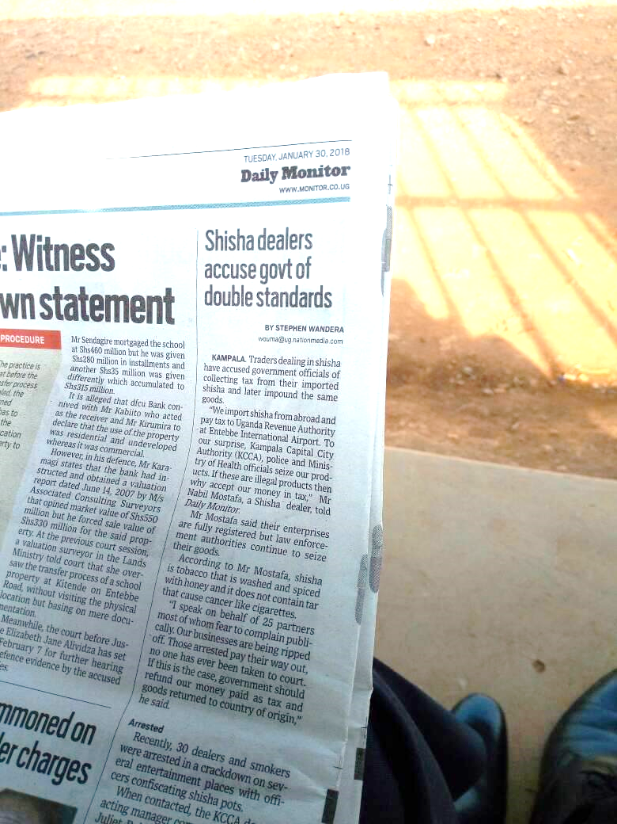

Figure 5: Newspaper cutting of industry complaint against enforcement of shisha ban in Kampala

* **Targeting youth and children**

Sale in single sticks as a marketing strategy to reach low-income earners and especially the youth is rampant. This lack of compliance has been attributed to various factors, including a lack of awareness among retailers about the existence of the law, a lack of enforcement by the designated authority and a lack of capacity (for example, regarding knowledge of the law, training, and staff availability). A study conducted by the Africa Tobacco Control Alliance in collaboration with partners in ten African countries found that Uganda had the most open cigarette packs of all retailers observed,37 a strong indication of the sale of cigarettes in single sticks. Furthermore, in some retail areas, posters advertising the price of single sticks of cigarettes is common.

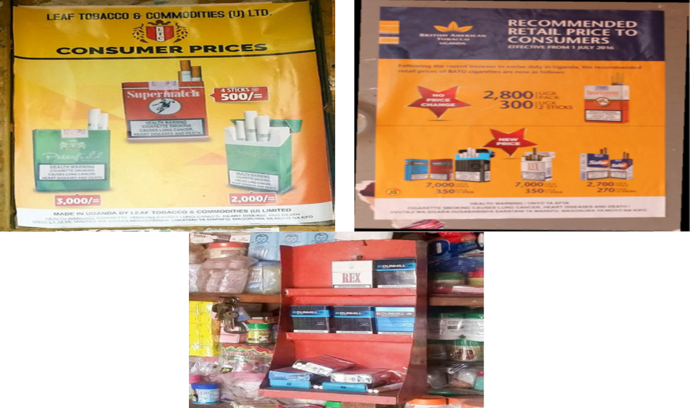

**Figure 6: Poster adverts for prices in single sticks and display with open cigarette packs**

The sale of cigarettes near schools is common, especially in single sticks, which make them easily accessible to children and youth. A study carried out by the Africa Tobacco Control Alliance in five African countries found that 63% of the schools surveyed had convenience stores or groceries and kiosks, and 44% had supermarkets in their vicinity selling tobacco products.38 In Uganda, cigarettes cannot be sold within 50m of school premises.

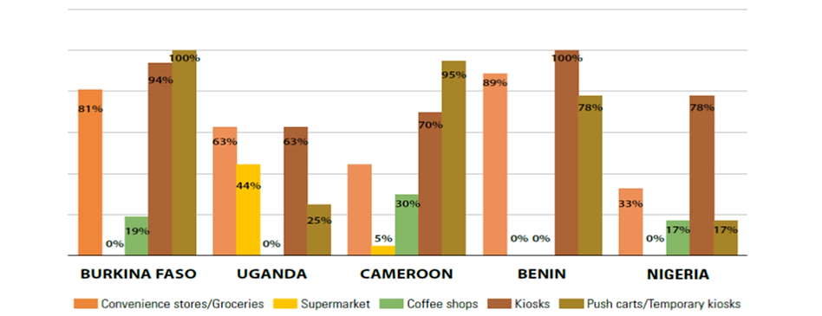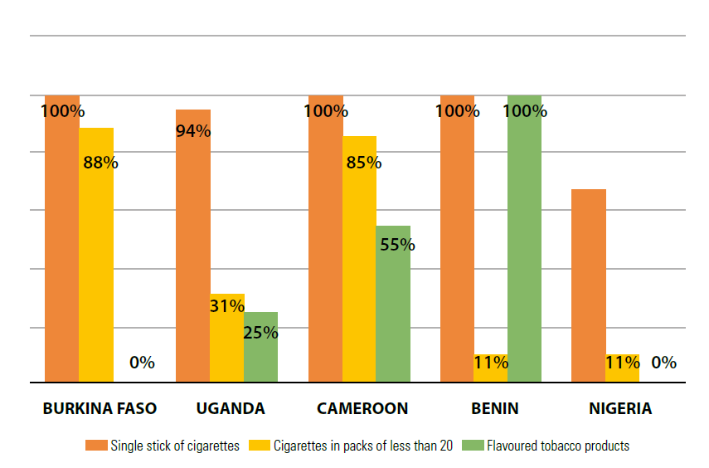

Figure 7:Form in which cigarettes are sold near schools

**Source: Big Tobacco, Tiny targets. Tobacco Industry targets schools in Africa. 201638**

Figure 8:Retail entities selling tobacco products near schools

**Source: Big Tobacco, Tiny targets. Tobacco**

**Industry targets schools in Africa. 201638**

Still related to the marketing of tobacco products to children, the 2011 Global Youth Tobacco Survey (GYTS) showed that one in ten students had been offered free cigarettes by a representative of a tobacco company and the same proportion had been given merchandise with tobacco company logos. Over half had seen pro-cigarette advertising on billboards in the 30 days preceding the survey and nearly half had seen pro-cigarette advertising in magazines and newspapers.3

Finally, a study by the Centre for Tobacco Control in Africa revealed that the tobacco industry produces cigarette-shaped sweets and sells them individually near schools.39 The three studies (by Africa Tobacco Control Alliance and the Global Youth Tobacco Survey (GYTS) indicate a strong marketing strategy by the tobacco industry, targeted at youth and children.

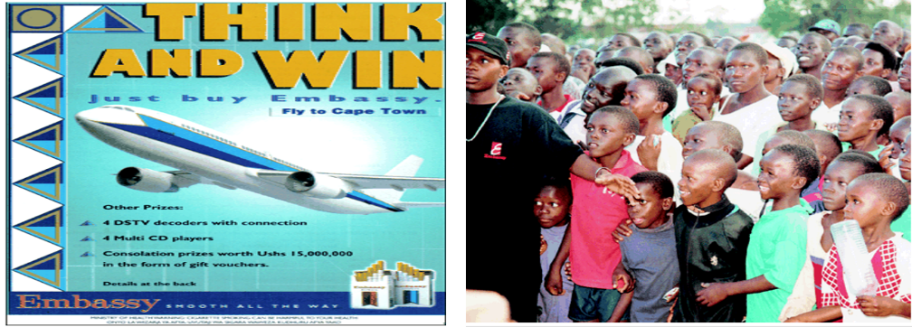BATU has provided sponsorship for youth- oriented events in Uganda; including the BATU “Think and Win” competition where consumers (with no exclusion for minors) were entered into a raffle upon purchase of five single cigarette sticks. Educational sponsorships have also been offered.35

Figure 9: Images from the BATU “Think and Win” competition targeting children and youth

Source: <http://www.tobaccotactics.org/index.php?title=Uganda-_BAT_Marketing_Strategies>

## 5.2. Manipulating public opinion including the use of “CSR” and media control

Violation of the TAPS ban by the industry as described in the previous section extends to a violation of the ban on Corporate Social Responsibility (CSR) activities. A key informant explained that the industry has continued with their CSR initiatives with the goal of influencing public opinion on their business, building and enhancing relationships with authority (as in the picture below) and demonstrating positive corporate citizenship. One interviewee explained:

…they say I will help you renovate this wing of the hospital, and until tobacco control lands on it and says this is not acceptable, but some of them go without our attention and you find that they have built a vocational school, they have renovated a health facility, they have done all sorts of marketing strategies…. they pay school fees for the most brilliant students in the tobacco growing regions…

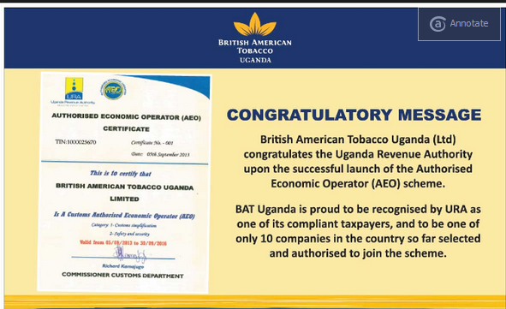

Figure 10: BAT congratulatory message as self promotion

Source. Newvision.co.ug archives

Tobacco industry documents reveal that Uganda was a priority target country for one of the tobacco industry biggest CSR programmes, the “Eliminating *Child labour Campaign*”through the Eliminating Child Labour in Tobacco (ECLT) Growing Foundation, which was started to improve to the image of tobacco companies.40 Examples of tobacco industry CSR activities in Uganda include the following:

* Engaging the government in strategic investment projects in order to get tax and market concessions and in contravention of the *TCA*. In 2017, the Meridien Tobacco Company (MTC) opened in Arua, Uganda. Meridien is owned by Tribert Rujugiro Ayabatwa, a long-term tobacco investor from Rwanda, and is part of his PanAfrican Tobacco Group (PTG). As part of its approach, the company is involved in CSR activities, including farmer development, food crop and forestry improvement programs.41
* Alliance One Tobacco Uganda has rewarded tobacco farmers in the Hoima District, Arua and Gulu with farm equipment such as solar panels, carts and motorcycles to comply with their right agricultural practices.42
* The Phillip Morris International (PMI)-funded Foundation for a Smoke-Free World has trained a number of African journalists, including some from Uganda.43,44 Discussions on harm reduction are likely to derail the tobacco control agenda. Already some journalists have been trained by the Foundation for a Smoke-Free World and could influence public perception, as well as critical actors such as researchers.

Table 5: Tobacco industry manipulation of public opinion

|  |  |  |  |  |
| --- | --- | --- | --- | --- |
| Activities | Who? | What? | When? | Outcomes (favourable opinion?) |
| Corporate Social Responsibility (CSR) | Meridien Tobacco Company | Strategic investments with the government | 2017 | Enhanced public perception  Improved relations with government |
| Media reports | BATU | Positive media messages targeted at the government |  | Good relations with the government |
| Promoting reduced-risk products | Foundation for a Smoke-Free World | Media partnerships | 2017/18 | Positive media coverage and influence public opinion |
| Agriculture labour practices | Alliance One Tobacco | Farmer support and child labour campaigns |  | Good relations with farmers, promote tobacco growing |
| Donations (financial, etc.) | BATU | Educational scholarships |  | Positive public perception |

## 5.3. Front groups

In Uganda, the International Tobacco Growers Association (ITGA) members mostly focus on studies on child labour and farming-related income. This information is used to counter tobacco control research and policy implementation. As an International Tobacco Growers Association member, the Uganda Tobacco Growers Association (UTGA) challenged the Tobacco Control Bill during discussions in Parliament, arguing that it would deprive them of their income.45Furthermore, in the run-up to the enactment of the legislation in 2016, the Hotel Owners Association, the Uganda Law Society and the Private Sector Foundation Uganda opposed the Bill, arguing, amongst other things, that the rights of adult smokers would be violated.46,47

Other front groups in Uganda and groups advancing industry goals in Uganda include middle men who purport to be tobacco farmers, with the intention of misleading the public and policy-makers on the economic benefits of tobacco growing.48 These individuals often work with leaf collection centres, as the key informant explains:

You find a rich middle man who benefit from tobacco business, comes out and say this tobacco control law is going to make us fail to get business, but many of them when you look at them they don’t grow tobacco, but they are middle men, they are the ones who benefit from the farmers. So, they come out as farmers and show their nice homes….

The tobacco industry in Uganda is also known to work with the Ministry of Trade, giving financial support to promote the tobacco crop. The Ministry has openly opposed the legislation, arguing that “the tobacco industry greatly contributes to the economy with approximately 6 billion Ugandan Shillings going directly to farmers’ pockets annually”49,50 The Ministry of Trade collaborated with the tobacco industry to compile a submission to the Parliamentary Committee on Health regarding the *UTCB* outlining the tobacco industry’s arguments against the different components of the bill.**49,50**

Table 6:Tobacco industry front groups

|  |  |  |  |  |
| --- | --- | --- | --- | --- |
| Institutions/ organizations | Who? | What? | When? | Outcome (Reports, policy briefs/memos/white papers) |
| Trade, retail and grower organizations | Uganda Tobacco Growers Association &  Hotel owners Association, Uganda | Oppose tobacco control policy enactment and implementation | During discussion on the *UTCB* | Newspaper reports condemning the *UTCB* |
| Policy groups | Law Society Private Sector Foundation Uganda | Oppose tobacco control policy enactment and implementation | During discussion on the *UTCB* | Presented arguments against the *UTCB* |

## 5.4 Economic manipulation

### 5.4.1 Tobacco taxes

Challenges to tax and price policies have been witnessed in Uganda where the tobacco industry has argued that the measures would be detrimental to their business and lead to illicit trade.52,53

In 2017 the tobacco industry influenced changes in the *Excise Duty (Amendment) Act* to impose preferential levies against international cigarette manufacturers and in favour of local manufacturers. This is in contravention of section 23 of the *TCA* and Article 5.3 of the WHO FCTC (prohibiting the incentivisation of the tobacco industry). However, BAT has now contested this provision and the case is ongoing at the East Africa Court of Justice in BAT(U) vs. Attorney General Republic of Uganda App. No. 13 of 2017.

In response to the East Africa Court of Justice case, the Uganda Health Consumers Association have provided legal interpretation and guidance to tobacco control advocates in the country. Through a committee comprised of delegates from the Uganda Health Consumers Association, the Ministry of Health and the Centre for Tobacco Control in Africa, a position paper was developed to advocate for reforming the *Excise Duty (Amendment) Act* to conform with section 23 of the *TCA*, Article 6 of the WHO FCTC and the Treaty for the Establishment of the East African Community and attendant protocols. The paper called for an amendment in the excise duty to provide for equal treatment for locally manufactured and imported products by charging at least 75,000 UGX per 1000 sticks for all soft cap brands, irrespective of their origin, and charge an excise tax rate of 100,000 UGX per 1000 sticks for all hinge lid brands, irrespective of their origin. The position paper was sent to the Ministry of Finance, Planning and Economic Development and has received a positive response that supports the Uganda Health Consumers Association’s position.

### 5.4.2 Illicit trade/smuggling

Uganda is reported to have lost approximately UGX 120 billion in 2017 due to illicit trading of tobacco products, most of which come into the country from Kenya and have been traced to two companies. The country recorded illicit trade volume (in million cigarette sticks) of 2,301.4 in 2018 and of 2,236.9 in 2017, of 2,186.2 in 2016, of 2,145.5 in 2015 and of 2,120.6 in 2014.34

The challenge of illicit trade has been blamed partly on a discriminatory tobacco tax regime that taxes locally manufactured tobacco products more favourably than imports. The Uganda Revenue Authority has reported that most of the tobacco products smuggled into the country in the six months up to April 2018 were Supermatch, and the SM brands manufactured by Kenyan companies Mastermind Tobacco and BAT respectively. The higher tax component imposed on imports has led importers to resort to illegal channels to get the products into the market.54 Between 2014 and 2016, the Uganda Revenue Authority seized more than 650 tonnes of tobacco.54. Reforming the tax policy to equalize the rates between domestic and foreigh brands will mitigate the challenge.

## 5.5. Litigation threats or actual legal challenge

In 2008, the Court of Appeal dismissed a petition by Joseph Eryau, a former BAT Quality Controller, challenging the ban on smoking in public places under the *National Environment (Control of Smoking in Public Places) Regulations* of 2004.55

Currently, besides the legal challenge relating to tobacco taxes at the East Africa Court of Justice, BATU has instituted a legal challenge in the High Court of Uganda against the *TCA*, declaring 25 articles of the Act as unenforceable and infringing on their trade rights. Although the company also applied for an injunction to stop implementation of the *Act* until the matter is heard and determined, this was rejected and the implementation of the *Act* is ongoing as hearing of the main petition continues.

The impact of this process has been the intimidation of government officials and uncertainty about the status of implementation.

# 

# CHAPTER 6: CONCLUSION AND RECOMMENDATIONS

## Conclusion

Uganda has one of the most comprehensive pieces of tobacco control legislation in Africa, which includes strong provisions on the implementation of Article 5.3 of the FCTC. While the law has had some positive effects on tobacco control in the country, the tobacco industry continues to circumvent the provisions of the law and interfere with the implementation of tobacco control policies.

Tobacco industry interference tactics in Uganda are similar to those in other countries and stretch across the entire tobacco value chain from farming, manufacturing and distribution to retail and marketing. Evidence from Uganda shows attempts to influence or lobby political and legislative processes to delay or defeat effective tobacco control policies in the country. This was seen during the process of the passage of the *TCA* in 2015 and has morphed to other strategies to delay its implementation and enforcement.

The tobacco industry invests heavily in approaches intended to influence public opinion of its business, for instance through CSR activities targeted at farmers, youth, media and other stakeholders. In some instances, tobacco industry CSR and other interference activities are driven by front groups including farmer groups and industry coalitions. Other front groups that have been encountered in Uganda are private sector foundations, legal bodies, as well as some government ministries and agencies that are yet to buy into the tobacco control message.

A major tobacco control area that is vulnerable to industry influence is tax and price policies, probably due to the potential impact on tobacco consumption and the bottom line of the industry – its profits. In Uganda, the industry has tried to influence national level tax policies and has followed up at the East African Community level to challenge tax policies that are not favourable to the industry. This legal challenge at the East Africa Court of Justice is in addition to a petition at the national level (in the High Court of Uganda), where the industry has challenged the constitutionality of the *TCA*. The legal challenges have the effect of causing confusion regarding the status of the legislation in question, leading to long delays in effective implementation and enforcement.

The knowledge and skills of tobacco control advocates on tobacco industry accountability in Uganda is not commensurate with the pace of the tobacco industry interference. A few advocates (civil society organizations, media, government) have been trained through different initiatives, including the BETA project, and have conducted industry monitoring activities in the country with varying impact. The magnitude and effectiveness of these activities are constrained by the limited financial and human resources available for tobacco industry accountability work in the country.

The BETA project has so far played a critical role in equipping a group of advocates with knowledge and skills in tobacco industry monitoring and has the opportunity to scale this up to cover more stakeholders and also promote other approaches to enhance effective tobacco industry monitoring and countering in Uganda and the region at large.

## Recommendations

* + - * Uganda should sensitize all relevant parts of the government to be aware that the tobacco industry is trying to undermine legislation, regulations, and policies, so that the government does not fall prey to it. This will ensure that no government ministry, department or agency is used by the tobacco industry to interfere with relevant policies.
      * More support should be given to grow the pool of actors trained in tobacco industry monitoring and accountability to enhance its reach and effectiveness in addition to support offered by ATIM/BETA. This can be done through:
  + skills transfer by the trained advocates to colleagues in the country to grow the constituency of advocates with the relevant capacity
  + the promotion of intercountry/regional collaborations between BETA actors to help address emerging issues (such as the East African Community tax issues), promote resource mobilization, enhance exchange of country experiences and promote effective tobacco industry monitoring and countering
  + resource mobilization for in-country tobacco industry monitoring and response activities by trained advocates.
    - * Newer non-traditional tobacco control actors should be sensitized on tobacco industry accountability, including actors such as researchers, media, policymakers and politicians (who are vulnerable to industry interference, and especially so with the emergence of the Foundation for a Smoke-Free World in Africa).
      * Media need to be supported to serve as a platform for calling out the industry on its interference tactics (a key strategy for countering tobacco industry interference). Social media should be explored as a platform for awareness on industry interference, but also as a platform to monitor industry activities targeted at certain population groups such as the youth.
      * There is a need to promote local evidence on tobacco control and tobacco industry accountability through incentivizing researchers to focus on tobacco control-relevant areas of research. This can be done by raising the profile of tobacco control as a response to a public health threat in order to attract financial and human resources towards research in this area. Some examples are the Economic Policy and Research Center and Tax Justice Alliance (TJA), who have the potential to generate useful economic evidence, but can also support local evidence generation around tobacco industry activities in relevant economic policies.

# REFERENCES

1. Uganda Bureau of Statistics. Statistical Abstract, 2017.
2. WHO. Global Adults Tobacco Survey (GATS) 2013 Fact sheet; Uganda.
3. WHO. Global Youth Tobacco Survey (GYTS) 2011 Fact sheet; Uganda.
4. MasakeOnline. History of the tobacco industry in Uganda and a glance at its impact on the country. 2013. Available from: <https://masakeonline.wordpress.com/2013/12/02/history-of-the-tobacco-industry-in-uganda-and-a-glance-at-its-impact-on-the-country/> Accessed 11 July 2018.
5. World Health Organisation, Tobacco control economics, tobacco free initiative, country profile: Uganda, 2012.
6. D’Souza J. Submission by British American Tobacco Uganda Limited on the Tobacco Control Bill 2014. 2014.
7. The World Fact Book. Africa: Uganda. Central Intelligence Agency. Available from: <https://www.cia.gov/library/publications/the-world-factbook/geos/ug.html>. Accessed 11 July 2018.
8. World Health Rankings. Uganda: life expectancy 2018. Available from: <http://www.worldlifeexpectancy.com/uganda-life-expectancy>. Accessed 15 October 2018.
9. Republic of Uganda. Uganda Health Accounts; National Health Expenditure, Financial years 2014/2015- 2015/ 2016.
10. Centre for Tobacco Control in Africa (CTCA). Health cost of tobacco use in Uganda, 2017.
11. Uganda Bureau of Statistics. Education: a means for population transformation; Thematic Series based on the National Population and Housing Census 2014.
12. Trade Economics. Uganda GDP Annual Growth Rate. 2009-2019 Data. Available from: <https://tradingeconomics.com/uganda/gdp-growth-annual>. Accessed 15 October 2018.
13. Uganda Bureau of Statistics. The Uganda National Household survey 2016/2017.
14. Ministry of Finance, Planning and Economic Development. Uganda’s employment challenge: An Evaluation of Government’s Strategy. 2014.
15. The World Bank. The Uganda Poverty Assessment Report 2016 Farms, cities and good fortune: assessing poverty reduction in Uganda from 2006 to 2013. 2016.
16. WHO. Tobacco and poverty: a vicious cycle. 2004.
17. Trading Economics. Uganda exports. 2009-2019 data. Available from: <https://tradingeconomics.com/uganda/exports>. Accessed 15 October 2018.
18. Uganda Bureau of Statistics. The informal cross border trade survey report 2016.
19. Daily Monitor. Why Uganda is not exporting enough products. Available from: https://www.monitor.co.ug/Business/Prosper/Why-Uganda-is-not-exporting-enough-products/688616-3485226-q94fohz/index.html. Accessed 13 October 2018.
20. Ntale A, Depio S, Munu ML. Tobacco industry in Uganda: economic gains and disastrous health effects. Economic Policy and Research Center. 2016.
21. WHO Report on the global tobacco epidemic, 2017. Country profile: Uganda.
22. Batre R. Report: 13,500 Ugandans die of smoking annually. 2012 Jan 13; Available from:   
    <https://ugandaradionetwork.com/story/report-13500-ugandans-die-of-smoking-annually>.
23. Mahoro B. Update: Uganda’s legal system and legal sector. Global Lex. 2016. Available From: <http://www.nyulawglobal.org/globalex/Uganda1.html>. Accessed 8 July 2018.
24. Uganda- BAT marketing strategies Available from: <http://www.tobaccotactics.org/index.php?title=Uganda-_BAT_Marketing_Strategies>. Accessed 8 July 2018.
25. WHO. Joint national capacity assessment on the implementation of effective tobacco control policies in Uganda. 2011.
26. Republic of Uganda. Tobacco Control Act, 2015.
27. Economic Policy and Research Centre. Using taxation to control tobacco consumption in Uganda. Policy brief. 2018.
28. Drope J, Schluger N, Cahn Z, Drope J, Hamill S, Islami F, Liber A, Nargis N, Stoklosa M. 2018. The Tobacco atlas. Atlanta (GA): American Cancer Society and Vital Strategies.
29. Daily Monitor. KCCA bans smoking in public places. Available from: <http://www.monitor.co.ug/News/National/KCCA-bans-smoking-public-places/688334-4692116-yjnldvz/index.html> Accessed 18 September 2018.
30. Centre for Tobacco Control in Africa (CTCA). Compliance with Smoke-Free Law in Hospitality Venues in Kampala. Factsheet. 2016.
31. Uganda Legal Information Institute. Asiimwe &2 0rs v Leaf Tobacco & commodities(u) ltd &anor MISCELLANEOUS CAUSE NO 43 OF 2013) [2014 UGHCCD 179 (21 October 2014). Available From: <https://ulii.org/node/25145> Accessed 16 October 2018.
32. WHO/UNCTAD. Status of tobacco production and trade in Africa: Fact sheets. 2015.
33. Ministry of Trade, Industry and Cooperatives. Launch of the Tobacco Season 2017. Available from: <http://mtic.go.ug/2016/index.php?/Current-News/launch-of-tobacco-season-2017/> Accessed 17 October 2018.
34. Euromonitor International. Tobacco market sizes for Uganda. Accessed 11 July 2018.
35. Tobacco Tactics. Uganda – timeline: industry interference with the Uganda Tobacco Control Bill 2014. Available from: <http://www.tobaccotactics.org/index.php/Uganda-Timeline:_Industry_Interference_with_the_Uganda_Tobacco_Control_Bill_2014> Accessed 16 August 2018.
36. Uganda National Health Consumers Organization. Uganda compliance monitoring with tobacco, advertising, promotion and product display at point-of-sale. 2017.
37. Africa Tobacco Control Alliance (ATCA). Big tobacco, tiny targets. Tobacco Industry targets schools in Africa. 2016.
38. Africa Tobacco Control Alliance (ATCA). Sale of single sticks of cigarette in Africa. Survey Report from 10 Capital Cities. 2018.
39. Centre for Tobacco Control in Africa (CTCA). Tobacco Industry Monitoring Regional Report for Africa. 2013.
40. Ortanez MG, Muggli ME, Hurt RD, Glantz SA. Eliminating child labour in Malawi. A British American Tobacco Corporate Social Responsibility project to sidestep tobacco labour exploitation. 2005.
41. Ayabatwa TR. Meridian opens in Uganda. 2017. Available from: <https://www.tobaccoreporter.com/2017/02/meridian-tobacco-opens-in-uganda/> Accessed 27 September 2018.
42. The Tomosi Group. Alliance One Tobacco Uganda rewards Hoima farmers. Kampala, Uganda. Available from: <http://tomosigroup.ug/news/alliance-one-tobacco-uganda-rewards-hoima-farmers>. Accessed 27 September 2018.
43. Business Today. Journalists to form tobacco harm reduction network. 2017. Available from: <https://businesstoday.co.ke/journalists-form-tobacco-harm-reduction-network/> Accessed 14 July 2018.
44. Magubo P. How technology can reduce tobacco harm. News of Rwanda [Internet].2017 Nov 23. Available from: <http://www.newsofrwanda.com/featured1/32675/how-technology-can-reduce-tobacco-harm/>
45. Edgar Angumya. Farmers up in arms over Anti-Tobacco Bill. The Observer [Internet]. <http://www.observer.ug/index.php?option=com_content&view=article&id=32419:-farmers-up-in-arms-over-anti-tobacco-bill&catid=38:business&Itemid=68>
46. Daily Monitor. Debate on Tobacco Control Bill suspended. 2015 <http://www.monitor.co.ug/Business/Markets/Debate-Tobacco-Control-Bill-suspended-/-/688606/2803042/-/ogb8ir/-/index.html> Accessed 18 October 2018.
47. Daily Monitor. Parliament warned on Tobacco Control Bill 2015. Available From: <http://www.monitor.co.ug/Business/Parliament-warned-on-Tobacco-Control-Bill/-/688322/2790084/-/11esucl/-/index.html> Accessed 21 October 2018.
48. Haular H. Ugandan farmers fighting for tobacco 2014. Available From: <https://www.voanews.com/a/ugandan-farmers-fighting-for-tobacco/1951229.html> Accessed 20 October 2018.
49. Monitor Reporter. Trade Ministry pokes holes in Tobacco Bill. 2014. Available from: <http://www.monitor.co.ug/Business/Commodities/Trade-ministry-pokes-holes-in-Tobacco-Bill/-/688610/2358098/-/7xi7diz/-/index.html> Accessed 20 October 2018.
50. DailyMonitor. Available from: <http://www.monitor.co.ug/Business/Commodities/Trade-ministry-pokes-holes-in-Tobacco-Bill/-/688610/2358098/-/7xi7diz/-/index.html> Accessed 18 October 2018.
51. Trade Mark East Africa. Uganda Revenue Authority certifies 12 companies as Authorized Economic Operators. Kampala. 2014. Available from: <https://www.trademarkea.com/news/uganda-revenue-authority-certifies-12-companies-authorized-economic-operators/> Accessed 10 July 2018
52. Daily Monitor. Tobacco companies in Uganda oppose planned increase in taxes. Available from <https://www.theeastafrican.co.ke/business/Tobacco-companies-in-Uganda-oppose-planned-increase-in-taxes/2560-2001674-j4jngf/index.html> Accessed 27 July 2018
53. The East African. Tobacco companies in Uganda oppose planned increase in taxes 2013. Available from <http://www.theeastafrican.co.ke/business/Tobacco-companies-in-Uganda-oppose-planned-increase-in-taxes/-/2560/2001674/-/2jjfwb/-/index.html>. Accessed 27 July 2018.
54. Monitor Reporter. Uganda loses Sh3bn to illicit cigarette imports. 2018 April. Available from: <https://www.businessdailyafrica.com/news/Uganda-loses-Sh3bn-cigarette-smuggling-URA/539546-4390224-v6av64z/index.html>
55. Jumlasupport. What happened? Smoking ban is on paper but not in public places Available from: <https://www.observer.ug/component/content/article?id=2961:what-happened-smoking-ban-is-on-paper-but-not-in-public-places/> <https://allafrica.com/stories/200802251158.html>
56. Ministry of Health 2014.  [Non-Communicable Disease Risk Factor Baseline Survey, World Health Organization STEPwise approach to surveillance (STEPS) survey 201](http://apps.who.int/gho/data/view.main.GSWCAH20v)4.

# APPENDICES

## Appendix 1: Timeline of industry interference concerning the *Uganda Tobacco Control Bill* (*UTCB*) 2014

| **Date** | **Event** |
| --- | --- |
| 12 April 2011 | Farmers in the Kanungu region, a major tobacco growing region in Uganda, received a message from a British American Tobacco (BAT) Uganda tobacco inspector that read: “This is to inform the farmers that no company apart from BAT is allowed to sponsor the production of tobacco as provided by law. Anybody doing so will be doing it as his/her own risk.”  In response, farmers in the Kanungu region appealed to the government to help end the BAT Uganda monopoly in the sponsorship of tobacco production and urged that other players be brought on board for fairer competition. |
| 24 July 2012 | A public hearing on the *UTCB* was convened by the Member of Parliament who was the mover of the Bill, and who was responsible for presenting and pushing the Bill through the Parliamentary procedure. The tobacco industry was heavily represented. |
| 7 August 2012 | The Private Sector Foundation Uganda (PSFU), sent the Hon. Chris Baryomunsi (the current mover of the Bill) and other top policy-makers and institutions arguments against the *UTCB*.  The PSFU is a corporate member organisation that describes itself as “the focal point for private sector advocacy” that sustains “a positive dialogue with Government on behalf of the private sector”. BAT is a fee-paying corporate member, estimated to pay the PFSU approximately UGX two million in membership fees and UGX one million Uganda Shillings in annual subscriptionsto represent the tobacco company’s interests in policy-making. |
| 5 June 2013 | Following World, No Tobacco Day, in an article for the Ugandan *Observer*titled “Anti-Tobacco critics should go slow”, BAT Uganda Managing Director, Jonathan D’Souza pledged the tobacco company’s support for the regulations, but asked that they be considered on the industry’s terms in a manner that is "sensible, balanced and enforceable for the benefit of all stakeholders".  D’Souza went on to explain that strictly regulating tobacco will result in an increase in illicit trade by “a network of criminals” and that anti-tobacco critics “should be careful what they wish for”. He continued: We (BAT Uganda) “are a legitimate company which conducts our business in a professional and responsible way, abiding by the laws in all the countries we operate in, often going above and beyond our legal requirements.” |
| 5 June 2013 | Farmers from the Bunyoro region protested against the *UTCB*, which they had been led to believe would stop them entirely from growing tobacco, leaving farmers “confused whether their crop will be bought because we have heard about a possible ban on tobacco growing”.  At this time the farmers of the Bunyoro region were predominantly contracted by BAT Uganda. The information concerning a ban on growing tobacco was entirely misleading, as the proposed *UTCB* seeks to regulate the manufacture, sale and use of tobacco products, but does not suggest a ban on tobacco growing. |
| 5 November 2013 | While awaiting the release of the certificate of the financial implications on the *UTCB* from the Ministry of Finance, the tobacco industry lodged a complaint to the Permanent Secretary to the Ugandan Treasury.  The Permanent Secretary subsequently wrote a letter to the clerk of the National Parliament, in which he expressed, among other issues raised by the industry, their claim that they were not consulted as stakeholders in the drafting of the *UTCB*. |
| 29 January 2014 | The Ministry of Agriculture wrote to the Secretary of the Treasury at the Ministry of Finance insisting that the ban on tobacco growing through the *UTCB* would have “serious negative effects” on farmers and the government, stating that amongst other things: “About 75,000 Tobacco farming families with about 70% of their income derive from tobacco will lose their income and livelihood” and that “The country will lose export earnings in terms of foreign exchange currently at 75 million dollars per year”.  This information is misleading, as the *UTCB* makes no reference to banning tobacco growing in Uganda, nor does it regulate the export of tobacco products.[[11]](http://www.tobaccotactics.org/index.php/Uganda-_Timeline:_Industry_Interference_with_the_Uganda_Tobacco_Control_Bill_2014#cite_note-Sem-11) |
| **28 February 2014** | ***Uganda Tobacco Control Bill* gazetted** |
| **6 March 2014** | ***Tobacco Control Bill* tabled in the Uganda parliament for the first reading by Kinkizi East MP Dr. Chris Baryomunsi** |
| 17 March 2014 | A news report claimed that details had emerged which suggested that officials from BAT Uganda had “secretly met” with members of key parliamentary committees including the Parliamentary Committee on Finance, Planning and Economic Development, the Budget Committee and the Natural Resources Committee, in an attempt "to lobby them against passing the Tobacco Control Bill 2014". |
| 19 March 2014 | BAT was accused of “blackmail” by the MP responsible for drafting and pushing the bill through parliamentary procedure. In a letter addressed to the MP that was the mover of the Bill, BAT Uganda Managing Director D’Souza expressed his concerns with the draft tobacco control legislation and informed the MP that while they “would normally start contracting farmers in the area during May…we regret to inform you that we will not be contracting farmers in Kinkizi [the MP’s constituency] for the 2014/15 season” as the challenges arising from the *UTCB* made it “impossible for us to commit at this point, to another season of tobacco sponsorship in Kinkizi “ |
| 7 April 2014 | A letter was sent from the Managing Director of BAT Uganda and the Uganda Tobacco Service (UTS) along with the Regional Leaf Manager from Leaf Tobacco & Commodities (LTC) to the Clerk of the Parliament highlighting the significant contributions the tobacco sector had made to the Ugandan economy and requesting permission to organise a meeting with MPs from tobacco growing areas "to discuss a number of operational issues touching on tobacco activity in their respective constituencies" |
| 11 April 2014 | At a closed invitation presentation hosted at the Sheraton Hotel Kampala, the tobacco industry lobbied MPs from tobacco-growing districts proposing arguments to challenge the *UTCB*.  The tobacco industry arguments leaned heavily on the negative consequences the Bill potentially might have on tobacco farmers within the MP's constituencies, claiming that the industry is responsible for supporting three million livelihoods in Uganda (10% of total population). |
| 11 April 2014 | The Ministry of Trade collaborated with the tobacco industry to compile a submission to the Parliamentary Committee on Health regarding the *UTCB*.  The submission outlined the tobacco industry’s arguments against the different components of the *UTCB*, without citing evidence to support any of their claims. |
| 14 April 2014 | BAT Uganda submitted a letter and review of the *UTCB* to the Parliamentary Committee on Health, in line with what they called “the principle of consultation as enshrined in the *Constitution of Uganda* (1995)” despite the limitations the FCTC places on its necessary restriction in policymaking.  On the same day, under the leadership of BAT, the tobacco industry of Uganda gave a presentation to the Parliamentary Committee on Health providing their input on the *UTCB*, and suggested that the majority of clauses within the Bill be repealed or amended according to the tobacco industry’s recommendations. |
| 25 April 2014 | Jonathan D’Souza, Managing Director of BAT Uganda, spoke out publicly against the *UTCB* Clause 15 (3), which seeks to ban the display of tobacco products at any point of sale and claimed that “there is no evidence to support a ban on tobacco displays” and that “display bans would also increase the illicit tobacco trade by driving legal tobacco sales under the counter”. |
| 1 June 2014 | A letter was sent from the Uganda Tobacco Growers Association to the Speaker of the Parliament of Uganda which outlined arguments opposing the *UTCB*. The arguments were presented as the voices and opinions of tobacco farmers in Uganda. However, the Uganda Tobacco Growers Association is a country member of the International Tobacco Growers Association, a front group set up, funded and mandated by multinational tobacco companies, including BAT, Philip Morris International and Alliance One International. |
| 17 July 2014 | A petition in favour of the *UTCB* was presented by farmers of West Nile Region, Kanungu and Hoima Districts to the Speaker of the Parliament of Uganda outlining the various reasons for their support of the Bill. This outlines the fact that there are groups of independent farmers not connected to tobacco industry-funded front groups like the Uganda Tobacco Growers Association that support tobacco control measures that will protect them from the detrimental and inequitable way tobacco companies run their business. |
| 16 September 2014 | Regional media reported that the tobacco industry-funded front group, International Tobacco Growers Association had "instigated a group of tobacco farmers to petition the Ugandan parliament to delete key provisions that exclude incentives or privileges that promote tobacco businesses in the Ugandan Anti-Tobacco Bill 2014”. |
| 26 September 2014 | The Minister for Trade Industry and Cooperatives submitted a memorandum to the Cabinet outlining why the Ministry should be represented at the FCTC 6th Conference of Parties in Moscow. The paper highlighted the importance of a multi-sectorial approach and reiterated arguments made by the tobacco industry against the bill, citing issues around intellectual property regulations, increased illicit trade and alluded to the fact that the ban on tobacco growing would have countrywide impacts, thereby misrepresenting the true objects of the *UTCB*, which does not seek to ban tobacco growing. |
| November 2014 | A press release from BAT Uganda was published in a local newspaper celebrating 50 years of Ugandan independence and BAT’s 85 years of business in Uganda. The release highlighted its contribution to the economy and its support to tobacco farmers, the environment and food security. It concluded by referring to the potential for tobacco control regulation and the need to include the “corporate compliant industry” in policy-making: |
| 17 November 2014 | In a letter to the Clerk of the Parliament, Dr. Okuonzi Sam Agatre, MP for Vurra (a tobacco-growing area), requested to present a petition with over 1000 signatures from tobacco farmers to the Parliament Business Committee. The enclosed petition insisted that they be included in the shaping of the legislation and states, “Your humble petitioners will be rendered landless, jobless, homeless, poverty stricken, will suffer hunger and even death if their interests are not put into consideration while handling the Tobacco Control Bill 2014.” The petitioners request “intervention by Parliament so to protect the interests of tobacco growers and tobacco companies”. |
| 2 January 2015 | While attending the official leaving ceremony of Jonathan D'Souza, outgoing Managing Director of BAT, the Minister for Investment Dr. James Mutemde spoke out about the *UTCB* claiming it was "unfair" and argued that the proposed law would impact negatively on tobacco production, advertising and consumption. According to local media reports, he added that the government should support tobacco processing companies because they provide a stable market for tobacco growers. The Minister concluded that “…while it is true that smoking causes diseases such as cancer, the smokers generate a lot of income for the government through taxes and I strongly believe they should be left to smoke!” |
| **14 July 2015** | **UTCB tabled for second reading at the Uganda Parliament by the second mover Hon. Rosemary Nyakikongoro.** |
| **28 July 2015** | After multiple setbacks due to lack of consensusand intense tobacco industry interference, the *UCTB* was passed in the Ugandan Parliament. The “stringent” tobacco control measures, sought to protect the Ugandan population against the health, social, economic and environmental consequences of tobacco and exposure. The new legislation introduced a range of tobacco control measures, which included increasing the age of legal purchase of cigarettes to 21 years of age, the introduction of graphic health warnings to cover 65% of cigarette packaging and a requirement that indoor public places and workplaces are 100% smoke-free. |
| **19 September 2015** | **Uganda President Museveni assents to the *UTCB* (now called the *Uganda Tobacco Control Act* 2015).**The regulations come into force six months after publication in the *Gazette*, which had yet to occur as of 25 November 2015. |

Source: Adapted from University of Bath Tobacco Tactics35

## Appendix 2: Implementation of the WHO Framework Convention on Tobacco Control in Uganda as of August 2018

| FCTC Articles | Legislative and regulatory actions | Gaps in legislative and regulatory actions vis-à-vis FCTC | Opportunities for Implementation | Barriers to Implementation | Tobacco Industry Interference | Response | | Recommenda-tions/ Way forward etc |
| --- | --- | --- | --- | --- | --- | --- | --- | --- |
|  |  |  |  |  |  | **Government** | **Civil Society** |  |
| 6 - Price and tax measures to reduce the demand for tobacco | * Cigarettes sub-ject to excise, value added taxes (VAT) and customs duty. * Tax and price measures are under the regu-lation of the Ministry of Finance, Plan-ning and Eco-nomic Develop-ment * The tobacco tax structure for Uganda has changed signify-cantly over the last 15 years shifting from an *ad valorem and* multi-tiered (based on brand, origin, product and packaging characteristics) system.27 * The price of a 20- cigarette pack of the most-sold brand is US$ 2.44, and excise tax accounts for 40% of the retail selling price for tobacco products.28   Uganda being a member of the East African Community benchmarks its tax policy against its obligations under the East African Community agreements. | * Tobacco taxes considered a purely public finance measure with no conside-ration of the public health implica-tions.25 * *Excise Duty Amendment Act* No. 11 of 2017 contradicts the FCTC and section 23 of the *TCA* by favouring locally produced products * No policy for ear-marking/ring fen-cing of tobacco taxes to support health program-mes, including tobacco control.27 | * The Minister for Finance Planning and economic development committed to integrating tax reforms to *Excise Duty Amendment Act* No. 11 of 2017. * Engaging in budget pro-cess which is done through consultative Sector Work-ing Groups and public partici-pation (Sector Working Groups). | * Legal challenges- On 27January BATU sued Uganda and secured an injunction stopping Uganda from collecting excise tax on cigarettes based on section 2 of the *Excise Duty Amend-ment Act* no 11 of 2017 over what they refered to as “discrimina-tory” provisions of the law. | BATU sued Uganda rejecting tax reforms on cigarettes in the East African Court of Justice. | Ministry of Health advised Ministry Finance and Economic Planning to reform the *Excise Duty Amendment Act* to affect cigarette prices so that they reduce affordability. | * Uganda Health Consumers Association partnered with Ministry of Health to draft a position paper on need to reform tobacco tax system to comply with the FCTC and the *TCA* * Uganda Health Consumers Association made submis-sions to the Budget process calling for reforms in tobacco tax regulatory framework. | * Civil society organizations must sustain advocacy to reform cigarette tax regime to reduce afforda-bility and ease administration by remove all tiers to curb shifting from expensive to less expensive. * Government should consistently increase cigarette taxes every fiscal year to keep up with income growth and inflation. * Industry monitoring and countering |
| 8 – Protection from exposure to tobacco smoke | * The Tobacco Control Act, 2015 provides for the right to a smoke- free environment and protection from second-hand smoke. * The Act prohibits smoking in public places, work-places and public transport. * Smoking is also prohibited in out-door spaces that are within 50 metres of a public place, workplace, transport terminal or any other place that pro-vides services primarily to children. * This makes Uganda 100% smoke-free in all indoor public places. | * In 2016, one year after the enactment of the *TCA*, comp-liance with the 100% smoke-free law was low, especially in hospitality venues with indoor smo-king visible in 17.8% of sampled venues, smell of tobacco smoke present in 39.2%, tobacco products visible for sale in 20.4%, designated smoking area present inside 35.6% of the venues, smoking cues present (e.g. ash trays) in 12.7% and remains of smoking (e.g. cigarette butts) present at 47.1% of the places. | The Kampala Capital City Authority on 1 August, banned smoking in public places in a bid to imple-ment the *TCA* and established a toll-free line to enable the public to report violations and strengthen compliance.29 | Low compliance likely due to lack of guidelines/ standards.30 |  |  | Advocacy | * Development of guidelines and standards for compliance with the provisions of the law. * Stronger enforcement. Following the example of Kenya the government can provide further training of enforcement officers, media and civil society organisations to support enforcement |
| 9 &10 - Regulation of the contents of tobacco products AND product disclosures | * Section 18 of the *TCA* provides for regulation of tobacco products contents and emissions disclosure * Section 45 (b) provides for product testing and measuring methods that shall be used for the reports on product consti-tuents and emis-sions and relation to any product standards that may be prescribed. | Regulation yet to be adopted. | Engagement with standards body on product and packaging standards. | Industry participation at the National standards body. |  |  |  | The government should adopt the regulations and enforce them. |
| 11 - Packaging and labeling of tobacco products | * The *TCA*, 2015 provides that health warning messages on tobacco packaging shall comprise text and pictures and occupy not less than 65% of each principal display area of the unit packet, package or outside packaging. * Section 15(3) of the Act prohibits labeling that includes a term, descriptor, trademark, figure or sign that is false, misleading, deceptive or erroneous. |  | Pictorial Health warnings are currently in the process of development by the Ministry of Health. |  |  |  |  | Finalize the Pictorial Health Warnings and implementation. |
| 12 - Education, communication, training and public awareness | * Section 50 of the *TCA* exempts charges on all notices displayed for the operation of the provisions of the *TCA*. * Section 13 requires of the person in charge of a public place to display notices. | The *TCA* does not explicitly provide for education, communication, training and public awareness. | * The Ministry of Health should develop a communica-tion strategy that will incor-porate public awareness and ongoing mass media strategies. * Development of pictorial health warnings is ongoing and is likely to impact on awareness levels on the harms of tobacco use, especially to tobacco users. * The *TCA* promotes research, surveillance and exchange of information on tobacco control. |  |  | * Ministry of Health with support from the WHO and civil society organizations has played a leadership role in crea-ting public awareness on the dangers of tobacco use through advocacy campaigns and World No Tobacco Day celebrations.18 * IEC material has been developed and dissemi-nated by stakeholders. | * Collaboration with Ministry of Health and other actors. * Media has collaborated with tobacco control actors from the government and civil society organizations, in creating pub-lic awareness in print and elec-tronic media. * Journalists have been trained under a “network of journalists” which has en-hanced their reporting on tobacco control issues. | * Finalize and implement the communication strategy * The Ministry of Health should finalize develop-ment of pictorial health warnings as part of public awareness on the dangers of tobacco use. * Invest in public awareness and mass media campaigns. * Build strategic partnerships with media. |
| 13 - Tobacco advertising, promotion and sponsor-ship | * Comprehensive TAPS ban2.6 | * Low public awareness. * Inadequate enforcement. |  |  | Incidents of industry violation of TAPS provisions have been recorded, e.g. marketing to children, sale in single sticks, CSR, sponsorship of events. |  | Monitoring and countering. | * Stronger enforcement steps against violators of TAPS provisions. Enforcement is done by Uganda Communication; Kampala Capital City Authority which has an ordinance that bans posters in the city, Uganda Police Force, and Uganda Registration Services Bureau on registration of Intellectual property. The Ministry of Information and Guidance is responsible for regulations on TAPS. |
| 14 - Demand reduction measures concerning tobacco depen-dence and cessation | No provision in the *TCA*. | No specific provisions on cessation in the *TCA* | The Ministry of Health of Uganda has developed National Guidelines for the treatment of tobacco dependence and also adopted the WHO ASSIST (Alcohol, Smoking and Substance Involvement Screening Test) tool for the treatment of tobacco dependence. However, these have not been adequately disseminated.25 |  |  | Implement MoH guidelines |  | Implement MoH guidelines. The Uganda National Health Con-sumer's Organ-isation is calling on the govern-ment to increase tobacco products taxes and ear-mark them as an alternative to using remittances from employment income alone to finance the National Health Insurance Scheme Bill of 2029. This will be duly passed by Parliament to earmark tobacco revenues to finance universal health coverage. |
| 15 - Illicit trade in tobacco products | No specific provisions in the *TCA*. | Country yet to ratify the protocol to eliminate illicit trade in tobacco products (ITP) |  |  | More than 22.3 million cigarette sticks were seized by the Uganda Revenue Authority (URA) in 2011, mostly origin-ating from Kenya in the guise of transit to Sudan or the Demo-cratic Republic of Congo (DRC).25 | Surveillance and enforcement of non- tobacco control illicit trade legislation. | Monitoring and surveillance. | Fast track ratification of the ITP and domes-ticate it through enactment of national policy and legislation. There is a need to sensitise the Revenue Author-ity and Customs Authority so that no further losses in revenue are incurred. |
| 16 - Sales to and by minors | * Section 17 of the *TCA* bans selling and buying of tobacco products by minors who are 21 years and below. * Section 17 further prohibits involvement of minors in tobacco cultivation, manufacture, importation, distribution, sale and purchase. * Sec 16 restricts the sale of tobacco products in places frequented by children and youth, display and direct access at points of sale, vending machines and mail/internet delivery systems where the age of the purchaser cannot be confirmed. | * Sale in single sticks is rampant25, particularly to minors, affecting negatively other provisions of the *TCA*, such as health warnings and tax provisions. * Marketing and sale near schools. | Evidence and recommendations from studies related to sale in single sticks, marketing to children (or near schools) etc. | Limited awareness of members of the public regarding the provisions relating to sale to and by minors. | Violations of the law. | Enforcement. | Monitoring/ response. | * Strict enforcement of legal provisions. * Public awareness. |
| 17 - Provision of support for economic-ally viable alternative activities | * No law on alternatives livelihoods to tobacco growing. * Ministry of Agriculture, Animal Industry and Fisheries is responsible for the development and implementation of agriculture policies in Uganda.25 | Policy and legislative lacuna. | Ministry of Agriculture, Animal Industry and Fisheries does not provides any financial, technical and extension service support for tobacco products. | As at 2012, Ministry of Agriculture, Animal Industry and Fisheriesdid not have any formal engage-ment with the Ministry of Health on tobacco control matters and hence was not involved in FCTC implementation in Uganda. | Tobacco is considered to be a major cash crop in Ug-anda. This has created a gap in farmer sup-port which has been filled by to-bacco com-panies.18   * Involvement with farmers through CSR.. | Collaboration between Ministry of Health and Ministry of Agriculture, Animal Industry and Fisheries. | Monitoring and response. | Collaboration between Ministry of Health and Ministry of Agriculture, Animal Industry and Fisheries.  Enforce ban on TAPS as relates to CSR. |
| 18 - Protection of the environment and the health of persons | Article 39 of the 1995 *Constitution of the Republic of Uganda* guarantees the right to a clean and healthy environment.  Section 12 of the *TCA* makes indoors 100% Ssmokefree environments and requires smokers to go 50 metres away from public places, work places and public means of transport. The *National Environment Act* (1996), and the *National Environment Regulations* (2004) have provisions for protection of the environment from degradation form tobacco farming. |  |  |  |  |  |  |  |
| 19 - Liability | In Asiimwe & 2 Ors v Leaf Tobacco & commodities (u) ltd & anor (MISCELLANEOUS CAUSE NO. 43 OF 2013) [2014] UGHCCD 179 (21 October 2014)31, the Kireka community secured judgement which consequentially banished the tobacco factory that had established residence in a residential area and exposed the community to public exposure of tobacco particu-lates and dust ,thus violating article 39 of the *Constitution* and the *National Environment Management Act* cap 139. |  |  |  |  |  |  | Promote opportunities for civil and criminal liability against the tobacco industry. |